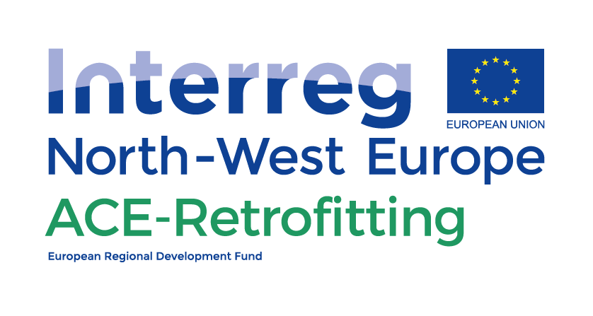

**Supporting the “demand” side - First steps**

**Convincing your condominium into action**

*19.12.2018*

*Prepared by Maastricht University – Deliverable DT2.2.1 bis*

|  |  |
| --- | --- |
| Who is this tool for? | Co-owner who wants to create support for retrofitting  Condominium Board  Retrofitting coach |
| What is the purpose of this tool? | This tool will help to structure your efforts to convince others that energy retrofitting is necessary and feasible |
| How to use this tool? | After some general information you will see a figure with 6 steps. You can click on each step and you will receive more explanation. Also, you will receive an indication which other tools you can explore. |
| Next steps | Form a resident’s project team. See also “determine your capacity to manage an energy retrofit project/ensure the project team has the right capacity/set up the project team”. |

Main source for whole document: <http://www.lowenergyapartments.eu/the-leaf-toolkit/the-toolkit/>

We know that it is not easy to convince your neighbours to act. Even with full support of some residents for the retrofit works, there may be others who are indifferent or against it. This could be due to various reasons, such as unfamiliarity or disbelief regarding the potential energy savings, concern over disruption, or lack of finances or financial assistance to pay for the work. Essential for creating a successful retrofitting project is understanding that different stakeholders have different expectations of the project and define success each in their own way.

Understanding the composition of your condominium and taking strategic decisions that take into account the needs and wishes of your fellow residents can improve the retrofitting process and help solve bottlenecks early on. Click here for a template to create such an overview.

**For example,** if 50% of all residents are elderly it might not be a good idea to only communicate through an online platform. On the other hand, if the majority are young professionals it might not be a good idea to plan a lot of physical meetings due to their busy work and social schedule.

And what to do if you are a **minority**? General tips on how to deal with this situation can be found here.

# How to convince residents?

# Click on each of the steps in this figure to obtain more explanation

**1. General benefits of a retrofit**

**The table below provides the general benefits a retrofitted building has in comparison to a non-retrofitted building. These benefits should be highlighted throughout the whole retrofitting project to ensure residents know what all the inconvenience within the building will result in. Also have a look at “get to know your building better”, and add any information you or your fellow residents might find useful, but always present it in the simplest possible way.**

|  |  |
| --- | --- |
| General benefit | Example |
| Reduce energy bills | Improved insulation helps to decrease heat loss and keep the cold out. |
| Increase the level of comfort in the home | Reducing draughty windows and cold walls results in better temperature control and a feeling of comfort. |
| Improve security and safety in properties | More safety created by replacing old and vulnerable windows with new, safer, and better insulated windows. Removing old heating systems also creates a safer building due to safer new technologies. |
| Increase property values | Retrofitted buildings are more interesting to prospective buyers because of their lower energy costs and increased comfort. Compared to the not retrofitted houses the value of these properties is higher. |
| Improved appearance | External wall insulation or glazing upgrades improve the outer look of the property, making it look newer. This will also increase the value of a property. Furthermore, this will reduce maintenance in the long-term. |

Back to the 6 steps

**2. Get in touch with those in favour of a retrofit**

**Gather all people in your building who support the retrofitting project. These innovators are important in convincing other residents. It is important to include well-respected residents from the condominium because people tend to be persuaded more easily by these people. You can make an inventory of who these people are with the help of** **this template****. Forming a resident’s project team with these so-called innovators will enhance the start of the retrofitting process. See “determine your capacity to manage an energy retrofit project/ensure the project team has the right capacity/set up the project team” on how to do this.**

Back to the 6 steps

**3. Distribute information**

**Gather professional and easy to read information and provide it in an attractive leaflet to your fellow residents. The leaflets are preferably shared by personal contact, so that your fellow residents can immediately ask questions concerning the provided information. Make sure that all initiators within the condominium provide unambiguous information (see** **minority****). The information provided to the residents should be easy to understand and should not provide irrelevant information or information which is only important in later stages of the project. Also see “communicate with your neighbours” for additional tips.**

Back to the 6 steps

**4. Organize visits to other buildings**

**Organize visits to other buildings where a similar retrofit was done. Collect reviews from residents in these buildings and ask about their experiences. Use case study examples. Two experiences are key; the process of installation and the impact the retrofit has had on their lives (e.g. cost savings). You could choose to collect the information from these residents and share it with your residents (e.g. video blog). You could also invite a resident from a retrofitted building and let this person answer questions. It is important to always consider your objectives and if the message from an outsider fits in with this. If not, it could be a better idea to use a more controllable method, such as a video blog in which residents from the retrofitted building are interviewed. See also “be inspired by general examples”.**

Back to the 6 steps

**5. Emphasize benefits rather than costs**

**The first question your fellow (unconvinced) neighbours will ask is “how much will this cost?”. This is a valid question, but very difficult to answer. As suggested in** **point 1****, always emphasize the benefits of the retrofit throughout your process. Also emphasize that the value of your building will increase and that energy costs will decrease. But be honest and indicate that a full overview of costs is complex and that it would be better to first investigate the state of the building and possible interventions. See “be inspired by general examples/ get to know your building better/obtain specialist information on technical, financial and legal issues/contact an expert for a full assessment”.**

Back to the 6 steps

**6. Assess possible partnerships**

**Try to form a partnership with the local authority or any other support organizations active in energy retrofitting and with knowledge about condominiums. External help might convince some neighbours to act. For instance, a project operating at council level could be helpful in communicating with your neighbours what options are possible. Important is to follow this up in person or with a meeting because some residents might not understand the information. Your condominium manager of council energy coordinator will have an idea about such projects applicable to your situation. Also see “communicate with your neighbours” for additional tips.**

Back to the 6 steps

# What to do if you are in the minority for change?

It could happen that you as an initiator of the retrofitting project are in a minority position. This might seem daunting, but it is known that a minority opinion is more intriguing than a majority opinion in a group discussion. As a result, the minority opinion receives more attention and is more deeply discussed and thus can become stronger than a majority opinion. That is, rather than sharing viewpoints with group members in case of a majority message, a minority message receives careful scrutiny to find out the true value of the minority’s opinion. This validation process, if positive, leads to private acceptance which makes the attitude change more durable. Minorities can thus make an important source of innovation in groups.

To make your minority position (the need to retrofit) into a majority opinion, however, it is important that you **maintain consistency in your opinion.** You can do so by preparing well in advance and **collect strong arguments** for example with the help of external experts and/or **show examples of best practices** elsewhere. While being in the minority it is important that you consolidate a good relationship with your fellow residents and/or team members. So, at times, you may also bend to their opinion, for example in case of opposition, acknowledging your understanding of their doubts, or give in on other not related decisions. However, remain consistent and persistent in arguing for your case. Because minority opinions can provide the best solutions it is important that project teams allow having these opinions on the table and to be discussed. Furthermore, you have to strive for a unanimous decision rule rather than having a majority-rules procedure. If simply a majority vote would decide whether a measure is implemented minority opinions can be easily disregarded. Within a project team, you would thus do best to strive for broad consensus by stressing the benefits for all and asking the approval of all.

Back to the 6 steps

# Example of a communication/residents inventory

|  |  |  |  |  |  |  |
| --- | --- | --- | --- | --- | --- | --- |
| Name | Apartment N° | Age (+ small children, special needs) | Time at home | Preferred communication method | Information frequency | Position in retrofit |
|  |  | …. Yes/no,.... | All day/evening/other…. |  | Weekly/bi-weekly/monthly | In favor/against/neutral |
|  |  | …. Yes/no,.... | All day/evening/other…. |  | Weekly/bi-weekly/monthly | In favor/against/neutral |
|  |  | …. Yes/no,.... | All day/evening/other…. |  | Weekly/bi-weekly/monthly | In favor/against/neutral |
|  |  | …. Yes/no,.... | All day/evening/other…. |  | Weekly/bi-weekly/monthly | In favor/against/neutral |
|  |  | …. Yes/no,.... | All day/evening/other…. |  | Weekly/bi-weekly/monthly | In favor/against/neutral |
|  |  | …. Yes/no,.... | All day/evening/other…. |  | Weekly/bi-weekly/monthly | In favor/against/neutral |
|  |  | …. Yes/no,.... | All day/evening/other…. |  | Weekly/bi-weekly/monthly | In favor/against/neutral |
|  |  | …. Yes/no,.... | All day/evening/other…. |  | Weekly/bi-weekly/monthly | In favor/against/neutral |
|  |  | …. Yes/no,.... | All day/evening/other…. |  | Weekly/bi-weekly/monthly | In favor/against/neutral |
|  |  | …. Yes/no,.... | All day/evening/other…. |  | Weekly/bi-weekly/monthly | In favor/against/neutral |
|  |  | …. Yes/no,.... | All day/evening/other…. |  | Weekly/bi-weekly/monthly | In favor/against/neutral |
|  |  | …. Yes/no,.... | All day/evening/other…. |  | Weekly/bi-weekly/monthly | In favor/against/neutral |
|  |  | …. Yes/no,.... | All day/evening/other…. |  | Weekly/bi-weekly/monthly | In favor/against/neutral |
|  |  | …. Yes/no,.... | All day/evening/other…. |  | Weekly/bi-weekly/monthly | In favor/against/neutral |
|  |  | …. Yes/no,.... | All day/evening/other…. |  | Weekly/bi-weekly/monthly | In favor/against/neutral |
|  |  | …. Yes/no,.... | All day/evening/other…. |  | Weekly/bi-weekly/monthly | In favor/against/neutral |
|  |  | …. Yes/no,.... | All day/evening/other…. |  | Weekly/bi-weekly/monthly | In favor/against/neutral |
|  |  | …. Yes/no,.... | All day/evening/other…. |  | Weekly/bi-weekly/monthly | In favor/against/neutral |

Back to the 6 steps