C 1.3 Multilingual upbringing
Verena Plutzar
Growing up and bringing up a child as multilingual are hard work. Not for nothing does Elke Montanari (2010) compare the process to a mountain climb. Many parents of children who are growing up multilingual have not grown up with more than one language themselves and therefore cannot draw on their own experiences of coping with this situation when faced with the challenges it poses. Myths about multilingualism therefore often determine how parents approach the issue. How they stand on the potential multilingualism of their children; whether they see it as an advantage or a disadvantage for their children's future development, is strongly influenced by the social prestige of the language(s) spoken at home and the place of that language or those languages in the education system. The significance of those languages for how parents see themselves, their role in parents' own life story and the level at which the languages are used and promoted within the family can also have an impact.
With regard to languages spoken at home, parents of children who are becoming multilingual may make certain observations that worry them. These include:
- Contact with the new language in the institutional environment of nursery or school is leading to a slowdown or stagnation in the process of acquisition of the language spoken at home.
- The child begins to transfer the forms and structures of one language to the other, producing "errors".
- When the child starts school, they (temporarily) stop using the family language(s) at home.

Such observations are accompanied by a desire and expectation that the children will learn the language of school at nursery, and in a way that enables them to follow lessons without any problems. The potential loss of one language (spoken at home) can then be offset by the hoped-for gain of the other language (German). However, a situation of "either-or" is not conducive to the development of a multilingual self-concept for children. What we need to do instead is to encourage parents to support their children in their overall language development and to offer children extensive and high-quality contact with the languages of their parents (see "Language tree" below). At the same time it helps the children if parents pass on a positive approach to the language of the educational institutions. It is important that children of nursery age are nurtured in terms of language – no matter what language – and the family is the most important language development institution at this stage.

The language tree
In response to the question "How can I support my child in their language development?", parents can be encouraged, for example at a parents' evening or progress and development meeting, to give their children language support that makes it easier for the children to develop their language skills – in any language. The essential elements of a supportive and linguistically stimulating environment can be explained on the basis of what it takes to turn an apple seed into a tree.

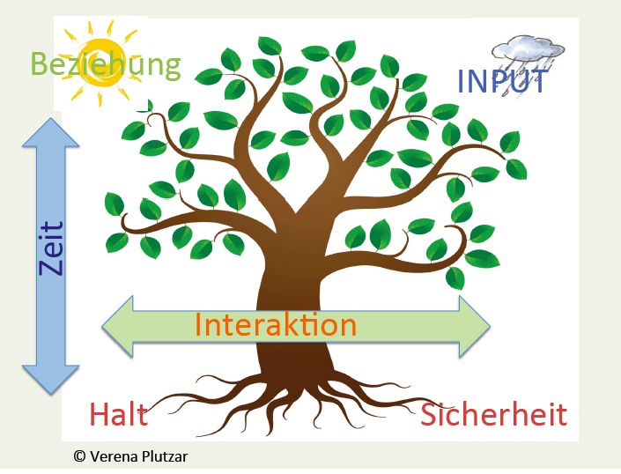

Language development takes time. It takes around ten years for an apple tree to begin to bear a good crop of fruit. Similarly, the start of school does not signal the completion of a child's language acquisition; instead, that acquisition continues throughout their time at school and beyond.
Language development needs relationships like an apple tree needs the sun. Focusing, concentrating on the child when in linguistic contact with them makes the child feel addressed and ensures that they will listen carefully. Language can develop when children feel secure, accepted and protected.

Acquiring a structure requires complex input like an apple tree needs water full of nutrients. Children do not adopt the structures of a language systematically and consciously, but instead learn them from the language around them to which they pay close attention. If that language is limited (for example to instructions, demands, commands, praise and reproach – but also to linguistic exercises), children have little chance of developing linguistically and therefore also cognitively. Alongside everyday conversations, children need complex stories (read aloud or told to them), songs and rhymes.
Interaction creates the space in which a language can grow. The language developed needs to be tested by children in exchange with others. Children need the opportunity to test the effect of the vocabulary and structures acquired on others and develop them further in the process. Conversations with adults and peers as well as role plays are therefore key to language development.
Support and security provide the necessary foundation: If a child does not feel safe and secure, this (temporarily or permanently) ties up their efforts and energy. An initial and important step towards further linguistic development can be to give the child stability and security.
These five aspects offer a guide. To summarise, adults who want effectively to help children with their language development can ask themselves the following question:
Am I an interesting and sympathetic figure for the child to talk to?

Bibliography and suggested reading
Brizić, Katharina (2007), Das geheime Leben der Sprachen, Münster: Waxmann
Montanari, Elke (2010), Mit zwei Sprachen groß werden. Mehrsprachige Erziehung in Familie, Kindergarten und Schule (9. Auflage), München.

The parental guide "Talk to Me and Listen to Me" was developed by okay.zusammen leben (Vorarlberg) and is available in a wide range of languages at https://www.okay-line.at/okay-programme/elternratgeber/ Text licences were obtained from Kinderfreunde Wien and the Federal Government of Lower Austria.

cf. "Myths about multilingualism" in basic text A 1.1 Multilingualism
cf. Brizić (2007)
cf. "In fact, being multilingual..." in basic text A 1.1 Multilingualism
cf. Basic knowledge A 1.2 Multilingualism and identity
Developed by Verena Plutzar
Diese Formulierung ist der leichteren Lesbarkeit geschuldet. Männer sind eingeladen, sich dennoch angesprochen zu fühlen.

