Feeling the Spirit of Nature in Latvia-Russia cross-border territory
The travellers to Latvia-Russia cross-border territory are no longer just passers-by who rush to their final destination. The locals from Ape (Latvia), Izborsk and Lavry (Russia) joined efforts to reveal the intangible gems of their native land – the spirit of genuine nature in the area adjacent to the border between Latvia and Russia.
The Spirit of Nature project was initiated by three quite minor settlements in Latvia and Russia – town of Ape (Smiltene municipality, Latvia), village of Lavry and village of Izborsk (both belong to Pechorsky district of Pskov region, Russia). The project was aimed at the promotion of natural objects as sources of energy and inspiration through local history and new solutions.
These three nature objects included manor park in Gaujiena, trail along the Gorodishchenskoye Lake by Izborsk fortress and park in the centre of Lavry village. The project beneficiaries aimed at enhancing the special atmosphere and spirit with new objects which could increase the attractiveness and sustainability of the locations. Ideally, the visitors should have gained the possibility to experience nature, history and culture in one visit. Did they manage?
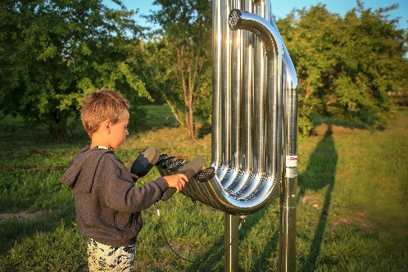
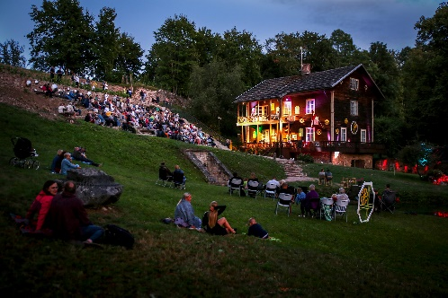
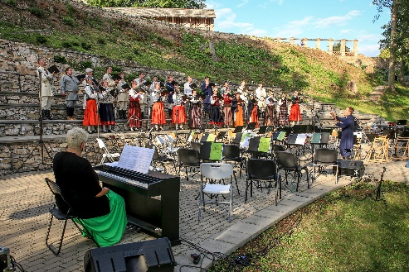
In Ape, Gaujena park went through a substantial reconstruction now offering the visitors a plethora of opportunities to feel the music of nature – through the interaction with outdoor musical instruments or enjoying an open-air concert auditorium at the Jazeps Vitols museum on the bank of the Gauja River. Now, the visitors to the museum can enjoy and even create the music in the natural environment using large harmony, hand pipes, emperor chimes and other instrument that connect humans with the universe of natural sounds.
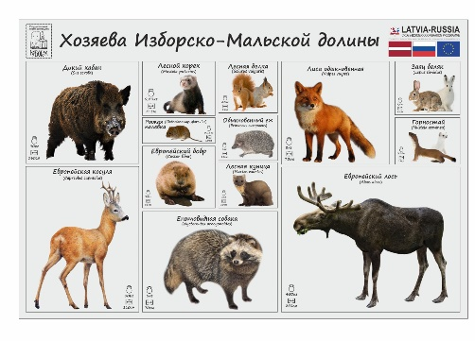
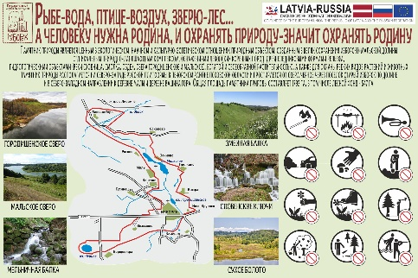
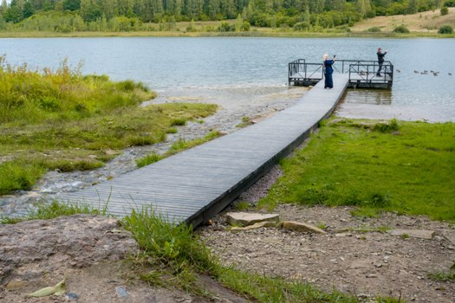
There is no way that you come to the ancient fortress of Izbosk and miss the opportunity to see the Slovenskie Springs – the local natural limestone waterfall surrounded by legends and local beliefs. The 550-meter trail down the hill was equipped with interactive elements that entertain the visitors on the way to the natural object and simplify the journey up the hill. Those include gazebos, benches with backrests, steps on steep slopes, information stand and easels to immediately connect tourists with the picturesque beauty of nature.

Music and Art are nothing without a sound basis in local beliefs and fairy tales. In Lavry village the historical Spirit of Nature finds its embodiment in the reconstructed park featuring fairy-tale characters familiar and dear to any child: Bogatyr, Baba Yaga, Golden Fish and many others. Straight from the project beginning the deprived bushy area turned into an attractive green zone in the very center of the settlement thus inviting locals, visitors and passers-by to forget about the city hustle and enjoy the company of true friends from the childhood.
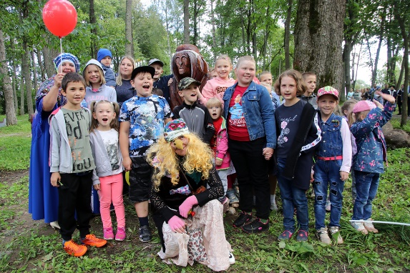
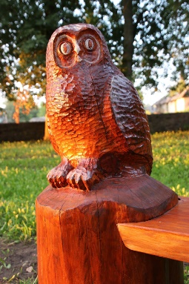
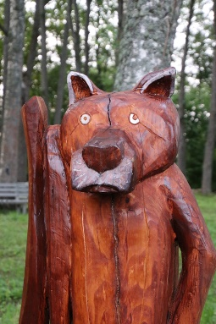
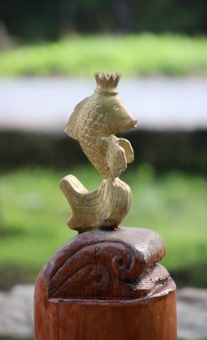
The soft part of the Spirit of Nature project was aimed at the promotion of newly reconstructed objects. The issue of involving people into the Music, Art and Magic of Latvia-Russia CBC was discussed by project beneficiaries at trainings, seminars and experience exchange events which resulted in a number of tailored tools aimed at adults and kids.
Individual quest games were developed for all three locations (Gaujena, Izborsk and Lavry) thus guiding the visitors through the experience of deep individual contact with the spirit of nature.
The challenging travel conditions pushed the project thinking further, and all partners created virtual tours around their renovated natural objects. Now, the Spirit of Nature will reach you even through the screen of your computer.
Looking back at the project experience, we are happy to confirm that dedication to the idea and genuine desire to share the best and to move forward are the cement for a true lasting partnership. The Spirit of Nature project demonstrated wonderful teamwork and inspiring flexibility in response to everyday challenges and concerns of today.

