Dive into park life with #latruscbc
At the end of 2021, the “Parks without borders” project was completed showcasing amazing results of aligning infrastructure and environment priorities at 7 city parks in Latvia-Russia cross-border territory! Project partners created safe and smart park infrastructure, engaging places for children to play, and new opportunities for physical activities in Spārīte park (Gulbene), Juzefova park (Naujiene), Preiļi Manor Park (Preiļi), Shchiglitsy Manor Park (Pskov district), City Square (Porkhov), Open Air park (Velikie Luki), Retro-park (Kunya township)! “The improvement of the parks has facilitated their versatile use for organizing events and festivals”, explains Elīna Strode, project manager at Gulbene Municipality Council (Lead Beneficiary). “The "green class" activities have shown the potential of these areas as an alternative and complementary learning environment”. Moreover, major improvements to the quality of all 7 parks stimulated people's desire to relax in the open air and encourage them to be more physically active.
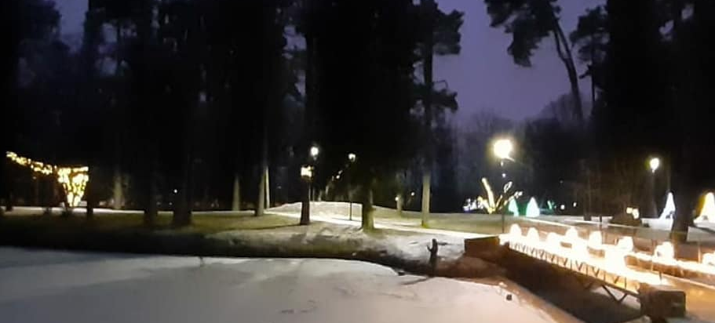
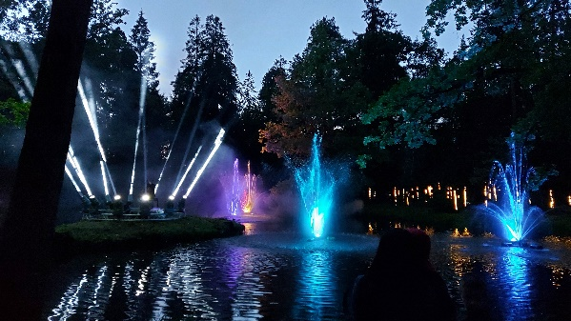
The nature learning path, giant twig nests, installed street lighting, cleaned ponds and attractive landscaping are now welcoming all Sparite park visitors in Gulbene. “The park can now be used by pedestrians, cyclists and young families with prams”, comments Elīna Strode. “Park became popular for running and other sports activities as well”. Moreover, Sparite park became one of the city's tourist electric train destinations, so the guests of Gulbene were very actively introduced to the unique history of the park. Gulbene Municipality Council is also looking for further educational activities in nature to involve locals, especially children, into the conservation and exploration of natural resources - a continuation of the "green class" activities started within the project.
Juzefova park now attracts not only locals for leisurely walks and admiring nature, but also curious students! Augsdaugava Municipality created interesting and educative places for enjoyable time outdoors: open space for environmental classes and an outdoor library. “Brand-new Green Class will be used for outdoor biology classes for Naujene Primary School pupils and for environmental education classes for students of municipal educational institutions during excursions”, explains Juta Valaine, project manager at Augsdaugava Municipality. “The Green class is a great addition to the nature exposition at the Naujene Local History Museum as well”.
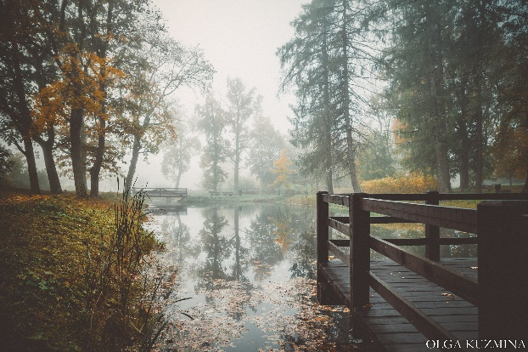
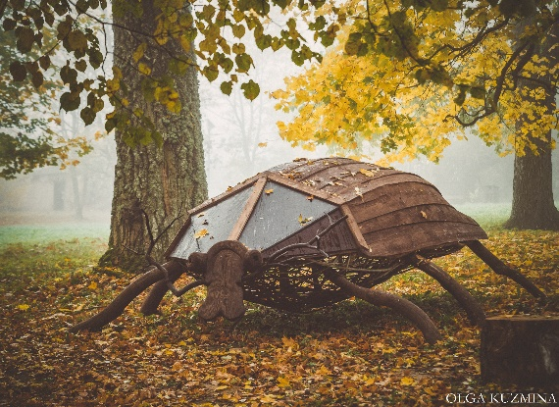
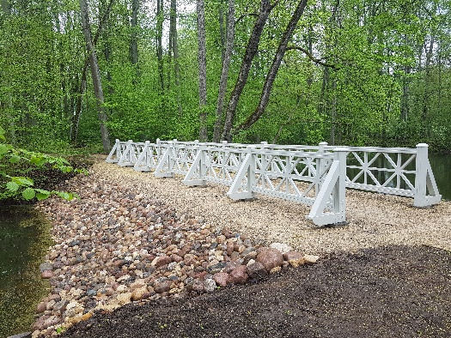
Have a lovely walk along a unique alley with four rows of linden, and admire old Preili manor and restored historical bridges at Preiļi Manor Park! Preili Municipality Council shaped the park development concept in close cooperation with locals to boost the tourism potential of the park and create a great all-season leisure site. “Since Preili Manor Park is a historical park, every improvement activity was considered very carefully to correspond to the historical appearance of the park and be approved by the State Inspection for Heritage Protection”, says Sanda Čingule-Vinogradova, project manager at Preili Municipality Council. “The park welcomed more than 70 000 people within 6 months in 2021”.
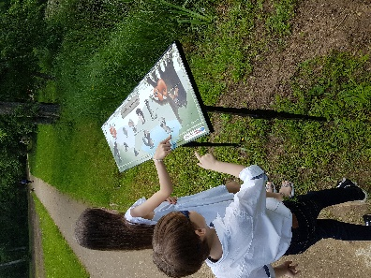

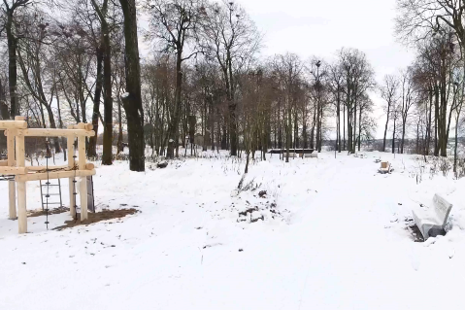
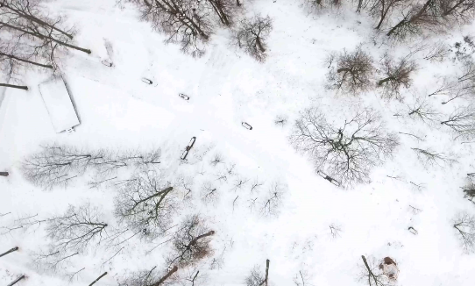
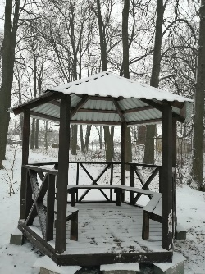
Shchiglitsy Manor Park experienced a complex reconstruction: dangerous trees were removed, riverbanks stabilized, and immense landscape clean-up was done to preserve natural recreation space. Now the park is fully equipped and redesigned as an attractive community area with a playground and beautiful paths. “Thanks to the improvements, the park acquired a well-groomed appearance, infrastructure, and became attractive for locals and guests from Pskov and Pskov region”, comments Elena Cherenkova, project manager at the Administration of the Pskovsky area.
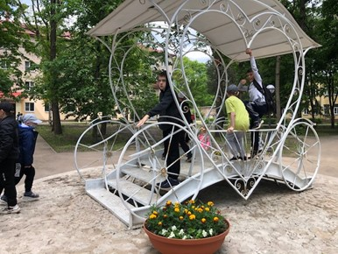
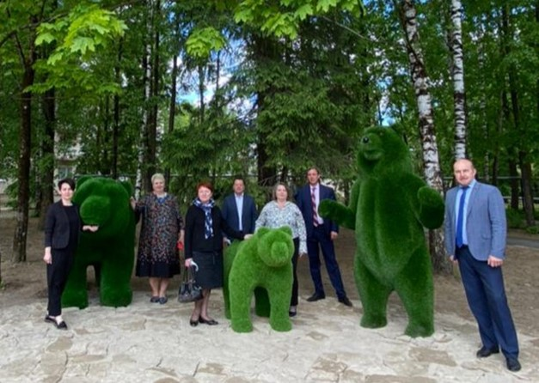
One of the most attractive places at the improved Porkhov City Square is the forged carriage with flowerpots located in the center of the square. “This place became a favourite photo zone for locals and guests of Porkhov”, comments Svetlana Pavlova, project manager at the Administration of the Porkhovsky area. “No less popular are topiary figures "Three Bears" located near the entrance to the park”. The Square became a great place both for photoshoots, relaxing walks and energizing jogging.
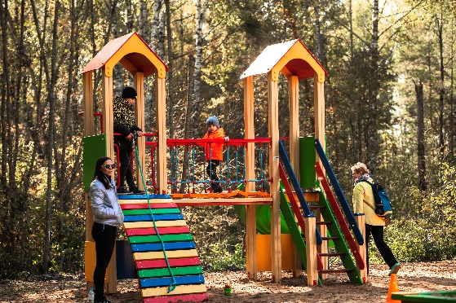
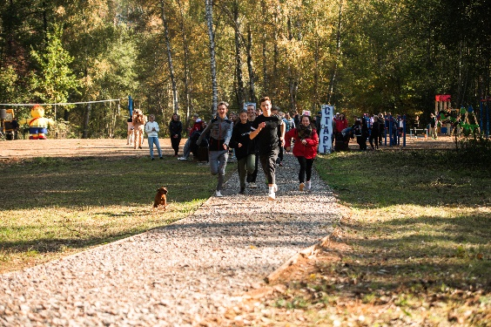
Open Air Park in Velikie Luki became a picturesque complex for sports, hiking, cycling, environmental seminars, and practical classes for children and students! Andrey Baykov, Head of the Department for the Implementation of Investment Programs in Construction at the Administration of the Velikie Luki town, appreciates the huge work done: “The Administration created 1645 meters long pedestrian and jogging paths, volleyball court, children's playground with swings, slide, sandpit and chess table, workout and recreation areas and a playground for people with limited mobility”. Moreover, a wooden bridge was built across the stream to connect the park with the city street for a more comfortable and welcoming entrance.
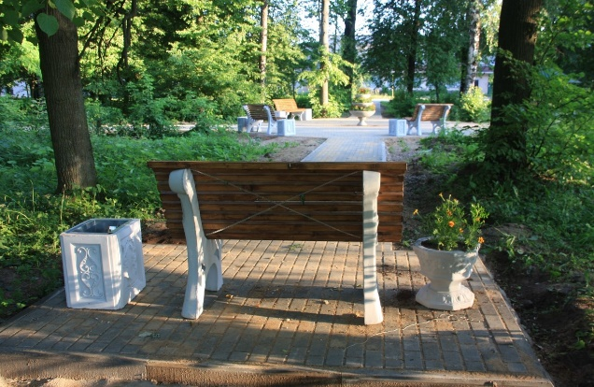
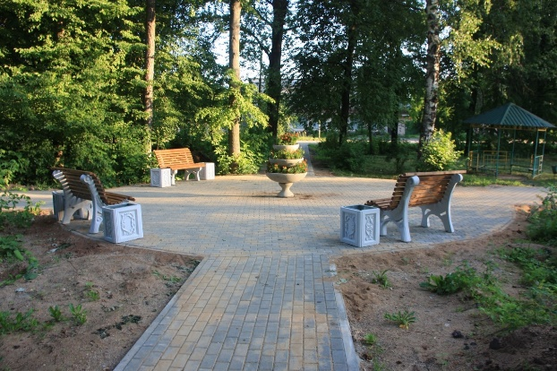
Improved Retro-park in Kunya became an exquisite place for relaxing walks and friendly meetings. The green zone was fully equipped for recreation, pedestrian paths were improved, and new trees were planted to replace the dangerous ones. “According to the federal program "Comfortable Urban Environment", it is planned to continue landscaping in the park in 2022: a children's playground will be installed, and a recreation area will be equipped”, comments Olesya Nadelko, project manager at the Administration of the Kuninsky area. “It is also planned to carry out further environmental campaigns for the locals, including preschool and school-age children”.
Project partners appreciated the opportunity to work in an international team, and combined their skills and knowledge to develop amazing handouts with maps, legends, practical tasks, and stories of all 7 parks: https://ej.uz/parki_bez_robezam_druka “During more than 2 years, good communication was developed between knowledgeable professionals in each of the partner organizations”, comments Elīna Strode, representative of the Lead Beneficiary. “It helped to maintain contacts even after the end of the project and provided the opportunity to facilitate the implementation of new projects.”
We are happy to celebrate the excellent work done by the project team and look forward to meeting you in the next Latvia-Russia CBC Programme!

