ARIEL PROJECT COD.278

REGIONAL REPORT ON PILOT ACTIVITIES FOR THE SMALL-SCALE FISHERIES AND AQUACULTURE

CROATIA

Type of Document | Public use
Partner Name and Number | Institute of Oceanography and Fisheries (PP3)
Work Package and Activity | WPT2 - Pilot activities for transnational and regional networking  Act. T2.4 “Testing Pilot Innovation in SFF and AQE
Deliverable | Deliverable T2.4.1 “Pilot Activities Report”
Version and date | Version: June 2020

TABLE OF CONTENTS

THE ARIEL PROJECT 2
REGIONAL CONTEXT 3
THE ACTIVITIES IMPLEMENTED UNDER THE ARIEL PROJECT 4
INNOVATION BROKERING FOR SMALL-SCALE FISHERIES AND AQUACULTURE SECTOR 4
TRAINING AND CAPACITY BUILDING 4
PILOT TESTINGS OF SOLUTIONS FOR DAY BY DAY NEEDS 4
Pilot testing results 4
CONCLUSIONS: TECHNICAL AND POLICY RECCOMMENDATIONS 4
ANNEXES 4

THE ARIEL PROJECT

ARIEL is a project co-financed by the INTERREG V B ADRION 2014-2020 Programme – Axis 1 Smart and innovative region (https://www.adrioninterreg.eu/).

ARIEL aims to promote technological and non-technological solutions for innovation speed-up and up take in small-scale fisheries (SSF) and aquaculture (AQ) among scientists-policy-makers-entrepreneurs, acting as a knowledge network and considering in a single frame the complex ecological, economic and societal challenges.

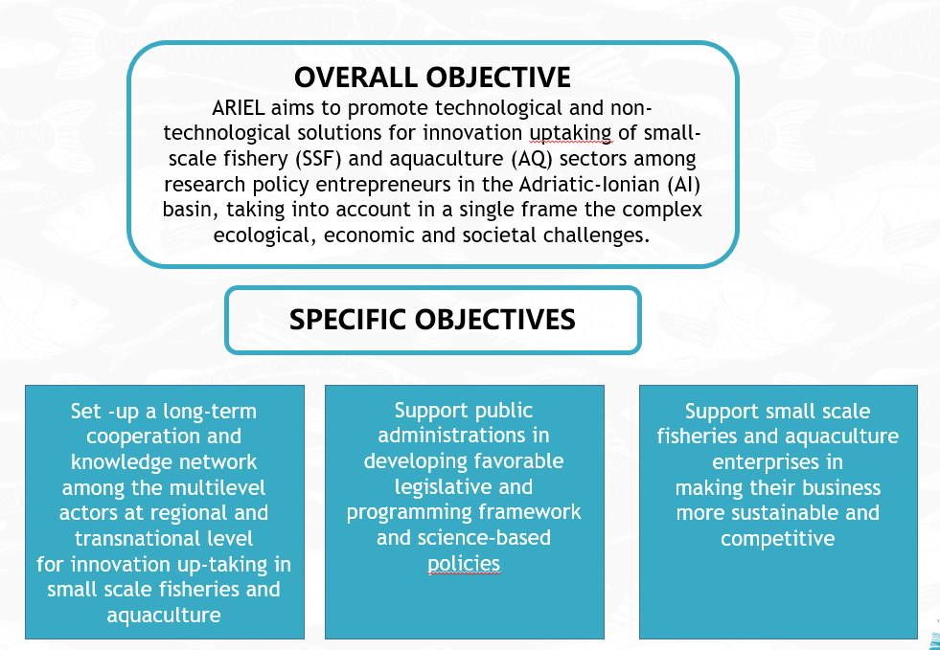

The ARIEL partnership is composed by 8 scientific and institutional organizations from 4 Countries:
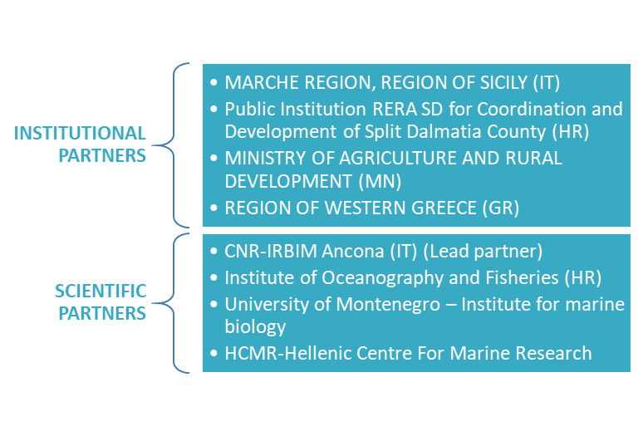
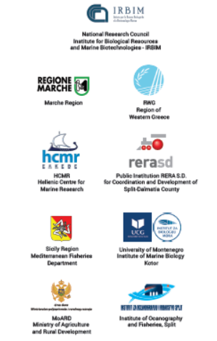

Project duration: 36 months (1.1.2018 - 31.12.2020)
Project budget: € 1 249 234.50

The logic of intervention
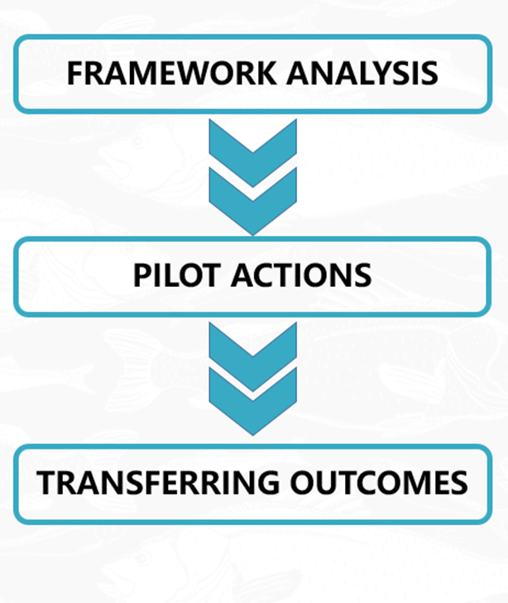
ARIEL foresees 4 Working Packages:

- WPT1 Small scale fisheries and aquaculture
framework analysis

It aims to identify the gaps and obstacles hindering innovation up taking and clustering into SSF and AQ sectors in the ADRION area for better understanding of the framework conditions in which SSF and AQ actors operate.

- WPT2 Pilot activities for transnational and
regional networking

It aims to facilitate and speed-up the innovation discovery process by an interactive engagement and cooperation of regional and transnational SSF and AQ key actors in knowledge exchanging and pilot testing of innovative solutions for day-by-day sustainable management.

- WPT3 Transferring:

It aims to provide strategic and operation guidelines to promote small scale fisheries and AQ network at regional and transnational level in ADRION area and the uptaking of open innovation led by academia and research centers, facilitated by policy makers, endorsed by entrepreneurs and recognized by consumers.

REGIONAL CONTEXT

Fishery and aquaculture represent significant economic activities for Croatia with particular emphasis on social and economic sustainability of rural areas of coast and islands. Total catch of Croatia’s fishing fleet in 2017 was 69.476 tons, and total income of 2016 catch estimated at EUR was 70.2 million (STEFC 18-07).

SSF

The Fishing Fleet Register of Croatia currently (on 31. Dec 2017) includes 7559 vessels. However, all national reports for 2014 indicate a number of 4385 vessels (this number includes all vessels active during that year).
Relatively small landing and total worth of landed catch by landing unit (around 5000 € per year) does not give good insight into this segment of fishing. SSF fishers have different motives for practicing commercial fishing. A large number of SSF fisher engages in fishing activity only during the season. A part of SSF fishers goes fishing in the summer during tourist season, while a part of fishers does not go fishing during the tourist season for the possibility of profiting in other jobs. Also, a part of SSF is engaged in agriculture, thus the fishing activity is connected with seasonal work in agriculture. Regarding the fact that the average size of the vessel is 7 meters, the number of days in year in which weather allows fishing activities is also a constraint.
SSF vessels predominantly use different types of fixed nets (gillnets and trammel nets) and operate from the shore and in coastal waters, in limited areas and during limited periods. The most important segment in this gear class is the one between 6 and 12 metres LOA, involving 673 vessels, representing over 25% of the fleet. They land mostly sole (21%) and a mixture of other demersal species (hake, cuttlefish, sea breams, common octopus). Quantities landed have been stable over time, with the share of small pelagic species clearly dominating the overall structure of catches (over 90%). The majority of the landings by purse seines included sardines (80%) and anchovies (11%). Small pelagic species also constituted the most important species in terms of value, accounting for over 50% of total value. On the other hand, Norwegian lobster accounts for less than 0.5% of landings, but represents over 7.5% in terms of value, whereas hake accounts for 1.1% of quantity landed, and 4.4% of value. Out of the total catch, fish represent 96%, cephalopods make up around 2%, and crustaceans and shellfish another 2% (Directorate of Fisheries 2015). However, the average prices of SSF products, intended almost exclusively for fresh consumption, are five to ten times higher than those of species caught by industrial fisheries. Moreover, these catches are probably underestimated, as illegal, unregulated and unreported (IUU) landings often occur in demersal and small-scale fisheries. The reconstruction of total catch estimated the IUU component to be as high as 43% with discards within the demersal fisheries and non-reporting of SSF catches being the main reason for the discrepancy. This highlights that the current method of fishery catch reporting is inadequate and incomplete, and more comprehensive reporting, which includes all fishing sectors is necessary to provide more accurate estimates of total catches.
SSF have always involved large numbers of professional and subsistence fishers, reflecting Croatia’s rich fishing tradition similar to other Mediterranean countries. This fishing sector was rarely influenced by country-level political issues in the past, as most fishing vessels have always been small (< 12 m LOA, < 15 GRT). It was generally privately owned throughout history, although a sharp upward trend in new entrants to the subsistence sector was observed in the early 1990s, during the war, when socio-economic reasons led to a high number of people engaging in fishing. The number of SSF fisher in the Republic of Croatia has not increased since 2009. It is because Croatia has stopped the increasement of the number of the licences for commercial fishery, for the purpose of protecting the resources.
Despite SSF not being very economically significant on global level, they do have great social importance. Analysis of the economic data collected under the Data Collection Framework for the reference year 2013 shows that SSF accounted for only 1.6% of total landing (Directorate of Fisheries 2015) but most landings were probably largely unreported and consequently their financial value too. Days at sea in SSF have a distinct seasonal character, depending on the migration of target species to the inshore area during the warmer period of the year. Data from 2017 show that, on average, multipurpose vessels have around 60 days at sea per fishing gear during the year (Directorate of Fisheries 2018).

The Regional SWOT Matrix for Small scale fisheries

STRENGTHS | WEAKNESSES
- Heritage through long tradition and historical importance of SSF fishery.  - Social and economic importance for local population and communities.  - Contribution to food supply on market for local and tourists  - Contribution to diversification of fishery products  - Organisation of an organization through the Crafts Chamber  - Good products  - Government and public support  - Existing scientific monitoring  - Easy access to the information related to legislation  - Operational Programme for Maritime Affairs and Fisheries of the Republic of Croatia for the programming period 2014-2020  - Up-to-date information on the public funding opportunities - European Maritime and Fisheries Fund (EMFF); national subsidies  - Healthy and unpolluted fishing areas | - Extortionate administration  - Heterogeneousness among SSF actors  - Lack of communication  - Slow progress of development of already started processes and programs. FLAGs are just established, short period for obtained results of such cooperation jet.  - Lack of promotional activities  - Insufficient knowledge and skills to use innovative technology  - Limited maritime infrastructures and limited access on landing places  - Restraint towards co management  - Conflict with other activities in coastal zones  - dispersion of fishermen across the coast and islands complicates cooperation and communication  - Difficulties in making unique rules due to the essential differences between SSF fishing areas
OPPORTUNITIES | THREATS
- Application of new technologies to collect more data on fish stocks, to optimize resource efficiency, and reduce the ecological impact of the sector on the marine environment.  - Preservation of traditional and cultural heritage as added value in quality of life  - Further colligation of SSF operators trough in FLAGs, Cooperatives  - Improving the quality of the services provided and enhancing the environmental advantages of the area.  - Simplified administration  - Consultation and cooperation through working groups for specific issues.  - Investments in innovations for improvement of quality of products.  - Development of specific projects Assistance in the preparation of professional studies, joint projects with identified issues  - Better organization on national level through government and legislatives | - Climate change  - Appropriate development of coastal industrial infrastructures  - Spreading and invasion of allochthonous marine species in the Adriatic sea  - Increase of pesticides and microplastics  - Growing number of top predators in the Adriatic sea  - Marine traffic pollution

AQUACULTURE

Croatia has great geographical advantages in terms of aquaculture tradition and potential areas suitable for aquaculture. Fish farms used to be local, primarily small farming units. Management was based on experience with no significant involvement of research-generated knowledge. Fish farming without processing plants did not require many employees. Then, transition from a social to a typically capital oriented economy was followed by "privatization". By the early 1990s the aquaculture sector went through restructuring, and professionals started to run the companies as an integrated enterprise, with ownership across local and even national borders. Research is needed to address every detail, from hatching to the marketing of the aquaculture product. Following the major economic crisis in 2008 and nearly 10 years of financial turbulence, the mariculture sector appears to have recovered. The outlook is positive, and the expectations regarding future growth are optimistic. According to the multi-annual National Strategic Plan for Aquaculture 2014 – 2020 (NSPA), further development of aquaculture will require diversification and will be competitive by following high environmental and production standards. As there was no centralized strategy for aquaculture, the planning instruments as well as licensing procedures were mainly left to county and municipal authorities and governed by numerous regulations. Today, a country having 4.5 million inhabitants is divided into 21 counties (7 of which are bordering the sea) and 556 municipalities. As in most of the neighbouring Mediterranean countries, the main obstacles to aquaculture development will be spatial positioning and complicated administrative procedures. In addition to the environmental pressure generated by numerous coastal users, the process of site selection and site management for aquaculture will be quite difficult due to its dependence on the maintenance of the health of the ecosystem. Sector performance in the period 2006-2016, the changes of production trends were recorded within two main aquaculture sectors, mariculture and freshwater aquaculture. While total mariculture production showed an increasing trend from 10.906 tonnes in 2011 to 11.244 tonnes in 2015, freshwater aquaculture decreased from 6283 tonnes to 4832 tonnes. Species distribution in both aquaculture sectors has changed significantly from 2006 to 2015.
Croatian marine finfish production amounts to 11.244 tonnes, representing around two thirds of total aquaculture production in 2015. More than 76% of marine finfish production is European sea bass (Dicentrarchus labrax) and gilthead sea bream (Sparus aurata). Sea bass and sea bream production almost doubled from 2011 to 2015. Other marine finfish species cultured in Croatia include Atlantic Bluefin tuna (EBFT), which represents around 15 %, while meagre (Argyrosomus regius; Figure 7), turbot (Psetta maxima) and dentex (Dentex dentex) together contribute less than 5%.
Today, Croatia is the 4th EU producer of sea bass and gilthead sea bream, after Greece, Spain, and Italy (FEAP, 2016). For Bluefin tuna farming, Croatia is among the three EU leading producers. The main production technique for marine finfish is cage culture, with fry being produced in land-based hatcheries. EBFT juveniles are captured in the wild, and after 18 to 30 months of growout in semi-offshore cages, are exported to sushi and sashimi markets in Japan.
The volume of European Bluefin Tuna farming is entirely linked to the catch quota regulated by the International Commission for the Conservation of Atlantic Tunas (ICCAT), which in 2006 adopted a 15-year recovery plan for overfished BFT stocks in the East Atlantic, including the Mediterranean. Thanks to good management and fisheries sacrifices, a recovery of the stocks has been recorded. Consequently, since 2013 about a 20% increase in the catch quota has been recommended, resulting in 13.500 tonnes of total allowable catch for the EU in 2017. The EU quota is shared by the eight Member States actively involved in harvest of Bluefin tuna - Spain, France, Italy, Croatia, Greece, Portugal, Malta, and Cyprus. Spain and France have the largest shares. Those vessels which catch the fish alive for farming purposes share 61% of the total EU quota. An increased fisheries quota allocated to Croatia in 2017 is expected to amount to 3000 tonnes of European Bluefin Tuna farming that will be available to export to the Japanese market.
The Croatian shellfish sector is going through an unexpected crisis, barely reaching a production volume of 800 tonnes per year, which is a historical minimum. Traditional production of Mediterranean black mussels (Mytilus galloprovincialis) and European flat oysters (Ostrea edulis) relies on an extensive production model employing hanging structures suspended below floating rafts. Spats are used for both mussels and oyster production collected from the wild. Mussels dominate Croatian production with nearly 96% of the total shellfish volume per year. An expected increase to 5.000 tons by 2020 (NSPA, 2015) is constrained by low production efficiency of small, mostly family-owned operators with low capacity to invest and modernize production, and also heavy predation by gilthead sea bream. Besides European flat oyster and Mediterranean mussels, according to the official data from Directorate of Fisheries, a small quantity of Mediterranean scallops (less than 1%) was also produced in 2015.
The Aquaculture sector in the Republic of Croatia is organized primarily through a chamber system. There is an Agriculture, Food Industry and Forestry Department within the Croatian Chamber of Economy (CCE) that is organized into associations, councils and groups. One of the associations is the Association of Fisheries and Fish Processing, a part of which is the aquaculture group, acting through the Committee for Freshwater Farming, and the Committee for Mariculture. The Committee for Freshwater Farming consists of the section in charge of warm water farming (carp) and the section in charge of cold water farming (trout). The Committee for Mariculture consists of the section in charge of the farming of “white” fish (sea bass, gilt head bream, meagre, common dentex and others), as well as the section in charge of tuna farming, and shellfish farming (mussels and oysters).

The Regional SWOT Matrix for aquaculture

STRENGTHS | WEAKNESSES
- Sustainable use of natural resources. Government support.  - Fish production, jobs in coastal communities, supporting rural economic development  - Competitive and a good product, market recognition.  - Government and public support  - Open offshore culture possibility | - Administrative barriers slowing down permits  - Low diversification of products (only mussels)  - Lots of processes and programs happen slowly; in Croatia FLAGs are just established, short period for obtained results of such cooperation jet. Cooperation benefits - organizations can more easily reach the defined goals  - Policy makers should consult more researchers and take into account their opinions. Researchers should provide more coherent and simple opinions/solutions that could be more easily integrated into policies and management. There should be more management related research (e.g. monitoring)  - AQ operators are private companies which are not eager to communicate about farming process due to the high market competition.  - Unification of data collection framework.  - The readiness and necessity of introducing innovation but competitions for the narrowband of the coastal zone slows down development, where a wide spectrum of urban activities takes place. Including target groups at all levels to identify problems and indications of solutions for determining direction and intensity of development.  - Slow administrative procedures and Risk of investment  - Acceptability access, method of data providing on national basis. Networking platforms development needs.  - Different priorities and political relatives/financial and political issues/ national and economical interests and strategies.  - National and international funding opportunities, initial capital for investment, high risk, high costs/unawareness, lack of examples of good practice  - Inadequate infrastructure profile  - Insufficient information and engagement of stakeholders, unconfident relationship between the stakeholders, no recognition of co-operation benefits.  - Certificates, competence, and branding. Operators should be informed about best practice examples from other countries.  - Market access.  - Availability of branding, faster procedures/market regulation, simpler administration  - Slow administration, small quantities of products on the EU market, smaller companies do not have enough capacity to be competitive as well as the price is determined by the manufacturers of larger capacity. Low market prices and problems with operational coast as well as problems with infrastructure especially with sewage system.  - Conflict with other activities in coastal zones
OPPORTUNITIES | THREATS
- Joining into LAG`s  - Assisting in adoption of legislation regarding efficient and sustainable farming  - Need for simplification of administrative programmes and ensuring sustainable development and growth through better spatial planning, innovation in environmental acceptable technology  - Consultation and cooperation through working groups for specific issues.  - Further development has been foreseen according to National plans.  - The application of new methods of data organization, data processing and statistics  - Illness prevention, treatment, adequate food and feeding, how to increase profit  - Investments in innovations for improvement of quality of products.  - Operators are open for new idea and collaboration regarding farming, processing and distribution.  - R&D departments collaboration with companies, better communication within sector, simplification of administrative procedures and more locations for sea-cage aquaculture as well as a stable market.  - Assistance in the preparation of professional studies, joint projects with identified issues  - Better organization on national level through government and legislatives | - Worsening of the quality of marine  - New diseases  - Climate change  - Appropriate development of coastal industrial infrastructures  - Introduction of quota system for tuna aquaculture. Low market prices.

THE ACTIVITIES IMPLEMENTED UNDER THE ARIEL PROJECT

All activities that preceded the selection of pilot studies and their implementation are listed below.

INNOVATION BROKERING FOR SMALL-SCALE FISHERIES AND AQUACULTURE SECTOR

Innovation Brokering event was held within the ARIEL Interreg ADRION project, organized by Institute of Oceanography and Fisheries. The meeting was conducted in Split, on 21.01.2019. at Radisson Blu Resort and Spa, bringing together key stakeholders from the small scale fisheries and aquaculture sector (operators, policy makers and researchers). In total 93 persons attended the meeting, including policymakers, public services, trade associations, AQ/SSF Local action groups, AQ/SSF organizations, education and research institutions, students, NGO, AQ operators, SSF operators, certification and branding experts, Marketing experts and SSF/AQ entrepreneurs (business). In light of project activities referring on pilot activities required an interactive and bottom-up approach to stimulate different actors of SSF and AQ (operators-advisors- academia/research/ - policy makers) grouping (in WG working groups) and discussing around core topics for innovation speed-up. There were stakeholders divided in 6 groups according to previously determined core topics, setting-up of regional SSF and aquaculture cross-sectoral working groups in aim to detect innovative solutions that can be more easily put into practice at each territory level for technologies and managerial innovation. Scientific experts and researchers made available R&D solutions, SSF and AQ operators outlined innovation needs and policy makers got insights for development of fit-for-purpose innovation policies and funding schemes. Each group draw findings, with included short discussions, conclusions and recommendations and proposed more than 20 pilot studies across 6 working groups. A framework agreement has been reached as well as plan for further stakeholder engagement on project activities.
After presentation of the findings of each group, there was a brief discussion with stakeholders to assess the feasibility of proposed activities. The facilitators proposed a framework agreement on the implementation of the subsequent activities and incorporating them into the project. After listing and describing all proposals from the working groups, facilitators invited the stakeholders to give their feedback and opinion on the presented proposals of each of the groups. There was almost a uniform opinion on the importance of such project activities at the regional and transnational level and almost all stakeholders stated they were willing to participate in the foreseen activities. In addition to welcoming the idea of the project itself, the stakeholders fully agree on the involvement and intensity of participation in the ARIEL project.

Proposed Pilot studies

Modernisation and improvements in fishing gear (selectivity,...) and vessels (new engines,...) towards environmental and socio-economic sustainability and Modernisation and improvements in production systems
1. Pots for catching Squilla mantis – innovation (not used in Croatia before)
2. Gill nets for Atherina boyeri – selectivity
3. Trammel nets for Sepia officinalis – innovation construction
4. Trammel nets for Solea vulgaris (selectivity 40mm versus 42mm)
5. Pesca tourism (SSF)
6. Regionalisation in policy – non-technological innovation
Diversification of activities and income and Diversification of products
1. Pesca tourism
2. Aquamanager – software for daily management on aquaculture farms
3. Virtual market – mobile phone application
4. New species catching and supply on market – blue crab, Callinectes sapidus
Short supply and distribution chain, higher prices and added value of seafood products
1.Virtual market – mobile phone application
2. Sorting and labelling of catches on board
3. Wholesalers and landing places
Traceability, marketing and branding seafood products
1. Know-how workshops on traceability, marketing and branding seafood products
2. Pooling of stakeholders in the co-operative
3. Attempt to certificate 3 SSF fishers as certificated label “friends of the sea”
Reducing competition with other players (other fishing sectors and animals – dolphins)
1. Acoustic pingers pilot studies against dolphins
2. Pinna nobilis settlement from ports
3. Dolphins watching – pesca tourism
4. Towing gears replacement for 1Nm (from 3Nm on 4NM)
5. NTZ for Solea vulgaris recovery in the Ecological and Fisheries Protection Zone (Croatian: Zaštićeni ekološko-ribolovni pojas, ZERP), a protected fishing area over Croatia's Exclusive Economic Zone.
Reducing predation and new disease appearance
1. Acoustic pingers pilot studies against Sparus aurata on shellfish farms
2. Target catching of Sparus aurata

TRAINING AND CAPACITY BUILDING

The training needs both at ADRION ad regional level emerged from the SSF and AQ framework analyses. The activities consisted of:
- N.2 pilot mobility week organization and delivery addressed towards researchers/technicians dealing with SSF and AQ issues. The mobility weeks were held in Croatia arranged by IOR and in Greece arranged by HCMR. The mobility exchanges programme were jointly proposed by the partners in charge taking into consideration what emerged from innovation on research actors as well as from the innovation needs collected at operators level and policy makers. The leading principle was how to effectively link science to practical needs of operators and how research can help and support SSF and AQ policies. The mobility programme in both countries were consisted in meeting with operators, survey, round tables,…The exchanges outcomes will also contributed to the transferring WPT3 which foresees the drafting of a research agenda and technical & Policy recommendations.
- The training kits for the SSF and AQ operators in the form of training modules. The training kits were consisted in:
- transnational modules common for the whole project area on financial opportunities for innovation in small-scale fisheries and aquaculture (workshop arranged by Marche Region in cooperation with ASSA)
- modules reflecting the regional training needs (Fish health management and disease control (Prof. Zrnčić, number of participants 28) Spatial conflicts co-management tools (prof. Katavić, number of participants 26)
Modules were delivered both in frontal lessons and in e-learning (on the ARIEL Platform)
Capacity building seminars were addressed towards policy makers facilitated by research that aim to give science – based inputs to policy (Spatial conflicts co-management tools (prof. Katavić, number of participants 26; financial opportunities arranged by LP on SC in Split, June 2019)

PILOT TESTINGS OF SOLUTIONS FOR DAY BY DAY NEEDS

Based on innovation brokering events findings where technological and non-technological (managerial) solutions embodying ecological, tecnological and economic aspects for AQ and SSF sustainable growth, PPs togethe with multi-actors groups WG selected and implemented the most suitable pilot actions for: Croatia. Pilot actions for SSF (n.4) were implemented on 3 vessels/area (SSF) while those for AQ were implemented on 2 farms/area (AQ).
In pilot actions we worked on innovative technologies by testing and reviewing innovative fishing gears with lower impact on marine ecosystem (trammel nets with higher selectivity and with reduced impact on marine invertebrates), alternative technique for SSF and AQ (environmentally friendly practices with reducing predation with acoustic dissussors), innovative managerial approaches (virtal market application). and for the development of traceability schemes for were in coherence with innovation targets and of course with sustainability criteria.

Type of Action

1. Acoustic pingers pilot studies against Sparus aurata on shellfish farms

Innovation needs addressed

The cultivation of mussels (Mytilus galloprovincialis) is a growing industry worldwide. In 2015, the largest production took place in Asia (1.05 million tonnes), followed by Europe (0.50 million tonnes), the Americas (0.25 million tonnes), Oceania and Africa (0.08 million tonnes) (FAO statistics, www.fao.org). Croatian shellfish culture has a hundred-year tradition and majority of production takes place within small family-owned farms associated with the lucrative tourism-based industry. In 2016, more than 150 producers were recorded, covering a total farming concession area of 1.3 km2 (Source: Ministry of Agriculture, Fisheries and Rural Development, Directorate of Fisheries, Croatia).
However, mussel predation by gilthead seabream Sparus aurata has become a significant challenge to mussel growers in Mediterranean causing extensive financial losses (Prou and Goulletquer, 2002; Šegvić-Bubić et al. 2011; Glamuzina et al. 14). Due to fish high damage on mussel stocks cultured on longlines, in recent years, a decline in Croatian mussel production is recorded, i.e. from the mussel production of 3000 tonnes in 2008, now day production dropped to only 920 tonnes. Among the many factors that have contributed to the decline of mussel production, i.e. small domestic market, great variability in larval dispersion and settlement, it is suspected that fish predation plays an important role in shellfish sustainability.
Recently, wild stock of gilthead seabream has been significantly increased in the eastern Adriatic where effects of global warming, fish escapement through farming and spawning in cages can partially explain such fish expansion. Mussels are a dominant prey item for gilthead seabream, which take advantage of mussel farms that provide a highly abundant and easily accessible food source.
Recent scientific study that aimed to quantified the predation impact of gilthead seabream on six most productive mussel farms during the one-year long survey revealed that predation is most pronounced during worm seasons (summer, autumn). In average, 66% of mussel ropes were destroyed within the first month of mussel deposition into the sea (IZOR 2018, Figure 1).

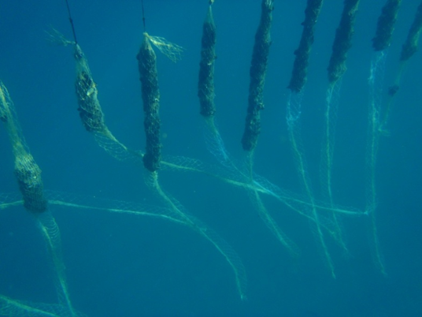 | 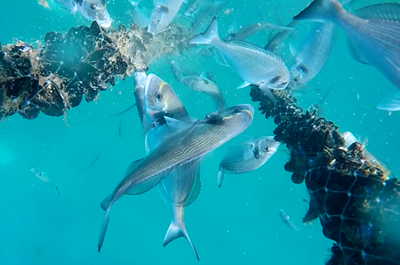
Figure 1. Impact of gilthead seabream predations on mussels ropes.

Currently, attempts to reduce predation are limited to anti-predators bags or predator control nets placed around culture structures. However, results have indicated that additional net protection significantly affects mussel growth rates and has limitations during production and harvest (Figure 2).

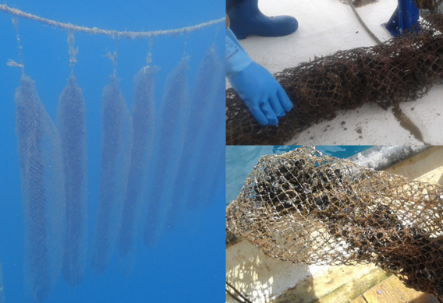 | 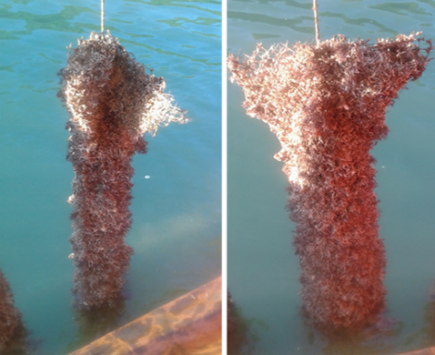 | 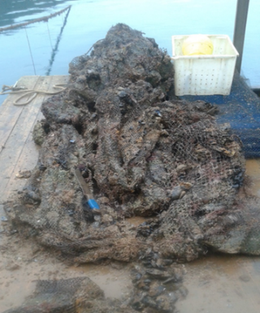
Figure 2. Anti-predator bags produce high biofouling biomass that reduce the lateral water transport and have negative impact on mussel growth.

Thus, new protecting methods are needed as underwater repellent against seabream or allowing recreational fishermen to fish in mussel farming area, for supporting farm management stability.
The aim of the present pilot study was to test repellent functionality of commercially available underwater dolphin dissuasive device (i.e. pingers) against gilthead seabream populations during the summer season when predation is the most intense, considering that device emits very wide frequencies spectra that may interfere with surrounding gilthead seabream stocks.

Pilot area

Lim Bay has been chosen for the pilot study considering that the bay is legally protected as a significant landscape and a specific marine reserve and any type of fishing effort is forbidden. Thus, only non-destructive protection methods from fish predation can be tested here, enabling as such better control of underwater acoustic repellent devices performance.
Six underwater dolphin dissuasive devices (type DDD03L, STM PRODUCTS s.r.l., Italy) that emits sound frequencies between 5 and 500 kHz with peak around 140 kHz and have batteries duration of 300 hours (see for details http://www.stm-products.com/public/mat/prodotti_download_file_id52.pdf) were deployed at two mussel farm concessions in the Lim Bay (Figure 3a), in locations that are greatly affected by seabream predation.
Locations consisted of up to 10 longlines supported by buoys and oriented parallel to the adjacent shoreline. Each longline was made up of parallel surface ropes up to 200 m long, separated by approximately 10 m. Water depth ranged from 7 to 20m and the mussel lines hung a minimum of 3 m above the substratum. During the study period, the size of mussel stock varied from line to line across the farm, since mussel spat are seeded onto lines throughout the year.
Two times per summer season, devices functionality against fish predation have been tested aiming to explore impact of sea temperature on device performance. In May and July, 100 newly seeded longlines were deployed at each farm concession together with 3 underwater dolphin dissuasive devices taking into consideration the device sound emission range of 300 m. Predation impact was monitored every second day following the protocol by Šegvić-Bubić et al. (2011).

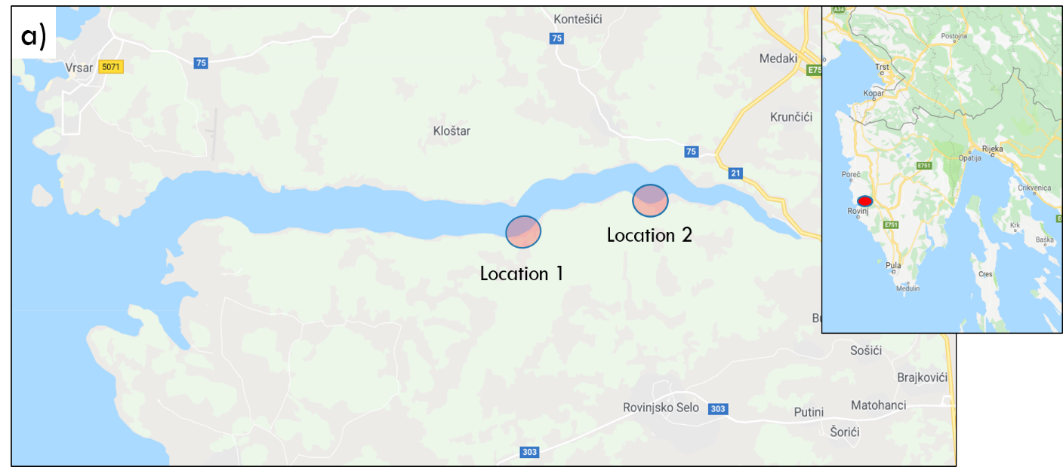
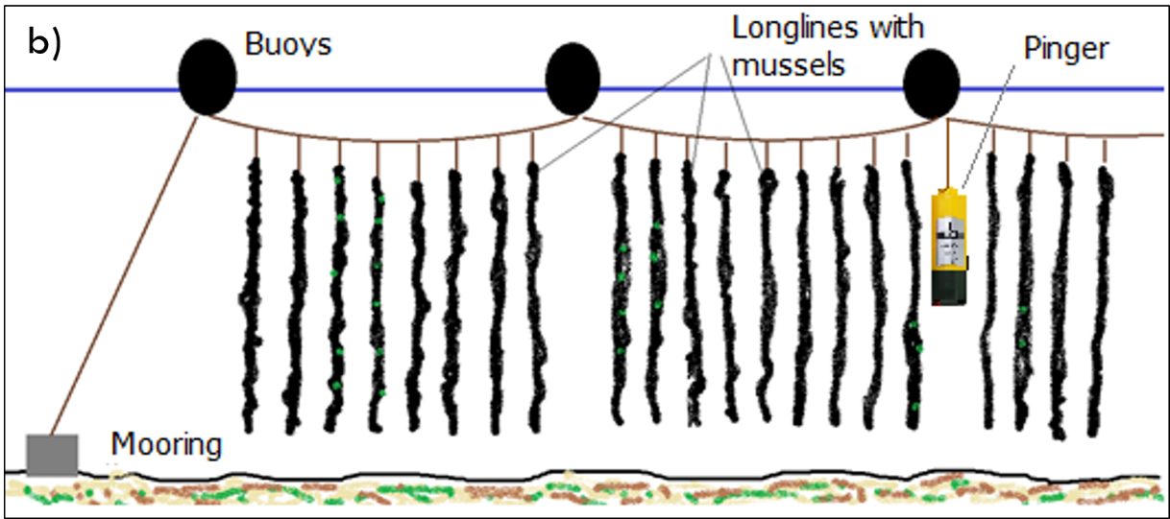
Figure 3. Locations in the Lim Bay under investigation (a) and schematic presentation of deployed underwater acoustic device i.e. pinger (b).

Company/operator/associations of operators involved

- ISTRIDA do.o., 2 concessions farm s, Emil Sošić, Bruna Valentija 61, Poreč
- Croatian Cluster of Mariculture, Crotia, www.klastermarikultura.hr
info@klastermarikultura.hr

Pilot testing results

In total 200 newly seeded and already formed longlines have been deployed at two farm concessions with varied mussel shell length i.e. from 35 to 55 mm. Underwater acoustic devices were placed and activated 3 May 2019 when sea temperature was below 20°C.
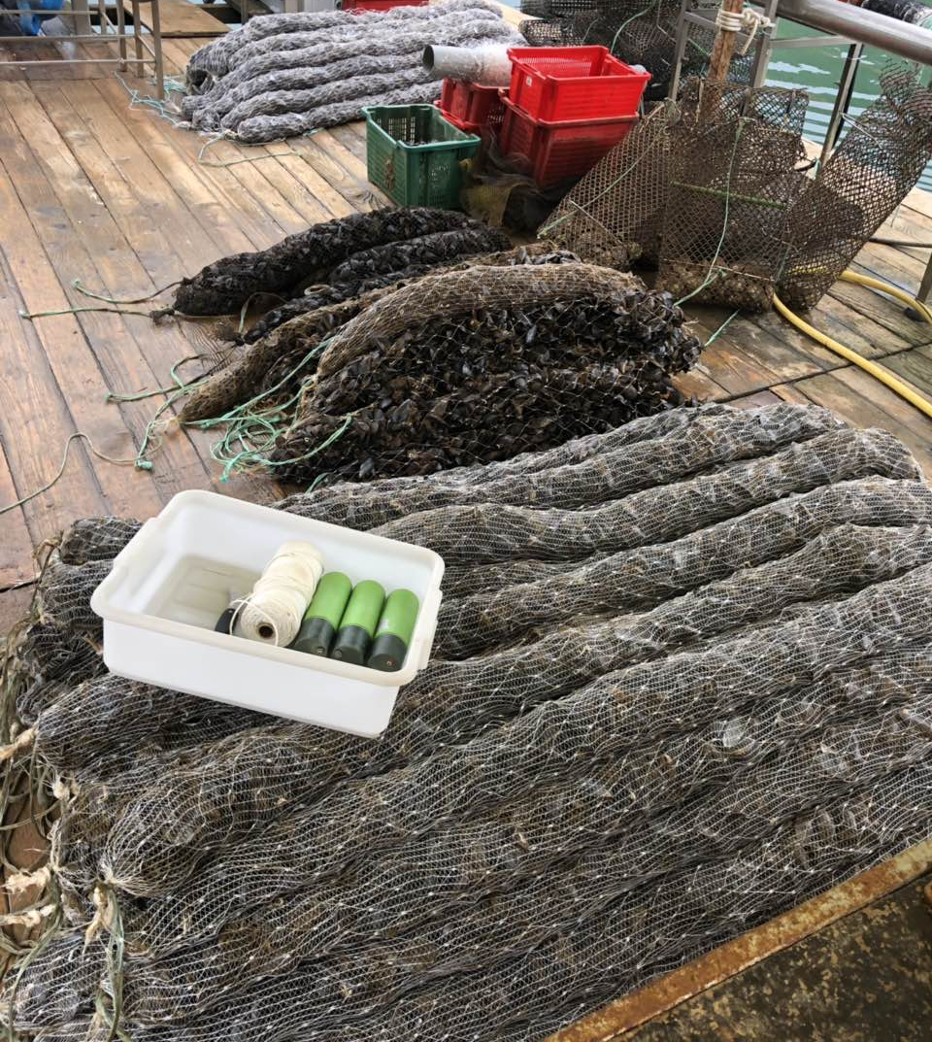 | 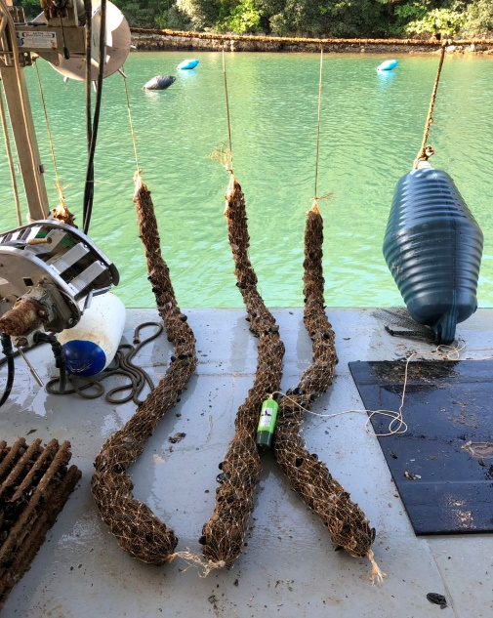
Figure 4. Newly seeded longlines and underwater acoustic devices used in the study.

Within first two weeks of longlines deposition, no fish predation has been observed indicating good devices performance. In the following 2-week period, light predation was recorded which coincided with sea temperature rise above 20°C. Thus, within first month of longlines deposition, only 5% of mussels were predated.
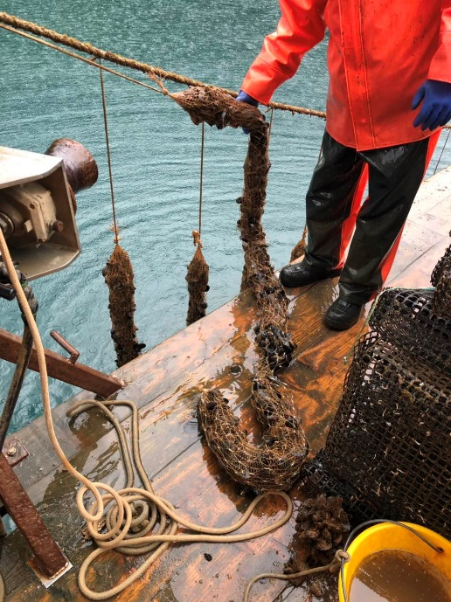 | 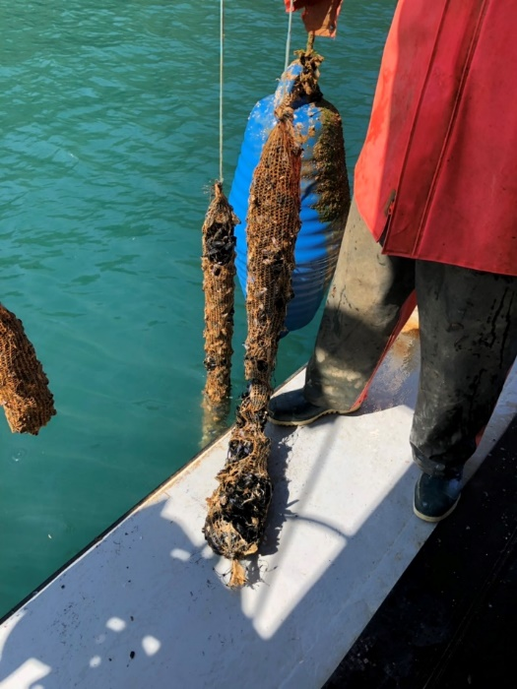
Figure 5. First signs of fish predation indicated with white arrows.
Still, when sea temperature reached 22-24°C in the mid July, all sound-protected longlines suffered from intense predation ending with about 20% of stocked mussels (Figure 6).
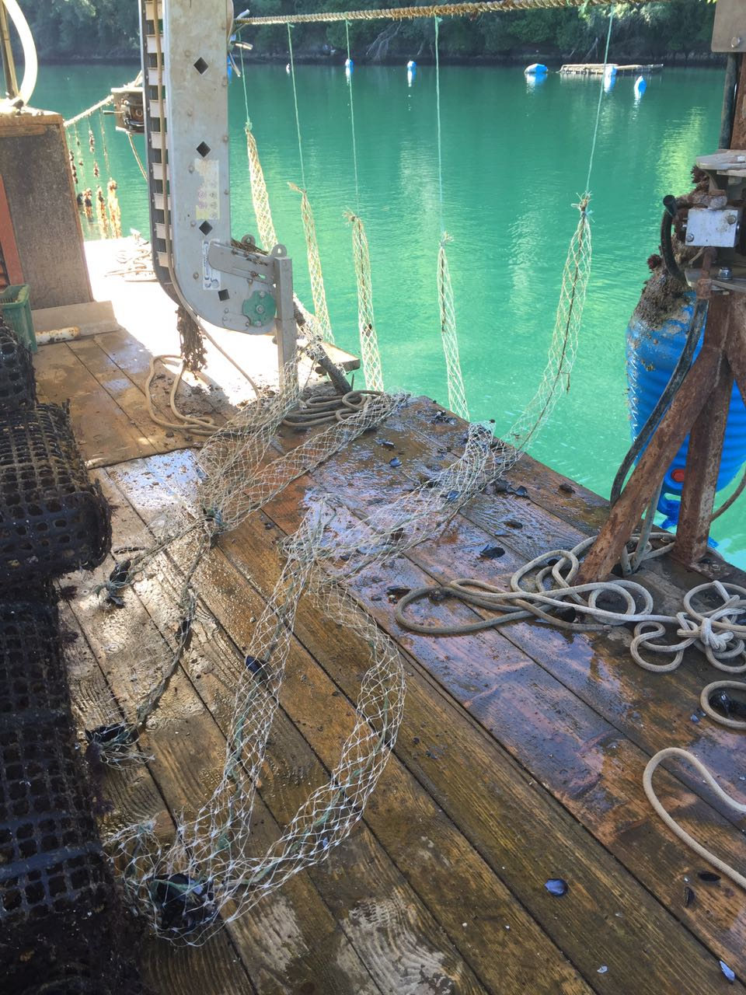 | 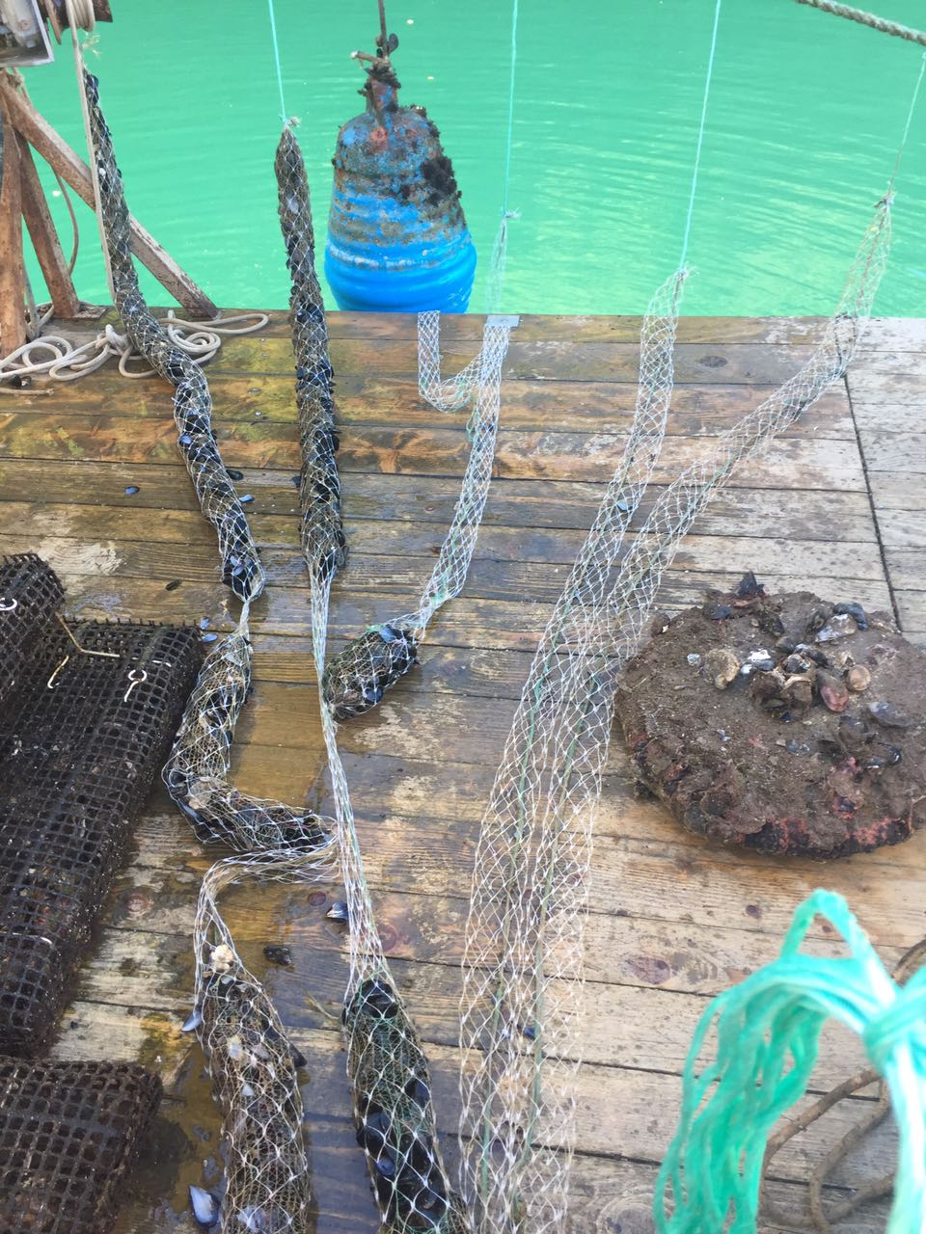
Figure 6. Intense predation observed at the sound-protected longlines.

- Second experiment conducted in July
New freshly stocked longlines were deployed within the farm concession at the beginning of July, encouraged by the good results of the first trial recorded in May 2019. Sound-protection was functional for the first two weeks but latter when sea temperature reached 22°C, intense predation was observed as in previous case.

Conclusion
Application of the underwater dolphin dissuasive devices at mussel farms that emitted sound frequencies between 5 and 500 kHz with peak around 140 kHz, showed to be non-functional agents fish predation. From the scare number of papers that investigated repulsive frequencies for marine fish, it can be speculated that used frequencies in this study were not functionally optimal. Namely, fish have been broadly categorized as either “hearing generalists” or “hearing specialists”, with specialists having an anatomical structure that connects the inner ear and a gas bubble (such as a swim bladder) to assist in transmitting sound waves to the inner ear. Generalists hear sounds below 1 KHz, whereas specialists are able to detect frequencies of up to several KHz (Schilt 2007). Gilthead seabream as hearing generalists that was exposed to a 0.1–1 kHz linear sweep (150 dBrms re 1 lPa) showed significant increase in motility as well as an increase in lactate and haematocrit levels accompanied with a significant decrease of glucose, pointing that low-frequencies have influence on fish behaviour and physiology (Buscaino et al. 2010). Thus, further study related with predation prevention should be oriented toward testing sounds with lower frequencies spectra in respect to the gilthead seabream behaviour.

Literature
Buscaino G, Filiciotto F, Buffa G, Bellante A, Di Stefano V, Assenza A, Fazio F, Caola G, Mazzola S. 2010 Impact of an acoustic stimulus on the motility and blood parameters of European sea bass (Dicentrarchus labrax L.) and gilthead sea bream (Sparus aurata L.). Mar. Environ. Res. 69, 136–142. (doi:10.1016/j.marenvres.2009.09.004)
IZOR 2018. Predation impact at Croatian farms by Gilthead seabream. Study financed by the Ministry of Agronomy and Fisheries.
Prou J, Goulletquer P. 2002 The French mussel industry: present status and perspectives. Bull Aquac Assoc Can 102, 17–23.
Schilt, CR. 2007 Developing fish passage and protection at hydropower dams. Applied Animal Behaviour Science 104, 295–325.
Šegvić-Bubić T, Grubišić L, Karaman N, Tičina V, Mišlov Jelavić K, Katavić I. 2011 Damages on mussel farms potentially caused by fish predation – Self-service on the ropes? Aquaculture 319, 497-504.

Type of Action

2. Testing Dolphin Dissuasion Devices (“pingers”)

Innovation needs addressed

Dolphin-fishery interactions have been known for more than a century (Backhouse, 1843), but in the context of a drastic decline in fish stocks, this topic is attracting worldwide attention because it also affects the survival of wild dolphin populations and the life of fishermen through the economic consequences (reduced landing catch of landing "), Especially in coastal fisheries (Jackson et al., 2001; Myers and Worm, 2003). While direct interactions involve the damage done by dolphins to fishing gear, indirect interactions (biological and / or environmental) relate to their negative impact on fisheries catch and yield. Damage to the ecosystem caused by overfishing and habitat degradation probably enhanced the very perception of dolphins as major pests in fisheries (Reeves et al. 2001). In Mediterranean coastal waters, dolphins are often seen as competition with fisheries and are held responsible for reducing overall catches.
Conflicts with dolphins in the Republic of Croatia have been mainly reported by fishermen working with triple-trap nets in the western coast of Istria, but interactions with dolphins have also been reported in single-trap nets, bottom trawl nets and surrounding purse seine nets throughout the Eastern the Adriatic coast. The interactions of dolphins and triple nets on the western coast of Istria are complex, because both fishermen and dolphins concentrate on a relatively small area of ​​high prey density. The greatest damage is caused by stagnant nets due to their long standing in the sea (overnight), which leaves a lot of time for dolphins to locate nets and eat caught fish. Dolphin is an opportunistic strategy to increase feeding rates, while at the same time reducing energy consumption for feeding. Such a prey capture strategy can lead to the tearing of the net, and if they fail to eat / tear out the whole fish, it will be damaged and not put on the market. The negative impacts of dolphins when fishing with trawls can be divided into direct damage (those made on the tool in terms of holes of different sizes, reducing the value of the catch, but also the amount of catch itself) and indirect damage (reducing the amount of catches as dolphins scatter prey, waste of money and time fishermen for procuring new and repairing old nets).
In fishing for fishery, dolphins scatter prey, and when drawing fish out, dolphins on the outside remove and eat fish that are trapped in the net, tearing the net. In addition to the holes being created, there is a potential risk that most of the catch will escape, additional efforts are needed to repair or repair the nets or to invest additional money to buy or repair new nets.
In trawl fisheries, the damage to the net itself is slightly less due to the construction of the net, which is much thicker and firmer than other fishing tools, but is also visible. The problem here is fish scare, so in the presence of dolphins the catches are significantly smaller and part of the catch is partially damaged so it is impossible to market it because the dolphins feed at the entrance to the net or remove fish from the net through the eyes of the net.
According to the literature, it is precisely the bites on fish heads or other body parts of fish caught in the net, and the recent nature and texture of these bites can indicate whether they are dolphins. Specifically, dolphins usually tear the body of the fish leaving characteristic oval bites, and often find only the fish's head in the net, while sharks, for example, halve the fish by half, leaving a clean cut. The presence of small bites on the body of a fish indicates predation by fish or crustaceans. Dolphins make medium to large holes in nets as they draw fish. Other organisms (fish, cephalopods and crustaceans) do more damage to the catch, while dolphins do significantly more damage to the tool. Dolphins also concentrate near fish farms and can attack fish in breeding cages.
Dolphins in the Adriatic have almost no natural enemies, but they face many threats that threaten their survival. Thus, in the Adriatic in the 1950s, dolphin was considered a great pest. During this time, an extensive program for their destruction was carried out, resulting in hundreds of dolphins killed, mainly in the northern and central Adriatic, significantly reducing its population. This was followed by strict protection of dolphins and the population has recovered to this day, as many fishermen testify every day. As highly intelligent animals, part of the population has developed the technique of fishing already caught fish in fishing nets, which they consider to be a new resource (Reeves et al., 2001).
The use of traditional noise-producing dissuasors has been proven to be, in general, quite ineffective. Either they increase the anthropogenic noise without a specific effect on dolphins, or they act as “dinner bell” attracting skilled (and smart) dolphins towards the fishing locations. Similar effects are produced by the noise of specific fishing activities, being the dolphins able to recognize a fishing boat from a navigating one. More recently, a new generation of dissuasors is becoming more and more in use. They detect the echolocation sounds produced by dolphins and react by generating random noise. An accurate and quantitative description of the hunting strategies actuated by dolphins and by a proof-of-concept description of the efficacy of new-generation dissuasors will be interesting.

Pilot area
The analysis was conducted with regard to the fishing zone (A1) and the number of fishing days reported, that is, the total catches and, in particular, the catches of the target species, Solea vulgaris, in which, according to preliminary surveys, the greatest damage was reported. The catch is calculated as the catch per unit of fishing effort (CPUE), where the unit represents 100 m of net.
Daily damage on Solea vulgaris was estimated as: the number of holes reported online * 0.201 kg (mean determined S. vulgaris mass during this study, but also mean from S. vulgaris catch data from DCF). According to the fishing days reported, fishermen are divided into 3 categories:
Category A:> 80 fishing days
Category B: 40-80 fishing days per year
Category C: <40 fishing days per year

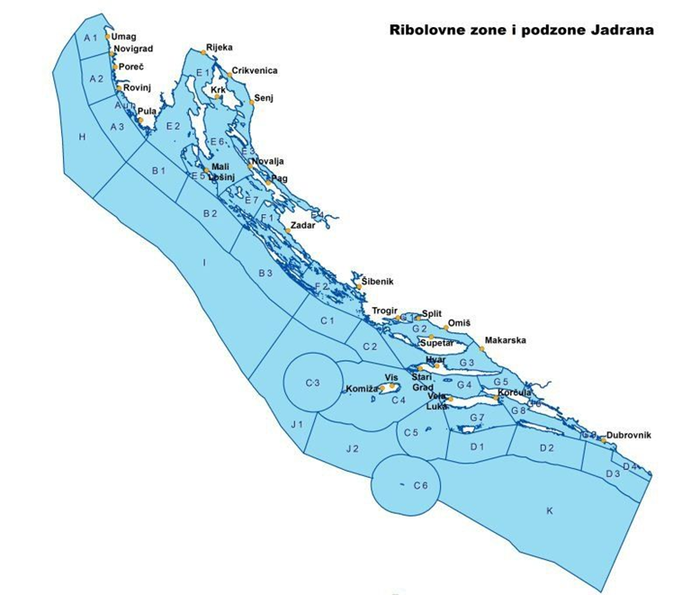

Figure 1. Fishing zones and subzones in the Republic of Croatia

Testing pingers to reduce/prevent dolphin bycatch. The pingers we intend to use are http://www.stm-products.com/prodotti/fishing-technology/dissuasori-per-delfini-green/did-01~54.html. Testing will involve n.1/2 vessel(s), setting-up and follow-up of a protocol from May to September (December) 2019. Budget line used is “equipment”.
The DiD (Dolphin interactive Deterrent) is an equipment able to keep the dolphins away from fishing nets, thanks to an efficient technique of interaction with their echo-localization system (sonar) (Figure 2). The DiD is the interactive evolution of the standard DDD 03 models. It produces the ultrasounds only when it detects the presence of the dolphins in the area, by means of its “hearing” circuitry, that is activated by the “clicks” emitted by the mammals. It is powered by internal (sealed) rechargeable batteries and generates an acoustic signal in case of insufficient charge. The advantages of this model in comparison with the DDDs are the reduction of the possibility that dolphins become accustomed to the signals, the increased duration of the battery charge and the reduction of the acoustic pollution. The level of the DiD emissions doesn’t produce any harm to mammals or fish; these last are insensitive to the frequencies emitted.
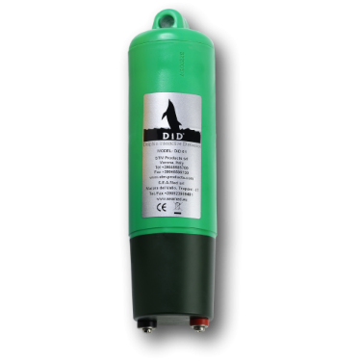
Figure 2. The DiD (Dolphin interactive Deterrent)

For 1 fisherman working with 400 m length it is needed 2 pingers (Pilot studies have to be performed at least on 3 vessels so min number of pingers for study is N=6). Before using the device, perform a complete battery charge for 20 hours at least. The use is very simple, just hang it to the fishing net (at the beginning and and). The devices have to be placed on the fishing equipment according to the best strategy considering the emission area and type of fishing. Don`t place a DiD less than 400 m from another DiD. The DiD behaviour may be influenced by the presence of another DiD units in the area so it may continuously produce signals, reducing drastically the battery duration and desired effect on the mammals. The DiD must be placed minimum 20-30 m above fishing gear. The DiD will be activated when it touches the water. After a first sound emission, useful to know the devices battery is charged, it remains in reception mode till the event of a mammal presence recognition, then it reacts by producing special variable ultrasound signals for about 50-60 seconds. The emission of random modulated signals, makes difficult to the mammals to adapt themselves to the signal. Detailed protocol for data analysis will be added later.

Sampling design

Plan is to have 3 fishers involved: 3 working with pingers, 3 working without pingers very close to them (possible impact), control group of fishers working out of range of pingers (no impact).
All fishers have to fill internal logbook (Figure 3).

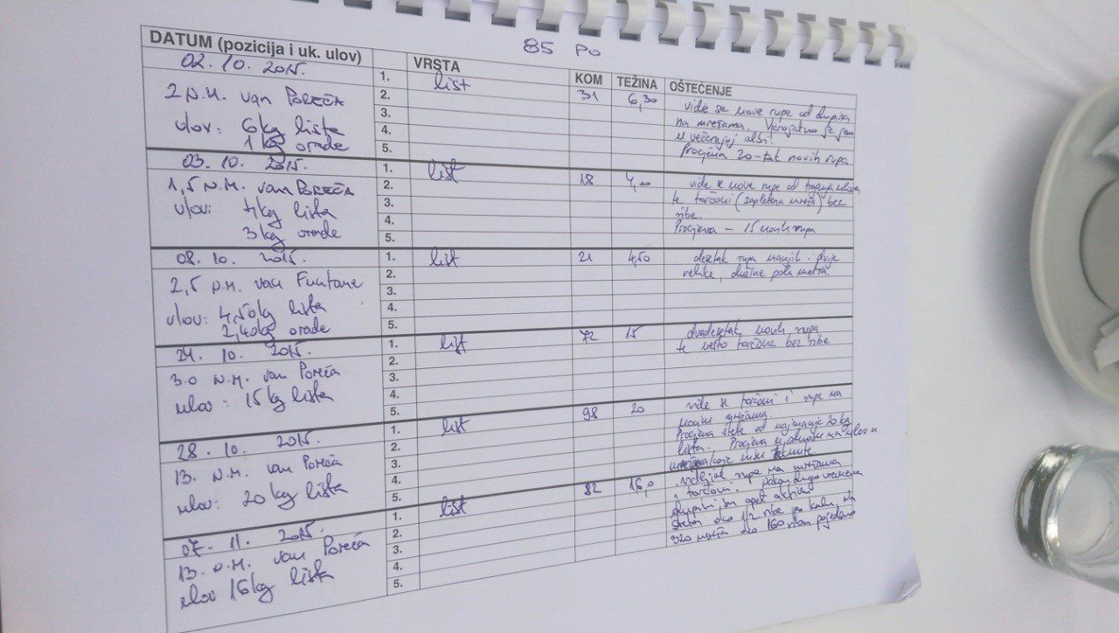
Figure 3. Logbook (date, position and total catch, species, quantity, weight, damage description)
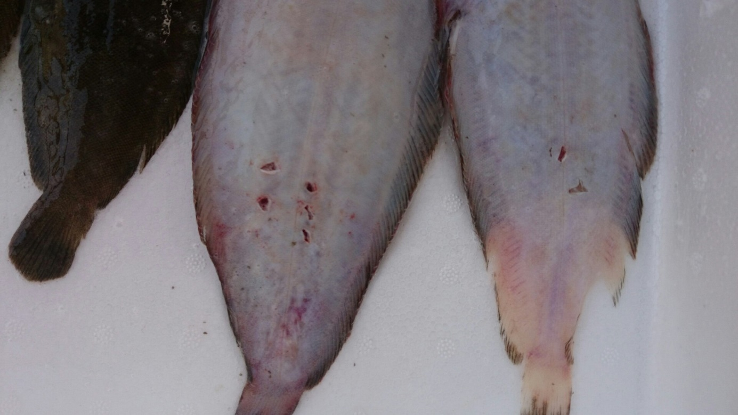
Figure 4. Damage

Data analysis
Excel and multivariate analysis in PRIMER.

Company/operator/associations of operators involved
- Daniele Turkovich
- Ranko Bonaca
- Diego Makovac

Pilot testing results
The damage to the catch is characterized by a series of round wounds suggestive of the dolphin's tooth (Figure 4). Specifically, dolphins usually tear the body of the fish leaving characteristic oval bites with 3-4 holes of teeth. Often in the net we only find a fish head or a torn net where the fish was caught. Sharks and for example Pomatomus saltatrix bite the fish in half, leaving a clean cut. The presence of small bites on the body of a fish indicates predation by other fish or crustaceans.
The size of the hole in the grid for the listara net depends on the distance at which Solea vulgaris was caught. If, for example, the 3 S. vulgaris are within 80 cm, then a hole of 1 m size is ultimately formed, and if the dolphin has torn off a single leaf, the hole length is 25 cm on average. However, it should be emphasized that in order to catch fish, a dolphin can go through the net and make a

hole larger than 2 m. fisherman uses. Generally, in proportion to the length of the nets, more fishing days and catches are identified, but ultimately more damage to the tool as a result of more intensive and dynamic use of the tool.

During the analysed period (4 months, in 120 days of intensive fishing for the target species, S. vulgaris), fishermen keeping logs had 28 to 114 fishing days, in average of 61.17 ± 38.04 fishing days. These fishermen had between 17 and 49 fishing days with damage (26.67 ± 13.60), and 10 to 74 days without damage (average 34.5 ± 28.091). The average percentage of damage was 47.41 ± 12.983% (R2 = 0.865) although the percentage of damage ranged from 26 to 100% depending on the fishermen. The analysis of the results shows that fishermen with more fishing days, on average, suffered less damage, which is in fact only a consequence of a larger number of fishing days in which a proportionately higher catches were made (Figure 5).

Figure 5. Percentage of damage to listare-nets, given the number of fishing days with and without damage

Out of the total of 122 fishing days recorded in zone A1, a catch of 2.23 t (average 18.21 ± 20.27 kg) was achieved and the average CPUE (catch / 100 m of net) was 88.87 kg at 12.2 km network (average 0.73 ± 0.92 kg) (Figure 6). The damage was inversely proportional to CPUE, and was clearly the highest in mid-November 2 NM outside Savudrija when it was estimated at 120 kg and the realized hunting was 31.5 kg (Figure 7).

Figure 6. Average total catches of Solea vulgaris by listare nets in zone A1

Figure 7. Relationship of CPUE and established dolphin damage to catches in listare net in zone A1

In the same period when fisherman applied pingers, direct damage on fishing gear and catch was reduced on <5% of daily damage value without using pingers. Daily catches achieved by SSF having pingers are on average at 50.33 kg, while when they worked without pingers catch was around 9.59 kg, or on average having pingers enable achievement of 81% better daily catch.

Although preliminary estimates of the daily needs of dolphins for food, as well as of the monthly damages for the period September-October, have been made, they will be presented in a subsequent report. The first indicators, as well as the literature, show that good dolphins (males and non-pregnant females and those that do not breast feed young) need about 2000 kg of fish and other marine organisms a year or about 5 kg a day. But a breastfeeding female has an increased need for food of 58-97% and is seeking prey to extremely high trophic levels. Young people begin to
feed on solid foods in the first year of life (foods with lower trophic levels), although they cease to suckle at the age of 14-37 months (Kastelein et al., 2002). Fish and cephalopods are their main food, and according to the works of European hake, Merluccius merluccius is the most important prey (Blanco et al., 2001). And from our preliminary surveys, it is clear that demersal whitefish and cephalopods are the main, basic prey, and everything else is secondary or incidental prey. There are no major seasonal differences in nutrition. They grow to about 270 cm in length and 260 kg in weight. The above data were entered as parameters in the daily needs calculations.
Fishermen most commonly spot dolphins in small groups of several individuals at dawn and dusk when feeding intensively (Figure 31). The same group appears in the same area for several days in a row, and then moves north or south. As fishermen usually stop fishing for several days after a few days of intense damage or notice of distractions by the dolphins (fishing away from fishing), it is possible that leaving the particular waters is also conditioned by the opportunistic behaviour of the dolphins. He moves on in search of other laid down networks nearby.
Dolphins are not afraid of fishermen, approaching extremely close to vessels, and trying to feed at the lowest possible energy consumption. No involvement of dolphins in the investigated tools was observed, nor any reported lethal outcome of the interaction of dolphins and tools during the study.
Damage to more than 20 different species of marine organisms has been identified, but it appears that the greatest damage is recorded in the following species: Solea vulgaris (26.2%), Eledone moschata (9.8%) and cuttlefish Sepia officinalis (8.4%). There is also considerable damage to crustaceans (8.9%), but also to other flatfish (5.1%). Fishermen report the highest number of damages during the autumn period (31%), although almost all report that they suffer damage throughout year, and dolphin attacks and sightings are recorded throughout the day and day and night, with an emphasis on dusk and dawn when fishermen most often see dolphins near fishing gears (nutrition). Almost all respondents (88.1%) had a negative attitude towards dolphins, but all contacted fishermen stated that they did not use any methods of scaring and dispelling dolphins.

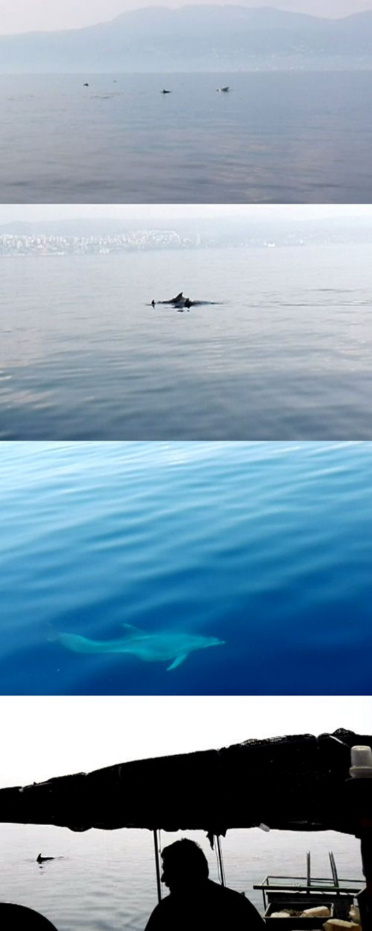

Figure 8. Dolphins behaviour near SSF
References

Azzali M, Casini L, Lamberti CV (1994) Relationships between dolphins, type of prey aggregations and their geographic distribution. European Research on Cetaceans 8: 183–187.

Backhouse J, (1843) A narrative of a visit to the Australian Colonies. Hamilton, Adams and Company, London. 560 pp.

Blanco C, Salomon O, Raga JA (2001). Diet of the bottlenose dolphin (Tursiops truncatus) in the western Mediterranean Sea. Journal of the Marine Biological Association of the United Kingdom 81: 2053-1058.

Jackson JBC, Kirby MX, Berger WH, Bjorndal KA, Botsford LM, Bourque BJ, Bradbury RH, (2001) Historical overfishing and the recent collapse of coastal ecosystems. Science 293: 629-638.

Kastelein RA, Vaughan N, Walton S, Wiepkema PR, (2002) Food intake and body measurements of Atlantic bottlenose dolphins (Tursiops truncates) in captivity. Marine Environmental Research 53(2): 199-218.

Myers RA, Worm B (2003) Rapid worldwide depletion of predatory fish communities. Nature 423: 280-283.

Notarbartolo di Sciara G, Demma M (1997) Guida dei mammiferi marini del Mediterraneo. (ur. Muzzio, F.) Padova, 2nd ed. 264 pp.

Reeves RR, Read AJ, Notarbartolo di Sciara G (2001) Report of the workshop on interactions between dolphins and fisheries in the Mediterranean: evaluation of mitigation alternatives. Report of ICRAM, Rome, Italy. 44 pp.

Type of Action

3. Testing trammel nets “sipara” special construction to reduce bycatch

Innovation needs addressed

One-layer gillnets and three-layer trammel nets are probably the most commonly used fishing gear along coastal eastern Adriatic. Regional differences, conditioned by the distribution of target species, exist in frequency of their use. While, in west coast of peninsula Istra (northern Adriatic), trammel nets of smaller height called “listarice”, with Solea vulgaris as main target, are the main trammel nets used in winter, in middle and south Adriatic trammel nets called “poponice” (min mesh size 40 mm) are prevalent (closed season 15.5-10.09). Also, specific trammel nets called sipara (min mesh size 32 mm) intended for catching Sepia officinalis nets (open season 01.2-15.06) have traditionally been used in the northern Adriatic. The trammel nets are the favoured fishing gear of Croatia’s artisanal fishermen as they regard it as the most efficient one providing them with catches as lush as possible. On the other hand, numerous studies, besides confirming their great catchability, have pointed out the low selectiveness resulting from their specific construction and operation properties (Jardas et al., 1998 and references therein). Although, artisanal fisheries are generally perceived as highly efficient low impact fisheries that generate few discards (Stobart et al., 2009 and references therein), this fishery affect numerous species due to continuous substantial fishermen practice, despite having preferred target species. Illustrative of the aforementioned, trammel nets are often target specific, but important part of the catch consists of multi-species by-
catch (Stergiou et al., 2006). Legislative changes of Croatian artisanal fishing regulations have mostly been aimed at trammel nets and encompass the increase in minimum inner layer mesh size of trammel net from 28 to 40 mm in 1999 and excluding the trammel net from subsistence artisanal fishing in 2002. Additionally, in 2002 for artisanal subsistence fishing legal provisions proclaimed a daily catch limit of 5 kg and reduced the allowed quantity of most types of gillnets, orienting it thus much more to trap and line fishing.

Pilot area
Pilot area will be northern Adriatic / West coast of Istria (3 vessels)
b)
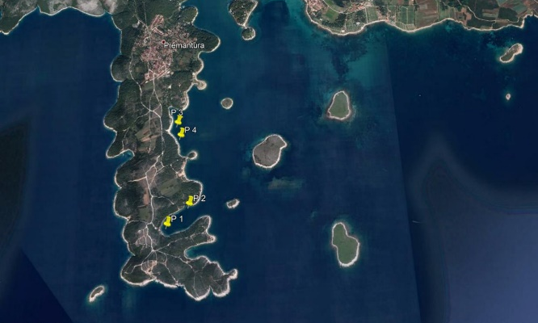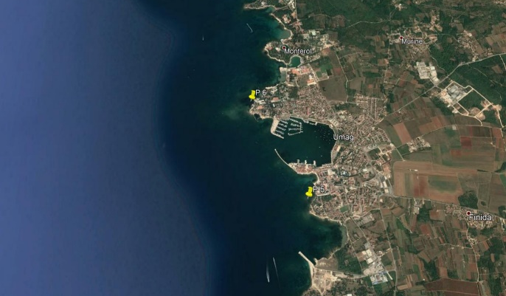
a)
Figure 1. Investigation area

The selectivity of these nets and their effectiveness in catching cuttlefish, Sepia officinalis and by-catches were investigated. The quantitative composition of by-catches of the trammel net sipara with and without additional net add in the lower part of the net (so-called alceta, Figure 2) was compared to reduce by-catches of other species (eg. Mollusca, Holothuria, Echinodermata,..). The additional part was constructed as gill net with min mesh size of 32 mm, maximum height up to 0.5 m and made of a thicker string. The trammel nets were of standard construction: 1.8 m high, 180 m long, with an inner mesh size of 32 mm and outer of 150 mm. All results were compared to determine catchability.

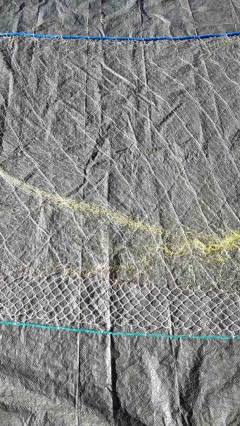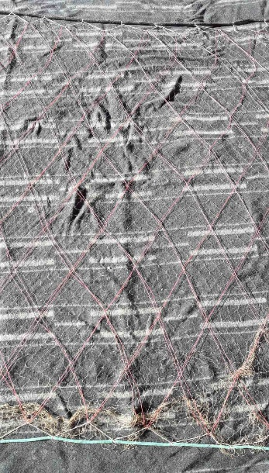
a)
b)
Figure 2. Trammel nets sipara a) with and b) without additional net add

Company/operator/associations of operators involved

- Daniele Turkovich
- Diego Makovac
- Kristijan Zović

Pilot testing results

Trammel nets sipare without „alceta
The qualitative-quantitative composition of the trammel nets sipare (without „alceta) (32 mm mesh size) expressed as catch / 100m over all three months of the survey is shown in Table 1. The target species, Sepia officinalis, was represented in the total catch with 26.4% in terms of abundance. In addition to cuttlefish, the dominant species in the catches are Hexaplex trunculus (21.4%), Bolinus brandaris (15.4%), Scorpaena porcus (10.0% biomass), and Holothuria tubulosa (8.4%) (Figure 3). The discarded portion accounts for 45.15%.
Table 1. Qualitative-quantitative composition of the trammel nets sipare (without „alceta) (32 mm mesh size) expressed as catch / 100m (April, May, June 2019)
Species | N | N%
SIPA (Sepia officinalis) | 269 | 26,35%
KVRGAVI VOLAK (Hexaplex trunculus) | 218 | 21,35%
BODLJIKAVI VOLAK (Bolinus brandaris) | 157 | 15,38%
ŠKARPUN (Scorpaena porcus) | 102 | 9,99%
TRP (Holothuria tubulosa) | 86 | 8,42%
MALA RAKOVICA (Maja crispata) | 61 | 5,97%
LUMBRAK (Symphodus tinca) | 25 | 2,45%
DRHTULJA MRKULJA (Torpedo marmorata) | 24 | 2,35%
GRMALJ (Eriphia verrucosa) | 20 | 1,96%
ARBUN BATOGLAVAC (Pagellus acarne) | 11 | 1,08%
PAUK BIJELAC (Trachinus draco) | 9 | 0,88%
KOSMAČ (Dromia personata) | 9 | 0,88%
KAVALA (Sciaena umbra) | 8 | 0,78%
ARBUN (Pagellus erythrinus) | 4 | 0,39%
ŠPAR (Diplodus annularis) | 4 | 0,39%
ZUBATAC (Dentex dentex) | 3 | 0,29%
KOMARČA (Sparus aurata) | 2 | 0,20%
PAGAR (Pagrus pagrus) | 2 | 0,20%
GLAVOČ BLATAŠ (Gobius niger) | 1 | 0,10%
CIPAL BALAVAC (Liza ramada) | 1 | 0,10%
HLAP (Homarus gammarus) | 1 | 0,10%
ŠNJUR (Trachurus mediterraneus) | 1 | 0,10%
PIRKA (Serranus scriba) | 1 | 0,10%
HINAC SIVI (Symphodus cinereus) | 1 | 0,10%
JAKOBOVA KAPICA (Pecten jacobaeus) | 1 | 0,10%
total | 1021 | 100,00%

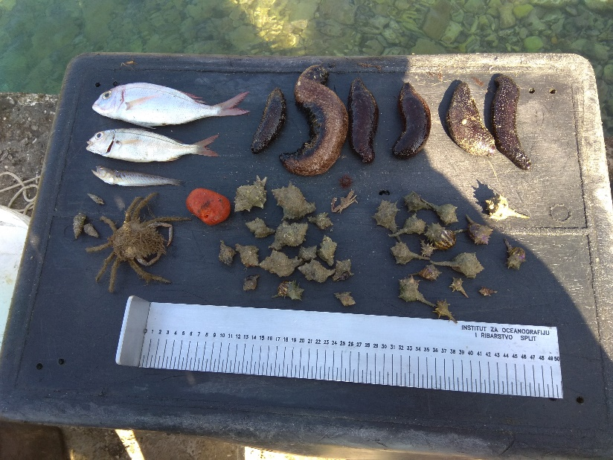
Figure 3. Dominant species in the landings of trammel nets sipara without „alceta“

Trammel nets sipare with „alceta“
The qualitative-quantitative composition of the trammel nets sipare (with „alceta) (32 mm mesh size) expressed as catch / 100m over all three months of the survey is shown in Table 2. Target species, Sepia officinalis was represented with 71.8 % in term of abundance in the total catch, following by Scorpaena porcus (8.6 %), Liza ramada (3,8 % biomass) and Eriphia verrucosa (3,8 %) (Figure 4). Discard was 3.97 %.
Table 2. Qualitative-quantitative composition of the trammel nets sipare (with „alceta) (32 mm mesh size) expressed as catch / 100m (April, May, June 2019)
Species | N | N%
SIPA (Sepia officinalis) | 1066 | 71,83%
ŠKARPUN (Scorpaena porcus) | 127 | 8,56%
GRMALJ (Eriphia verrucosa) | 57 | 3,84%
MALA RAKOVICA (Maja crispata) | 37 | 2,49%
CIPAL BALAVAC (Liza ramada) | 32 | 2,16%
KVRGAVI VOLAK (Hexaplex trunculus) | 25 | 1,68%
BODLJIKAVI VOLAK (Bolinus brandaris) | 19 | 1,28%
LUMBRAK (Symphodus tinca) | 16 | 1,08%
TRP (Holothuria tubulosa) | 15 | 1,01%
KOKOT BALAVAC (Trigla lucerna) | 14 | 0,94%
BATOVINA (Uranoscopus scaber) | 12 | 0,81%
LIST (Solea solea) | 12 | 0,81%
PAUK BIJELAC (Trachinus draco) | 11 | 0,74%
ŠPAR (Diplodus annularis) | 7 | 0,47%
KOMARČA (Sparus aurata) | 6 | 0,40%
ARBUN (Pagellus erythrinus) | 5 | 0,34%
DRHTULJA MRKULJA (Torpedo marmorata) | 4 | 0,27%
TRLJA BLATARICA (Mullus barbatus) | 3 | 0,20%
TRLJA KAMENJARKA (Mullus surmuletus) | 2 | 0,13%
CIPAL BALAVAC (Liza ramada) | 2 | 0,13%
HINAC SIVI (Symphodus cinereus) | 2 | 0,13%
SALPA (Sarpa salpa) | 1 | 0,07%
MODRAK (Spicara maena) | 1 | 0,07%
PAVLINKA (Symphodus ocellatus) | 1 | 0,07%
PIC (Diplodus puntazzo) | 1 | 0,07%
PIRKA (Serranus scriba) | 1 | 0,07%
GLAVOČ BLATAŠ (Gobius niger) | 1 | 0,07%
GRDOBINA ŽUTKA (Lophius budegassa) | 1 | 0,07%
ARBUN BATOGLAVAC (Pagellus acarne) | 1 | 0,07%
GOLUB (Myliobatis aquila) | 1 | 0,07%
MORSKA PASTRVA (Salmo marmoratus) | 1 | 0,07%
total | 1484 | 100,00%

Figure 4. Dominant species in the landings of trammel nets sipara with „alceta“.
Conclusions

Selectivity analysis of the investigated trammel nets of different construction designs with and without “alceta” with the allowed minimum mesh size to catch the target species cuttlefish, Sepia officinalis indicates that the cuttlefish is the most represented species in the catch in both designs, with represented by 26.4%, and in the case of alcetes, catchability increased to 71.8%, which shows that by changing the construction the almost exclusive representation of the target species in the landings is achieved. In trammel nets with “alceta” design, the percentage of discards never exceeds 10%, while without “alceta” design, discard is always around 50%. The percentage representation of the discarded portion and the number of different species in the landings will fluctuate spatially, but indisputably the trammel nets with “alceta” decreases the catchability of benthic invertebrates in the lower part of the net.

References

- Anonymous, 1993. Report of the Working Group on the Assessment of Southern Shelf Demersal Stocks. ICES Doc., C.M. 1993/Assess: 3.
- Cetinić, P., Jardas, I., Dulčić, J., Soldo, A., Pallaoro, A. 1999. Diversity of fishing gear in coastal area of the Eastern Adriatic and its influence on coastal fish communities. Proceedings of International Symposium on responsible fisheries and fishing techniques Insko-Poland: 165-176.
- Dulčić, J., Dragičević, B., Kraljević, M., Matić-Skoko., S., Pallaoro, A., Stagličić, N., Tutman, P. (2008): Monitoring naselja riba i drugih morskih organizama. Institut za oceanografiju i ribarstvo, Split, 1-133.
- Dulčić, J., B. Dragičević, M. Kraljević, S. Matić Skoko, A. Pallaoro, N. Stagličić, P. Tutman, 2008. Monitoring naselja riba i drugih morskih organizama. Procjena stanja obnovljivih gospodarski iskoristivih zaliha ribolovnog mora Republike. Studije i elaborati, IOR-Split, 290: 133 pp.
- Jardas, I. 1996. Jadranska ihtiofauna. Školska knjiga d.d., Zagreb, 536 p.
- Jardas, I., A. Pallaoro, M. Kraljević, J. Dulčić & P. Cetinić. 1998. Long-term changes in biodiversity of the coastal area of the Eastern Adriatic: fish, crustacean and cephalopoda communities. Period Biol, 100: 19-28.
- NN, 74/94 : Zakon o morskom ribarstvu.
- NN 84/2015: Pravilnik o obavljanju gospodarskog ribolova na moru mrežama stajaćicama, klopkastim, udičarskim i probodnim ribolovnim alatima
- Stergiou, K.I., D.K. Moutopoulos, M.C. Soriguer, E. Puente, P.G. Lino, C. Zabala, P. Monteiro, L.A. Errazkin & K. Erzini. 2006. Trammel net catch species composition, catch rates and métiers in southern European waters: a multivariate approach. Fish. Res., 79: 170–182.
- Stobart, B., R. Warwick, C. Gonzalez, S. Mallo, D. Diaz, O. Renones, & R. Goni. 2009. Long-term and spillover effects of a marine protected area on an exploited fish community. Mar. Ecol. Prog. Ser., 384: 47-60.

Type of Action

- Testing trammel nets “listare” selectivity mesh size 40mm and 42 mm

Innovation needs addressed

One-layer gillnets and three-layer trammel nets are probably the most commonly used fishing gear along coastal eastern Adriatic. Regional differences, conditioned by the distribution of target species, exist in frequency of their use. While, in west coast of peninsula Istra (northern Adriatic), trammel nets of smaller height called “listarice”, with Solea vulgaris as main target, are the main trammel nets used in winter, in middle and south Adriatic trammel nets called “poponice” (min mesh size 40 mm) are prevalent (closed season 15.5-10.09). Also, specific trammel nets called sipara (min mesh size 32 mm) intended for catching Sepia officinalis nets (open season 01.2-15.06) have traditionally been used in the northern Adriatic. The trammel nets are the favoured fishing gear of Croatia’s artisanal fishermen as they regard it as the most efficient one providing them with catches as lush as possible. On the other hand, numerous studies, besides confirming their great catchability, have pointed out the low selectiveness resulting from their specific construction and operation properties (Jardas et al., 1998 and references therein). Although, artisanal fisheries are generally perceived as highly efficient low impact fisheries that generate few discards (Stobart et al., 2009 and references therein), this fishery affect numerous species due to continuous substantial fishermen practice, despite having preferred target species. Illustrative of the aforementioned, trammel nets are often target specific, but important part of the catch consists of multi-species by-
catch (Stergiou et al., 2006). Legislative changes of Croatian artisanal fishing regulations have mostly been aimed at trammel nets and encompass the increase in minimum inner layer mesh size of trammel net from 28 to 40 mm in 1999 and excluding the trammel net from subsistence artisanal fishing in 2002. Additionally, in 2002 for artisanal subsistence fishing legal provisions proclaimed a daily catch limit of 5 kg and reduced the allowed quantity of most types of gillnets, orienting it thus much more to trap and line fishing.

Pilot area

The trammel nets listare are used predominantly in the western Istrian waters intended for the catching Solea vulgaris (family Soleidae), but also of some other species, like Synapturichthys kleinii and Pegus impar. They also effectively catch cuttlefish (Sepia officinalis) and other demersal fish, crustaceans and cephalopods. The nets commonly used Croatia are 18 m long and usually 0.8 m - 1 m high. They are usually made of synthetic trophil twisted thread and are joined in series of up to 250 or more nets. They are intended to use only at night: either all night (from afternoon to morning) or only part of the night (from afternoon to late night - the so-called alba). They also descend tens of miles offshore, perpendicular to the open sea (transversely to the direction of motion of the fish), but always solely depending on the sea currents (always downstream due to less dirt).

The studied area is a specific area, which in its properties differs in many respects from other parts of the Adriatic, of which only some stand out: , shallow depth and high intake of organic nutrients from the land, especially nitrogen and phosphorus, which is why abundance of phytoplankton species is usually accompanied by seasonal and annual fluctuations of freshwater influences of the northern Adriatic alps and nutrient intakes, b) the area is characterized by sandy-detrital biocenosis, mainly muddy bottom, with low transparency, c) the closest part of the Adriatic, whose depth in the study area is generally about 30 m, except for some limited depressions near Umag and Cape Savudrija, where the depth was slightly deeper, d) the area where they occur some economically significant species, which are rare or not found at all in other parts our fishing sea. Our sampling was mainly done in the waters of Savudrija, Umag and Poreč (Figure 1).

Pilot area was northern Adriatic / West coast of Istria (3 vessels)
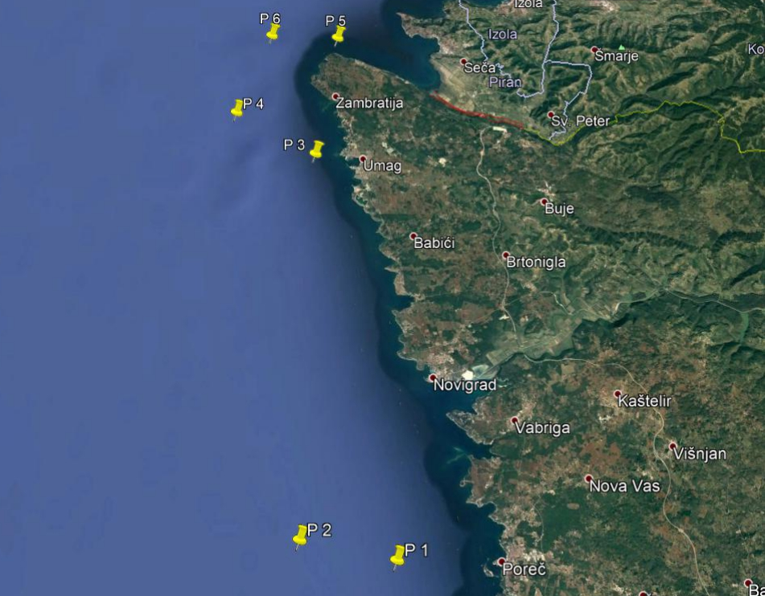
Figure 1. Investigation area

The spatial and temporal representation of Solea vulgaris and other species caught in the surveyed nets was analyzed based on the results of their catch per month when surveys were carried out and the results of catches per unit of fishing effort, which in our studies made up the total catch per one net.

Company/operator/associations of operators involved

- Daniele Turkovich
- Diego Makovac
- Ranko Bonaca

Pilot testing results

The qualitative-quantitative composition of the trammel nets listara (mesh size 40 mm) expressed as catch/100m is presented in theTable 1. In total, 902.9 kg of different fish (9 species), crabs (1) and cephalopoda (1) and bivalve (1) in cca 4.3 km of nets were caught. Target species, Solea vulgaris were represented in total catch with 92.6 % in term of abundance and 91.4 % in term of biomass. Total catch of Solea vulgaris was 47.1 kg (Figure 2). Other dominant species were Scophthalmus rhombus (0.9 % biomass) and Sepia officinalis (1.2 % biomass). Discard is presented in the Table 2.
Table 1. The qualitative-quantitative composition of the trammel nets listara (mesh size 40 mm) expressed as catch/100m (2019)
LANDINGS | N | N % | W | W %
ARBUN BATOGLAVAC (Pagellus acarne) | 0,01 | 0,32% | 0,71 | 0,08%
JAKOBOVA KAPICA (Pecten jacobaeus) | 0,01 | 0,18% | 0,75 | 0,08%
KOKOT BALAVAC (Trigla lucerna) | 0,14 | 3,36% | 37,26 | 4,13%
LIST (Solea solea) | 3,87 | 92,55% | 825,31 | 91,41%
LIST CRNORUBI (Solea kleinii) | 0,01 | 0,32% | 2,59 | 0,29%
MUZGAVAC (Eledone moschata) | 0,01 | 0,16% | 2,49 | 0,28%
RAŽA CRNOPJEGA (Raja montagui) | 0,01 | 0,27% | 5,81 | 0,64%
RUMB (Scophthalmus rhombus) | 0,02 | 0,52% | 8,41 | 0,93%
SIPA (Sepia officinalis) | 0,03 | 0,76% | 10,34 | 1,15%
ŠKARPINA (Scorpaena scrofa) | 0,02 | 0,44% | 5,07 | 0,56%
ŠKARPUN (Scorpaena porcus) | 0,01 | 0,19% | 1,37 | 0,15%
ŠNJUR (Trachurus trachurus) | 0,00 | 0,12% | 0,86 | 0,10%
VABIĆ (Squilla mantis) | 0,03 | 0,82% | 1,95 | 0,22%
TOTAL | 4,181644 | 100,00% | 902,9155 | 100,00%
Table 2. The qualitative-quantitative composition of the trammel nets listara discard (mesh size 40 mm) expressed as catch/100m (2019)
DISCARD | N | N % | W | W %
KOVAČ (Zeus faber) | 0,02 | 33,3% | 1,11 | 44,8%
PLOSNATICA BARJAKTARKA (Arnoglossus thori) | 0,02 | 33,3% | 0,44 | 17,9%
LIST HRAPAVAC (Monochirus hispidus) | 0,02 | 33,3% | 0,93 | 37,3%
TOTAL | 0,06 | 100,0% | 2,48 | 100,0%

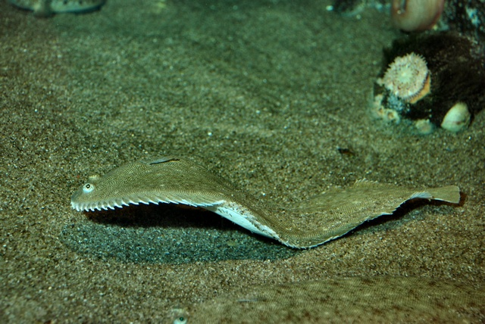

Figure 2. Common sole, Solea vulgaris
The qualitative-quantitative composition of the trammel nets listara (mesh size 42 mm) expressed as catch/100m is presented in theTable 3. In total, 1132.2 kg of different fish (17 species), crabs (1) and cephalopoda (1) and bivalve (1) in cca 3.8 km of nets were caught. Target species, Solea vulgaris were represented in total catch with 92.1 % in term of abundance and 90.3 % in term of biomass. Total catch of Solea vulgaris was 52.9 kg. Other dominant species were Scophthalmus rhombus (1.4 % biomass) and Mustelus mustelus (2.1 % biomass). Discard is presented in the Table 4.
Table 3. The qualitative-quantitative composition of the trammel nets listara (mesh size 42 mm) expressed as catch/100m (2019)
LANDINGS | N | N % | W | W %
BATOVINA (Uranoscopus scaber) | 0,01 | 0,3% | 1,66 | 0,1%
CIPAL PUTNIK (Chelon labrosus) | 0,01 | 0,3% | 8,18 | 0,7%
JAKOBOVA KAPICA (Pecten jacobaeus) | 0,01 | 0,3% | 1,93 | 0,2%
KOKOT BALAVAC (Trigla lucerna) | 0,04 | 0,8% | 11,35 | 1,0%
KOVAČ (Zeus faber) | 0,00 | 0,1% | 0,92 | 0,1%
LASTAVICA (Trigloporus lastoviza) | 0,01 | 0,1% | 1,90 | 0,2%
LIST (Solea solea) | 4,13 | 92,1% | 1022,29 | 90,3%
LIST CRNORUBI (Solea kleinii) | 0,01 | 0,1% | 0,99 | 0,1%
LUBIN (Dincentrarchus labrax) | 0,03 | 0,7% | 15,44 | 1,4%
MORSKI PAS MEKUŠ (Mustelus mustelus) | 0,03 | 0,7% | 24,31 | 2,1%
PIŠMOLJ (Merlangius merlangus) | 0,00 | 0,1% | 0,76 | 0,1%
RAŽA CRNOPJEGA (Raja montagui) | 0,01 | 0,1% | 7,10 | 0,6%
RUMB (Scophthalmus rhombus) | 0,02 | 0,5% | 16,38 | 1,4%
SIPA (Sepia officinalis) | 0,01 | 0,1% | 1,93 | 0,2%
ŠKARPINA (Scorpaena scrofa) | 0,01 | 0,2% | 3,83 | 0,3%
ŠKARPUN (Scorpaena porcus) | 0,00 | 0,1% | 1,48 | 0,1%
ŠNJUR (Trachurus trachurus) | 0,01 | 0,1% | 0,68 | 0,1%
TRLJA OD BLATA (Mullus barbatus) | 0,01 | 0,1% | 0,53 | 0,0%
VABIĆ (Squilla mantis) | 0,13 | 2,8% | 8,89 | 0,8%
ZUBATAC (Dentex dentex) | 0,01 | 0,1% | 1,60 | 0,1%
TOTAL | 4,49 | 100,0% | 1132,18 | 100,0%
Table 4. The qualitative-quantitative composition of the trammel nets listara discard (mesh size 42 mm) expressed as catch/100m (2019)
DISCARD | N | N % | W | W %
DRHTULJA ŠARULJA (Torpedo marmorata) | 0,05 | 9,5% | 9,88 | 6,8%
LIST (Solea solea) | 0,44 | 84,2% | 108,07 | 74,7%
ŠKARPINA (Scorpaena scrofa) | 0,03 | 6,3% | 26,73 | 18,5%
TOTAL | 0,53 | 100,0% | 144,68 | 100,0%

Differences in catchability of trammel nets listara with 40mm and 42 mm minimum mesh size is presented in the Table 5.
Table 5. Differences in catchability of trammel nets listara (40 mm i 42 mm) (2019).
Mesh size | 40 mm | 42 mm
Total N | 224 | 224
Total biomass (kg) | 47.10 | 50.43
% N | 92.6 | 92.1
% W | 91.4 | 90.3
mean TL (cm) | 28.2 | 28.99
SD | 2.283 | 1.654
mean W (g) | 210.3 | 236.0
SD | 62.668 | 172.7

Selectivity analysis resulted in fact that more individuals were caught in listara of min mesh size 40 mm. However, with further analysis of Solea vulgaris biological characteristics, it is obtained that longer and heavier individuals were caught when listara of 42 mm were applied. (Tablica 5; Slika 3).

Figure 3. Differences in catch of Solea vulgaris according to different mesh sizes (40 mm and 42 mm) (2019).

Conclusions

Target species, Solea vulgaris was represented in the total catch with 92.6 % in the 40 mm and 92.1% in the 42 mm trammel nets listara in terms of abundance, while in biomass this percentage was 91.4% for a listara with 40 mm minimum mesh size, or 90.3% for a 42 mm min mesh size. However, this higher proportion of individuals by number and biomass in the smaller mesh size is expected, while all other indicators are more on the side of the larger minimum mesh size.
Catch analysis indicates that by increasing the minimum mesh size of the listara trammel net from 40 mm to 42 mm, SSF would catch 3% longer individuals and 11% more in total biomass, and it is therefore valid and justified to consider changing the legislation in terms of increasing the minimum mesh size from 40mm to 42mm.

Type of Action

- App for virtual market

Innovation needs addressed
Virtual market application for mobile phones like the ABALOBI* (http://abalobi.info/) initiative is an open, transdisciplinary and social learning endeavour, bringing together various stakeholders, with traditional fishers taking centre stage. Our virtual market app like Abalobi, as a mobile app suite and programme, is aimed at social justice and poverty alleviation in the small-scale fisheries chain, transformation in the way we produce knowledge, stewardship of our marine resources, and resilience building in the face of climate change. Promoting traceable, storied seafood by empowered small-scale fishers from hook to cook, in a manner that is not only ecologically responsible, but also socially fair. Because who fishes matters.

The main idea or innovation addressed is working towards good governance and embracing a human-rights-based approach to fisheries: Through the development of an integrated small-scale fisheries information management system and mobile app suite, the ABALOBI initiative aims to enable small-scale fishing communities to be incorporated into information and resource networks: from fishery monitoring and maritime safety, to local development and market opportunities

Pilot area

Pilot area will be northern Adriatic / Istra region where at least 5 SSF operators and 5 restaurants will be included in pilot studies. Alternatively, the similar study will be conducted in the Zadar County.

Setting up and testing n.1 app for virtual market on n. 15/20 users of which at least 5 SSF operators and 5 restaurants. We will also involve consumers ‘association, private buyers, “Solidarity Purchase Groups”. Main issue: all SSF operators willing to receive the user’s license shall agree on a common price of seafood. To this, a focus group will be arranged by CNR to formalize the interest and the involvement of fishermen according to fair criteria. Testing the app will cover the period December 2019 – March 2020. The app will be development by CNR (using external expertise budget line) in 4 languages and it can be used by all partners involved in pilot testing by purchasing monthly licenses.

Company/operator/associations of operators involved

- Fishers: Daniele Turkovich, Diego Makovac, Mladen Pandur, Kristijan Zović, Ranko Bonaca
- Restaurants: have to be arranged

Pilot testing results

Results and conclusions

The app is currently in testing phase within our researchers. We select several participants as fishers, buyers, association. In next weeks it will be distributed to all interested in. Preliminary results are expected in the autumn 2020.

References

- http://abalobi.info/

CONCLUSIONS: TECHNICAL AND POLICY RECCOMMENDATIONS

- Application of the underwater dolphin dissuasive devices at mussel farms that emitted sound frequencies between 5 and 500 kHz with peak around 140 kHz, showed to be non-functional agents fish predation. From the scare number of papers that investigated repulsive frequencies for marine fish, it can be speculated that used frequencies in this study were not functionally optimal) Thus, further study related with predation prevention should be oriented toward testing sounds with lower frequencies spectra in respect to the gilthead seabream behaviour.
- When fisherman applied acoustic dissussors of specific technical characteristics (pingers), direct damage on fishing gear and catch was reduced on <5% of daily damage value without using pingers. Daily catches achieved by SSF having pingers are on average at 50.33 kg, while when they worked without pingers catch was around 9.59 kg, or on average having pingers enable achievement of 81% better daily catch. So, this findings can serve as base for future policy recommendations.
- Selectivity analysis of the investigated trammel nets of different construction designs with and without “alceta” with the allowed minimum mesh size to catch the target species cuttlefish, Sepia officinalis indicates that the cuttlefish is the most represented species in the catch in both designs and in the case of alcetes, catchability increased to 71.8%, which shows that by changing the construction the almost exclusive representation of the target species in the landings is achieved. In trammel nets with “alceta” design, the percentage of discards never exceeds 10%, while without “alceta” design, discard is always around 50%. The percentage representation of the discarded portion and the number of different species in the landings will fluctuate spatially, but indisputably the trammel nets with “alceta” decreases the catchability of benthic invertebrates in the lower part of the net. Thus this findings is valuable input for policy recommendations.
- Target species, Solea vulgaris was represented in the total catch with 92.6 % in the 40 mm and 92.1% in the 42 mm trammel nets listara in terms of abundance, while in biomass this percentage was 91.4% for a listara with 40 mm minimum mesh size, or 90.3% for a 42 mm min mesh size. However, this higher proportion of individuals by number and biomass in the smaller mesh size is expected, while all other indicators are more on the side of the larger minimum mesh size. Catch analysis indicates that by increasing the minimum mesh size of the listara trammel net from 40 mm to 42 mm, SSF would catch 3% longer individuals and 11% more in total biomass, and it is therefore valid and justified to consider changing the legislation in terms of increasing the minimum mesh size from 40mm to 42mm.
- The app is currently in testing phase within our researchers. We select several participants as fishers, buyers, association. In next weeks it will be distributed to all interested in. Preliminary results are expected in the autumn 2020.

ANNEXES

