ARIEL project cod.278
WPT1 – Small Scale Fisheries and Aquaculture Framework Analysis

THE ADRION SMALL – SCALE FISHERIES SWOT

Type of Document | Project Deliverable D T.1.2.3
Authors | IBMK with contribution from MoARD, CNR-IRBIM, HCMR, IOR, PI RERA SD, REMA, RESI, RWG
Work Package: | WPT1 – Small Scale Fisheries and Aquaculture Framework Analysis
Version and date | Final Version, November 2018

THE ARIEL PROJECT
Aquaculture (AQ), along with Small-scale fisheries (SSF), are emerging sectors with high socio-economic importance and represent key drivers for the sustainable growth of Adriatic-Ionian communities. AQ sector faces challenges, such as: key enabling technologies and capacity creation, improved technological and market research for more cost-effective and sustainable solutions, co-management of resources, science-based policies, improved collection and assessment of biological data and data on production, and finally, viability and sustainability of ecosystem functioning. Under these premises the ARIEL Project, which is co-financed by the INTERREG VB ADRION Program 2014-2020, aims to promote (non-) technological solutions for the innovation of AQ and SSF among scientists, policy-makers and entrepreneurs, acting as a knowledge network and taking into account, in a single framework, the complex ecological, economic and societal challenges. ARIEL will develop capacity-building actions for policy makers to facilitate the adoption of a science-based approach to improve co-management of resources and develop appropriate supporting schemes to stimulate actors’ networking and clustering. Project activities will lead to strategic and operational guidelines to promote open innovation in SSF and AQ led by research institutes, facilitated by policy makers, endorsed by entrepreneurs and recognized by consumers. ARIEL promotes the uptake of open innovation led research in SSF and AQ facilitated by policy-makers and endorsed by operators by involving multiple-skill-organizations from Italy, Croatia, Montenegro and Greece. These organizations can effectively tackle, both strategically and operationally, the complex challenges of the growing SSF and AQ sectors in the Adriatic-Ionian Region, and can identify key innovation drivers for policy and research. Finally, they can ensure the durability and transferability of the projects’ results.
The ARIEL partnership
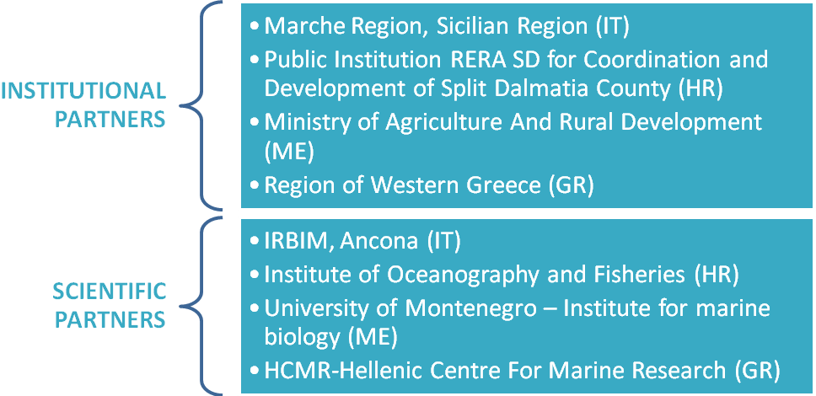

ADRION SMALL-SCALE FISHERIES SWOT

The present SWOT table outline the strengths, weaknesses, opportunities sand threats detected in the small-scale fisheries sector of the Adriatic Ionian Region territories.
The SWOT table was developed by the Institute of Marine biology of Kotor (Montenegro), merging the regional SWOT tables delivered by the Italian, Croatian and Greek partners and the information from the desk survey.

STRENGTHS | WEAKNESSES
- Long tradition of SSF in the region  - Low environmental impact  - Low impact on resources  - Short supply and distribution chain  - Generally high quality of landings/products | - Vessel age  - Low level of cooperation  - Illegal fishing  - Differences in SSF products pricing in different areas  - Low human capital  - Lack of interest/capability to use innovative technologies/modern equipment  - Lower level of monitoring
OPPORTUNITIES | THREATS
- Growing consumer demand for fisheries products  - Traditional and cultural heritage protection  - Improvement in SSF operatives cooperation  - Modernisation and improvements in fishing gear and introduction of new technologies  - Cooperation with scientific/research institutions | - Overexploitation from other metier and/or foreign vessels  - Pollution through anthropogenic activities  - Lingering effects of economic crisis, low access to credit, high input cost (fuel)  - Increased competition from other (EU/non-EU) markets  - Growing number of top predators

ARIEL PROJECT CONTACTS
https://ariel.adrioninterreg.eu/
Facebook@ARIELADRION

Lead Partner: CNR-IRBIM Ancona
fabio.grati@an.ismar.cnr.it

DISCLAIMER
“This Report has been produced with the financial assistance of the European Union. The content of the Report is the sole responsibility of the ARIEL project partnership and can under no circumstances be regarded as reflecting the position of the European Union and/or ADRION programme authorities”

