@slowadventuring #slowadventuring
Building a Digital Transnational Campaign

The Aim

To raise awareness of Slow Adventure as a concept and Slow Adventure products in Norway, Finland, Sweden, Iceland, Ireland Northern Ireland and Scotland which have been developed as a result of the SAINT Project.

In doing so, it will introduce the consumer to an alternative dimension of ‘adventure’. Discovering wild and nature rich landscapes at a slower pace through softer more immersive experiences instead of associating adventure with high adrenalin and fast-paced activities.

This digital campaign is a platform which brings together Slow Adventures transnationally and is an opportunity to represent the variety of tourism products equally. The social media platforms are used to inspire the consumer. The campaign website (or landing pages for each country) will be used as a place to link posts on social media and to divert enquiries to Slow Adventure SMEs.

The Slow Adventuring campaign is a prototype for the Slow Adventure organisation and a way to build on the momentum already underway.

Communicating slow adventure on your pages

You may wish to use the following text next to your slow adventure experience on your website to help explain what slow adventure is. Please feel free to add how you connect with the main features on slow adventure also – time, nature, comfort (in the outdoors), passage

“Slow adventure - inspiring connections with the outdoors. A chance to explore and engage with wild, open and natural places. To journey through breath-taking landscapes at a slower, immersive pace. Creating memories through meaningful experiences as you invest time in a place, in its traditions and community. Surrendering to the natural forces of the environment as you reflect, reconnect and become closer to nature.

Slow adventure brings together people who enjoy sharing their sense of place with visitors by sharing traditional skills, local knowledge, storytelling and spending time together in nature. Each slow adventure has been crafted to offer unique experiences by working with carefully selected people and businesses.

Slow Adventure forms part of the Slow Adventure in Northern Territories Project which is co-financed by the European Union’s Northern Periphery and Arctic Programme.”

How can we achieve this?

By creating, curating and promoting slow adventure content (i.e. photos, descriptions, emotions, videos, podcasts etc.) and sharing globally through social media and other relevant digital marketing tools.

Digital marketing guidelines

Please follow these key steps to help us tie together the slow adventuring campaign

Example – Otter Adventures

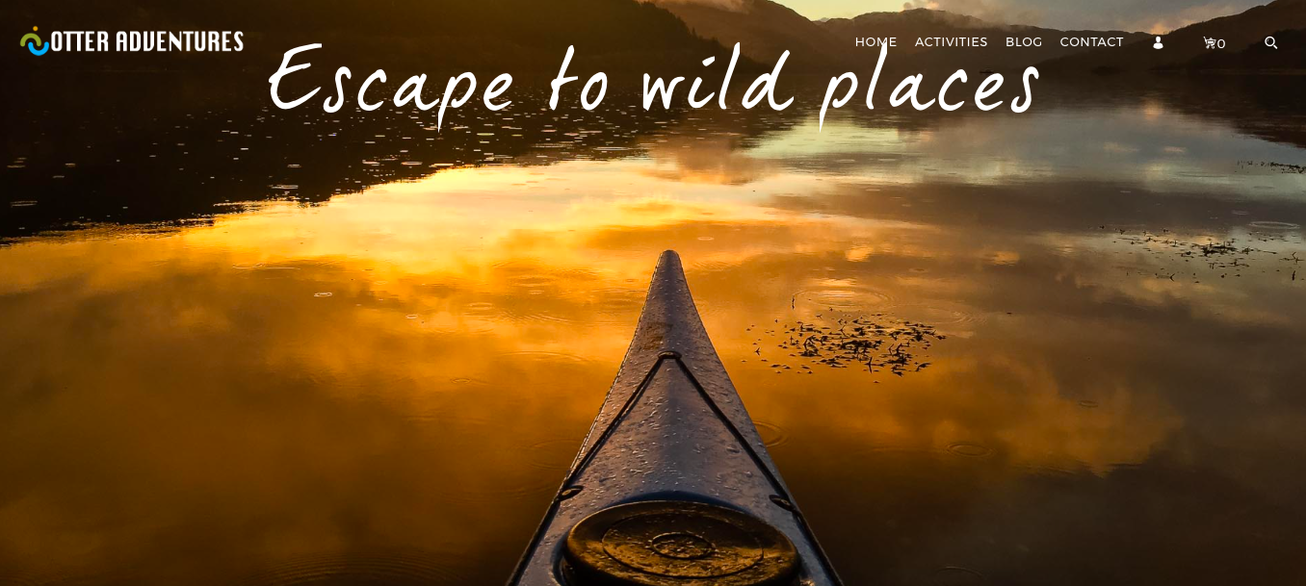
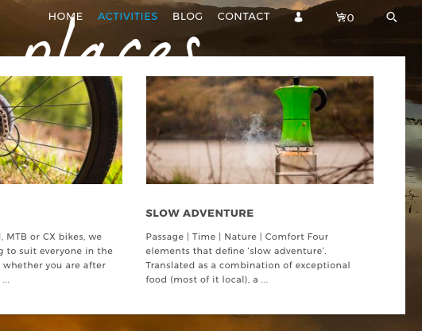
Otter Adventures has added a separate page for the slow adventure product on their website. This includes details about the experience, who is involved, dates, prices, how to book, and an interesting description about what slow adventure is in the context of this slow adventure.

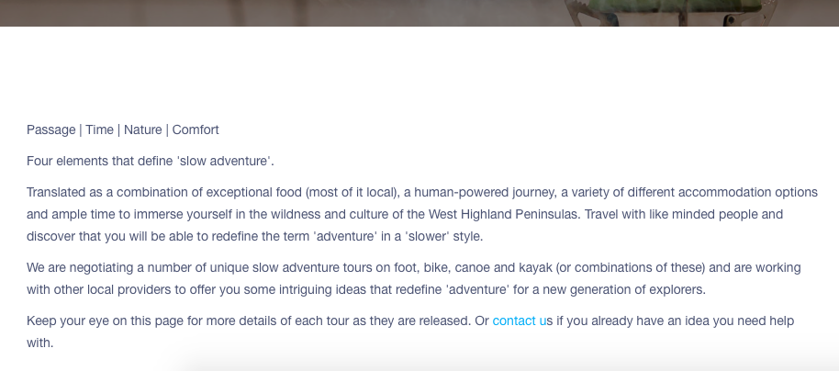

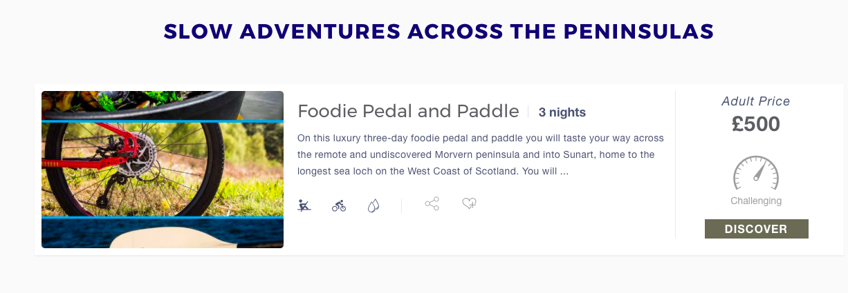

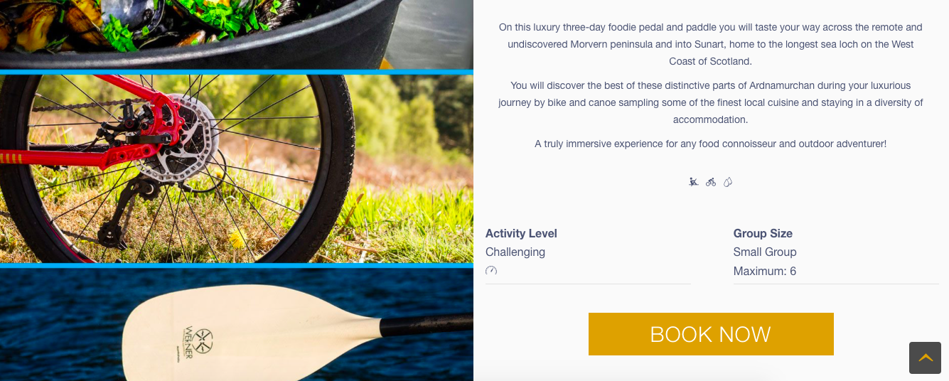

Promoting slow adventure products – tag & share

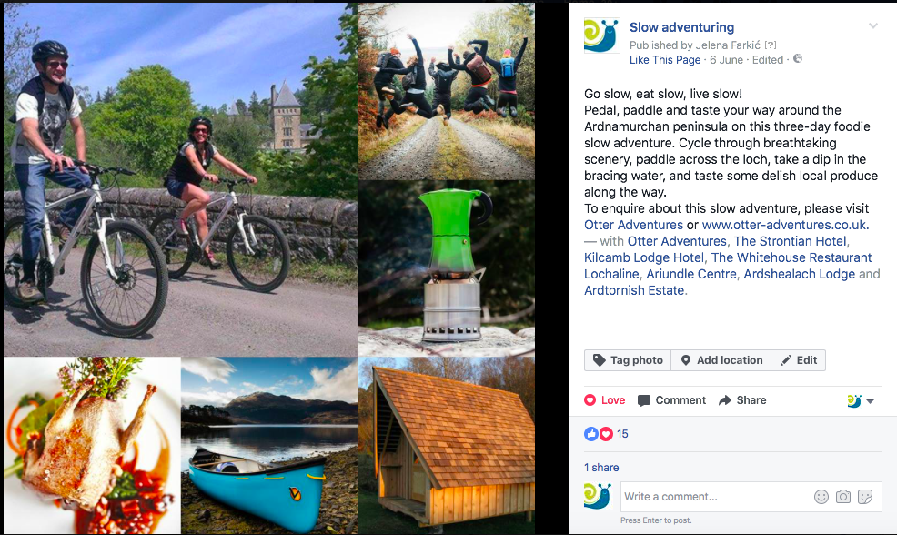

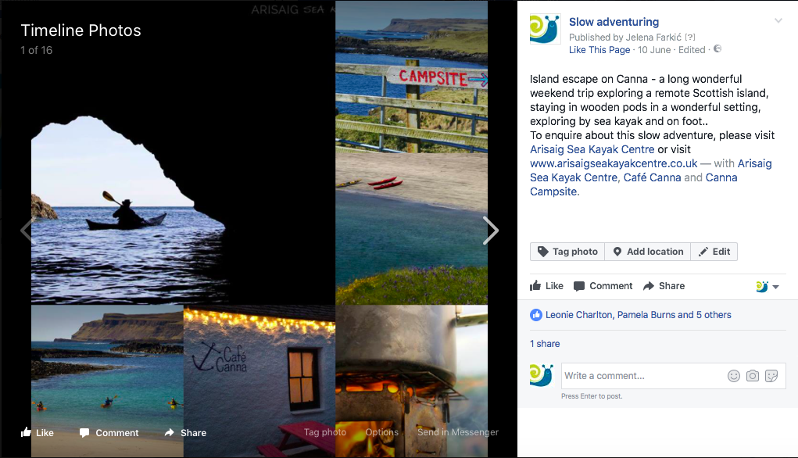

Social media

Using social media in digital marketing enables us to project our brand image globally. While each platform has its own unique environment, our visual identity should stay consistent across all of them. In order to clearly communicate our message, we should offer valuable content to attract and engage the audience. The content can vary from images, videos, and infographics to any relevant text-based content. The most important thing is that it calls for action (like, repost, share, pin, tweet, etc)!

Here are a few simple tips how you can tie in with the Slow adventuring campaign:

- Follow Slow adventuring

Pinterest
Facebook
Instagram
Twitter

- Share content
If you think your audience will enjoy the content published on Slow adventuring social media, feel free to share/repost it! We will do the same as sharing is caring!

- Mention the campaign
When uploading content on your personal social media, whenever appropriate, use the following hashtags #slowadventuring #slowadventure or mention the campaign @slowadventuring

- Populate pinboards
Make sure to send us any images that depict slow adventuring in your country. They will appear in boards:
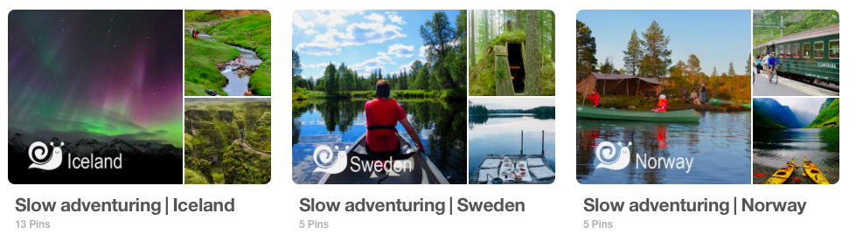

- Send us your photos - Please make sure to add a short description of your slow adventure product, containing some of the SA key words to accompany the images. We will share them across Slow adventure social media.

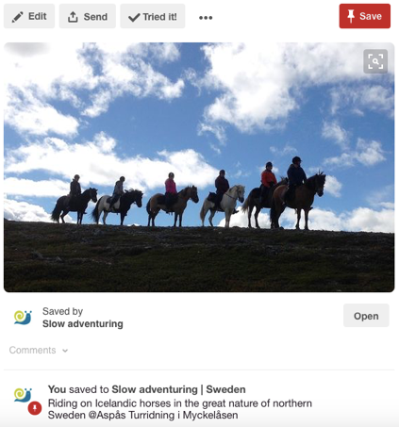

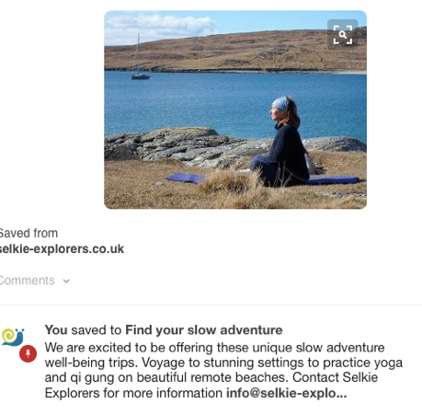

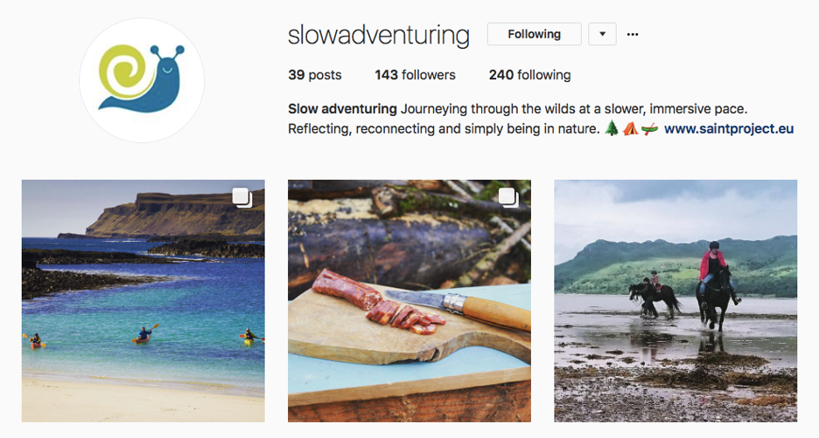

What are #hashtags?

Hashtags are the most popular means of categorising content on social media. It makes your own content discoverable and allows you to find relevant content from other people and businesses. The hashtag also allows you to connect with and engage other social media users based on a common theme or interest.

Useful link:
https://later.com/blog/ultimate-guide-to-using-instagram-hashtags/

Recommended hashtags

General

#slowlife
#naturelovers
#neverstopexploring
#outdoors
#outdoorlife
#landscape
#slow
#camping
#wildlife
#kayaking
#slowfood
#mindfulness
#yoga

More specific

#slowadventuring
#slowadventure
#slowscotland
#crielfishing
#greatglen

