Project Title: Promotion of green maritime technologies and new materials to enhance sustainable shipbuilding in Adriatic Ionian Region

Project Acronym: NEORION

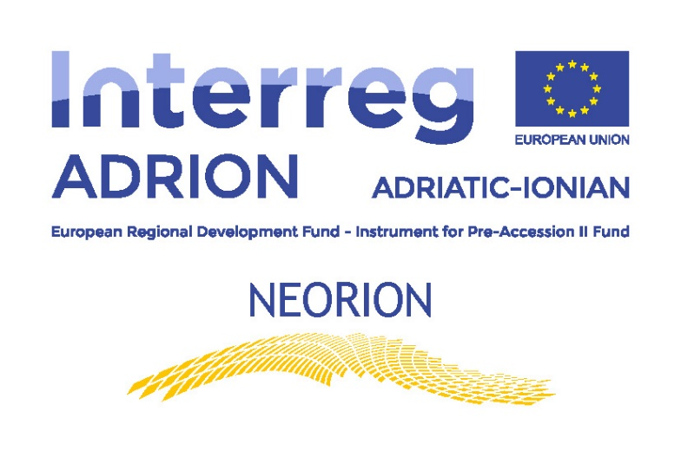

T.2.1 – Press Releases
WP: Communication

Authors: Technology Park Ljubljana Ltd – PP8
and the University of the Aegean - LP

Content:
1. Press Release Identity Card 3
2. Contribution 4
3. Picture(s) list 6
4. English contribution 8

Press Release Identity Card
Here inside please enter some basic data about Press release in order to make correspondence off all contributions clear & accurate.
Press Release Identity Card
Press Release Number: 2
Neorion partner: Technology Park Ljubljana
Title: Inovacijske priložnosti in prakse v pomorstvu in navtiki
Title (English): Innovation opportunities and best practice in maritime industry
Events location(s) (towns) included: Ljubljana, Slovenia
Events date(s) included: 5.3.2020
Link to online posts (if exists): https://www.tp-lj.si/sl/novice/inovacijske-priloznosti-in-prakse-v-pomorstvu-in-navtiki-2020-03-06
Publication Name & Number (if exists):

.

Contribution
Here inside the written text of contribution need to be added by design as follow:
Inovacijske priložnosti in prakse v pomorstvu in navtiki
Seminar “Inovacijske priložnosti in prakse v pomorstvu in navtiki” je bil organiziran v Tehnološkem parku Ljubljana 5. marca 2020. Prisotni so bili podjetniki, proizvajalci, inovativni deležniki, raziskovalna organizacija, akademiki in tudi oblikovalci politike. Dogodek je bil skupaj za projekt NEORION (Promocija pomorskih tehnologij in materialov za izboljšanje trajnostnega ladjedelništva v jadranski jonski regiji) kot za SHIPmEnTT (oba v programu Interreg ADRION), da bi združili sinergijske učinke med udeleženci in tudi s predstavniki.

Uvodni govor je imel dr. Jernej Pintar (direktor Tehnološkega parka Ljubljana), ki je udeležence spodbudil k inovativnnosti, pogumu in odprtosti za svetovni razvoj. Sledile so presentacije, nanašajoč se na pomorsko industrijo.
- izr. prof.dr. Peter Vidmar (Fakulteta za pomorstvo in promet) je predstavil priložnosti nove tehnologije v pomorstvu in poudaril, da pomorstvo vodi k novim standardom v okoljskih izzivih, digitalizaciji in energetskem sektorju:
- ga. Mateja Geder (Univerza TechnoCenter v Mariboru) je predstavila novosti na področju energetike, logistične varnosti in okoljskih vprašanj ter projekt SHIPmEnTT;
- g. Aleksander Nemec (Pleione, raziskave in razvoj, Aleksander Nemec s.p.) je predstavil svojo podjetniško pot od zagona do globalnega svetovalca in partnerja na področju e-mobilnosti v pomorski industriji. Predstavil je priložnosti in grožnje pri vnosu električne energije na rekreacijska plovila in večje čolne;
- g. Andrej Justin (Justin Yacht Design) je izpostavil, da velik poudarek namenjajo individualnemu odnosu in resnično dajejo najboljše izdelke in rešitve partnerjem. V predstavitvi so bile prikazane tehnološke rešitve in primeri, ko so pomagali globalnim podjetjem ali posameznim velikim kupcem pri iskanju rešitev za optimizacijo zmogljivosti plovila;
- g. Jaro Žuraj (SIMARINE d.o.o.), kot strokovnjak za elektro digitalno industrijo je predstavil aplikacijo (programsko in strojno opremo), ki je bila zelo dobro sprejeta zaradi preprostosti in zasnove. Po MVP so našli slovenske partnerje, ki so svoje izdelke začeli vključevati v svoje čolne in tako vstopili na svetovni trg;
- g. Kristjan Košič (JUNIBA d.o.o.) je predstavil svoj družinski inovativen izdelek: to je rešitev za jadrnice, ki označujejo gibanje in lokacijo njihovega sidra. Z njihovo rešitvijo bodo bodoči čolni pluli z manj skrbi;
- dr. Monika Cvetkov (Tehnološki park Ljubljana) je predstavila projekt NEORION iz širše perspektive, zakaj je pomembno nadaljevati z njim in kakšena je korist deležnikov.
V drugem delu seminarja je potekala okrogla miza na temo zelenih pomorskih tehnologij, inovacij v pomorski industriji, sodelovanja med podjetji in politike. Poleg predavateljev sta bila prisotna še Katarina Goli (Ministrstvo za infrastrukturo) in gospod Anton Habjanič (TehnoCenter Univerza v Mariboru). Okroglo mizo je moderiral gospod Peter Vidmar.
V Tehnološkem parku Ljubljana bomo skozi projekt Neorion, skupaj s partnerji, ustanovili grozd, zato vabimo vsa podjetja, ki delujejo ali jih zanimajo pobude na temo inovacij in zelenih tehnologij v pomorstvu, ki bi lahko pomorsko industrijo digitalizirala ali na kakršenkoli drugi način izboljšala njeno konkurenčnost, da se nam pridružijo.
Veselimo se objave v vašem mediju!

Kontaktna oseba za program:
Monika Cvetkov, monika.cvetkov@tp-lj.si
Kontaktna oseba za medijska vprašanja:
Mateja Prinčič, mateja.princic@tp-lj.si
T: 041 373 797

Picture(s) list
While the placement of picture depends on advertiser requirements, it is strongly recommended to:
- make an overview of pictures/photos added in a table in local and English language
- specify event & location & date for each picture/photo
- if pictures are sent to journalists, they must be attached also (fulfill jpg. Numbers)

No. | JPjpg. no | Picture: Text & Location & Date
1 | 2337.jpg | (in local): Predstavitev Aleksandra Nemca, Tehnološki park Ljubljana, 5th March 2020
 |  | (in English): Aleksander Nemec`s presentation, Technology Park Ljubljana, 5th March 2020
2 | 2343.jpg | (in local): Predstavitev Andreja Justina, Tehnološki park Ljubljana, 5th March 2020
 |  | (in English) Picture 2: Andrej Justin`s presentation, Technology Park Ljubljana, 5th March 2020
3 | 2405.jpg | (in local): Gostje okrogle mize, Tehnološki park Ljubljana, 5th March 2020
 |  | (in English): Picture 3: Round table guests Technology Park Ljubljana, 5th March 2020

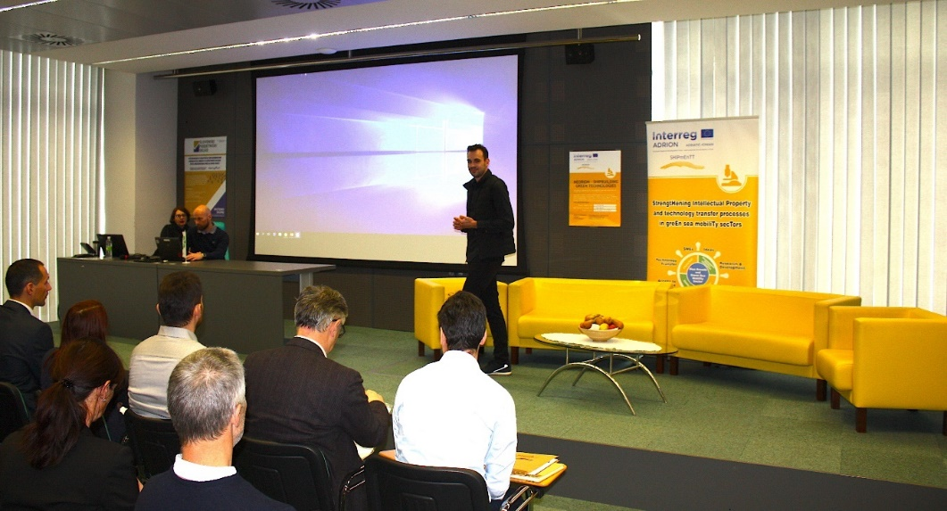
Slika 1: Predstavitev Aleksandra Nemca, Tehnološki park Ljubljana, 5th March 2020
Picture 1: Aleksander Nemec`s presentation, Technology Park Ljubljana, 5th March 2020

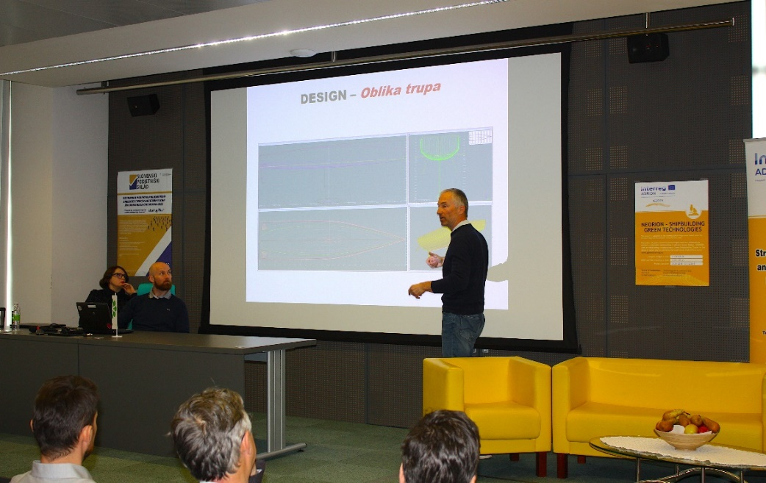
Slika 2: Predstavitev Andreja Justina, Tehnološki park Ljubljana, 5th March 2020
Picture 2: Andrej Justin`s presentation, Technology Park Ljubljana, 5th March 2020

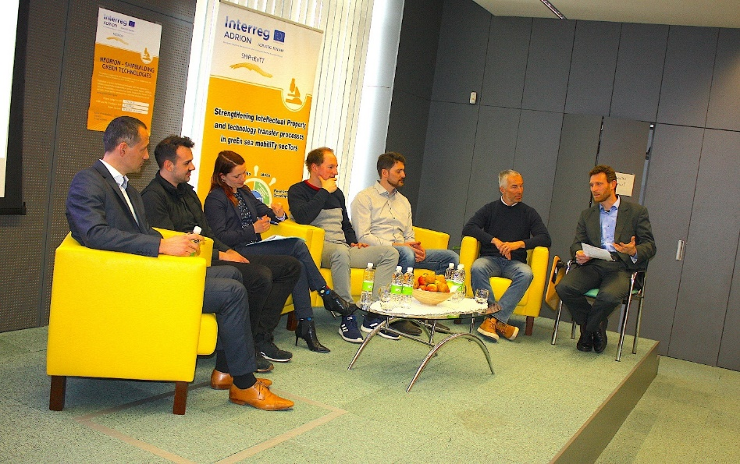

Slika 3: Gostje okrogle mize, Tehnološki park Ljubljana, 5th March 2020
Picture 3: Round table guests, Technology Park Ljubljana, 5th March 2020

English contribution

For those partners who want to share this contribution also in English, do not forget to write & translate into English version, that could be shorter as in local language.
If you send us press release just in local language, a press release will be also published on the web site Neorion with Note (local language).

The event was organized in Technology Park Ljubljana, Slovenia on 5th March 2020. The public invited to the seminar was from broader stakeholder group. Present were entrepreneurs, manufacturers, innovative stakeholders, research organization, academia and also policy makers. The event was organized together for NEORION project as for SHIPmEnTT (both ADRION Interreg programme) in order to combine synergy effects among participants and also with presenters.

After welcome speech of Mr. Jernej Pintar, director of Technology Park Ljubljana professor Mr. Peter Vidmar (Faculty of Maritime studies and transport) presented opportunities of new technology in maritime. It became clear that maritime is heading towards new standards in environment challenge, in digitization and in energy sector.

Ms. Mateja Geder (TechnoCenter University of Maribor) presented innovations in energetics, logistic safety and environmental questions and also SHIPmEnTT project.

Mr. Aleksander Nemec (Pleione R&D ltd.) was presenting his entrepreneurial path from start-up towards global consultant and partner in the field of e-mobility in maritime industry. He presented opportunities and threats when bringing electricity into recreational vessels and bigger boats.

Mr. Andrej Justin (Justin Yacht Design) presented the references of Justin Yacht: Big focus they give to individual relationship and really giving best products and solutions to the partners. In presentation were shown technological solutions and cases when they helped global companies or individual big buyers in finding solutions to optimize boat performance. Additional, future trends and new designs were reviled to the visitors which could this way see future in maritime industry.

Mr. Jaro Žuraj (SIMARINE ltd.) showed the way how no-maritime experts could enter this industry and could even have benefits by not being affected by present industry perception. He with his partner were present in electro digital industry and had no experience in maritime industry. By need when sailing, they realised what is lacking on the market. So they developed application (software and hardware) which was adopted for general mass users of the boats, by simplicity and design. After MVP they found Slovenian partners, which started integrating their products into their boats and this way they enter global market.

Mr. Kristjan Košič (JUNIBA ltd.) was presenting their family innovative product which is also under patent process. It is a solution for sailing boats to mark the movement and location of their anchor. The idea arose in bad conditions in night time while sailing. It is a typical situation, when creativity and users needs arise. With their solution, future boats will sail with less worries. It is interesting how their company too is not from maritime industry but through partnerships they develop solution which is going to be marketable.

Ms. Monika Cvetkov (Technology Park Ljubljana) presented NEORION project from broader perspective, why it is important to proceed with this project and what everything gain stakeholders from it.

At the second part of the event there was a Round table on topic of Green maritime technologies, Innovations in maritime industry, Cooperation among companies and policy. Next to the presenters, there were also present Ms. Katarina Goli (Ministry of infrastructure) and Mr. Anton Habjanič (TehnoCenter University of Maribor). The round table was moderated by Mr. Peter Vidmar.

On ideas and proposals from guests was also pointed out to make more events where stakeholders could meet each other and discuss new potential cooperation in wish to have synergy effects among all stakeholders.

