Sohjoa Last Mile: Kongsberg Pilot Report 2021

Content
Introduction 3
Summary of partner roles in relation to activities 3
Pilot activities 3
Main phases of activities 4
Main results of the activities 8
Wider context of the activities’ achievements 8
Parties affected by the activities 8
Pilot statistics 9
Output results 10
Application processes 10
Output 10
New insights gained from the application processes 12
Evaluation of the application processes 13
Data from the pilot and report on practical aspects 14
Output 14
Insights gained and lessons learned: challenges and adjustments 15
Feedback and results of surveys 18
Obstacles and drivers in the process 23
Discussion of the on-demand transport and success factors of the pilot 25
The on-demand solution 25
Challenges and success factors 26
Summary of recommendations for further development or research topics related to the output 28
Abbreviations 29

Introduction

The Kongsberg pilot represents the Norwegian pilot in the Sohjoa Last Mile project. Fundamentally, its ambition was the same as that of the pilots in Tallinn and Gdansk, namely to provide a fully driverless shuttle service. However, Kongsberg differed from Tallinn and Gdansk in some important aspects, particularly as the autonomous shuttle service that was put in place following the success of the Sohjoa Baltic project was still running and the use of this type of technology was therefore more current.

In this report, we will document the outputs of the pilot with respect to goal attainment, experiences from all its stages, success factors and obstacles that were encountered. Analyses of data collected will form the basis of evaluations and discussions about the pilot’s achievements, as well as barriers that need to be overcome in order to maximise the benefits of the technology.

Summary of partner roles in relation to activities

Kongsberg Municipality as the project owner was involved in all activities, in particular during the early stages of the pilot when its cornerstones and expected outputs were being defined. While Applied Autonomy was contracted to take care of all practical aspects of the pilot, Kongsberg Municipality was informed and had control over the operations at all times.
Applied Autonomy took care of the different steps required to achieve the pilot’s main ambition, namely operation of an autonomous vehicle (AV) without an operator on board. This covered the application process, arranging of the actual operations and different types of administrative work around the pilot. A survey of available technology by Kongsberg Municipality and Applied Autonomy revealed that for operations without an operator on board and without the need for remote driving, EasyMile had the most promising solution. Accordingly, EasyMile was chosen to be the technology provider in the project and as such also took on a role in the different activities as will be further described below. Additional partners in the Kongsberg pilot were public transport operator Brakar and the Norwegian Public Roads Administration (NPRA). These partners also contributed funding to the project, with a view towards furthering their knowledge about the technology and processes. Accordingly, they were regularly updated about the state of the pilot, and actively made suggestions for different aspects of it.

Pilot activities
In order to set the context for the later output sections, we will first put the pilot in context by providing an overview of the pilot activities that were undertaken.

Main phases of activities
The Kongsberg pilot underwent several, partially overlapping phases of activities. A summary of the timeline is given at the end of this section in Figure 2 below. Taking into account all stakeholders’ needs and wishes had to be balanced with adhering to the timeframe set by the project, and adjustments to the original pilot plan were necessary underway. The three main phases of activities can be described as follows:
- Deciding on a route
There were several iterations of finding a suitable route for the pilot, as there were a number of constraints that had to be respected. Starting in February 2021, Applied Autonomy consulted both Kongsberg Municipality as the pilot owner and EasyMile as the technology provider regarding possible route options. For Kongsberg Municipality, the main priority in deciding on a route was its usefulness, both with respect to testing the technology and providing a meaningful transport offer for the citizens of Kongsberg. EasyMile’s main concern was to ensure the safety of the operations, and thus that the route be inside the vehicle’s operational design domain (ODD). As operations without an operator on board were still rather new at the time, the ODD was restricted to closed environments, meaning areas with access control. This allowed to eliminate risks due to possible interactions of the AV with especially vulnerable road users, such as for example unsupervised children. As the only closed environment in Kongsberg is the Kongsberg Technology Park (KTP), it was decided to run the pilot there. This brought with it additional restrictions, as some of the companies in the park are involved in national security and the use of cameras and other sensors is thus not freely allowed in the KTP. Additionally, there are several hills in the park, which were found to be outside the AV’s ODD. The route was therefore restricted to the upper part of the KTP, which is flat and houses both offices and workshops. Additionally, the main visitor’s entrance as well as three further staff entrances and the main canteen are located in this area, providing a mixed and busy environment for the pilot to be run in. Once the general area had been decided, Applied Autonomy consulted with EasyMile about the specific route. Several proposals were made before the route shown in Figure 1 below was agreed upon in April 2021.
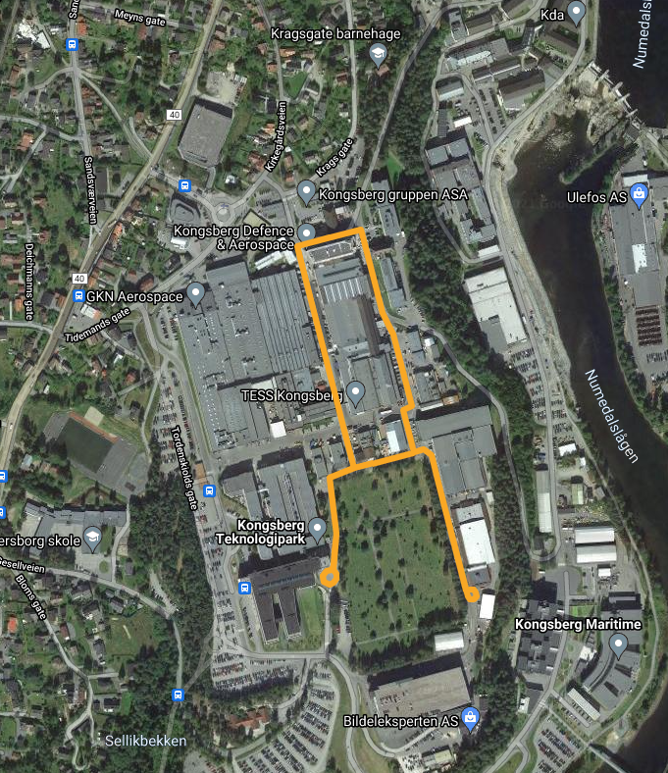
Figure 1: Route of the Kongsberg pilot (shown in yellow)

- Obtaining approval
Approval to operate had to be obtained from multiple stakeholders. The first approval had to be obtained from EasyMile, where internal committees evaluated the proposed routes and gave feedback on critical safety considerations. In a second step, KTP also had to approve the routes and proposed safety measures to ensure that there were no security concerns and that the pilot would not interfere with the usual activities in the park. Additionally, despite KTP being a closed environment, a permit to operate the AV there had to be applied for at the road directorate of the NPRA. Once approval from EasyMile and KTP had been secured, Applied Autonomy sent an application to the Norwegian authorities on 03/05/2021. Limited approval was awarded on 25/05/2021, more details are given in section 4.1.1 Output below.
Once the first round of approvals had been obtained, the pilot preparations could begin. Applied Autonomy arranged the setup of the route, which involved programming the AV on the agreed track and subsequent approval of the mapping by EasyMile. For the necessary infrastructure changes and in particular the setting up of signs, Applied Autonomy received help from KTP. The entire setup was finished on 15/06/2021 and an updated safety report showing pictures of the risk mitigating measures put in place was sent to both EasyMile and the Norwegian authorities. Approval from EasyMile was registered on 17/06/2021. The Norwegian authorities do not give a second approval at this point, the updated safety document serves instead as reference document in the event of an inspection by the authorities, who are free to verify that AV testing is carried out as agreed with the pilot responsible (in this case Applied Autonomy) at any time.
For the final, fully driverless phase of the project, a second application had to be sent to the Norwegian authorities, with approval given on 13/09/2021, and the pilot also had to pass a second round of internal procedures at EasyMile, who approved the operations on 20/09/2021.

- Operating
For the actual pilot operations, there were four phases, all of which took place inside the KTP on the same route:
- Phase 1: Operation with an operator on board
This phase ran from 21/06/2021 until 03/08/2021. There was no operation from 19/07 - 30/07 due to summer holidays. In this first phase, the main emphasis was on testing the programmed route during normal operations in the KTP and to spot any potential conflicts or issues. It also allowed the workers inside the KTP to become acquainted with the AV, and to raise awareness for the project. As at least 100 hours of operating time had to be logged in order to collect enough data and progress to the next phase, the service was not operated as an on-demand service but simply continuously ran along the programmed route, covering all stops. The AV was in service from Monday to Friday from 07:30 until 14:30. These times were chosen to cover the hours when the largest number of employees would potentially make use of the service, especially when arriving at work (three of the bus stops were by entrances to the park) and during lunch time (one of the bus stops was the main canteen).
- Phase 2: Operation with an operator on board and a supervisor in training in the control centre
This phase ran from 06/08/2021 until 27/08/2021. The operator on board was still in charge of the AV, but a newly trained supervisor would follow operations from the control centre to gain experience with monitoring the AV remotely. During this phase, the setup of the control centre could also be tested with respect to the quality of the data provided by the AV’s sensors to the supervisor and also the communication capabilities. The AV ran in the same service pattern as in phase 1 in order to clock up the required minimum 50 hours.
- Phase 3: A supervisor in the control centre and an undercover operator on board
This phase ran from 30/08/2021 until 20/09/2021. In this phase, the supervisor assumed responsibility for the AV and in particular for stopping it in case of situations where the AV did not correctly stop by itself (no such situations occurred). As an added safety measure, the operator was still on board the AV, but acted like a passenger until called upon by the supervisor to instead exert the role of field operator. The undercover operator did not wear their Vy uniform during this phase, such that passengers and other road users inside the KTP were also not aware of there still being an operator on board (although some regular passengers had of course come to know the operators). The AV ran in the same service pattern as in phase 1 in order to clock up the required minimum 50 hours.
- Phase 4: A supervisor in the control centre and a field operator ready to go out and assist the AV
This phase ran from 21/09/2021 until 04/11/2021. There was no more operator on board the AV in this phase, with only the supervisor monitoring the AV from the control centre. The other operator acted as a field operator, meaning an operator ready to reach the shuttle on foot within 5 minutes of the supervisor flagging a need for assistance (for example to assume remote control of the AV to drive it around an obstacle). As there were no more requirements for a minimum number of operating hours, the AV was now operated as an on-demand service, meaning that anyone with access to the KTP could order a journey via a website. The AV therefore only operated when there was an actual need for it, with the additional occasional trip to move the AV out of the way or to a location where it might raise more awareness for the service at a given time of day (entrances/cantine).
During all phases, operators were contracted from Vy to take on the different roles, with a deployment engineer from Applied Autonomy available as backup. During phase 1, when only one operator was needed, different Vy employees operated the AV. All of them were already experienced with the AV from operating the same type of vehicle on the Kongsberg bus route 450, the autonomous bus service resulting from the Sohjoa Baltic project. In order to take on the role of supervisor and field operator, additional training was provided by EasyMile for two Vy employees and one of Applied Autonomy’s deployment engineers. The training ran on 04/08 and 05/08 at the premises inside the KTP and covered the correct use of tools, communication protocols between the supervisor and the field operator, as well as the correct logging of incidents during operations. The three people qualified as supervisors were then the only operators allowed to work with the AV during phases 2-4.
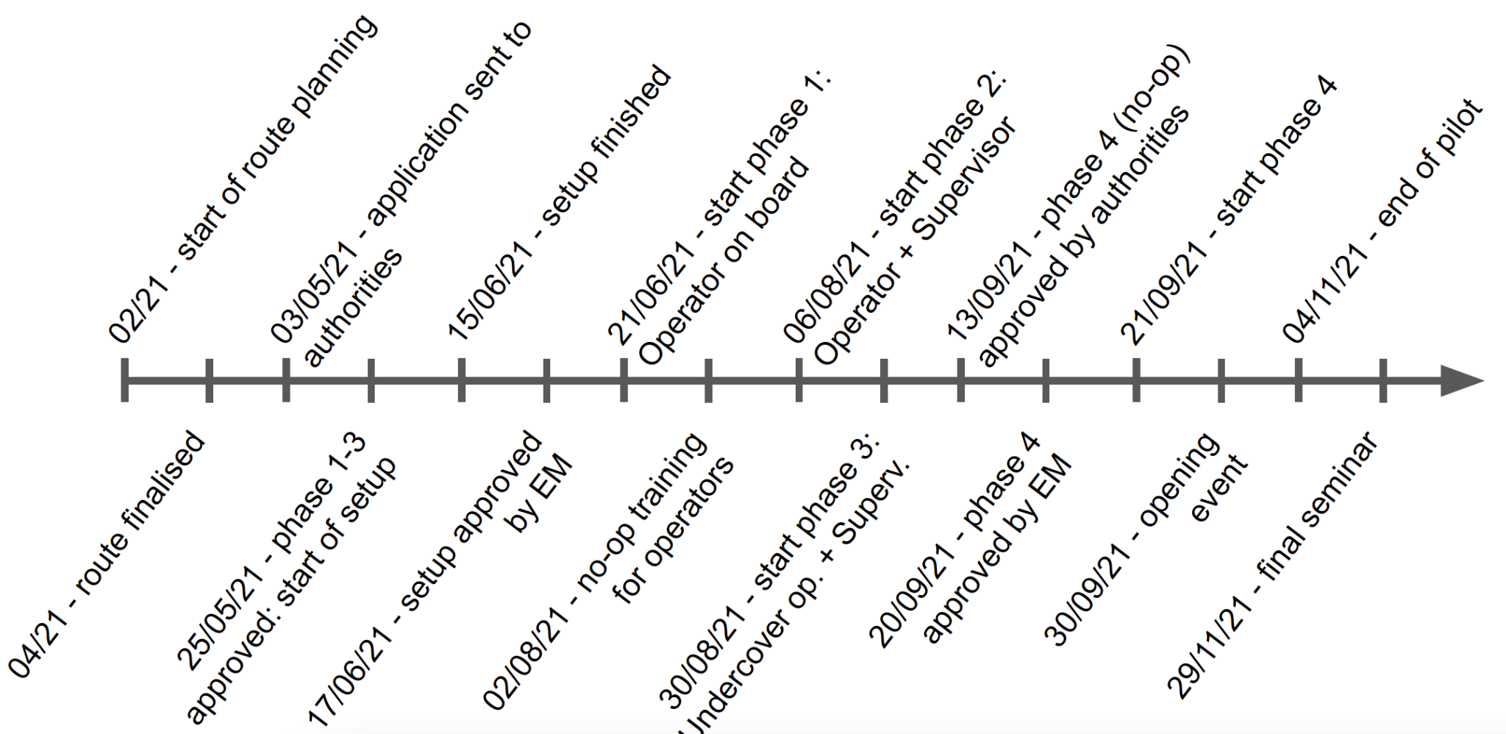
Figure 2: Timeline of the main activities and events

Main results of the activities
The activities thus described had effects beyond the impact on immediately involved process participants. We will now outline these, and also provide data on the most imminent result of the aforementioned activities: the passenger numbers.

Wider context of the activities’ achievements
The main achievement of the pilot was to demonstrate operations of an AV without an operator on board in a real-life setup and traffic situation. As the first pilot of its kind in Norway and also one of the first projects of this kind for the technology provider EasyMile, it also gave valuable insights and experiences into the application processes and daily operation challenges for this type of pilot. Furthermore, it exposed the public in Kongsberg to a new type of AV operation and allowed to collect data on the experiences of both passengers and road users who came into contact with the AV. Thanks to a dedicated opening event at the beginning of phase 4 and various communication efforts, awareness about the demonstrated technological progress was raised throughout the stakeholder chain.

Parties affected by the activities
Immediately affected by the pilot were of course the employees and visitors in the KTP who directly interacted with the AV throughout the different phases. They had the opportunity to try out the service and ask questions, and were also the first to report any potential issues with the AV operating alongside the usual industrial processes inside the park. Most employees and visitors of the park are not allowed to enter with their own vehicles and bicycles and scooters are not permitted in the park at all, which means that people usually walk from the entrances to their places of work and to and from the canteen. Operating an AV inside the park therefore provided a new service and way of moving around.
All other parties involved in the pilot, either directly or indirectly, were also affected by the project as it provided a unique and in many cases first learning opportunity. For Applied Autonomy, Brakar, the NPRA and Vy, their first-hand involvement in the pilot gave valuable insights into the unique challenges of fully driverless operations and created an understanding of both the current technological limitations and their consequences. For EasyMile, the pilot represented an additional use case for a newly developed technology and an opportunity to receive feedback from a different type of users. Finally, the Norwegian authorities (the road directorate of the NPRA, who issue test permits for AV pilots), for whom this was the first time that they were granting a permit for testing fully driverless passenger transport, used the pilot to establish a new baseline for future, similar pilots.

Pilot statistics
The table below lists the essential statistics of the pilot, both for phases 1-3 and phase 4 to reflect the fact that phase 4 employed an on-demand solution and the AV was thus only operating when needed.
 | Phases 1-3 (14.06.2021 - 20.09.2021) | Phase 4 (21.09.2021 - 04.11.2021)
Maximum speed allowed on the route | 11 km/h
Length of the route | 1.7 km | Varying: trip length
Realisation of the planned schedule of operation | No schedule | On-demand:up to 2 minutes timing delay
Distance between the garage and the actual route | 2.4 km
Amount of energy used | 11.2 kWh / day | 10.6 kWh / day
Number of bus stops and distance between the stops | 10 stops, on average 108 m between stops
While in phases 1-3 there was no schedule of operation (the AV just drove around on the track as much as possible in order to generate data for the KPIs), the schedule in phase 4 was dictated by the passenger ordering the trip. Within this schedule, delays of up to two minutes were possible for both pick-up and drop-off times. This was due to the dispatching system assuming clear paths for the AV, while in reality there may have been some slowing down or stops due to other vehicles or obstacles.
The energy consumption of the AV is dictated by the same factors as that of all electric vehicles: starting from standstill, sharp braking and climate control are the biggest sources of energy consumption aside from normal driving. Given the time of year, the slightly higher energy consumption in phases 1-3 could therefore be due to a slightly higher use of climate control, but is likely also due to a larger number of stops and emergency stops in the early stages of the pilot, before service-improving adjustments were made.

Output results
In this main section of the report, we will present and evaluate the outputs of the pilot. We will provide details of the application processes along with new insights gained and present data collected from the pilot operations in order to discuss goal attainment, obstacles and success factors. We will also provide details of the on-demand solution and lessons learnt.

Application processes
A major added value of the pilot were the procedures and results of the different application processes. In this section, we will first document both the application process in relation to legislation and the experiences from the service in traffic in more detail and then also discuss whether the permissions were necessary requirements, along with some suggestions for improvements.

Output
A first output of the pilot is a newly gained understanding of the application processes required for achieving fully driverless operations. In practical terms, there were two main stakeholders who had to express their approval: The NPRA’s road directorate on the one hand and EasyMile on the other hand.
EasyMile as the technology provider requires as part of their procedures that any pilot that utilises one of their AVs is carefully evaluated and assessed for safety, in order to ensure as smooth and safe operations as possible. Pilots that involve particularly risky aspects and all fully driverless pilots have to be approved by an internal project risk committee (PRC). The PRC had to give approval before the start of phases 1, 3 and 4. Approval before phase 1 was contingent on finding a setup and route inside the AV’s ODD, while approval for phases 3 and 4 required a number of key performance indicators (KPIs) to be met. Applied Autonomy submitted a Site Visit Report to formally start the discussions with EasyMile, the report showing the envisaged pilot in broad brushstrokes. Based on the Site Visit Report, a Site Assessment Report was then produced, giving a full overview and risk analysis of the proposed operations, as well as detailing risk mitigating measures that were proposed to be put in place. The Site Assessment Report formed the basis for EasyMile’s approval to start operating phase 1. The table below lists the KPIs along with the values required for progressing into each next pilot phase:
KPI | Acceptable value
# Localisation issues + # of trajectory deviations | 0
# Interventions by operator (manual emergency stop, soft stop, manual switch...) due to a risk situation | 0
# Passenger incidents (manual interventions by passengers, inappropriate behaviour) | 0
# of AV inappropriate or dangerous behaviour at intersections | 0
# Unexplained emergency stops in autonomous mode | 0
Frequency of all emergency stops in autonomous mode | < 0.1/hour
# Interactions with other vehicles per hour of service | < 3/hour
# Manual interventions from Safety op at intersections | 0
In order to record the KPIs and also to monitor the operations, the operators were therefore required to fill in an events log provided by EasyMile.
In the summary drawn at the end of phase 3, it was concluded that the pilot fulfilled all the KPIs set with two exceptions: There was one unexplained emergency stop in autonomous mode, and there were more than 3 recorded interactions with other vehicles per hour of service. The emergency stop was accepted by the PRC on condition that the data would be analysed more thoroughly. The interactions with other vehicles were, for the vast majority, either due to incorrectly parked vehicles or delivery vehicles parked correctly but on the path of the AV (more on this in section 4.2.2 Insights gained and lessons learned: challenges and adjustments below). The PRC could be convinced that these interactions and resulting switch to manual mode were annoying to passengers but not a danger per se. A compromise was found whereby the PRC would accept this KPI, but that it would be reduced by stopping the fully autonomous service (and switching back to a service with operator on board) in case there was a vehicle parked on the AV’s trajectory for a longer duration (for example for a big unloading/loading procedure).
Once EasyMile had approved the start of phase 1, an application could be sent to the road directorate of the NPRA, who issue the permits required for all tests with AVs transporting passengers. As for previous projects, the application had to comprise a safety assessment of the route (for which the safety assessment provided to and approved by EasyMile could be used), as well as written agreement by the owners of the land on which the pilot was to take place (in this case KTP, who approved not only the route but also the number and type of warning signs that were put in place). After an initial assessment, the road directorate raised some questions, emailed directly to Applied Autonomy as the applicant for the permit. In the following dialogue, Applied Autonomy provided further details on the project and its ambitions, outlining the role of passenger surveys and envisaged sharing of lessons learnt, but also commenting on practical aspects such as the precise nature of the warning signs to be put in place.
Due to the pilot being the first of its kind, the road directorate decided to award a partial permit covering only phases 1-3, i.e., the phases where there would still be an operator on board. They asked for an intermediate report at the end of phase 3 along with supporting data before they would consider approving operations in phase 4. While this allowed the pilot to start, the proposed procedure was problematic: With the pilot being strictly limited in time, both for budget reasons and to avoid driving on snow, which was deemed outside the ODD for fully driverless operations at that point, it was not going to be possible to interrupt the pilot after phase 3 and wait for further approval before commencing phase 4. While the road directorate has fairly short processing times (normally approval is given within a month of applying), a delay of several weeks would have severely impacted the project and dramatically reduced the time spent operating in phase 4 which was, after all, the whole aim of the project. It was therefore argued that phases 2 and 3 were not too dissimilar with respect to the operational setup, such that the essential data and preliminary observations to be delivered could also be provided after phase 2. Accordingly, a report and an updated application were sent to the authorities on 26/08/2021 and a permit for phase 4 was issued on 13/09/2021 without further comments.

New insights gained from the application processes
The application processes described above were essentially new to all involved actors: Applied Autonomy and the Norwegian authorities had never worked on a fully driverless pilot, while EasyMile had never run such a pilot in Norway. While there was a good foundation of pilots to build on, such as a previous pilot in Testarena Kongsberg that saw the operator walking alongside the shuttle instead of being on board in the pedestrian zone, the distance between the operator and the shuttle was a big step forward. This was also the reason for the continued involvement of EasyMile in the pilot and the multiple rounds of approvals. Crucially, the operator did not have the vehicle directly in sight but monitored it via the AV’s three cameras (showing the areas in front of, behind, and inside the AV), and the switch to manual mode required the field operator to reach the vehicle first. This last aspect was criticised by the authorities, who felt that the AV blocking the road due to not being able to circumvent obstacles by itself would lead to a disruption in the flow of traffic and therefore potentially dangerous situations. They therefore made it a requirement in their approval that an operator be able to reach the AV within 5 minutes at any time.
In order to present the project and the processes leading up to the beginning of phase 4, an opening event and workshop were held on 30/09/2021 (a week into phase 4).
The event contributed to increasing awareness about the Sohjoa Last Mile project in general and the Kongsberg pilot in particular, with several speakers providing background to the state of driverless public transport and the need for national and international collaboration across both public and private actors in this field. Both the Mayor of Kongsberg and the head of the County Council for Transport attended the event and officially opened the service (see figure 3).

In the workshop that followed the opening under the umbrella of Testarena Kongsberg, more details about the pilot were provided, including the legislative background. The need for streamlining and making this legislation applicable to fully scaled autonomous transport services was underlined both by the pilot participants, as well as stakeholders from different parts of the public transport value chain. Topics that were discussed included visions for the autonomous public transport of the future, who would benefit from it in what way and whether increasing automation requires a new view on the legal processes involved, how autonomous transport might be utilised in more rural mountainous regions or as part of logistics processes in ports and other industrial environments, and how the technological developments can be advanced as quickly as possible.
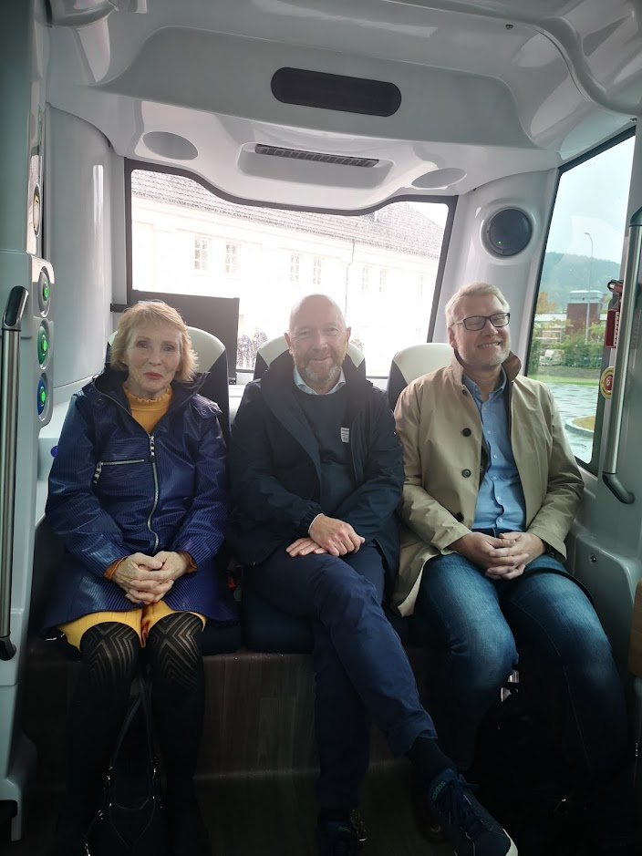
Figure 3: The mayor of Kongsberg (far left) on the AV at the opening event

Evaluation of the application processes
The application process for this project was not as linear as for previous projects with AVs in Norway, and in particular projects involving EasyMile vehicles. Both before and after the submission of any applications, a lot of discussions were had with the different process participants. This required and benefitted from good established communication pipelines, especially between Applied Autonomy and EasyMile and also Applied Autonomy and the Norwegian authorities.
Having to go through several rounds of applications for the different phases of the project was an additional burden on the pilot operations. This was partially due to the additional effort this entailed, but mostly due to the different time constraints. Each time a new approval had to be sought, this brought with it processing time and thus some waiting before progress could be made. Additionally, having different stages and pass criteria meant that the pilot was constantly at risk of not meeting its final goal of operating in phase 4, which created a lot of uncertainty at the various stakeholders involved.
In hindsight, this process could have been handled differently. Both the Norwegian authorities and EasyMile were in fact willing to allow for some leeway (submission of a report and data after phase 2 instead of phase 3 in the case of the Norwegian authorities, willingness to disregard estops that were due to programming bugs in the KPIs in the case of EasyMile), which significantly contributed to the success of the pilot. In view of this, it was perhaps not necessary to impose as strict requirements as were put in place, especially as they did not actually add to the safety of the service but in some cases simply increased passenger comfort. A recommendation would be to have a more open dialogue and closer collaboration between the partners applying for permits and those granting them, so that a realistic and useful set of criteria can be employed to ensure the safety of the operations throughout the pilot.

Data from the pilot and report on practical aspects
As mentioned in section 3.1 Main phases of activities above, the pilot underwent several phases before finally achieving the desired fully driverless operations. We will now analyse the performance of the service throughout the entire pilot and discuss critical practical aspects of the pilot as a whole.

Output
The pilot’s goal had been to achieve 80% operating time in fully autonomous mode, meaning in phase 4. The table below shows operational data, including the percentage of autonomous mode, in phases 1-3 and in phase 4:
 | Phases 1-3 (14.06.2021 - 20.09.2021) | Phase 4 (21.09.2021 - 04.11.2021)
Operating hours/day (planned) | 7.5 hours per day incl. setup and shutdown
Operating hours/day (actual, average) | 6.7 | 7.5
Kilometers driven | 1628 | 358
Number of trips | N/A: no timetable | 163
Number of passengers | 46 | 112
Maximum speed achieved | 11.7 | 11.5
Average speed achieved | 6.7 | 6.7
Time spent in autonomous mode | 93.2% | 89.3%
Time spent in manual mode | 6.8% | 8.7%
Number of emergency stops made in autonomous mode | 241 | 59
Number of interventions by an Operator | 473 | 25
Number of emergency stops of the vehicle made by an Operator | 0 | 0
First and foremost, it can be seen that the 80% autonomous operation mode was successfully achieved. The drop in time spent in autonomous mode when going from phase 3 to phase 4 was to be expected: This is due to the vehicle dropping out of autonomous mode when performing an emergency stop. Where the time to re-enter autonomous mode is rather short when there is an operator on board (in whatever capacity), the AV spends more time in manual mode when the supervisor could not confirm that operations could be continued safely and the field operator has to reach it first before being able to check or solve the situation and re-activating the autonomous mode.
That the average operating hours per day were lower in phases 1-3 than in phase 4 was due to some technical difficulties which lead to the AV having several days of downtime. Additionally, some time was lost due to bad weather conditions, which meant that the service had to be cut short. The number of trips, which was not a meaningful measure to record in phases 1-3, can be seen to be higher than the number of passengers in phase 4. This was due to the AV doing a number of “empty” trips which were ordered not by passengers but from the control centre in order to move the AV between locations inside the KTP. For example, the AV was parked close to an entrance at the beginning of the day, to encourage workers entering the park to take the AV. Towards lunch time, the AV was usually sent on an “empty trip” to the canteen, to maximise its visibility and entice passengers to order a trip.
Both the number of emergency stops and of interventions decreased significantly over the course of the pilot. This was largely due to adjustments made to the route on the one hand, and improved parking behaviour on the other. The following section will explain these phenomena in more detail.

Insights gained and lessons learned: challenges and adjustments
The biggest cause for having to interrupt the fully autonomous operations and switch over to manual were cars parked on the AV’s path. On the one hand, these were cars that were parked outside the designated parking areas. KTP was consulted about this problem as their security services normally deal with illegal parking (also with a view to safety, as escape and access routes for emergency vehicles should never be blocked). It was agreed that the operators would talk to drivers where possible to ask them to move their cars, attach flyers explaining that the car is in the way of the AV, and finally inform the security services about cars they saw repeatedly parked incorrectly. This combined approach led to a strong decrease in the number of incidents and is arguably what affected the rising proportion of time spent in fully autonomous mode the most. On the other hand, the AV’s path was on occasion also blocked by delivery vehicles which are permitted to stand outside the marked parking zones in order to load/unload goods for the various businesses and activities in the park. As deliveries are part of the normal operations of a technology park, this could not be changed or adjusted. Additionally, deliveries are somewhat unpredictable in timing, both with respect to when they occur and how long they might last. In order to increase the level of service, it was therefore decided to not continue with fully driverless operations when a delivery vehicle was blocking the AV’s path and it could be expected that a manual intervention would be needed every time the AV would pass this time. Once the obstacle was gone, fully autonomous operations could be resumed.
There were a number of adjustments that had to be made during the pilot. Some adjustments were made following the surveillance plans, other adjustments were made following the discovery of some issues in the operations. There were some minor adjustments, such as the repositioning of warning signs in order to ensure sufficient clearance when large industrial vehicles manoeuvred around them, but also some more important adjustments such as the tweaking of the AV’s path. These were made only after several weeks of operations, when the operators became sufficiently familiar with the route that they picked up on certain areas where the shuttle would slow down due to close proximity to other objects along the path or due to an uneven bit of road surface. Adjustments were therefore small, often amounting to shifting the path by only a few centimetres, but had a significant impact on the smoothness of the operations. Being able to make this sort of adjustment requires non-negligible efforts (taking the time to detect issues, having personnel which is experienced enough to make suggestions for solutions, having personnel able to make the adjustments), but especially for longer projects it is worth the investment. The path changes were mapped by Applied Autonomy and approved by EasyMile before being put in place. Some temporary adjustments were also made in order to accommodate different events in the KTP, such as road resurfacing or the planned closure of parts of the route due to special deliveries and similar events. These did not require approval by EasyMile but could simply be made using the control centre, which allowed to take selected bus stops temporarily out of service.
As will also be discussed in section 4.2.3 Feedback and results of surveys below, an important aspect of the operations was the fully autonomous crossing of pedestrian crossings. The AV had been programmed to respect pedestrian crossings, meaning it would stop in front of a crossing if an object was detected within a defined bounding box. While this method is safe, it does not differentiate between a human road user intending to cross the road and two pedestrians standing by the side of the road, facing away from it and chatting. From a road user’s point of view, it is also difficult to fully understand the AV’s behaviour because the bounding box is not visible. One one occasion, a bounding box was expanded after a road user complained that the AV had not stopped at a pedestrian crossing when the road user had clearly intended to cross the road. This is an example of a level of uncertainty that could be dramatically reduced if the AV communicated more clearly about what it detects and decides to do, and if road users were more used to and educated about common behaviours of AVs.
A big part of the operations of phases 2-4 was the control centre. The control centre or control room was set in one of Applied Autonomy’s offices inside the KTP. This allowed the operators to immediately reach out to Applied Autonomy when there was a need for support, and also allowed the supervisor and field operator in phase 4 to share a space when the field operator was not needed outside. This made the work significantly more pleasant for them. The setup in the control centre comprised a laptop, a wide angle screen, a headset, and external mouse and keyboard (see figure 4).The bigger separate screen was used to show the map with the AV’s position and feeds from the cameras inside the AV at all times, while the smaller laptop screen was used to access the log file and journey booking system (for the on-demand service of phase 4 only).
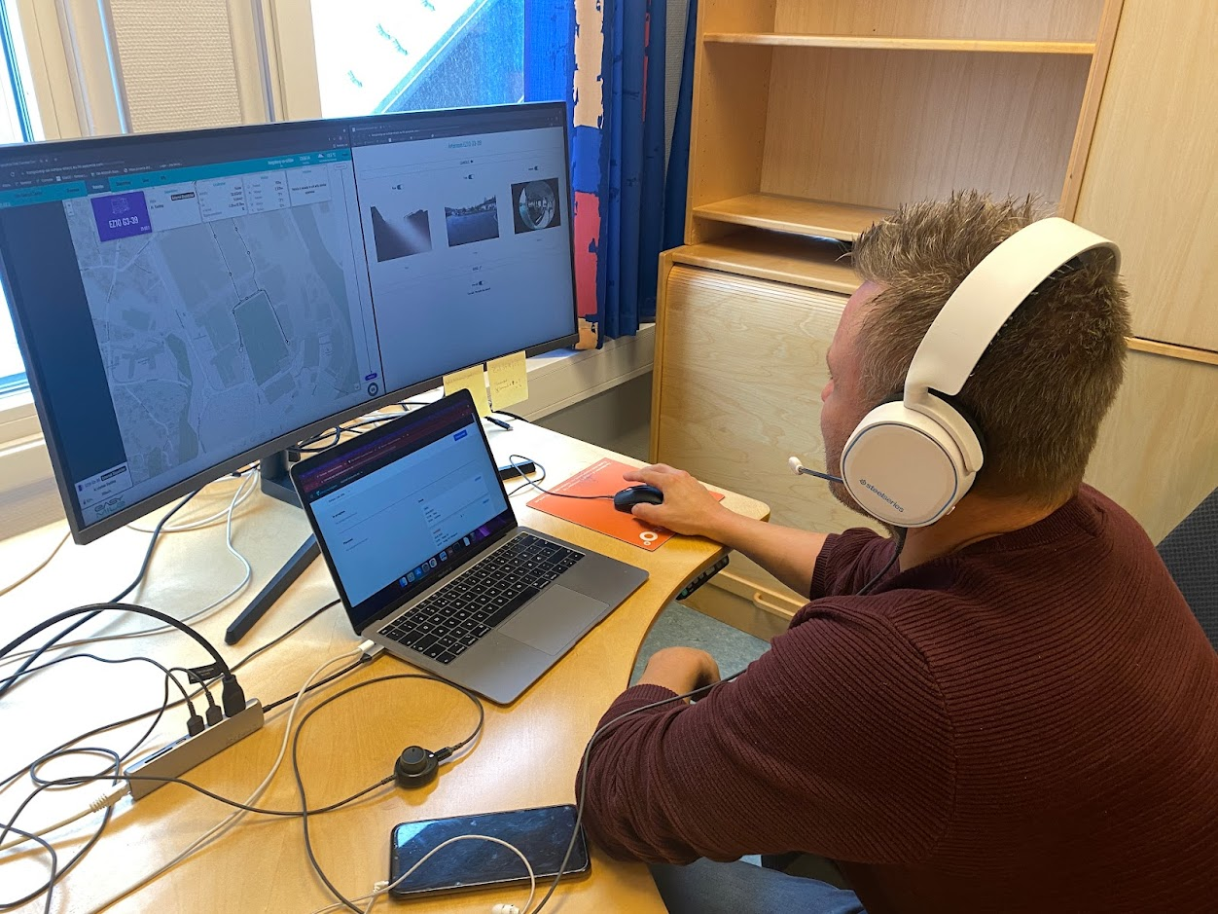
Figure 4: One of the operators in the control centre
The internet connection between the AV and the control centre was crucial to the operations: Both the camera feeds and the remote controlled functions (such as the supervisor stopping the AV) required stable and reliable connections. When setting up the control centre, the network connection was first provided via Applied Autonomy’s network, which uses 5G. It was then discovered that EasyMile requires the network that the AV connects to to use full-cone NAT in order to stream the videos correctly, while the network in place was set up with symmetric NAT instead. A quick workaround was established by using a VPN, which however introduced noticeable latencies, and a mobile 5G router was temporarily used as well before the network protocols could be fixed. The mobile router and final solution worked well and provided a stable connection. This illustrates how the digital infrastructure influences the physical operations.
It should be noted that streaming camera feeds from three cameras, as well as a high-resolution location map results in significant data volumes being transferred. If the type of setup used was to be scaled to a fleet with a large number of vehicles, a supervisor following all camera feeds from all vehicles would not just lead to cognitive overload of the supervisor but also rapidly become technologically infeasible due to limited bandwidth. It should be kept in mind though that the present pilot was the very first of its kind in Norway, and that it is to be expected that as the technology matures and trust is built, the supervisor will not have to continuously watch a camera feed but only switch on the cameras when the AV requires it.
At no point did the 5G functionality or any other network related feature lead to any downtime of the AV. However, it was found that the cameras on the AV were not suitable for providing enough information to the supervisor in all conditions: There were a few issues with the camera feed freezing (not necessarily on all three cameras simultaneously, and with the map being unaffected, ruling out a network issue), the root cause of which was never identified as the issue became less and less frequent and could not be reproduced. Additionally, it was found that the built-in cameras were not able to cope with more challenging light conditions, and in particular bright sunlight. This was raised as a concern to EasyMile, who have since developed an improved camera solution. Unfortunately, the time frame of the pilot did not permit testing this. Naturally, as soon as any camera issue was detected, the fully driverless operations were changed back to driving with an operator on board immediately.

Feedback and results of surveys
The high availability of the service meant that there were no complaints from the passengers about the service being unreliable. Then again, with the service being free and operable even when a fully driverless service was not possible or desirable, it is doubtful that the passengers would have complained even if the availability had been lower.
A passenger survey was conducted during phase 4 of the pilot, as the main interest was in analysing opinions about a fully driverless service. Efforts were made to encourage as many people as possible to both try out the service and also to fill in the survey, with notices inside the AV and a link to the survey becoming available for every passenger who had ordered a trip. Employees of the KTP were also emailed information, and gift cards were randomly hidden on the bus in order to further incentivise people. The survey revealed that all surveyed passengers felt either safe or very safe on board the AV, and that all had a good or very good experience:

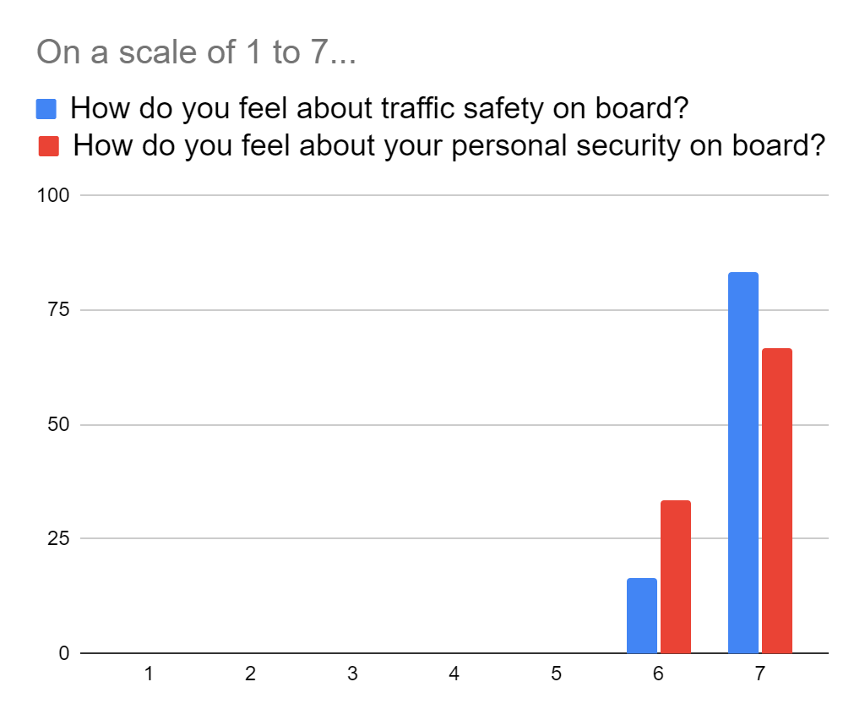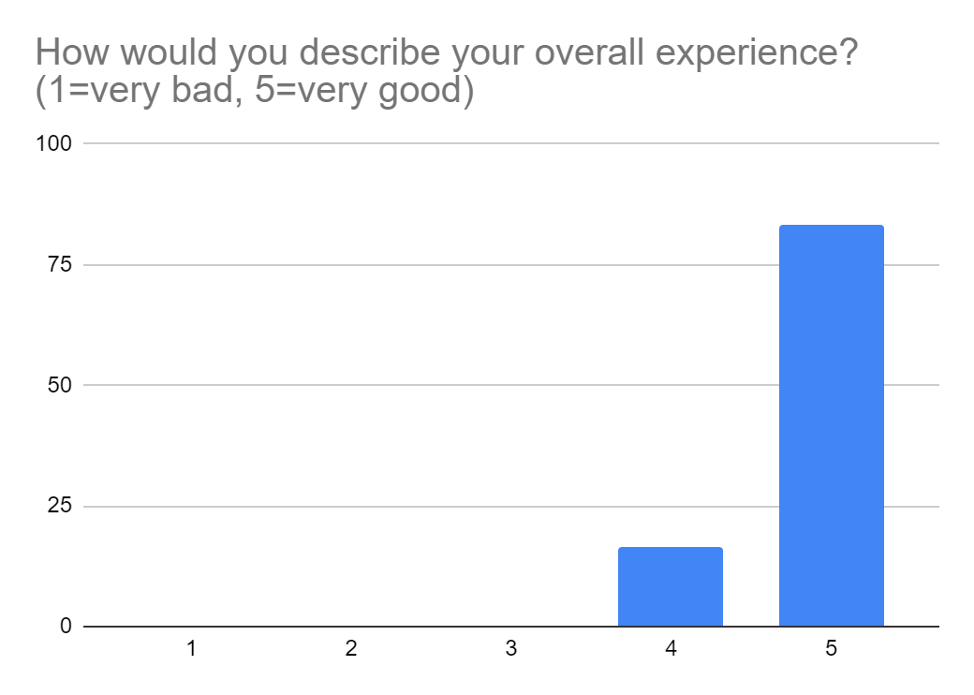
Passengers were further surveyed regarding the behaviour of the bus, such as its communication when arriving at a bus stop, how they would use such a service if it were permanently available, and about their interactions with the supervisor or remote operator.
The majority of people felt safe enough with the technology that they would use the AV even without a remote operator supervising it. Similarly, having a phone number or an on-board phone was deemed sufficient means for communicating with the remote operator by most, which can be read as a sign that people are content with a lower level of contact than a video call would have provided. However, passengers wanted to be informed about the mode the AV is in (automatic or manual). Given the recorded levels of subjective safety, it can be asserted that this is more due to the passenger’s curiosity rather than any safety concerns.
When asked for other feedback or any wishes for future driverless AV services, the passengers indicated that they wanted the service to run at higher speed, and be generally more efficient.
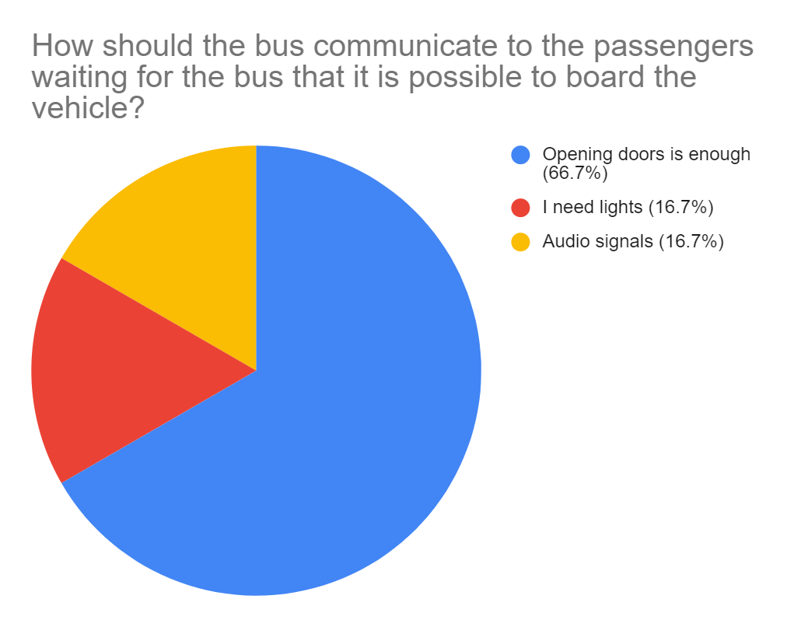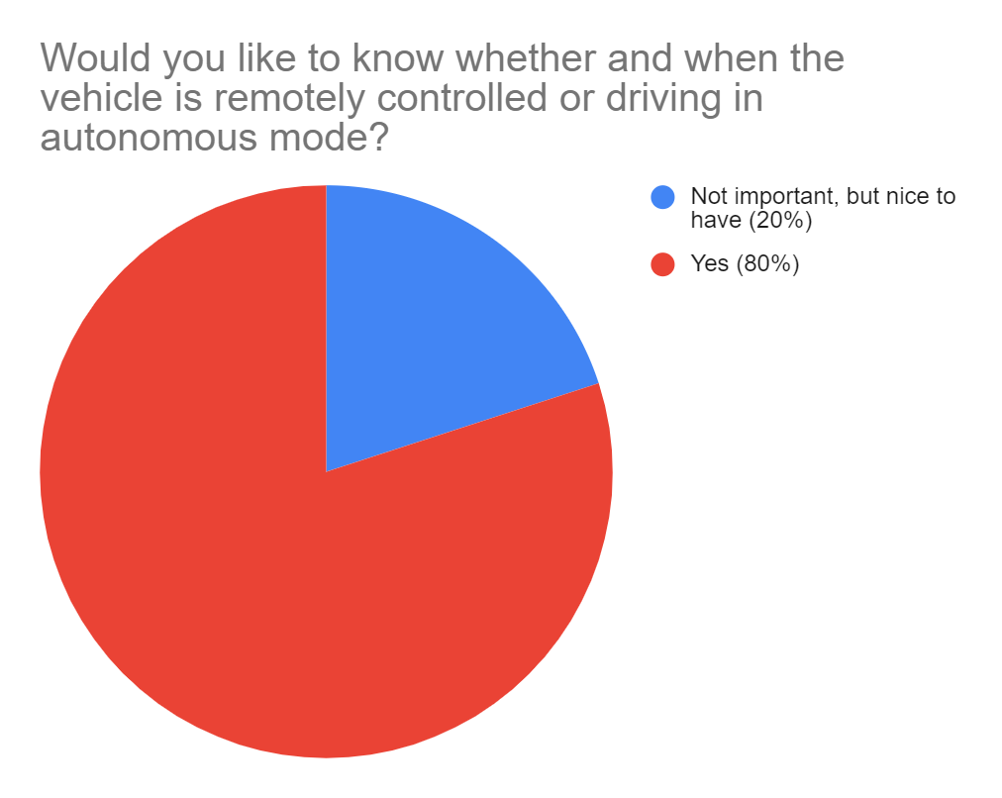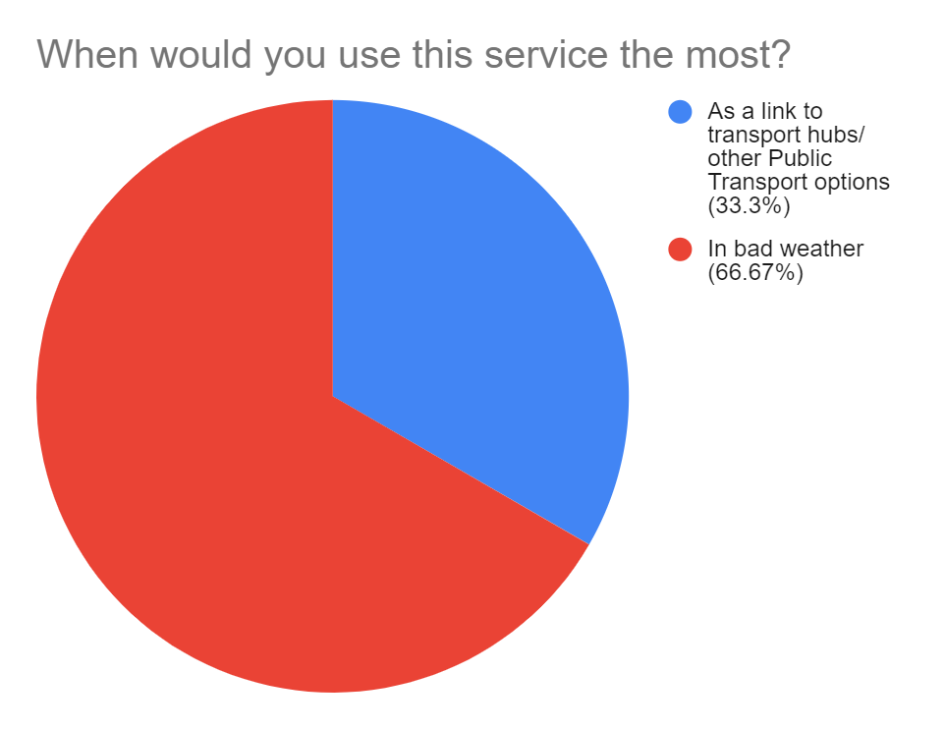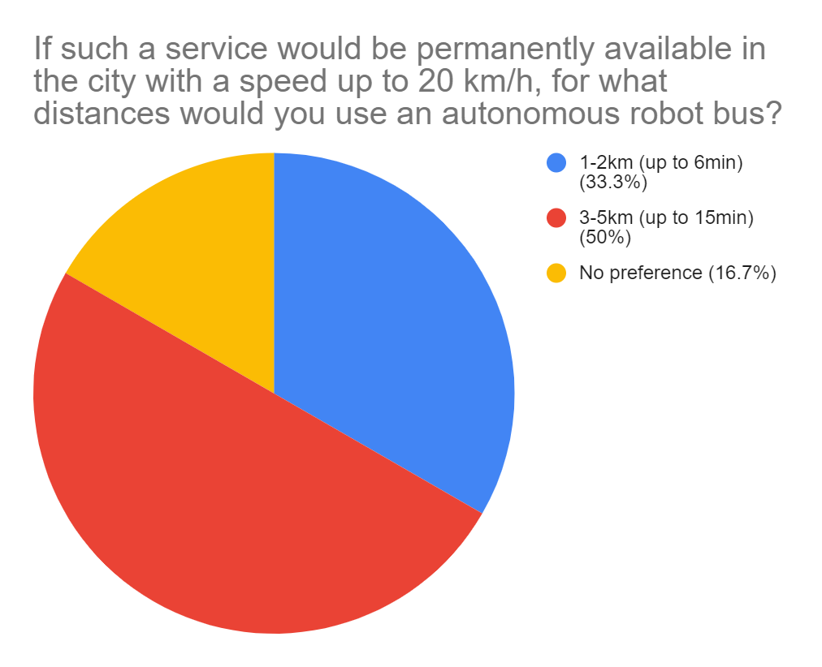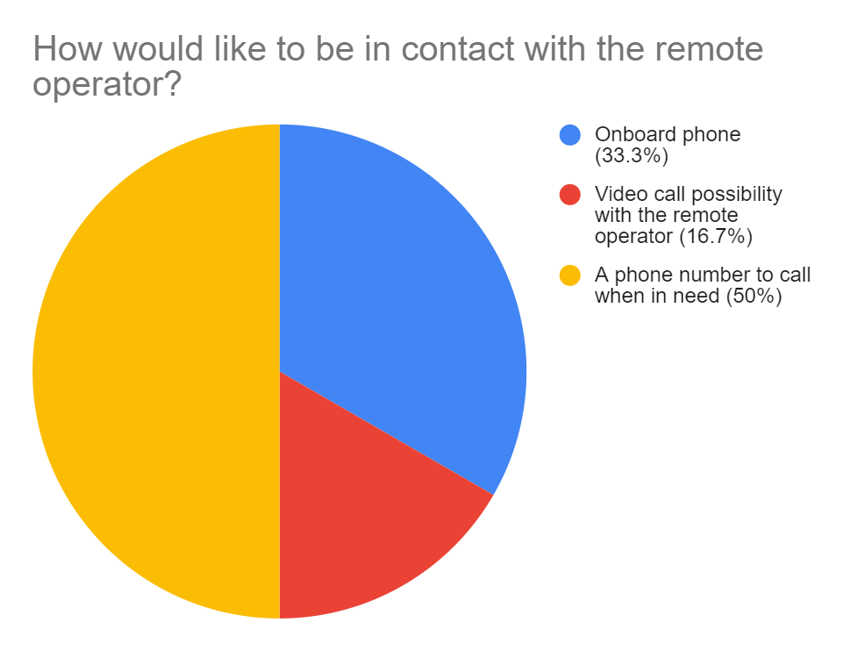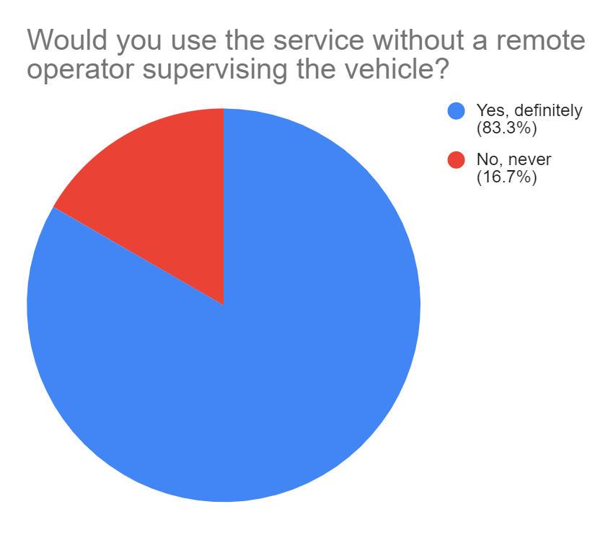
Given that nobody was forced to use the AV, the results of the passenger survey reflect the opinions of people who were perhaps already somewhat positively minded about the AV, or at least curious about testing the technology. In order to provide a second point of view, a second survey was therefore conducted, this time aimed at road users who came into contact with the AV while for example driving or walking in the park, but who did not use the shuttle. As shown in the survey results below, these road users were more critical of the service and the AV:
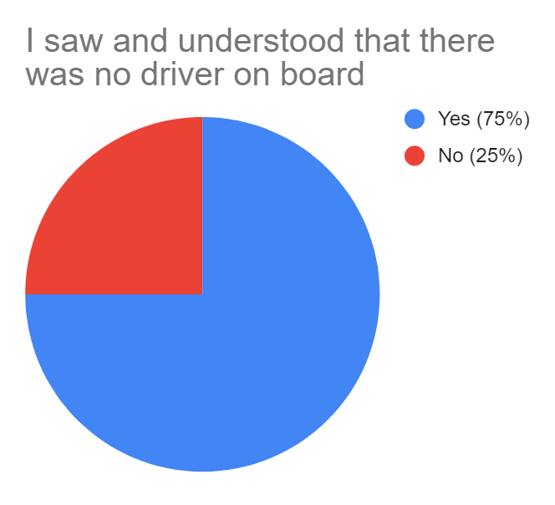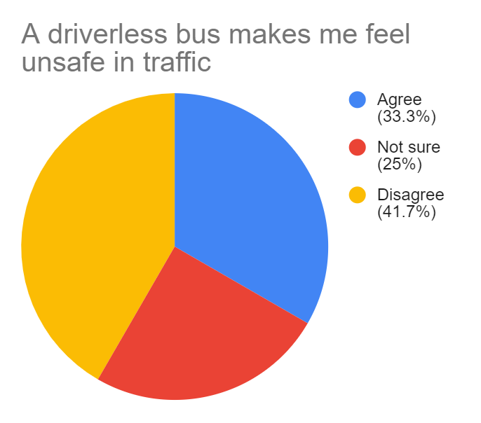
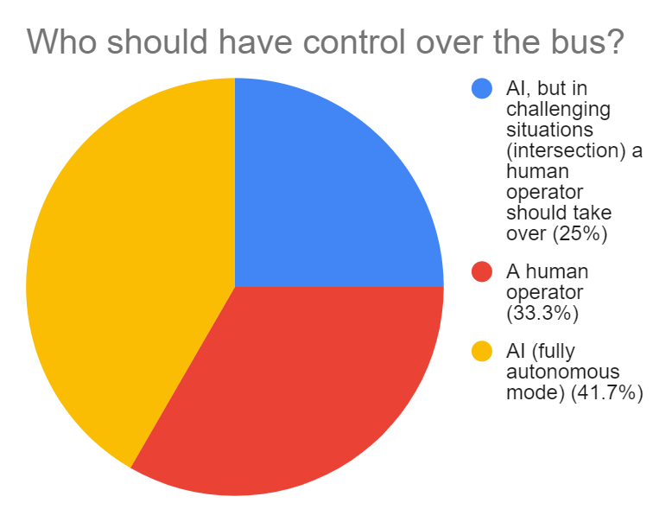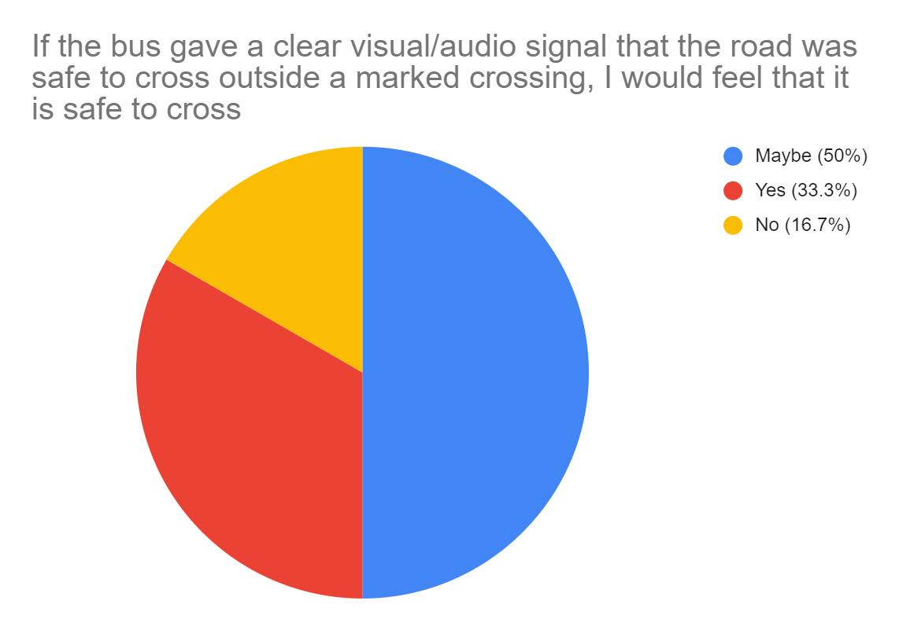
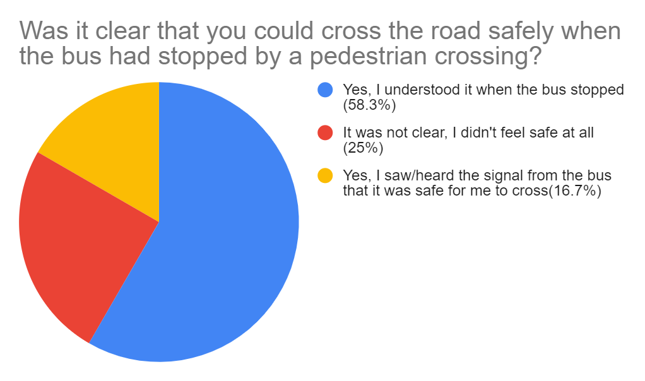
Road users who were not passengers were generally more weary of the bus, with a third feeling less safe in traffic because of it. Nonetheless, the majority felt that an AI should have control over the bus instead of a human operator, and would cross the road in front of the bus if given a clear indication that it was safe to do so. It appears that communication between the AV and other road users needs some improvements, which was also reflected in the open questions at the end of the survey. Here, several road users said that they wanted clearer signals from the bus, both at pedestrian crossings and in general. They also echoed the passengers’ opinion that the bus should go faster. There was a wide spectrum of opinions about autonomous passenger transport in general, with some people expressing doubts as to the usefulness of the technology and outright rejecting it, while others welcomed it and said they had no criticisms.
As mentioned in section 2 Summary of partner roles in relation to activities above, regular meetings were held with different stakeholders in the public transport ecosystem over the course of the pilot, in particular public transport authority NPRA and public transport operator Brakar. Both of these project participants had previous experience with AV pilots, and contributed valuable insights and comments to the project. From the NPRA’s perspective, the application processes were of particular interest, as projects like the present pilot serve to build knowledge that is to be shared on a larger scale. They provided a wider perspective to the pilot, pointing out processes that should ultimately not just be streamlined but also automated as much as possible, such as approval of certain classes of routes not just by the Norwegian authorities but also by the technology providers. Brakar, on the other hand, contributed an important perspective on the economic sustainability of fully autonomous AV services. Their observations and comments are crucial feedback for future ambitions to convert pilots into sustained, long-term transport offers. While they welcomed the progress in removing the operator from the AV, paving the way for larger scale operations with fewer operators than vehicles, they criticised the limitations of the AV’s ODD, pointing out that improvements will have to be made quickly in order for the technology to stay relevant.
This sentiment was also shared by the two Vy employees who acted as the main operators of the pilot. When interviewed at the end of the pilot, they stated that they enjoyed working on the project and with the technology, but felt that known problems would have to be solved before the pilot could be expanded into a permanent service. They were particularly concerned by the quality of the cameras on the AV, which they deemed inadequate, and asserted that the use of an automated overtaking function would have led to a smoother service and higher percentage of driving time in autonomous mode. Such an overtaking function is already available for services with an operator on board, but was not activated in this fully driverless service as the current camera setup did not permit the supervisor to have a sufficiently good of the situation to validate an automatic manoeuvre for driving past an obstacle. As mentioned in section 4.2.2. Insights gained and lessons learned: challenges and adjustments above, an improved solution has since been developed but could not be tested during the course of this pilot. Overall, the operators felt that the service was safe and were confident that the vehicle would stop for any obstacles, even if there were a sudden camera problem such that the supervisor could not be relied on. They suggested a number of improvements, such as a reduction of the detection clearance in front of the vehicle (which makes it possible to drive over objects less than 30cm high) and a better communication system in the AV, as the current microphone/speaker setup occasionally led to echoing or feedback. In line with what was found out in the passenger surveys, they also pointed out that communication between the AV and passengers or other road users could be improved. They also suggested that for fully autonomous services with only one vehicle, as was the case in the present pilot, the supervisor and the field operator roles could be fulfilled by the same person if this person were able to take the control centre with them on a tablet, especially in order to keep an eye on the cameras.
All these suggestions and comments are invaluable feedback for the project, and will help shape future projects with autonomous public transport vehicles.

Obstacles and drivers in the process
As is to be expected when setting up a new pilot, there were a number of smaller issues and obstacles that had to be overcome before the start of the pilot. Some of these helped with identifying significant drivers in the process, which we will outline here.
As mentioned in section 3.1 Main phases of activities above, KTP could not permit the AV to operate in certain areas of the park for security reasons. It was attempted to solve this issue by starting a dialogue on possible cybersecurity concerns (addressing first and foremost the processing of sensor data captured by the AV), but it soon became apparent that the required thorough process would not fit inside the pilot’s timeline. While the route could be adapted, an additional challenge was posed by finding an appropriate garage for the AV. The garage originally proposed by KTP was in an area that was ultimately off-limits, and as KTP’s rules do not permit the charging of electric vehicles in a closed building but the AV’s ODD requires it to be stored under a roof and protected from the weather, options were limited. It was considered to set up a tent with a charging point, but the costs for this were prohibitive. Eventually, Vy agreed to store the vehicle in their garage on the other side of town, where the other AV shuttle in Kongsberg that operates bus route 450 is also stored. While the distance from the garage to the park would normally be much too long, the route coincides with route 450. This meant that no extra programming was needed to drive the AV on this route (always with an operator on board) and no additional permit had to be obtained from the NPRA as the pilot vehicle had previously already been used on the same route. This was therefore an elegant solution which underlined the willingness of all partners to find solutions and make the pilot succeed.
Another obstacle were the signs that had to be set up in the park. These were 6 information signs on the one hand, and 11 signs to force other vehicles to give priority to the AV on the other hand. This was a large number of signs, bringing with it significant cost and also required suitable places for setting them up: Where one might use lamp posts and existing sign posts in a city street context, this type of infrastructure was not available at the KTP site. Applied Autonomy made use of their networks to solve these problems. To reduce the number of signs that would need to be produced, the project owners of a previous pilot on Herøya, Porsgrunn (about 2 hour’s drive from Kongsberg) were contacted to ask whether they still had “Give way to the AV” signs that could be reused. They did and were happy to loan out the signs they still had in storage. Should there be another pilot with an AV shuttle on Herøya in the future, the additional signs produced for the Sohjoa Last Mile Kongsberg pilot will in turn be lent to them. As signs, especially higher quality ones as are needed for longer pilots or those in challenging weather conditions, are costly but also easily reusable, it makes sense for a new pilot to achieve an overview over past projects in the vicinity and check whether there are any signs that could be borrowed. With many countries seeing increasing numbers of pilots, efforts should be made to formalise this knowledge in some way (for example in a database), such that available resources can be optimally used.
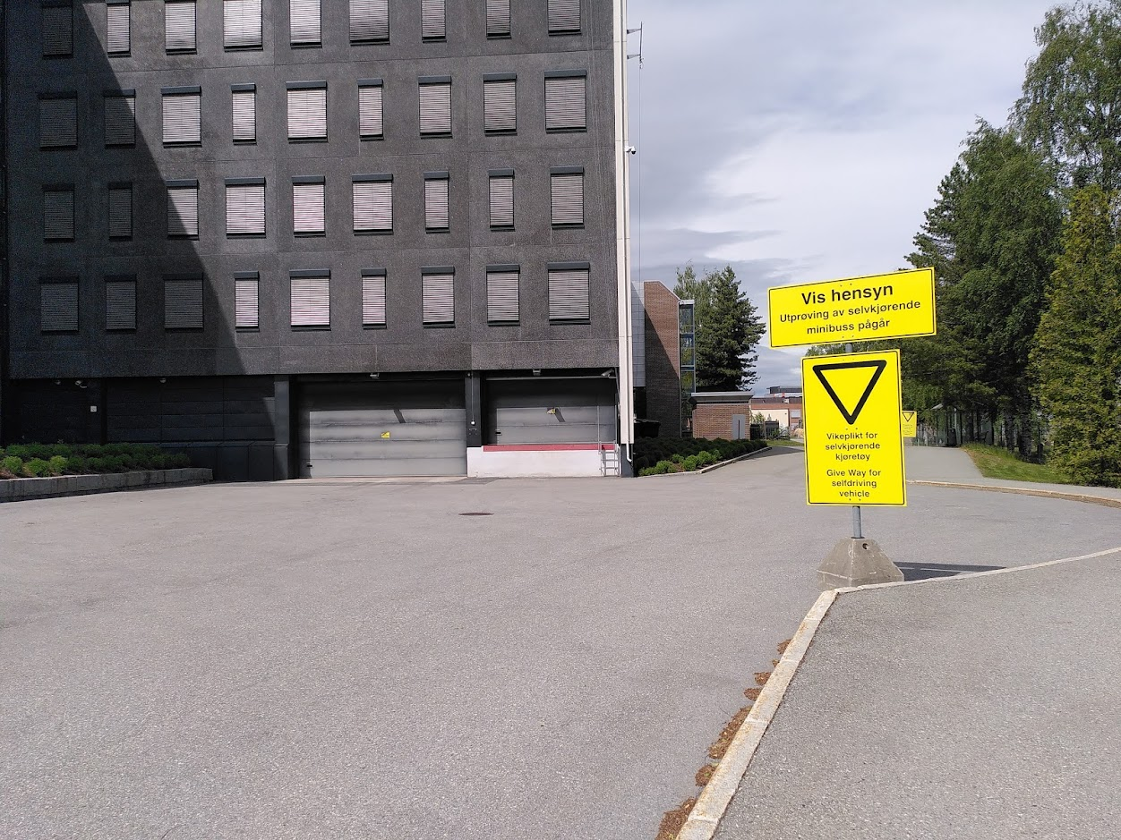
Figure 5: Example of warning and priority signs set up in the park
To set up the signs in a way that would now allow for them to be easily moved, KTP provided metal stands on concrete blocks. This also allowed to set up the signs exactly where they were needed, without relying on existing mounting points. KTP were in this way instrumental to ensuring the correct setup of the pilot, and it became clear that without their assistance and solution-oriented approach, the different steps that had to be taken would have taken significantly more time, which could have put the pilot at risk. As such, KTP as a highly cooperative landowner of the pilot site were a definite driver in the project.
Another driver in the process was the ability to offer the pilot services for free. Not only did this mean that the integration of a payment solution was not necessary, it also removed an important hurdle in encouraging as many passengers as possible to use the service. This was especially important as the compromises that had to be made when setting the route for the pilot significantly limited its usefulness for potential users in the park. As the AV could only drive on the flat, and at limited speed, it was felt by users that the AV did not provide a significant advantage over walking the route, especially in nice weather. Had the AV been able to cover longer distances, or run on one of the hills whose steep inclination make them unpopular with pedestrians, uptake of the service would have been significantly higher. This is something to be kept in mind for future pilots, as a pilot aimed at testing people’s reactions can only be as useful as the number of passengers participating in it.

Discussion of the on-demand transport and success factors of the pilot
In this section, we will provide further details on the on-demand solution that was used in phase 4 of the pilot and evaluate challenges and success factors of the vehicle, route and surrounding aspects.

The on-demand solution
In order to increase the sustainability of the AV service, it had been decided from the start of the project that the fully driverless phase of the pilot would be run with an on-demand solution, such that the AV would really only operate when there was a need for it, thus minimising energy consumption. The on-demand solution was developed and provided by Applied Autonomy, and supported by their dispatch system. As the AV service was free, there was no need for any kind of payment system.
The on-demand solution used a web-based interface, whereby users would access a website (by scanning a QR code on one of the numerous information posters put up around the KTP or entering a link directly). A user would then enter their phone number and be sent a confirmation code in order to access the ordering page. This allowed users to later access their previous or ongoing bookings even after closing their browser, but represented a significantly lower threshold than the installation of a dedicated app.
On the ordering page, users could choose a start and end point for their trip, as well as a desired arrival or departure time. They could also indicate the number of passengers they were ordering the trip for. After the user entered the details, the dispatching system would check the availability of the AV, determine a route, calculate the timings of the trip and propose a solution to the user. The user could then either accept the proposed trip and book it, or alter the entered details and be shown a new trip proposal. As the users of the service and the solution were familiar with the environment, there was no need to for example display a map on which users could identify start and end points and a drop-down menu was sufficient. For larger scale pilots or for pilots in places with a high number of tourists, a visual representation of the options would be more useful.
The user could then track the progress of their trips in the same interface, being informed when the AV was on its way to the designated pickup location, when it would arrive, and whether there were any delays. It was also possible to cancel booked trips, to look up the history of past trips, and to fill in a user survey once a trip was completed. Users found the solution easy to use and intuitive. There were also very few cases of users “abusing” the solution, meaning that they ordered trips just to test the solution, without ever turning up for the trip.
In the control centre, the supervisor had a full overview over all past, current and future trip bookings. Moreover, the supervisor could book trips themselves, or cancel other user’s trips. This was especially relevant in case of technical issues, such as when bad weather meant that the AV had to be taken out of service. If the supervisor cancelled a trip, the user would be sent a corresponding notification, apologising for the inconvenience and asking them to rebook the trip. The operators using this on-demand tool from the control centre found it efficient and simple, and took to it quickly.
For the realisation of fully autonomous on-demand services, the present solution would work, but it might be advantageous to implement more extensive functions. For larger scale operations with several AVs, some modifications might also be required. For example, if not all vehicles in the fleet are equivalent, it might be desirable to give the user several trip options. This would be particular true if different vehicles involve different costs, as the choice of using a slower but cheaper vehicle over a faster but more expensive vehicle should be up to the user. In line with the user feedback detailed in section 4.2.3 Feedback and results of surveys above, the on-demand solution could potentially also be used to improve communication between the AV and the passenger. For instance, the interface might also inform the passenger, or even non-passenger road users, about the state of the AV, sharing information such as the cause of emergency stops or signaling detection of a pedestrian. In the case of services without an on-demand solution, alternative means for providing this information should be found.
Overall, the on-demand solution performed well and allowed the different process stakeholders to perform the actions they needed. For larger scale pilots, the solution tested in the present pilot will form a solid foundation to which any required additional functions can be added.

Challenges and success factors
One of the major challenges of the pilot was posed by the fact that it employed cutting-edge technology. This meant that there was little real-life data available for an AV in fully autonomous operation from any previous projects. This limited the AV’s ODD and thus the route of the pilot. The application process was also more challenging as the routines were not yet well-established and there was no precedent for such a pilot in Norway. As a result, more discussions and closer connections were needed than for other pilots with AVs, especially between EasyMile and Applied Autonomy.
This increase in communication also highlighted some cultural differences between Norway and France, which had to be understood and worked with in order to make the sufficient and quick progress that was required for the pilot.
When thinking about the scaling of this type of pilot outside of a single country, such cultural differences are therefore crucial to be aware of and need to be addressed in order to achieve good collaboration across Europe. For example, it had to be understood from a Norwegian perspective why EasyMile as a French company would be more likely to at first deny a request for an exception to their internal rules. Where a Norwegian party denying a request would consider this answer final, this is usually not the case for a French party, who might find it easier to amend an initial negative answer and avoid disappointing by giving an initial positive answer that later has to be changed to a more negative one. These differences, while seemingly minor, have a decisive impact on the progress of a project. If it is known that a party who said “no” in a first instance can be made to change their response after some negotiation and altering of the request, these negotiations can be worked on immediately, rather than waiting for the party to maybe present a solution of their own accord.
Also within the Norwegian actors in this pilot, good and efficient communication gave a definite edge to the running of the pilot. As mentioned earlier, having established communication channels not just with the technology provider but also with the permit-issuing Norwegian authorities and actors able to influence practical aspects of the pilot helped solve multiple problems and sped up the processes considerably. Collaboration at all levels is therefore required in order to achieve the most efficient and successful pilot possible.
Another success factor that should be mentioned is the attitude of the actors involved, either directly or tangentially, in the pilot. The Kongsberg pilot benefited enormously from previous experiences gained from Testarena Kongsberg projects and an established ecosystem of actors, all of whom wanted the pilot to succeed. This allowed finding the compromises that were necessary for realising the pilot, from KTP allowing operation of the AV despite the cybersecurity concerns (by providing an area for the route that only hosts less sensitive activities) to the authorities obtaining the confidence they required for issuing a permit for the fully autonomous operations by asking for an interim report. This highlights that an evolution of the technology also requires an evolution of the actors involved as well as their processes: In order to support innovation, everyone involved in it has to display a certain degree of flexibility.
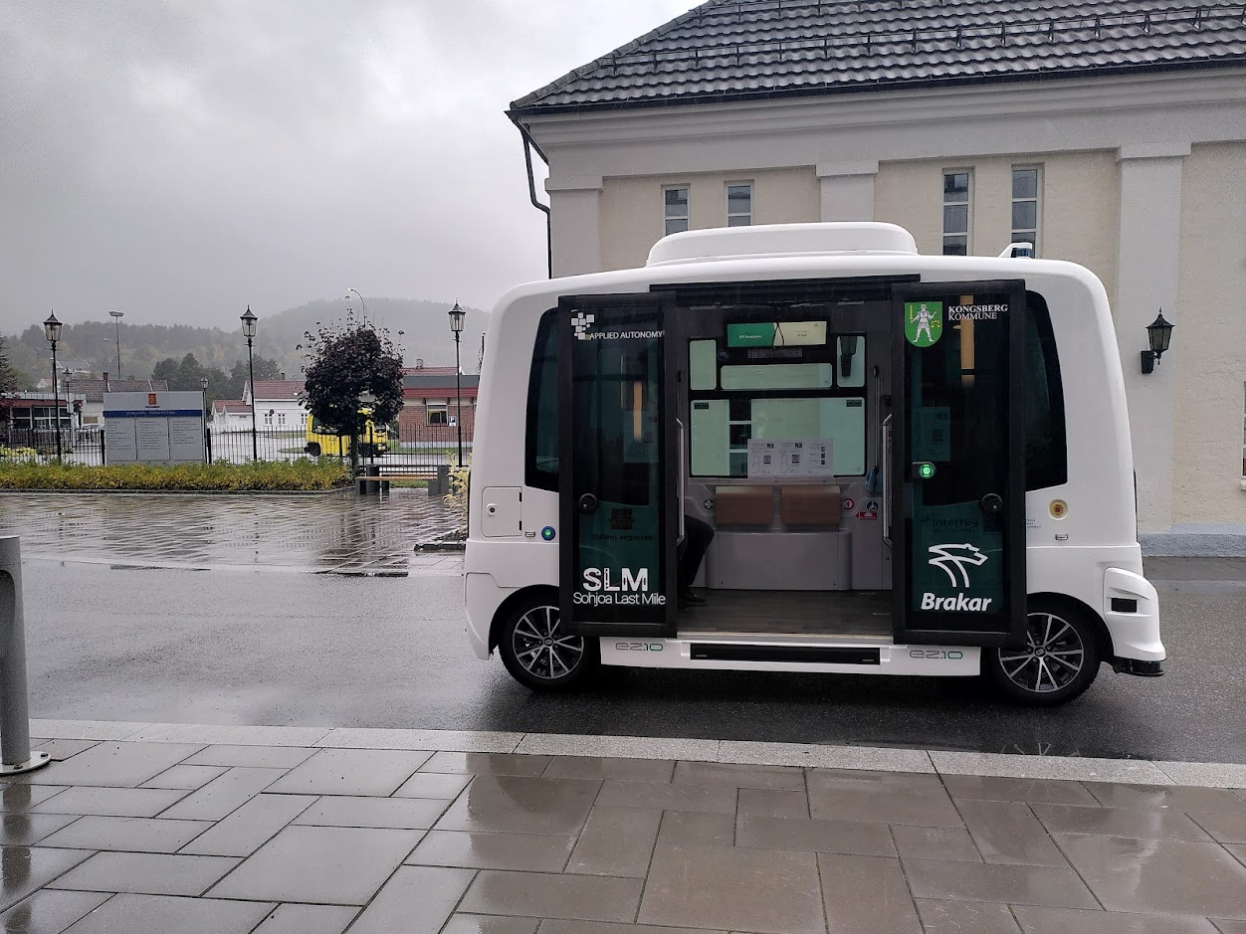
Figure 6: Sohjoa Last Mile shuttle in white, route 450 shuttle (follow-on from Sohjoa Baltic project) in yellow in the background
It was known from previous pilots that the use of cutting-edge technology also involved certain practical issues, which become more likely to appear the longer a pilot runs. Hardware issues with vulnerable vehicle components such as wheel encoders are known factors for small form factor AVs. It therefore contributes immensely to the success of the project and in particular to achieving a high operation time if there are knowledgeable technicians at hand or easily available. When a hardware problem occurs, it makes a big difference whether a technician has to be flown in from a different country (resulting in days if not weeks of downtime, as well as significant cost) or whether support is available locally. Even in cases where the local support is not able to solve the problem, they are able to either diagnose the problem or help with its diagnosis, which allows for faster and more targeted help. The present pilot enjoyed both involvement of very experienced operators by Vy, who have worked with different generations of the AV since 2018, as well as knowledgeable and seasoned deployment engineers by Applied Autonomy, who moreover have a background as car mechanics. Together, they identified and fixed various smaller and bigger problems, from route adjustments to vehicle software issues, which would have cost the pilot weeks of delays had they not been resolved the way they did.

Summary of recommendations for further development or research topics related to the output
Having successfully achieved fully driverless operations with an on-demand solution, the next logical step will be to expand the AV’s ODD to allow for operations in a wider range of contexts. This will enable testing on routes with higher demand, and in different traffic situations, in order to build a more complete picture of the impact of the technology and public reactions to it. Importantly, this is also an essential requirement for establishing commercially viable fully autonomous services. It has been shown in this pilot that there are a number of essential technological improvements that must be made, such as a better camera solution that permits more effective monitoring of the vehicle. Further research should also be made into the communication between a fully driverless AV and other road users, especially to also increase confidence in the technology. Thanks for close collaboration with the technology provider, efforts to improve the technology to solve these problems are already underway.
The Kongsberg pilot differed essentially from the other pilots in the Sohjoa Last Mile project in that there were no remote driving capabilities. It was found that this solution, while it requires a field operator to be relatively close nearby the AV, provided a good level of service once the pilot had reached a stable state and all the initial adjustments to the route had been made. In order to scale an operation of this kind, more confidence must be gained from more data, so that crucially the supervisor does not have to monitor all the cameras all the time anymore. Especially in view of the technological advances that can realistically be expected within the next year or so, it can be anticipated that the field operator will be needed less and less. Some analysis should therefore also be done to define the job description of a field operator in a larger scale, more long-term project: spending most of their time idle is neither desirable from the operator’s point of view, nor is it economical.
In conclusion, the Kongsberg pilot provided valuable insights into the challenges, achievements and requirements of a fully driverless pilot. Through the feedback collected and lessons learned, both the potential and required improvements have been identified in order to bring this technology yet another step closer to fulfilling its role as enabler of reliable, safe and attractive public transportation.

Abbreviations

AV | Autonomous Vehicle
KPI | Key Performance Indicator
KTP | Kongsberg Technology Park
NAT | Network Address Translation
NPRA | Norwegian Public Roads Administration
ODD | Operational Design Domain
PRC | Project Risk Committee
VPN | Virtual Private Network

