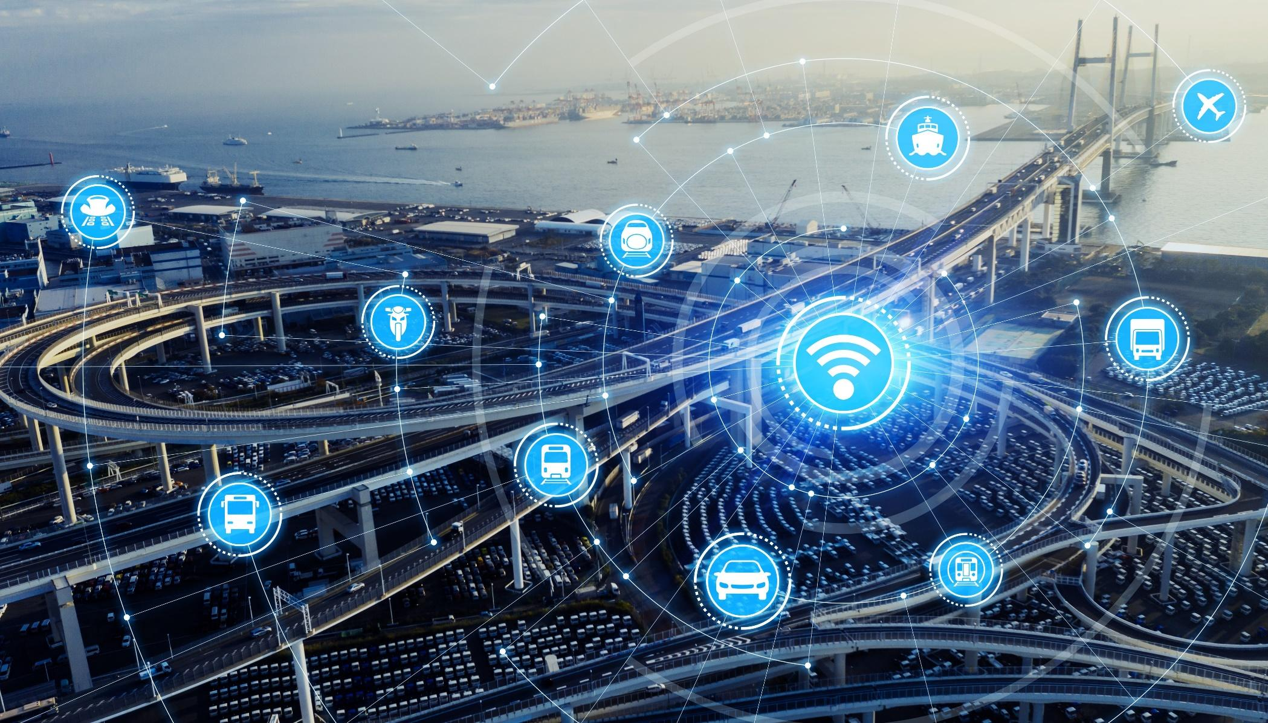
SOHJOA LAST MILE: TALLINN PILOT REPORT 2021
Editor: Jaanus Müür

Authors: Karl-Robert Läll, Krister Kalda, Hagar Nakkurt, Barış Cem Baykara

This publication has been prepared as part of the Sohjoa Last Mile project (2020-2021) funded by Interreg Baltic Sea Region Programme. The main targets of the project were to learn, perform, document and disseminate how to operate automated shuttles without a safety operator.

Foreword
During the last 5 years cities around Europe have run pilots with autonomous buses. The cities in the Baltic Sea region have especially been active in this field as they have understood the challenges related to last-mile transportation and the opportunities that the autonomous buses offer. The public transportation planners, companies, and universities have been working together to set up and run such pilots. These pilots have so far had a safety person onboard. The reasons for this have been both legal and technical. However, as years have passed, so has also developed the technology. The partners of Sohjoa Baltic project decided to continue the cooperation in the form of Sohjoa Last Mile and with the aim to run autonomous bus pilots without a safety person onboard.

The current publication brings together all the project outputs of Tallinn pilot and is divided between the following sections:

- Chapter I (output 2.1.1) is the report on the technical capabilities and potential risk when driving without a safety driver focusing on four main risks that have been identified by the project team in TalTech such as risks related to teleoperation, on-site safety person, actions of passengers onboard the bus, and actions of other road users.
- Chapter II (output 2.1.2) summarizes the results of the passenger survey and the survey which focussed on the communication between the bus and other participants in the traffic.
- Chapter III (outputs 2.1.3 and 2.1.4) looks at the 5G network advantages and requirements, and vehicle to infrastructure communication.

About Sohjoa Last Mile project
Sohjoa Last Mile is the continuation of the Sohjoa Baltic project. Currently, public transport is funded by subsidies and is not able to offer competitive options alongside private cars. The flexible, on-demand type of operation, and especially the gap in the last mile connectivity becomes a major barrier to using public transport. Sohjoa Last Mile will continue to promote the usage and support the change in the region in the field of urban public transportation, including automated driverless electric minibuses as part of the public transport chain especially for first/last mile mobility needs. Providing improved and additional public transport services are expensive with today's production method, as the driver represents up 60% of the costs. The operation of vehicles without an operator or driver in the bus will therefore represent a game-changer for public transport and transport operators. The lessons learned and experiences from the pilots of the Sohjoa Baltic project support the aim of the Sohjoa Last Mile project to take piloting to the next level. The main targets for the pilots in Sohjoa Last Mile is to learn, perform, document and disseminate how to operate automated shuttles without a safety operator. The target for remote-operated vehicles is cost reduction and more flexible services for public transport. To meet public needs for transport, the service needs to perform as regular buses. The Sohjoa Last Mile project deploys pilots in three cities: Kongsberg, Tallinn and Gdansk.

Alongside the piloting, the project will disseminate the successful results that are achieved by organizing workshops by partners Gdansk/Poland, Metropolia/Finland and Zemgale region/Latvia, regarding the deployment, city planning, public transportation services, technology and related regulatory framework issues. As an addition to delivered tasks, this project focuses on influencing the legal process and policy making stakeholders. To ensure positive regulatory evolution in order to provide a harmonized and reasonable business environment for autonomous public transport, key stakeholders are engaged with personal level communications. The project will also boost best practices by networking and knowledge sharing between stakeholders.

I REPORT ON THE TECHNICAL CAPABILITIES AND POTENTIAL RISK WHEN DRIVING WITHOUT A SAFETY DRIVER (OUTPUT 2.1.1)

In Tallinn the bus was operated under these specific parameters:
- The bus was always monitored by a safety person via teleoperation and an on-site safety person.
- Even though the bus was capable of traveling from the garage to the operating area autonomously and without a safety person on board, the safety person was on-board the bus for that period of driving and for the first lap of the regular driving route. This was so that the safety person could conduct the daily emergency braking test and make sure that everything is working normally on the route and intervene quickly in case problems were found either in the functioning of the bus or on the route. The emergency braking test consisted of making an emergency stop via pressing the remote emergency stop button that the safety person carried with themselves the whole time. An example of a problem with the bus would be losing localization of the bus, an example of a problem with the route would be a tree that has fallen over during a storm and is now blocking the road.
- After completing the safety tests and check-ups, the safety person stayed outside of the bus but within eyesight (up to 50 m distance) unless people approached the safety person and the normal conversation led to a point where the people wanted to go on board the bus but also wanted to continue the conversation. In cases like that the safety person went on board with the person to continue the conversation and introduce the technology and explain what and why the people are experiencing and how the technology acts in specific situations but did not intervene in what the bus was doing. Once the people left the bus, so did the safety person.
- At the end of daily operations, the safety person went on board the bus to change the regular operating route to the route that takes the bus back to the garage.
The safety person was equipped with a long range (LoRa) radio transmitter that had an emergency stop button on it. The bus was equipped with a receiver that could detect if the radio transmitter was in range or not. In case the receiver lost the signal of the transmitter, the bus would make an emergency stop. The range of the transmitter was tested and was found to be very dependent on the area of testing, varying from 50 to 250 meters.
The teleoperator had constant full access to all of the bus’ live data, lidar and video feeds and could monitor the surroundings and the interior of the bus and had a separate emergency button in the office that was also tested occasionally.

Potential risks when driving without an on-board safety person fold into the following categories, all of which will be discussed separately:
- Risks related to teleoperation;
- Risks related to the on-site safety person;
- Risks related to actions of passengers onboard the bus;
- Risks related to actions of other road users.

Risks related to teleoperation
Teleoperation relies on several factors that all must be considered and fulfilled on a continuous basis. Firstly, teleoperation requires a stable, low latency connection. Real life testing has shown that objects such as trees or houses can have a significant impact on the quality of the connection between the remote driving station and the bus. The quality of the connection can and does vary significantly within 10 meters of driving distance. It is also plausible that the noise of other different signals that naturally exist in a high-density city can have a negative effect on the connection between the bus and the remote driving station. The risk of having a problem with the quality of the signal can be mitigated by using several different signals (4G and 5G) or by using the same signal technology and wavelength but from different service providers. It is also crucial that just like with the LoRa radio transmitter, the bus must be able to understand when it loses the connection while it is being operated via teleoperation. A bus that suddenly has no new commands can coast quite far before reaching a natural stop, unless the brakes are applied. Even worse, a bus that keeps repeating the last received command can actively create dangerous driving situations. In our pilot such issues did not arise but if the bus does lose connection, it is programmed to do an emergency stop. This has been tested and is a working solution.
Secondly, teleoperation requires attention to cybersecurity. In our operations we luckily did not have such issues, but it is clear that in the past regular vehicles have been used to do harm and autonomous vehicles have the potential to be used as weapons by a malicious 3rd party. There are several aspects of cybersecurity that need to be addressed such as security related to ROS, the operating system that is used, the segmentation of different systems, data encryption etc. TalTech employs a wide array of methods to increase cybersecurity that will not be explained in greater detail.
Thirdly, teleoperation requires working hardware. This means both generic working hardware that one can find in any motor vehicle (battery, headlights etc) and hardware that is specific to teleoperation. Hardware that is specific to teleoperation can be divided into two parts: hardware that is required for decision-making and hardware that is required for controlling the bus. Another way of naming these two categories would be input- and output-related hardware. While it is relatively easy to detect a malfunction in the input hardware, it is not so with output hardware. A teleoperator will easily detect if a camera, a lidar or any other sensor has stopped providing live data as the teleoperator will see that the data is missing or corrupt, but the opposite is with output-related hardware. A person inside a moving vehicle has all their senses available for them. Before a specific part fails, there might be noise, vibration, sound, smell, heat, or other forms of information available for the person inside the moving vehicle that there is a problem. Most of this information is difficult to transmit over the internet, especially as this would require a very large number of sensors. For example, there are a lot of moving parts in a motor vehicle and equipping each one of those parts with a heat, vibration, and sound sensor to prevent a failure is economically unfeasible and difficult to monitor as what is considered a normal range can vary a lot depending on current weather and road conditions. In our pilot we did experience hardware-related issues. For example, a lidar bracket broke which meant that a lidar could not be fixed in its correct position. That meant that the lidar could not give correct data and the bus was unable to operate autonomously until a new bracket was 3D-printed. During the course of operations there were a few blown fuses which rendered the equipment behind those fuses inoperable. Also, the mechanism that opens and closes the door malfunctioned resulting with the door closing in an incorrect position, leaving a small, few centimeters wide gap in the closed position. These are all examples of issues that are hard to notice and/or solve while teleoperating.
In our operations teleoperation was not used while the bus was operating under the normal schedule, regardless of whether there were passengers onboard or not. Teleoperation as the means of moving the bus was tested outside the normal operating hours but was not the preferred modus operandi of operating the bus. Teleoperation was used regularly, almost daily, to verify, control or manipulate specific parameters of the bus that might or might not relate to the driving and moving of the bus. The examples would be checking and changing the parameters of the doors to make sure that they are operating as expected or changing the waypoints that the bus is following or checking the statuses of different subsystems. If the teleoperator or the on-site safety person deemed it necessary, the bus was temporarily stopped so the teleoperator could complete whatever task they might have had at hand. In most of the cases, stopping the bus was not required. In our operations no incidents occurred while the bus was under the control of the teleoperator.
To sum up, the main risks related to teleoperation are:
- Risks related to a stable connection between the shuttle and the teleoperation station.
- Risks related to cybersecurity.
- Risks related to working hardware and the detection of malfunctioning hardware.

Risks related to the on-site safety person
There are several key risks regarding the on-site safety person. First is human error which presents itself in various guises. The on-site safety person is usually the last person to be in contact with the bus before it starts autonomous driving. This means that the safety person is responsible for making sure that all the parameters for autonomous driving are set correctly. There are parameters that might be technically correct and accepted but incorrect for the specific application. The simplest example of this is turning off or changing some parameters of some sort of equipment for testing or troubleshooting purposes and later failing to return the equipment to its original state or failing to start a specific subroutine before autonomous driving. An example of this would be forgetting to run the specific subroutine that identifies people next to a pedestrian crossing. This would cause the bus not to differentiate between people who are just standing on the pedestrian road and people who are waiting next to the pedestrian crossing and wish to cross the road. Since there might be prolonged periods between two consecutive times when the bus is operated, it is important to have written down SOP-s and other relevant aspects of operating the bus. Our pilot had two people always available for any procedure which mitigated the risks because it is quite unlikely that two people will make the same mistake or forget the same specific line of code at the same time.
Another aspect of human error has to do with manually driving the bus. Since the bus is currently unable to overtake an obstacle, it is still the job of the safety person in case there is a need to do so. An example of an obstacle is a construction vehicle on the road loading or unloading materials. This obstacle needs to be manually overtaken. That can lead to risks such as the operator accidentally pressing the wrong button on the controller and causing an accident or the operator misjudging the distance and accidentally hitting another object or the operator falling into a false sense of security because that specific overtaking maneuver has already been completed many times during the day. We did experience situations where manually driving the bus was required but did not experience any issues with it.
To continue on the topic of false sense of security, another potential risk is the bus operating correctly as expected. The longer the bus operates correctly, the more it is likely that the safety operator will start taking safety as guaranteed. For example, in our project we had a 58-day period during which the safety operator had to intervene only once. Lengthy periods of safety can lower the level of attention that the operator pays to the bus and can create a situation where the safety person is not paying attention in a crucial moment.
The best way of lowering such a risk is in carefully choosing your safety person(s) to make sure that they have appropriate personality traits or previous work experience where staying vigilant even if everything is working perfectly for extended periods of time is required. Another way of lowering such a risk is having a team of safety people, who work in shifts. In that way if the pilot has four safety people and the bus does not have an issue for 40 days, it still feels like “10 days without an accident” for everybody.
Another risk related to the on-site safety person is vision. As the safety person, by definition, is on some side of the bus, the bus itself blocks vision to the other. This risk can be lowered with the safety person being physically higher than the bus or further away. Both of those solutions allow the safety person to have a wider awareness of what is going on in the area where the bus is operating. In all cases, mitigating such a risk is very specific to the geometry of the area where the bus is operating.
To sum up, the main risks relating to the on-site safety person are:
- Risk of human error.
- Risks relating to manual driving.
- Risks relating to the vision of the on-site safety person.

Risks related to actions of passengers onboard the bus
Risks related to actions of passengers on the bus can be divided into three categories. Firstly, there is a risk related to passengers trying to manipulate something they should not be manipulating. Secondly, there is risk due to the passengers' perceived sense of safety. Thirdly, there are risks involving entering and exiting the bus.
The first risk arises from two types of passengers: curious passengers and malicious passengers. Curious passengers are genuinely interested in technology and how it works. They will not try to access physical areas of the bus that by common sense are off-limits for the passengers but might try to do something unusual. For example, they might press the door opening button while the bus is moving to see what happens. Malicious passengers are set to do harm. They might try to access areas that are off-limits and do things that clearly should not be done, for example try to take control of the bus. Both curious and malicious passengers stop being an issue once they realize that their actions are observed. An extreme case of a malicious passenger would be a passenger who is violent towards other passengers or destructive towards the bus, or somebody set out to perform industrial espionage. In most cases, most of the problems can be solved with physical interior design choices. In general, warning signs are not enough as curious passengers tend to not notice them while malicious passengers clearly have an agenda to ignore such signs. In our pilot a keyboard, a mouse, and the controller of the bus were left on a desk inside the bus where they were freely accessible to passengers. In our pilot over 500 passengers used the bus and less than 1% of passengers tried to use any of the three devices. Virtually all passengers understood that these devices are not there for them to use. In cases where a passenger did try to use a device, the on-site safety person stopped the bus, made eye-to-eye contact with the person and a simple wave of the finger was enough for the person to understand that they had not acted correctly. The on-site safety person made sure that nothing harmful was done with the devices and operations continued as normally. No passengers tried to use the controls for a second time.
The second risk with passengers on-board is that they tend to believe the bus is absolutely safe. This belief comes from two factors. First, the passengers tend to overly trust technology. Many passengers on-board the bus tend to believe that nothing can go wrong with the bus because it is modern technology and technology is perfect and error-free. It means that the passengers start doing things that they would not do in a normal bus or automobile such as standing or moving around in the bus without grabbing from any place to hold. Second, people are lulled into a false sense of security due to the low speed of the bus. Most people do not believe that an emergency braking situation from as little as 7 km/h could have any serious effect while in reality emergency braking from that speed means that people who are standing up and not prepared for it will fall over and hurt themselves. This risk can be mitigated somewhat by signs but mostly by the on-site operator. If the on-site operator sees that a bigger crowd is trying to board the bus, the operator goes to the bus stop and explains that standing in the bus is not allowed. Most people understand the warning but still if they choose to stand up, not much can be done. If the safety person now stops the bus because somebody is standing up, the safety person will cause the same falling of the person that the safety person is trying to avoid in the first place.
The third type of risks are related to entering and leaving the bus. This risk can be divided into three parts: risks involved with passengers wanting to stop the bus so they could enter it; risks involved with the actual procedure of entering and exiting; and risks while inside the bus. Firstly, some people will try to stop the bus while it is driving so they can get on it. Typically, this results in hailing the bus which has no effect and then trying to hit the door opening button on the moving bus. This could result in the person losing their balance and falling in front of or against the side of the bus. In our pilot, people tried to get on a moving bus on several occasions using methods that they clearly would not use with a regular bus, mainly because nobody wants to be run over by a big vehicle. Currently it is quite challenging to differentiate between a dangerous and non-dangerous situation. In everyday life this is a question of tens of centimeters and fractions of a second. It literally takes only one step for someone to step from the pavement onto the road and even though the bus recognizes objects that are blocking its way on the road, the bus is still subject to the laws of physics. The safety person can sometimes anticipate these situations and react before the situation emerges. Distinguishing between the intentions of pedestrians is currently very difficult. How does one distinguish a person who is looking towards the bus because they want to get on from the one who is looking towards the bus because they are simply interested in looking at it from one that is looking at the bus to see when they could cross the road in the wrong place? Machine learning can help here but there is still a lot of work to be done.
Secondly, entering or exiting the bus means navigating the door of the bus. The door of the bus is a moving piece of equipment and hence entails the risk of either getting hit by the door as it is opening or getting caught between the door and the side of the bus as the door is closing. The actions of the bus while stopped in a bus stop have been pre-programmed and do not take the specific situation into account. For example, one person leaving the bus takes less time than four people leaving the bus and four people entering the bus, however the bus door stays open for a set number of seconds. That invariably leads to one of two situations: either the doors are kept open for a very long time on every stop, or they are kept open for a more usual time which can create a situation where the bus door starts to close even though people are still moving through the door opening. In our pilot we tried to counter the issue by having a sensor on top of the door opening that senses if somebody is in the door opening. The solution had limited success. We also used a speaker to communicate the message “The door is closing in 15 seconds.” Currently our door does not recognize if a foreign object is prohibiting it from closing, so it will try to close no matter what. However, the force that the door uses for closing is relatively small, meaning that in the event of getting stuck between the door even a child has enough strength to pry the door open. More work needs to go into understanding how long any specific bus stop should last and understanding what are the intentions of people near the door of the bus, for example have they stopped near the door of the bus because they want to get on the bus or they have stopped near the door of the bus because they have just gotten off the bus and have decided to observe what the bus is doing or just have not decided on where they want to go.
The third risk of entering and leaving the bus is also related to the stopping time of the bus. Just as with the door, it is possible that people are still moving around in the bus when the bus starts moving. There is a set time between when the door of the bus closes and when the bus starts to move. If that time is too short, people will not have had enough time to sit down before the bus starts moving. If that time is too long people start arguing about who gets to sit where: who wants to sit in the back, who in the front, who is next to someone and so on. This is especially true for younger passengers. Finding the correct timing is a matter of trial and error. In our pilot we used a message saying, “The bus will leave the station in 15 seconds,” which in most cases led people into sitting down in any place they could, because they knew that the bus was about to move.
To sum up, the main risks relating to the actions of passengers on the bus are:
- Risks relating to passengers pressing buttons, “testing” functions.
- Risks relating to passengers’ belief that because technology is perfect and/or the speeds are low there are no risks involved and any sort of action is permitted.
- Risks relating to boarding and leaving the bus.

Risks related to actions of other road users
Other road users can be divided into several categories. For the purposes of this report, they will be divided into the following categories: pedestrians, cyclists and motorists, and birds and animals.
Currently self-driving buses are visually quite recognizable as they do not look like anything else that is on the road. That visual difference has both advantages and disadvantages. The advantage of the visual difference is that every road used recognizes that something different or unusual is happening and they take notice of what is happening and have a heightened sense of awareness. It also means that if something is to go wrong, they are more likely to take notice and perform evading actions.
The negative side of that visual difference is that some pedestrians who recognize what is happening start testing the bus. For example, they will stand in front of the bus or stay very close to the bus or start moving erratically on a pedestrian crossing to see what happens. This behavior creates dangers both in relation to the bus but also in relation to other road users because if somebody is “testing” the bus, they might not notice another road situation that might be developing and of which they otherwise would be aware of. Also, “testing” the bus can create a lot of discomfort for the people that are inside the bus because it can lead and has led to the bus having to stop very quickly because of the danger that has suddenly occurred. All of this is much more likely to happen with groups of children. Again, in most cases a simple wave of the hand from the on-site operator is enough to solve issues like this but sometimes the people “testing” the bus are so occupied with their actions that they do not notice what is going on around them.
Cyclists and motorists fall under the same distinction of moving quicker than the bus does. That very often leads to cyclists or motorists overtaking the bus in a place where they should not. This sometimes leads to situations where the overtaking cyclist or motorist does not have a lot of room to get back in the correct lane either because of oncoming traffic or a traffic island. This can be mitigated by operating the bus in areas where the speed of the traffic is more closely matched with the speed of the bus or where there is limited or no traffic. In our pilot the route of the bus was on a road that was a cul-de-sac, which meant that there was quite little traffic and most of the route of the bus was in an area that was prohibited for other traffic. This however did not stop other traffic from using the road as food delivery service vehicles such as Wolt or Bolt are impervious to traffic rules.
On the topic of actors that are impervious to traffic rules, we come to mother nature. Our pilot ran in an area that was next to a forest which meant that in addition to domesticated animals who were out on the street with their owners, we encountered stray cats, rabbits, squirrels, and a fox. These animals can jump out of seemingly nowhere and in front of the trajectory of the bus, causing the bus to brake very suddenly. These interactions can be minimized by choosing where to operate but in quieter, greener districts not much can be done to stop these interactions unless we start fencing off forests and parks. Finally, we have birds. Birds that tend to cause problems can mainly be divided into two categories: birds that are flying and flocks of birds sitting on the road. Both tend to cause unnecessary braking events. Flying birds will fly across the path of the bus and make the bus brake because the bus believes it suddenly has an object in front of it. Flocks of birds that are sitting will suddenly all start flying when the bus gets near them, causing the same problems as a singular flying bird. These issues can be mitigated by one of the two options. Either reacting to object detection can be pushed a bit further timewise or machine learning needs to be used to recognize birds. Pushing object detection a fraction of a second later has been previously used in other pilots and helps to fight against unnecessary braking events caused by either noise or quickly moving objects that are not going to collide with the bus. The downside of such a solution is that ALL object detection is pushed later, so even in an event when the bus does have to make an emergency stop, it will do so a fraction of a second later until it is clear that the object is not noise: a bird, a leaf, or something that is on the path but is moving away from the bus. Machine learning takes time as currently the bus does not differentiate between all possible actors on the road.
To sum up, the main risks relating to the activity of other road users are:
- Risks relating to other road users trying to test the bus.
- Risks relating to the slow speed of the bus compared to other traffic.
- Risks relating to birds and animals.

II HUMAN PERCEPTION TOWARDS THE DRIVERLESS BUS AND THE LANGUAGE OF DRIVING (OUTPUT 2.1.2)

Passenger experience and acceptance
It is important to ensure that the users of public transport feel comfortable in using autonomous buses. Therefore, it is important to collect feedback from the passengers already during the pilots. As during the Sohjoa Baltic project, we collected passenger feedback also during the Sohjoa Last Mile project. As the pilots of Sohjoa Last Mile are run without the operators on board, it is especially important to find out what passengers think about such a setting and what can be improved. For example, what do the passengers think about how the bus and its remote operator should communicate with them? The answers to such questions are critical for the further development of autonomous buses. The current section brings out the results of the passenger survey.

We conducted a similar survey during the Sohjoa Baltic project during which a safety operator was still inside the vehicle. This gives us later an interesting opportunity to compare the answers of these two surveys. The current report focuses solely on the Sohjoa Last Mile pilot that took place mainly during the summer months of 2021 (no winter weather or road conditions). The initial plan was also to use spring for the pilot, but due to Covid, we had to postpone the start. There were altogether 539 passengers, but the answers and the analysis are based on the experience of 53 persons who participated in randomly selected interviews (as there were some school classes joining the drives, we did not want the results to be showing the perception in majority from one specific group of demographics). The pilot took place at the campus of Tallinn University of Technology and therefore one has to take into consideration that the participants can be more knowledgeable about the existence of autonomous vehicles compared to the general population. Still, for many people, it was their first experience with an autonomous bus.

52.8% of respondents were men and 47.2% were women. 34% of the respondents were under the age of 18. A quarter (24.5%) belonged to the age group 18-30. These were mostly students commuting in the campus area. Slightly over a fifth (20.8%) belonged to the age group of 31-45 and 17% to the age group of 46-60. Just 2 respondents were over 60 years of age. 52.8% of respondents were with a university degree, 30,2% with primary education (children) and 17% with secondary education (high school or vocational degree). 59.6% were employed and the rest were students (40.4%).

48.1% answered that they are using public transport on a daily basis and 17.3% are weekly users. 30.8% respondents answered that they use it less often. Just 2 people (3.8%) answered that they never use any public transport. 40.4% of the respondents got to know about the pilot through personal invitation to try it out. 25% had heard about it from the media. 23.1% saw the bus on the street and approached it. 19.2% had heard about it from a family member, and 28.6% got the information about it also from their teacher or via their school/university.

First we asked to rate the overall feeling of safety on the scale of 1 - 7:
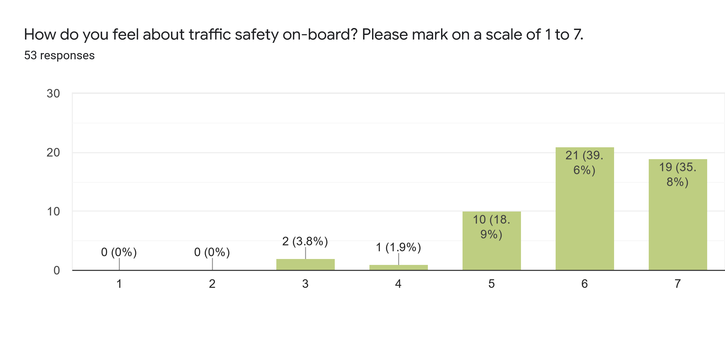
Chart 1: The overall feeling of safety on the scale of 1-7.

Nobody felt completely unsafe. 2 persons rated it with “3” and 1 person with “4” - mainly because of the sudden stops and they did not have their safety belts on. Also, it raised a modest panic as after the safety stop, the doors remained closed and the bus was “speaking” in English and not in the local language. There is still a lot of uncertainty about autonomous vehicles really taking over the traffic. Many are sceptical about the time when autonomous and non-autonomous cars will be driving on the streets together which creates prejudice that the autonomous cars can be safe enough for everyday traffic. However, while taking the drive they see that at low speeds it is quite safe and there is much focus on safety in general. 18,9% of the participants rated the overall safety with “5” and 39,6% rated it with “6” (the most common rating). A little over one third (35,8%) of all respondents rated the overall safety with “7”. It means that over 75% of all respondents feel “very safe” while driving on the autonomous vehicle even without the safety operator onboard. This encourages us to look further into the possibilities of connected and cooperative autonomous vehicles (CCAM).

Next, we wanted to know how the passengers felt about their personal safety. The results were quite similar, with just minor changes. 7,6% of the passengers who gave the lowest points (“3” or “4”) and can be considered the most sceptical ones, explained their low grades with a worry that “at least somebody should be onboard”, “the seatbelt was missing” and “it created a little phobia being in a closed room and the robot bus communicating in a foreign language”. 28,3% of people rated it with a low safe “5” which is substantially higher compared to the previous question, showing that people are more worried about their personal safety than about the overall traffic safety. The majority still considered it “very safe”, with 30,2% of people rating it “6” and 34% rating it with “7”.
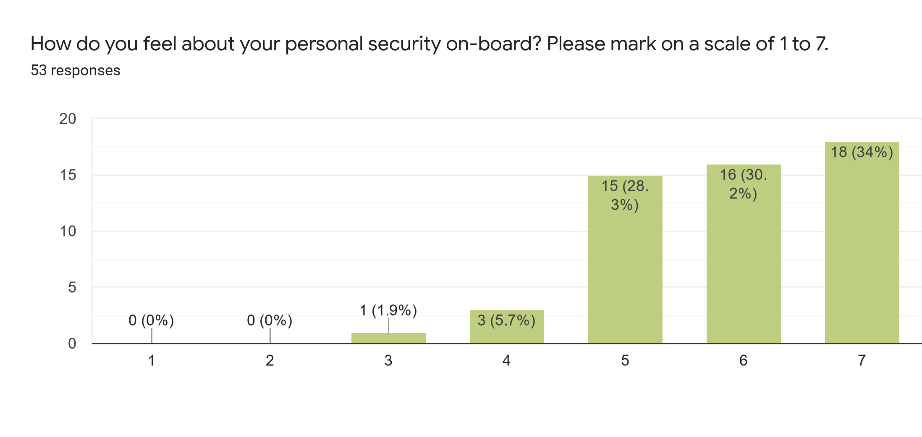
Chart 2: Personal security on-board the AV bus on the scale of 1-7.

Like in the Sohjoa Baltic project, we also wanted to know how long distances are people ready to cover with an autonomous bus.

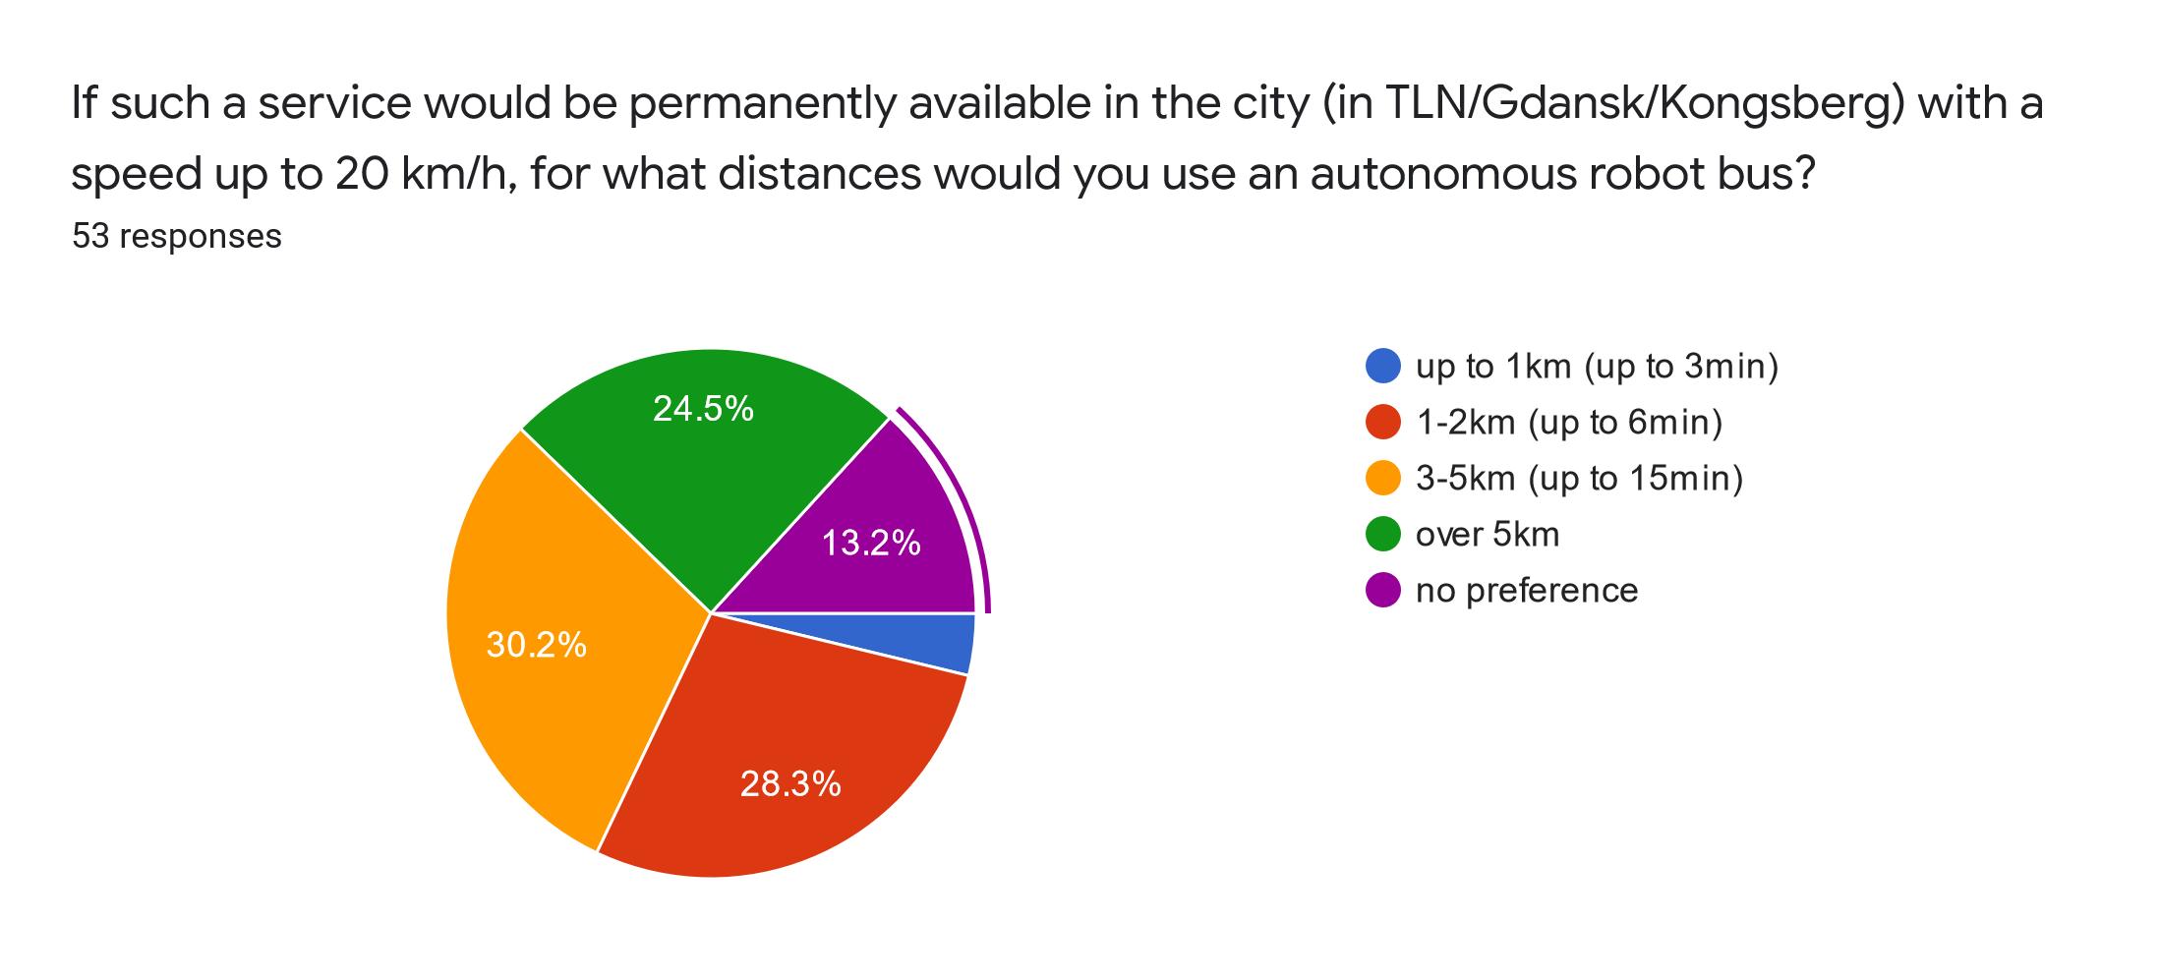
Chart 3: Results to the question for what distances would passengers use an AV bus.

The results of that particular question show that the autonomous buses could have more functions than just providing the last-mile service. While slightly less than one-third of the answers preferred to use the service in the range of last-mile service, over half of the people answered that they would like to use the service even on longer distances. However, over 60% of the respondents prefer to use the service in the range of up to 5km. Interviews clearly showed people’s feeling that in such a distance the vehicles are best controlled. Slow speed has another strong effect on these answers, as most people felt it would be a waste of time if autonomous buses would serve longer distances. Nevertheless, almost a quarter of passengers who answered the survey (24,5%) indicated that they do not really see reasons to limit these distances. Some of them added that with bad weather or missing other means of transport such a service could be really helpful, especially for the elderly (also disabled people) living in rural areas for whom getting to the food store or town centre can be a struggle. In addition, elderly people have time and they might even prefer a slower ride.

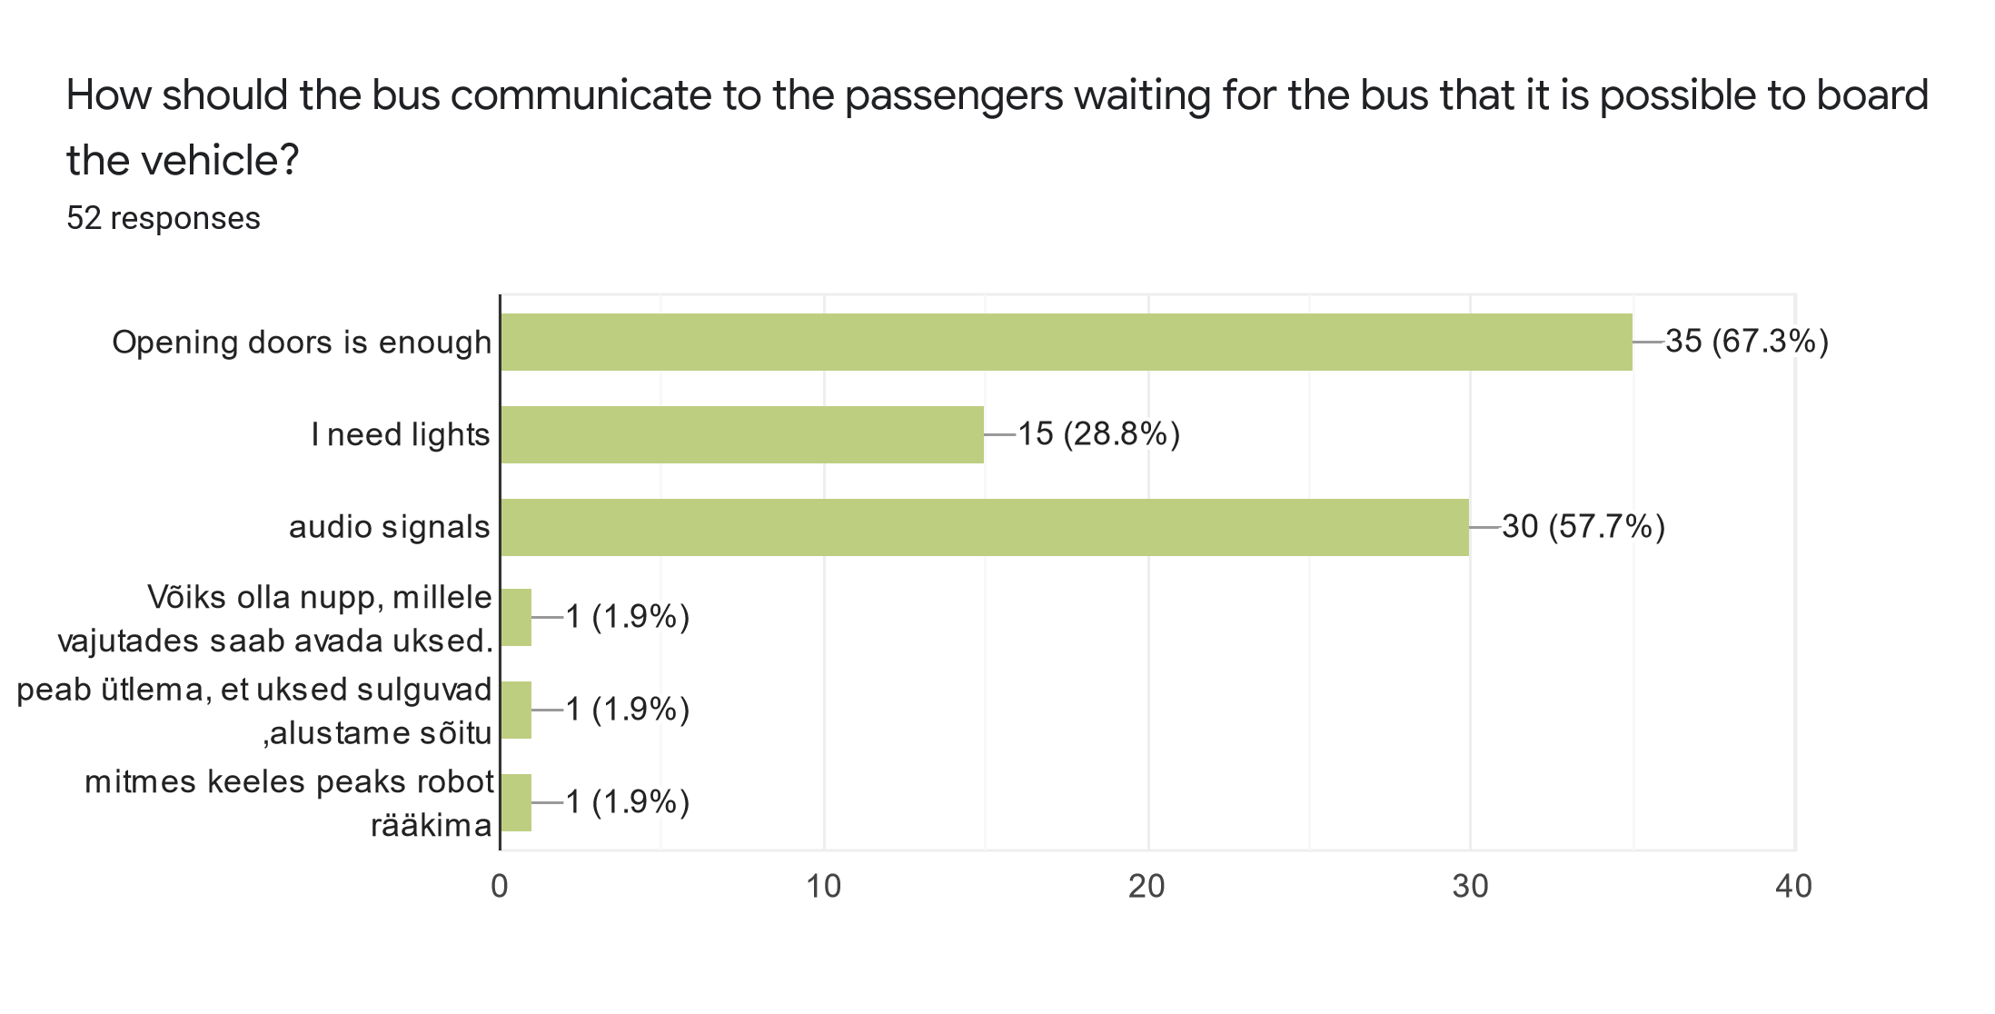

Chart 4: Results to the question of how should the bus communicate to the passengers waiting for the bus that it is possible to board the bus. The bottom three were open responses answered in Estonian (From top to bottom: There should be a button which would open the door (1); The bus should say that it is closing the doors and is starting to move (1); The robot (bus) should speak in several languages (1)).

We also asked people how autonomous buses should let passengers know that the boarding has started. People who are used to public transport were sure that simply arriving at a bus stop and opening the doors is enough information for them to enter the vehicle (67,3% of all respondents). As it was a multiple-choice question, there was a significant number of respondents who wished to get an audio signal (57,7% of all respondents). For example, it can be a voice saying that it is safe to board the vehicle and it is in taking them to the next stop. 28,8% of respondents would like to have lights or signs blinking through which the bus could communicate to passengers that it is possible to board the vehicle. With just 1 person (the same person) saying that there should be a button to open the doors and the bus saying that the doors are closing and the drive will start and wanting the shuttle to “talk” that all in several languages. Mainly also because he wanted there to be all possible ways of indicating everything.

Going even deeper into the actual perception of a fully driverless bus service (even without the remote operator), we first and foremost wanted to know how ready the people are to actually have such a service where there is not even a teleoperator controlling the vehicle while they are driving in the bus. 60,4% of respondents answered that they would use the service even without the remote operator. However, many people specified that they would use it if the technology is proven safe and it is used also by others.
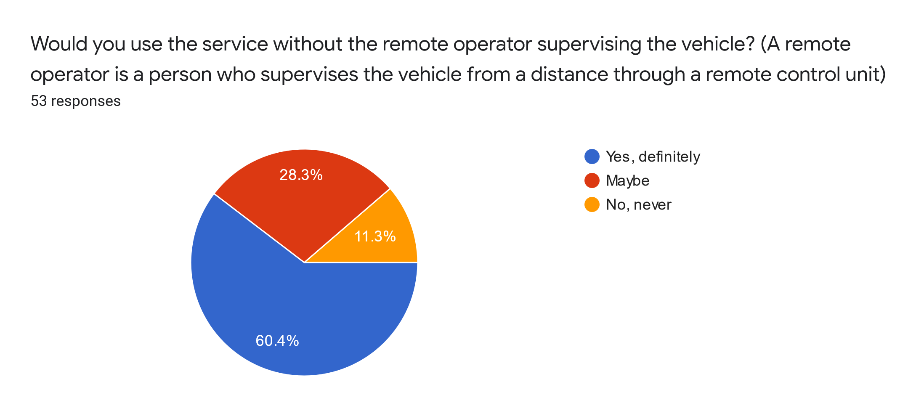
Chart 5: Results to the question would passengers use the service without the remote operator supervising the vehicle.

A little over a quarter of answers (28,3%) were questioning the safety aspects more strongly, saying that they might use the fully autonomous shuttle services and 11,3% answered that they would never use such service. The biggest worry was personal safety, especially if we talk about mass transit. There were respondents who added that having a remote operator who keeps an eye on the situation in the bus should be a minimum at least. Others feared vandalism, drunk people or bullying and added that because of these reasons there should always be a safety operator onboard.

While using teleoperation or other ways to remotely control the shuttle, it can clearly be indicated also to the passengers in which exact form it is driving. We asked people if they would like to know whether and when the vehicle is controlled remotely or driving in autonomous mode.
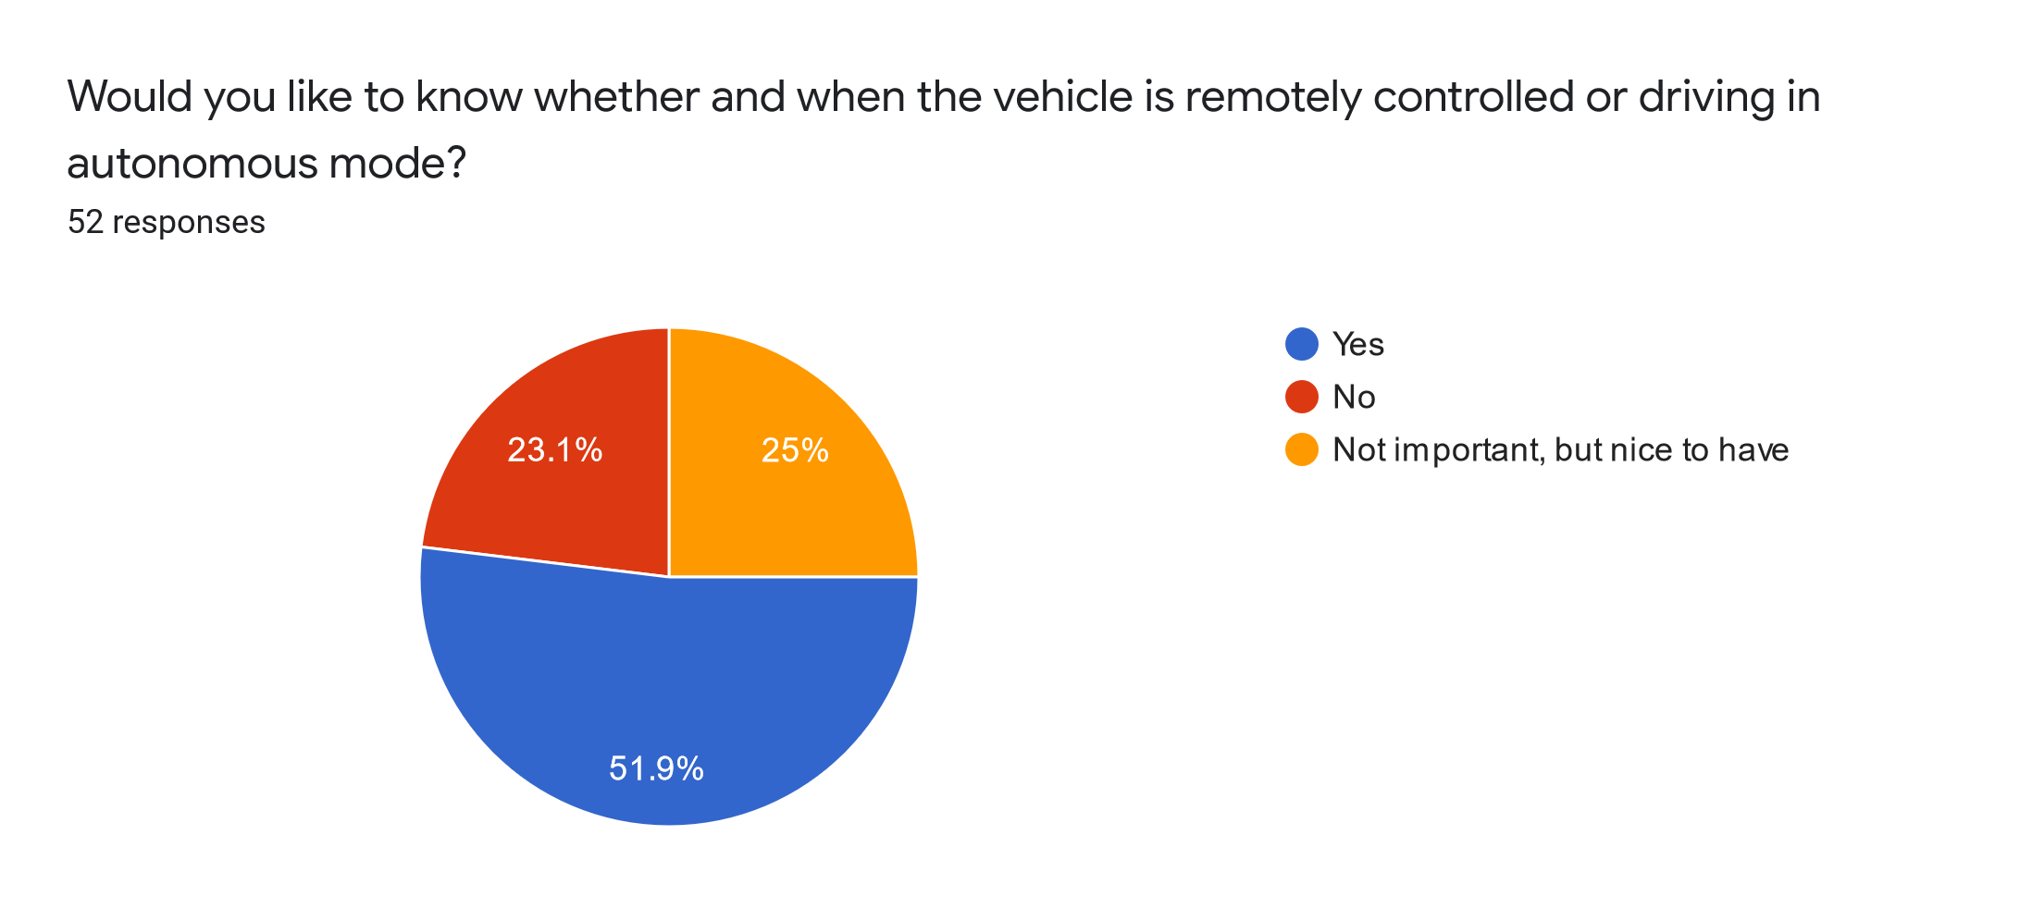
Chart 6: Results to the question would passengers like to know whether and when the vehicle is remotely controlled or driving in autonomous mode.

51,9% of the respondents answered that it is important for them to know whether the bus is currently using the autonomous mode or controlled remotely. They want to be informed at all times about what is happening with the bus and be alert when it is fully autonomous. We also have to take into consideration that this is “new” for everybody. Some added that when in time this kind of transport becomes “normal”, they might change their opinion. 48,1% considered it not to be important as they expect any public transport to be safe and not to be allowed on the streets if otherwise.

While driving on the bus, we asked people how they would want to be in contact with the remote control centre if for some reason they would need that. Here we can see differences based on nationality. Estonians tend to be more by themselves, not wanting to communicate unless it is not avoidable. People with Russian background wanted more to be connected and also more means of communication to choose from. Here again, we let people choose several answers if they wanted to.

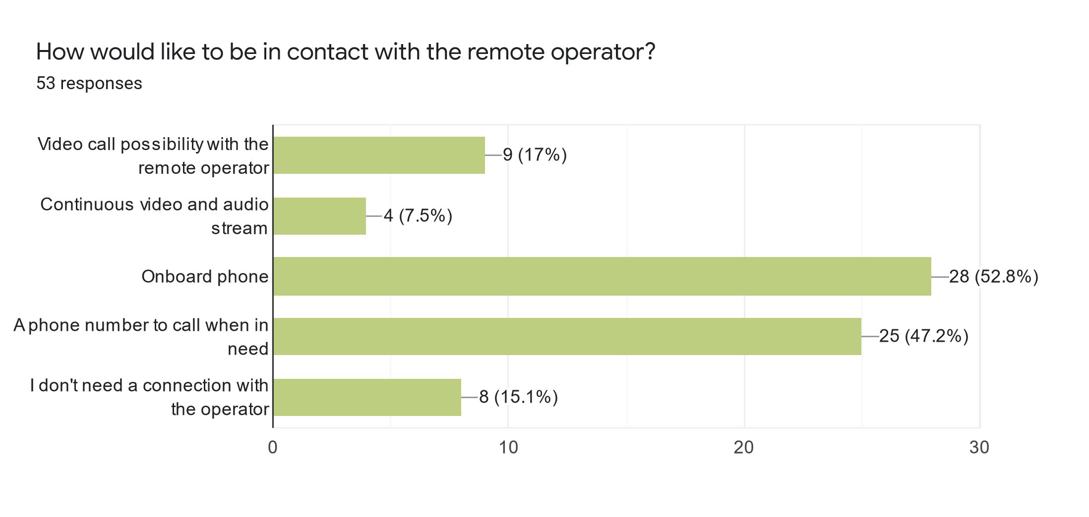
Chart 7: Results to the question of how would passengers like to be in contact with the remote operator.

52,8% of respondents would like to have an onboard phone which enables them to contact the operators. 47,2% of respondents answered that even just a phone number to call, when needed, is enough. The rest of the answers were substantially less popular. 17% answered that they would like to have a video call possibility with remote operators. 15,1% do not need any kind of connection at all with the operator, referring to their public transport usage so far, where they are not communicating with drivers nor the offices of the public transport about any issues. Only 7,5% of respondents wanted a continuous video and audio stream. These are the same people who gave lower safety marks and also have not very high hopes of autonomous vehicles becoming part of public transportation any time soon.

Like during the Sohjoa Baltic project, we again asked the passengers when they would use such service the most. Compared to the previous project, the answers have stayed the same.

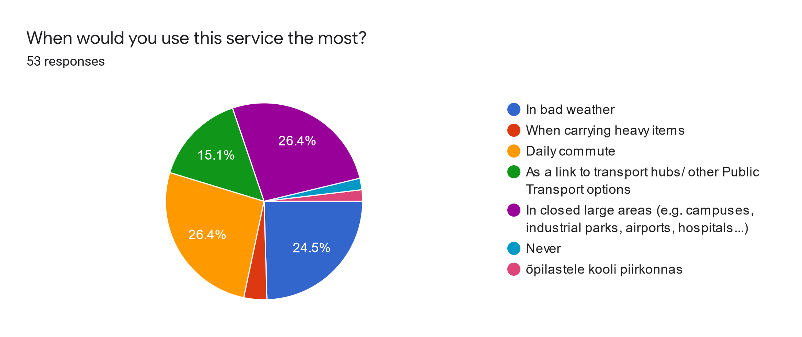
Chart 8: Answers to the question when would passengers use this service the most.

Quite equally the passengers see themselves using self-driving buses for their daily commute (26,4%); in closed areas such as campuses, industrial parks, airports, hospitals etc; and in bad weather (24,5%). Surprisingly the possibility to use the service as a link to transport hubs or other public transport options was not the most popular answer. This could have been affected by the actual area where the pilot took place as there were no visible bus stops close by. As people could choose only one answer, the most preferred option was using the service for daily commute which can include other reasons. Some passengers who gave a different answer added that they would also use it on other occasions.

We asked passengers to rate the overall experience on a scale of 1-5. The average score was 4,44 which we consider very high. While 50% of all participants gave “5” and 46,2% gave a strong “4”, we did have one person giving a “3” and one person giving a “2”. These two people added that “it is not safe” and “I am afraid to drive without a driver”.

Language of driving - the communication between the autonomous bus and other traffic participants
As part of the Tallinn pilot, a survey was conducted among the other participants of the traffic. This mostly includes pedestrians and to a lesser extent the users of light modes of transportation. Visual communication between the traffic participants plays an important role in dealing with different situations. For example, pedestrians rely a lot on visual contact with the drivers to assess whether it is safe to cross the road. As the end goal is to remove operators from the autonomous buses, we also need to re-think how the vehicles communicate with other participants in the traffic. The aim of the survey was to collect feedback on how autonomous buses without an operator on-board should communicate with other traffic participants (Language of Driving - LoD). To receive more in-depth insight, we gathered input through structured interviews which were conducted on the street of the pilot area at TalTech campus. During the pilot, we conducted 176 interviews in total.

Out of 176 people, 50,3% fell into the age group of university students 18-30. Second biggest age group was children under the age of 18 who composed 17,4% of total respondents. 16,8% were 31-45 and 11,4% 46-60 years old. The smallest response rate was from the 60+ age group with only 4,1% of total respondents. 54,5% of respondents identified themselves as male and 45,5% as female. 51,3% of respondents were with a university degree (the pilot took place in TalTech campus area), 30% with secondary education (high school/vocational school) and 18,7% with primary education.

The vehicle can currently illuminate different signalling patterns to pedestrians via its LED lights. A blinking red cross pattern is used when ISEAUTO detects an object that is on its path. It is intended to alert people in dangerous situations. When a driving vehicle detects objects next to or on a crosswalk, it displays animated green arrows before stopping. Green indicates an invitation to cross, stripes indicate that vehicle detects pedestrian crossing and a red cross indicates one should not cross. All signs are displayed on all three panels - one horizontal panel in the middle and two vertical panels on the sides. (See table 1 on the next page).

Trigger | The vehicle is approaching a pedestrian crossing. Pre-defined either by vector map or V2I communication | Objects detected by the sensors | Objects detected by the sensors
Situation | The vehicle is approaching to a pedestrian crossing | The vehicle is approaching the pedestrian crossing and objects are detected on the zebra or near-by | The vehicle is driving on the road and objects are detected close to waypoints or their moving trajectory is about to cross with the vehicle
Visualization

Table 1: LED signalling patterns used by the AV bus to communicate with other participants in the traffic.

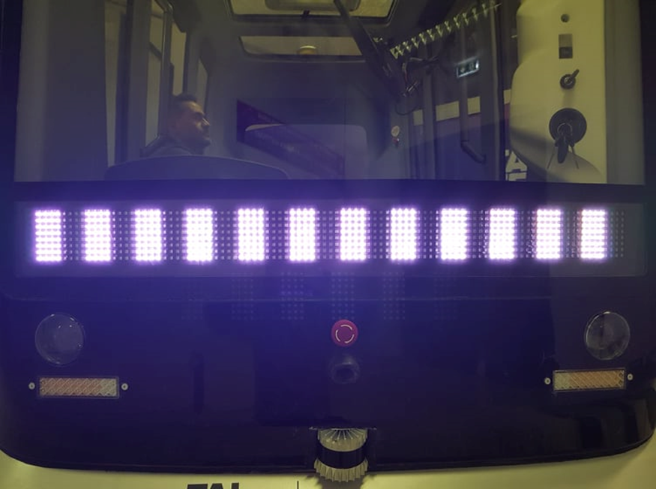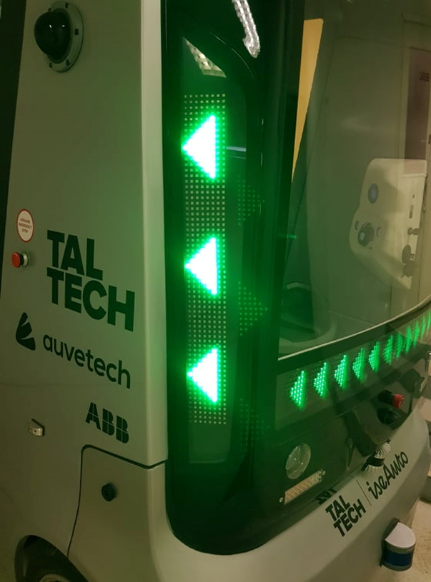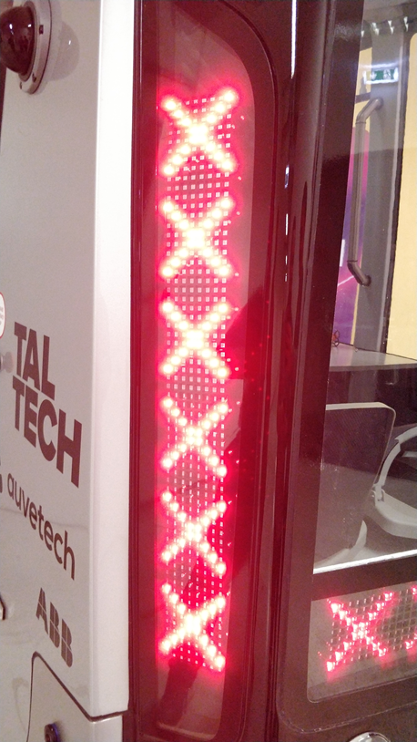
From left to right: Pedestrian crossing (Picture 1); Green triangles indicating that objects have been detected next to the pedestrian crossing (Picture 2); Red crosses indicating that an object has been identified on the trajectory of the bus (Picture 3)
[INSERT “WHITE CROSSING,” GREEN TRIANGLES” AND “RED CROSSES” PICTURE HERE UNDER THE VISUALIZATIONS]

First, we wanted to know how conscious people in traffic really are and whether they even notice that there is no driver in the shuttle that is in their visibility reach in the traffic. The results show that 93,7% did notice it and only 6,3% did not understand that the bus is moving totally by itself.
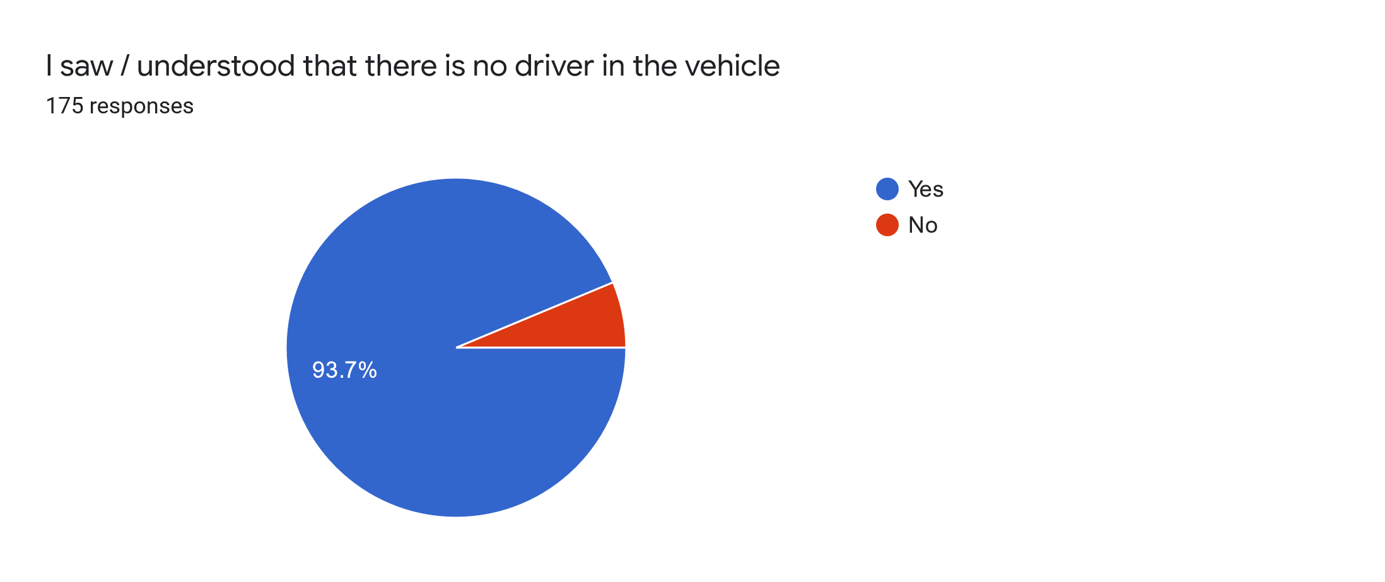

Chart 9: Answers to the question did the pedestrians understand that the bus is moving without the driver.

Interestingly, 68,2% of respondents answered that they were not uneasy or intimidated by the vehicle without the driver in the traffic. Many of them added that the autonomous buses are so slow that if it is necessary, they have plenty of time to step aside or react. While 31,8% of the people answered that they feel uneasy and intimidated while sharing the roads with autonomous vehicles, many of them felt it is just odd and noticeable and thus makes them be more attentive.

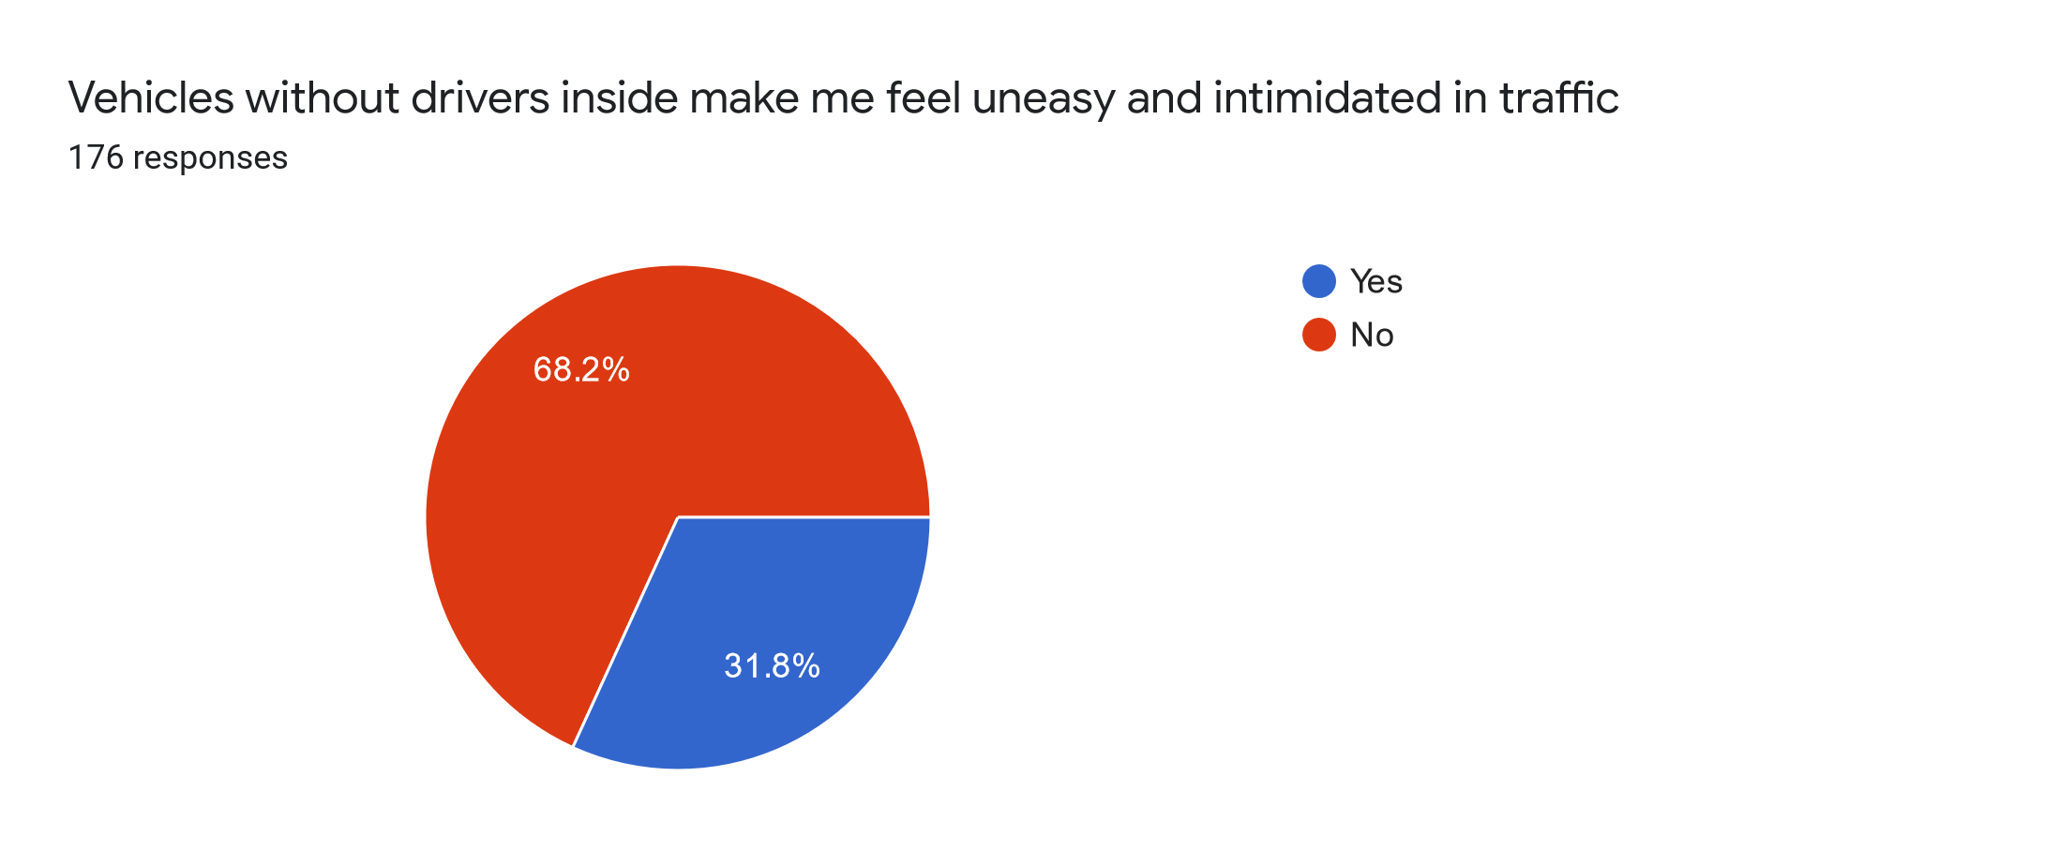

Chart 10: Answers to the question are vehicles without drivers inside making the pedestrians feel uneasy and intimidated in traffic.

On the pilot site, we had one official and one “unofficial” pedestrian crossing. The latter refers to a place where it is convenient for people to cross the road. This gave us a possibility to also address the safety issues related to crossing the road in front of a fully driverless vehicle. We asked about it from two different angles.

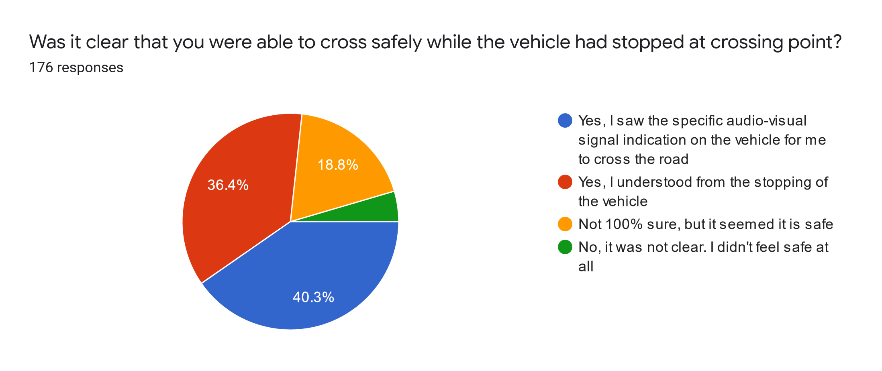

Chart 11: Answers to the question whether it was clear that the respondent was able to cross safely while the vehicle had stopped at the crossing point.

Only 40,3% of the respondents answered that they saw the specific audio-visual indicating that it is safe to cross while the vehicle stopped in front of the pedestrian crossing. 36,4% of the respondents answered they understood that it is safe to cross solely from the stopping of the bus. 18,8% were not sure, although they did cross the road as it seemed safe. 4,5% of the respondents answered that it was not clear at all whether they can cross the road and they did not feel safe to do it. The results show that there is room to improve the audio-visual signals by making them more understandable. It is of utmost importance that people feel safe in such situations as it will also affect the overall perception of safety in traffic with autonomous vehicles.
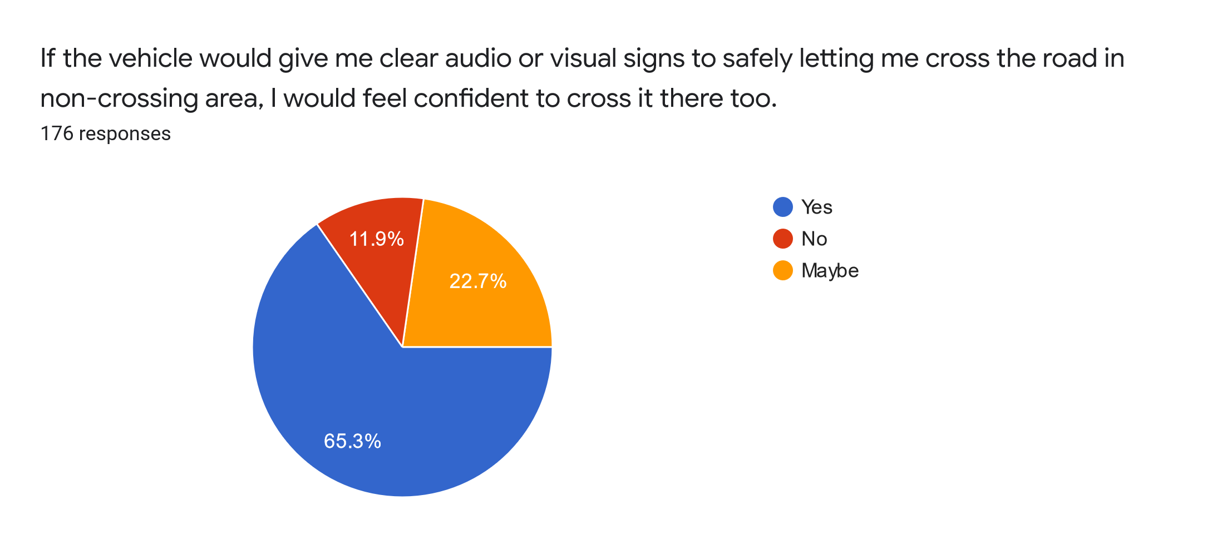
Chart 12: Answers to the question whether respondents would feel confident to cross the road in a non-crossing area if the vehicle would give clear audio or visual signs that indicate it is safe to cross it.

When we asked about whether the respondents would feel confident to cross the street in a non-crossing area while the bus is giving audio-visual signs that it is safe to cross, 65,3% of the respondents answered “yes”. 22,7% answered “maybe” and added that it depends on the overall street traffic. 11,9% were sure that they would not cross the street even if the vehicle gave them the priority and showed that it is fully safe to cross in a non-crossing area. We also have to keep in mind that some people would not cross anywhere where it is not allowed. In addition, 17,4% of the respondents were children which also can influence the results of this question.

For some respondents, our question about who should have control over the vehicle was somewhat confusing. Many of them did not understand what exactly artificial intelligence (AI) is, including its limits and how it makes decisions. Fortunately, as the survey was conducted at the university campus, many of the respondents were connected to the university as students or employees and had a better understanding. Therefore, we did not have to provide a very in-depth explanation over AI to them. Most of the respondents considered AI to be more intelligent than a human, having the knowledge, precision, and even the reaction time faster better and faster than humans do.

61,7% of respondents answered that AI should have control over the vehicle but in more difficult situations such as crossings a remote operator should take over. Over a quarter of the answers indicated that full AI mode is also acceptable. 12% thought that the drive has to be under the remote operator’s control at all times.

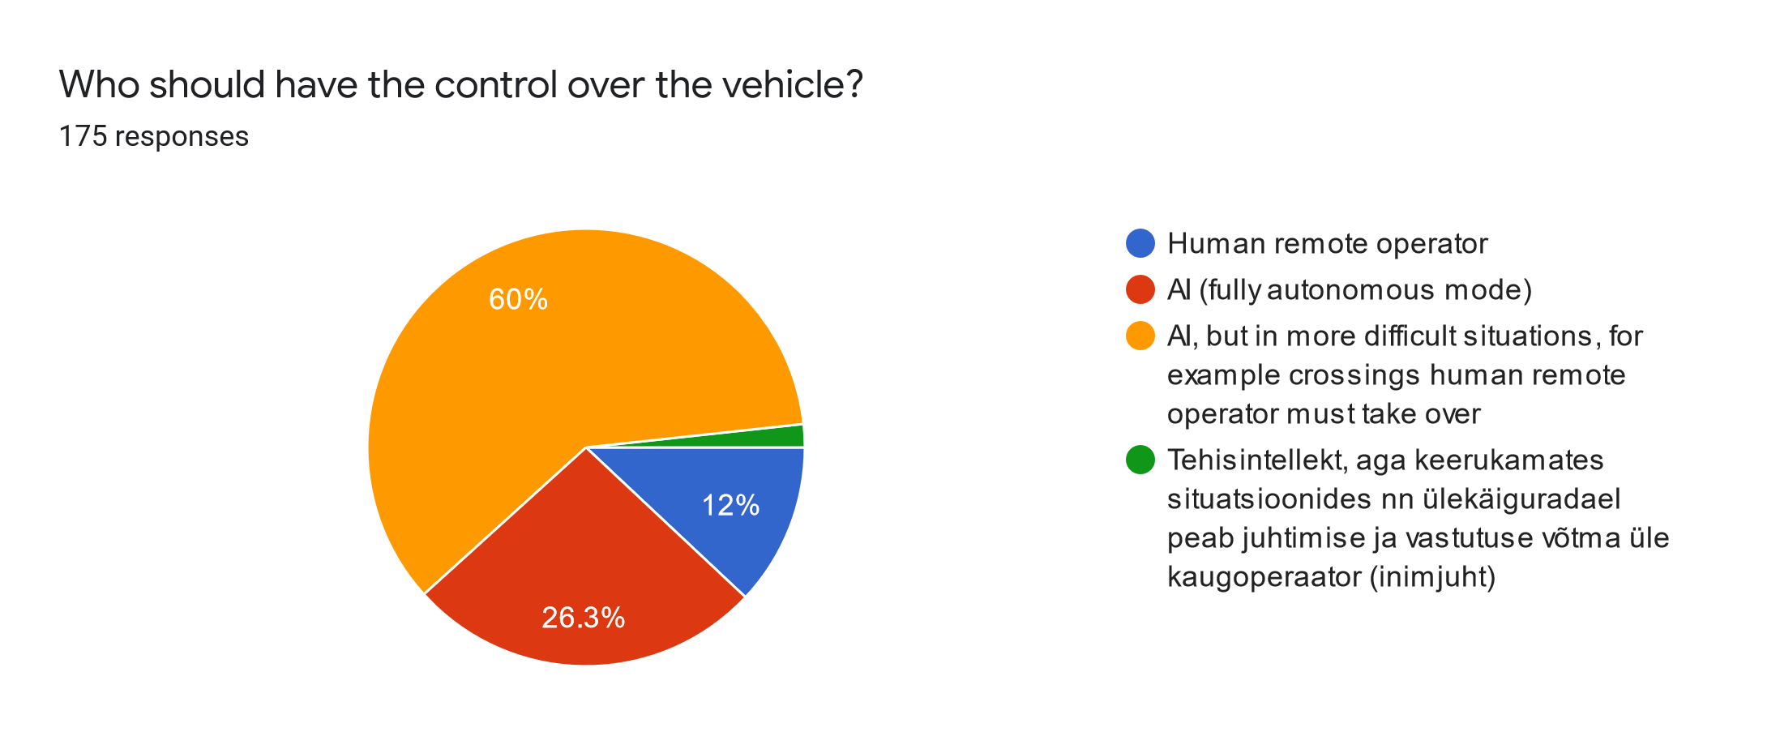
Chart 13: Answers to the question who should have the control over the vehicle.

Additional suggestions

During the two surveys we also got a number of comments as suggestions for the future development of autonomous robot buses:

- Speed - people want the buses to drive faster as this was the most common comment.
- Vehicle to passenger communication:
  - The bus should preferably “talk” in several languages;
  - The bus should be more communicative and explain what and why it is doing (e.g why the bus had a sudden brake);
  - There was a suggestion to play lounge music inside the bus.
- Language of driving:
  - More audio should be used to communicate with other participants in the traffic as the signs shown in Table 1 were not fully understood or it was hard to see them under the direct sunlight. The audio text should also be shown on the screen(s) as it can be hard to hear it in the traffic;
  - Some suggested using only text instead of the signs in Table 1.
- Design:
  - Both the interior and outer design should be more appealing;
  - The use of brighter colors was recommended to better differentiate AV buses from the regular vehicles.
- Smart bus stops and the size of the bus:
  - The one who orders the bus should also be the one who gets in as these shuttles are quite small in size, taking up to 6 people;
  - The size of the bus should be bigger and at least for 10 people.
- Passenger and traffic safety:
- Worry about not having a safety operator was expressed as some passengers or even vandals might break the bus;
- Passengers also worried about the missing seatbelts which can easily be added and according to the law should be there if there is a wish for such buses to be operated in the open traffic.

III REPORT ON THE COMMUNICATIONS NETWORK REQUIREMENTS FOR REMOTE-CONTROL DRIVING AND THE EVALUATION OF 5G NETWORK ADVANTAGES BASED ON REMOTE CONTROL PILOTS OVER TALTECH 5G (OUTPUT 2.1.3 AND 2.1.4)

The teleoperation of self driving cars and using 5G network for it
5G has been publicly lauded for offering very high speeds and very low latency. In our pilot we tested 5G for controlling the bus and we also measured the speeds and latency of 5G in 11 different points and compared it to 4G in the same points. RSSI measurements were made for 4G but no such measurements were possible for 5G due to our technical limitations.

As was previously mentioned, we rarely had the need for teleoperating the bus and when we did have the need, no issues arised. In general, teleoperating happens in difficult, non-standard situations and in most cases these situations occur on a fairly small amount of space. A wrongly parked car takes 5 meters of road space, a construction vehicle might take 15 or 20 meters. Once these obstacles are passed, the bus resumes autonomous driving.

In our tests we found an upload speed in the region of 40 Mbps and a download speed in the region of 40 Mbps to be sufficient for teleoperation. Having bigger upload and download speeds do have a small effect on the overall experience of the teleoperator and lower the latency a bit but making sure that each part of the track has adequate internet coverage is more important than having extremely high peak speeds. As a general rule, RSSI of -67 dB to -70 dB is good, -80 dB is very weak and -90 dB is as good as non-existing. It is worth mentioning that RSSI is measured in decibels, which is a logarithmic scale, so -70 is actually two times less than -67 and -80 is ten times less than -70.

Information about the operating track
The track, with the access road from the garage to the operating site is almost 600 m long and has several critical points for teleoperating. The five main points of attention are the two crosswalks, a small intersection and two bus stops. The network coverage at these points is critical, which is what is going to be looked into in this part of the report. The track consists of two parts, the main operating road (points 1-7 see below) and the road from the university to the main road (points 8-11).

Information about the measuring process
The measurements were taken on two separate days with a 26 hour interval. The distance between two consecutive measuring points was about 50 m. Three measurements were taken in every point with a 12 minute interval both in the Telia 5G and 4G network. The results shown in the document are averages. On both days the weather was cloudy.

Picture 4: Measurement points as shown on a map.

Description of the measurement points
1. Bus stop, right next to a building
2. Before a crosswalk, under the trees
3. Crosswalk, next to a building
4. Near the dormitories, no confounding factors
5. Gate for the dormitories parking lot, no confounding factors
6. Crosswalk, no confounding factors
7. Bus stop, no confounding factors
8. Stop sign at the sidewalk, some trees and buildings
9. Sidewalk, on a curve, behind the U06 building, under the trees
10. Behind U06, next to the building
11. On a sidewalk, under the trees

Measurement results

 |  | 4G |  |  |  |  |  | 5G
Point nr | Download Speed  (Mbps) | Upload Speed  (Mbps) | Latency  (ms) | RSSI  (dbm) |  | Point nr | Download Speed  (Mbps) | Upload Speed  (Mbps) | Latency  (ms)
1 | 74.9 | 38.2 | 14.7 | -77 |  | 1 | 440.1 | 38.4 | 12.7
2 | 80.0 | 44.7 | 15.3 | -67 |  | 2 | 744.2 | 43.9 | 10.0
3 | 82.2 | 40.8 | 15.0 | -69 |  | 3 | 763.3 | 45.1 | 10.7
4 | 77.7 | 44.2 | 16.0 | -65 |  | 4 | 707.7 | 46.2 | 10.3
5 | 82.3 | 43.1 | 16.3 | -67 |  | 5 | 793.3 | 47.5 | 10.0
6 | 85.1 | 42.1 | 14.7 | -72 |  | 6 | 771.5 | 43.9 | 10.0
7 | 84.5 | 39.8 | 14.0 | -73 |  | 7 | 760.8 | 47.6 | 10.3
8 | 58.7 | 27.4 | 16.3 | -75 |  | 8 | 84.1 | 31.7 | 16.0
9 | 40.6 | 19.6 | 14.3 | -93 |  | 9 | 58.8 | 15.4 | 17.0
10 | 28.3 | 11.5 | 17.7 | -97 |  | 10 | 31.4 | 11.7 | 15.7
11 | 63.1 | 30.7 | 14.0 | -87 |  | 11 | 131.6 | 21.1 | 10.7
Table 2: Measurement results

Interpretation of the measurement results

From the result it’s clear to see that 5G coverage is several times better on the actual route of the bus (points 1-7) than it is on the service road (points 8-11), while such a distinction can not be drawn in the case of 4G, where download speeds do not differ in orders of magnitude and upload speeds, while slower, are still not two or three times slower than in the case of 5G. Points 8-11 are on a road that is between a six storey building and a similarly high forest. Clearly this has had a negative impact on the signal and the negative impact is much, much stronger in the case of 5G than it is in the case of 4G. This massive deviation in 5G speeds that is directly related to the physical geometry of the operational area is quite alarming. As it was previously pointed out, an upload and download speed of 40 Mbps has proven to be good enough in our tests. Average upload speeds of 11-31 Mbps (points 8-11) clearly do not live up to that standart. While it did not cause any problems for us, because the bus was never teleoperated on or near those points, it still is worth mentioning that network speed and latency values that are provided by the ISP are theoretical and can massively differ in the real world. This issue can be mitigated by having several tactically placed 5G masts to make sure that there is enough coverage all along the route. In our operations we did not find any use cases that dictated or required that we must use 5G because 4G was not fast enough, however 4G was more stable than 5G, so unless the aim is specifically to test 5G, we suggest using 4G as it is good enough for our requirements. To give an idea of what a spot with high speeds and low speeds look like, we have added a few pictures:

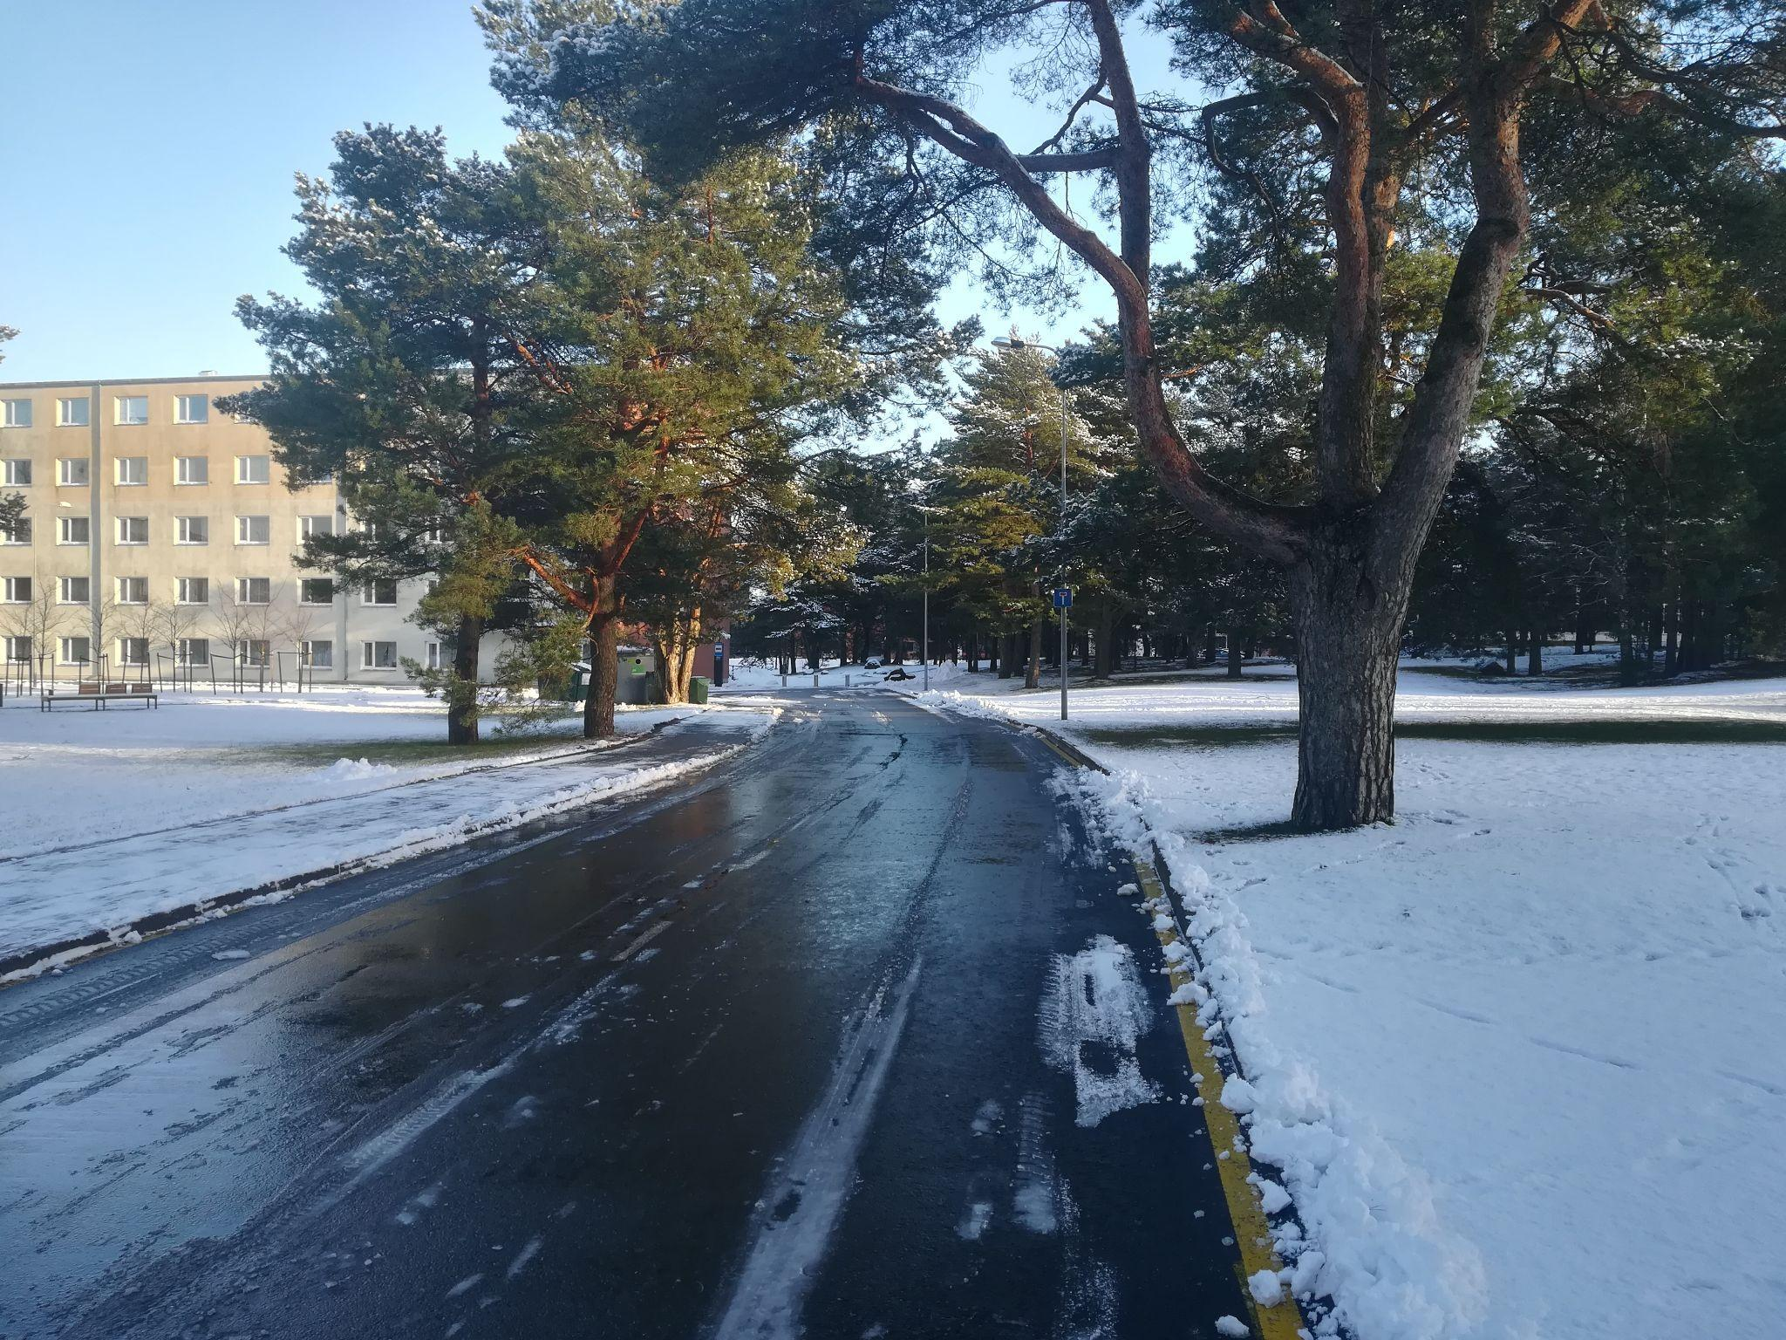
Picture 5: Measuring point No. 2 with good connection.

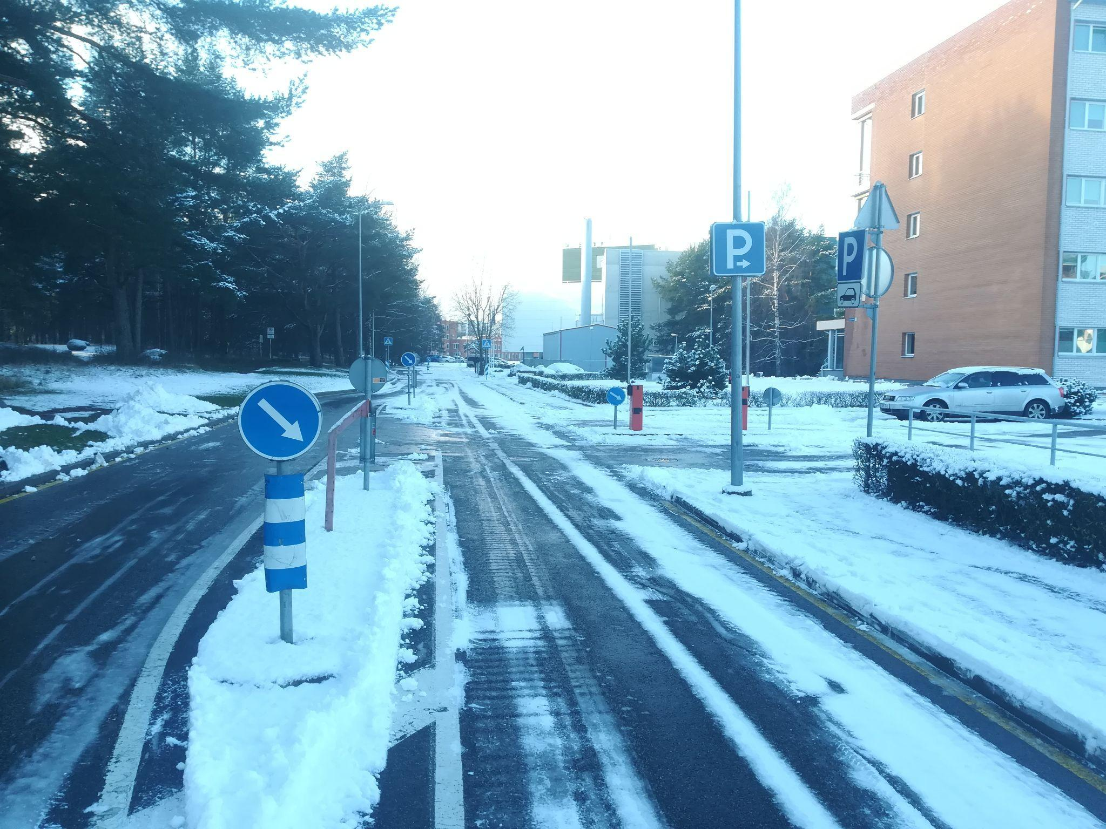
Picture 6: Measuring point No. 5 with good connection.

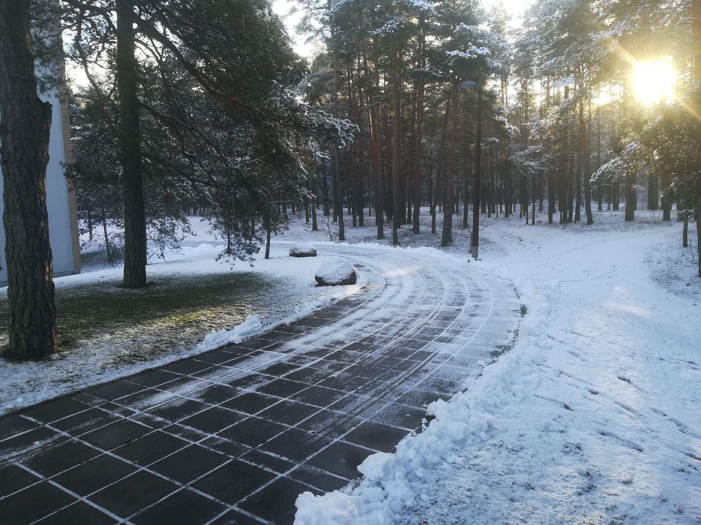
Picture 7: Measuring point No. 9 with bad connection.

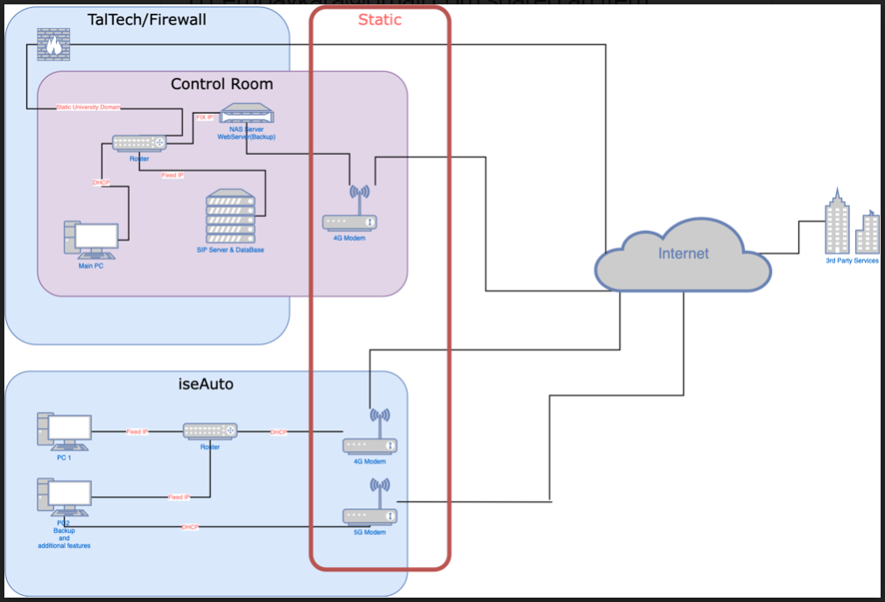

Picture 8: Scheme depicting communication between the control room and Iseauto.

Vehicle to infrastructure communication

In cooperation with Tallinn Transport Department, two smart bus stops were installed on the route to test vehicle-to-infrastructure communication. The smart bus stops run on solar power and do not need any extra installation, drilling, welding or securing to the ground, which makes installing it fairly simple. The bus stop comes with a 90kg concrete weight at the bottom of it which works as a stabilizing ballast against adverse weather conditions or simply people trying to push the bus stop over as a practical joke. The bus stop connects wirelessly to the other parts of the infrastructure.

The bus stop has a monochrome e-ink paper display and five programmable buttons. The display can be used to display various information, for example, the live location of any bus that is a part of the system, the possible bus stops, the waiting times for the buses, information about local events or any information regarding the ordering of the buses. The screen itself is not a touch screen, so all the commands are given through the five buttons - this makes the system easy to use for the part of the population that is not used to using touch screens.

In our operations, we created the back end on which the system worked, registered the inputs of people in the bus stops and displayed the live location of our bus. The system needs more testing on a bigger scale, as there are some questions that could never have risen during our pilot. For example, if you have one bus operating you will never have the question of which bus should come and pick up the client. Similarly, if you only have two bus stops and the client is in one of them, you never run into the questions of where does the passenger want to go and what is the best route to take. In addition, boarding the bus can create conflicts, especially if the bus is almost full. Let’s imagine a situation where a public transport user presses the button available on the smart bus stop to order the bus. The person is later joined by several other public transport users who arrive at the bus stop before the bus arrives. However, the bus is almost full. The question of how to ensure the “first come, first served” principle is something that definitely needs to be resolved. This is especially the case when we think about the more vulnerable groups such as kids and elderly people.
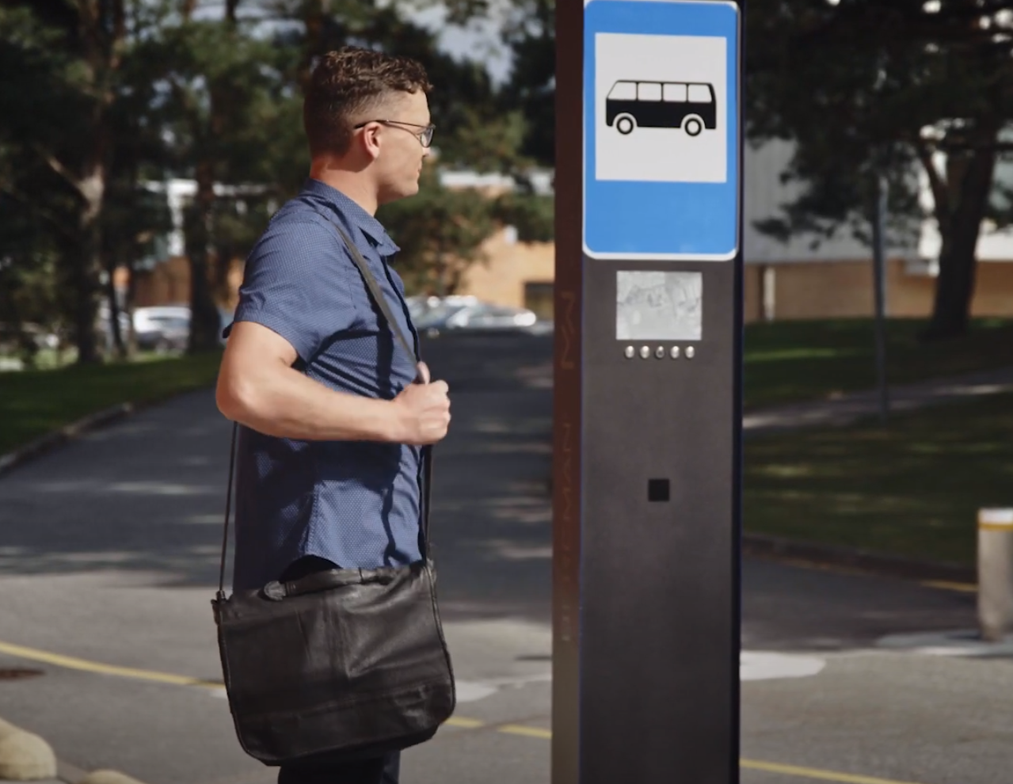Picture 9: Smart bus stop.

