T1 Creating Digital Tools and Assets
Development of Model of Storytelling using immersive technology (activity T1.2.1)
This document reveals and discusses the narrative features of immersive technology marketing products and promotes various approaches that need to be integrated into a development plan for immersive solutions that can help marketers to optimize their campaigns and enhance various types of consumer engagement.

Ulster University

Table of Contents

OVERVIEW 3
Immersive technology definitions 3
Virtual Reality (VR) 3
Augmented Reality (AR) 4
360-Degree Video 5
IMMERSIVE TECHNOLOGIES AND MARKETING 7
A GUIDE TO DEVELOPING IMMERSIVE TECHNOLOGY MARKETING SOLUTIONS 14
Designing AR experiences 14
Designing VR Experiences 21
Challenges for VR 25
IMPLEMENTING AN IMMERSIVE TECHNOLOGY STRATEGY 26
Budgeting for an immersive technology strategy 26
VR experience design costs 26
VR experience development costs 26
AR experience design costs 27
AR experience development costs 27

OVERVIEW
What are immersive technologies?
- Immersive technologies include 360-degree filming and augmented and virtual reality technologies, and are used to create unique storytelling experiences that blur the line between the digital world and the physical world.
- Using these technologies, businesses can communicate to, and entertain customers with innovative stories about their business and the product or service they deliver.
What can Immersive Technology deliver for business?
- Immersive technologies have a host of benefits for business. Immersive environments let users explore products, processes, and services in the context of how they are used. This helps to create a positive engagement with the brand and deliver content that is tailor-made for individual customers. Creating a high brand value automatically generates more business over time and also helps to retain more customers.
- In addition, immersive technologies have the potential to create more precise analytics that track customer data more accurately and reliably, on the basis of which you can frame your campaigns accordingly.
- Having the knowledge and ability to use immersive technologies effectively, can ultimately empower smaller businesses to produce higher quality marketing content at lower cost.
- Using these technologies, businesses can communicate to, and entertain customers with innovative stories about their business and the product or service they deliver.

Immersive technology definitions

Virtual Reality (VR)
Virtual Reality creates a digital simulated world that the user is fully immersed in from a visual perspective, generally through a Virtual Reality headset.
The arrival and increasing accessibility of VR applications pose yet a new set of opportunities and challenges related to marketing management. The launch of several commercial VR head mounted devices, such as Samsung Gear, HTC Vive, PSVR and Oculus Rift, are enabling businesses to exploit and embrace the creative potential inherent in this innovative technology. The release of more accessible products such as Google Cardboard, which is open source, allows customers to adapt their mobile devices into immersive headsets and affords companies the ability to customize and brand the devices to help in campaign integration, brand awareness and visibility.
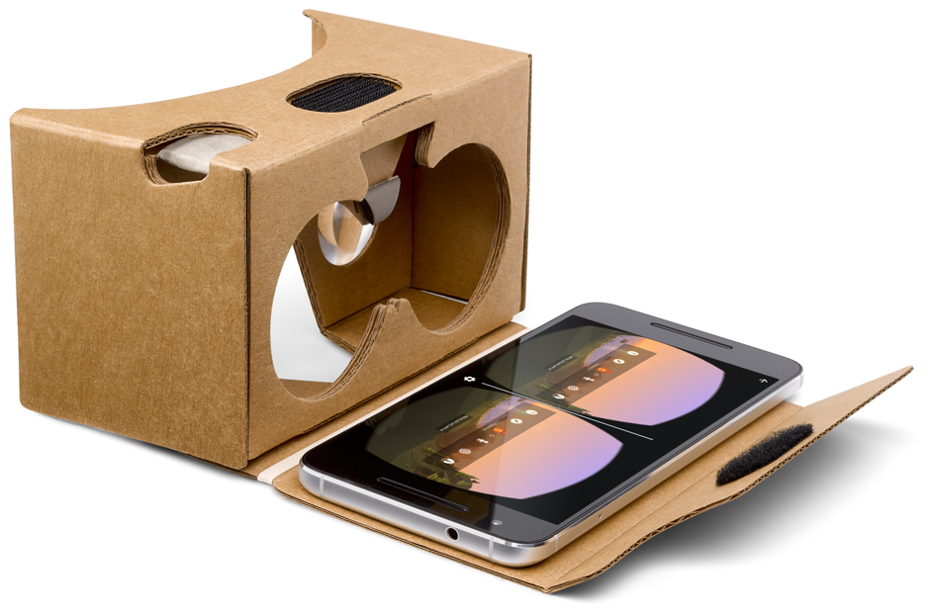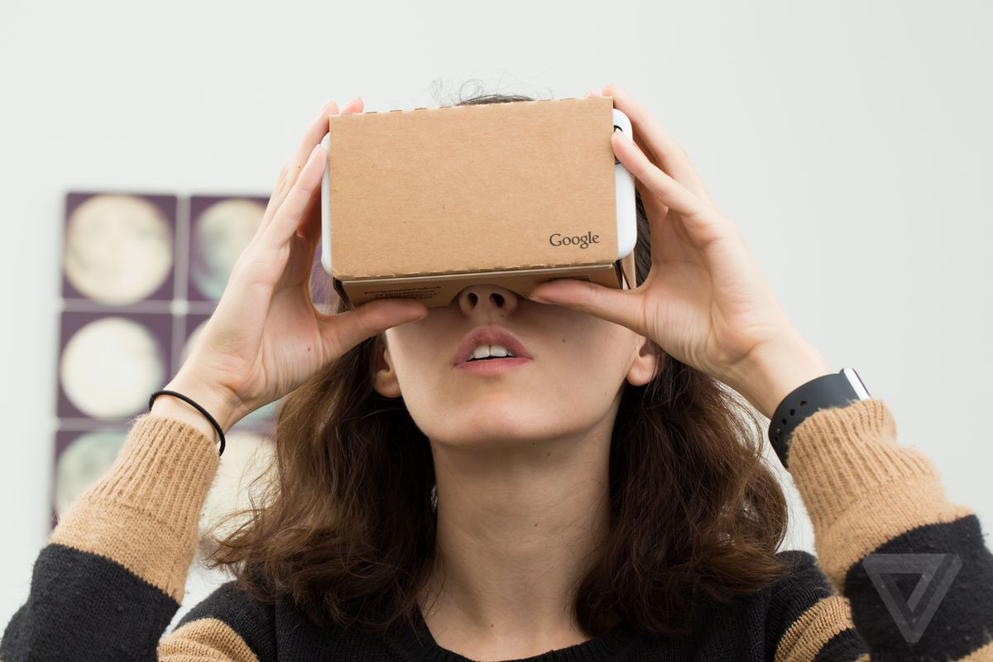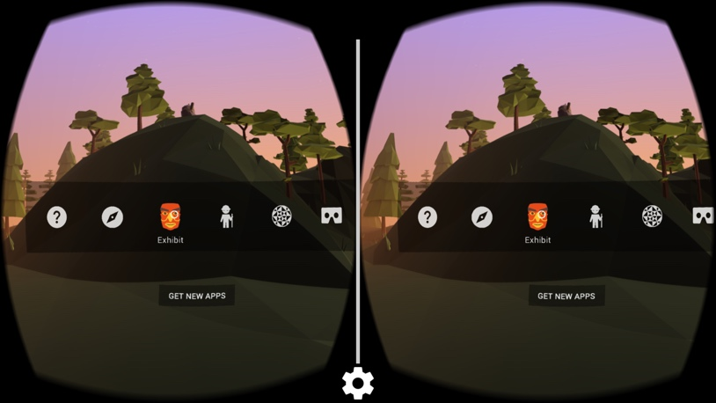
Coca-Cola, Volvo, Disney, and General Electric are just a few of the increasing number of firms that are seeking to employ VR for marketing purposes including product development, product promotion and product trial. VR for marketing can then happen at different scales and depths, in showrooms with high fidelity showcases, full body immersion and huge amounts of interaction, or in smaller, more nibble ways using mobile devices and branded cardboard headsets which allows wider adoption and interaction, but usually at low fidelity, with smaller scale interactions, and reduced immersion.
However, adoption of VR for marketing purposes brings with it a set of challenges. These challenges involve, but are not limited to, the considerable time and technological investments required for firm and customer adoption, ethical considerations and financial costs.
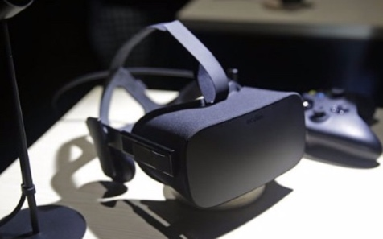
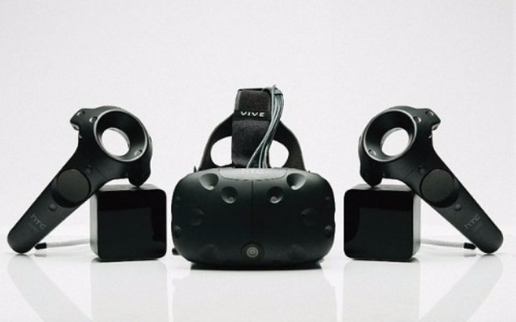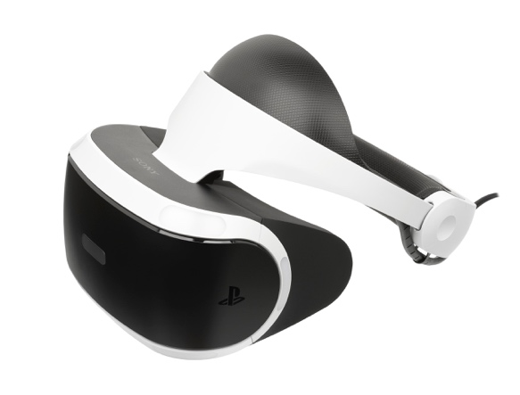

Augmented Reality (AR)
Augmented Reality is the integration of digital information or brand assets with the user's environment in real time as a digital overlay. Unlike virtual reality, which creates a totally artificial environment, augmented reality uses the existing environment and overlays new information on top of it.
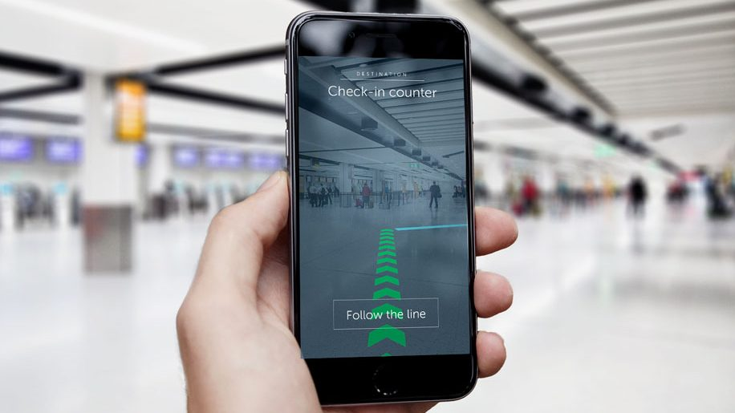
Example: Wayfinding in airport using AR and beacon technology

Much like VR, Augmented Reality can be experienced at different scales and depths. There are a number of commercially available AR headsets such as the Microsoft Hololens and the Magic Leap in which the users use goggles or a visor to view the content and interact with the brand experience. These high-end experiences also allow gesture control, body tracking and advanced types of interaction with the experience which can be used to interact with and promote the brand experience. More commonly AR is experienced with a mobile device such as a smart phone, where an app takes a live feed from the devices camera and adds additional content to the live feed using markers, the users location, image recognition or other data inputs to position the content. This can be used for information overlays, narrative content, playful experiences or adding brand identity to images through asset overlays.

360-Degree Video
360-degree video is an engaging and immersive type of video content which allows the viewer to move around the camera without limits, giving them control of what they see. The video is shot using a special camera which captures the surroundings or is created as an immersive animation. The video is usually linear and the user can move the camera either by clicking and dragging in a browser window, moving their mobile device if viewed on a mobile, or looking around the scene using a VR headset. The video is mapped on the inside of a virtual sphere, like an inverted globe, and the user can move the camera to direct it at points of interest. Audio, and lighting are usually used to direct the users attention to areas of interest in the video.
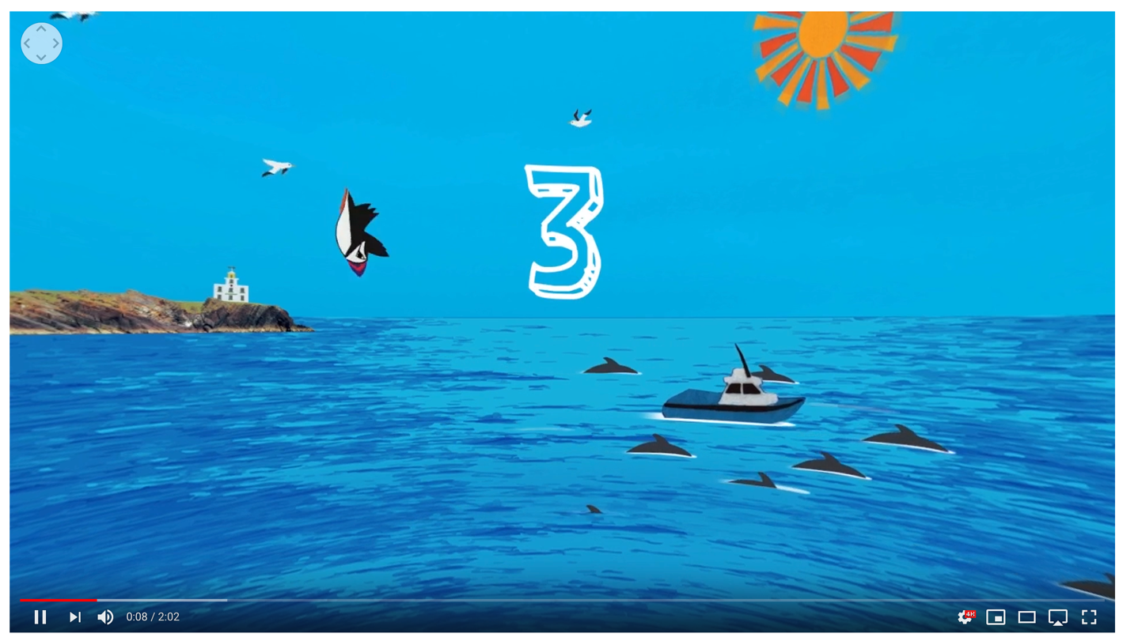
Example: 360 Animated Video on Youtube which gives a 360 immersive experience.

IMMERSIVE TECHNOLOGIES AND MARKETING
Immersive technologies can be used to:
- Demonstrate product attributes, features, functionality
- Communicate the brand’s mission at point of sale
- Immerse users in a branded entertainment experience
- Help consumers make more informed choices so they’ll be happier with their purchases
- Add a new, more immersive and exhilarating dimension to traditional print and video story-telling
Demonstrate product attributes, features, functionality
Travel/tourism companies are using a “try before your fly” approach to marketing destinations. The Wildlife Trust of South and West Wales has produced two VR videos, which immerse potential visitors into the Teifi Marshes Nature Reserve in 3D glory. Among tourists who have watched the videos, 85% say they intend to visit Wales—a good conversion rate, especially for an out-of-the-way destination. This is a good example of B2C immersive marketing.

Example: Wild Wales Adventures and Legends offers a 360 immersive video of tourist attractions
Key Technology worked with the Stein IAS agency to develop a immersive expo experience for their new VERYX Technology, a digital sorting platform. The company developed a VR Experience for expos in which they created a computer generated version of the sorting machine in VR and created a short 360 video experience to showcase the product. The video showcase video gives key features and technical spec and then the user flies through the machine, becoming a green bean to be sorted by the machines sorting technology. This video is then used as an immersive experience for headsets at exhibition stands, and then released online as a 360 promotional video allowing interaction at different scales by the audience. This is a good example of B2B immersive marketing.

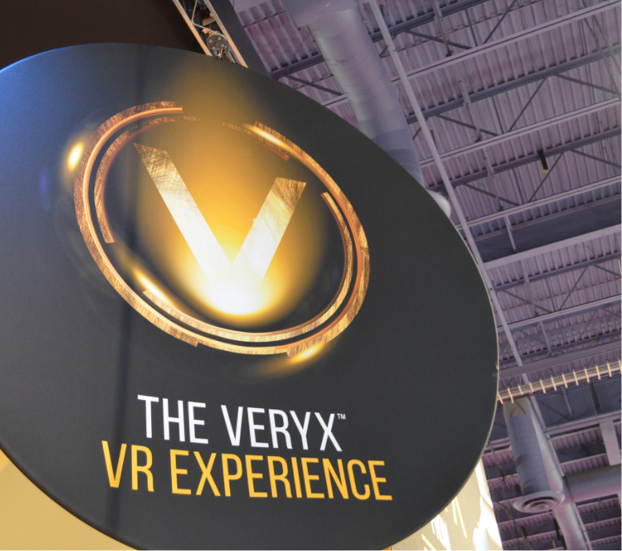

Example: VERYX used VR to create immersive CGI experience and expo materials

Communicating the brand’s mission at point of sale
Tom’s in-store virtual reality chair, connecting customers to Tom’s giving mission. The VR experience transports customers to a remote village in Peru where you experience a giving trip. Tom’s are a well know show brand which donates one pair of shoes to a child in need, for every pair purchased by a customer. This immersive story helped to communicate this core brand ideal, and allowed the customer to feel a part of the journey. This deepens brand engagement and communication of the brand values to customers.
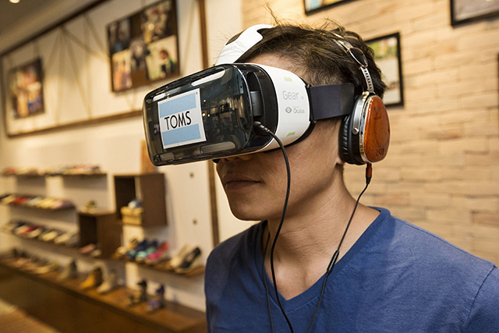
Example: Tom’s use VR to promote their giving mission to customers on location to help commitment to purchase while in store
Immersing users in a branded entertainment experience
Rather than viewing a 360-degree VR video distillery, consumers take a roller coaster-like ride from the perspective of Jim Beam’s bourbon. They start in the pipes of the bourbon still, traveling through a rack house, a flaming barrel lid, into a barrel and eventually, being poured into a shot glass. When users take off the VR headset, the virtual shot glass has become a real shot glass with a sample ready for them to drink. Jim Beam have embraced VR early because today’s consumers are surrounded by technology and it’s an integral part of their daily lives. As a result, consumers’ needs and desires around brand engagement have changed. They are looking for brands that can be integrated into their daily lives.

Example: Jim Beam Immersive Tours uses VR to give an enhanced visitor experience
In 2014 clothing brand Topshop used Immersive Technology to emphasise its relationship to high fashion and promote brand association with its ‘be there’ campaign which installed seats and VR headsets in one of its large London stores on Oxford Street. The headsets live streamed footage from the front row seats at London Fashion Week, allowing users to feel as if they were on the front row of the event, right next to the catwalk. This event based, and live experience of VR gives a unique entertainment experience for its users, and also a popular exhibition for their front of house to attract in new customers to store locations. The brand has also experimented with entertainment experiences with this installation of a VR Waterslide experience in Oxford Street.

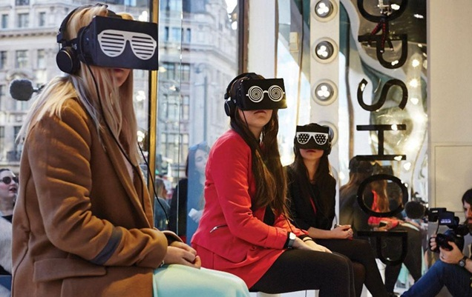
Example: Topshop use immersive experience and live streaming to offer in store visitors a unique experience and increase instore footfall

Helping consumers make more informed choices so they’ll be happier with their purchases
Lowe’s Home Improvement AR app enables customers to visualize the company’s products within their own home. Lowe’s have also rolled out a new VR tool to help customers become confident with DIY projects. In the Holoroom customers can perform projects in a virtual environment before trying them in their homes. Holoroom makes use of VR to overcome a major marketing hurdle. If customers are more comfortable using the company’s products, they will be more likely to buy the company’s products. This experience was used for product placement, upselling and brand visibility, but its primary focus was on building customers confidence in completing common DIY work. The experience was tested against traditional ‘how to’ videos and users had a 36% increase in their ability to recall what they needed and what they needed to do to complete the tasks.
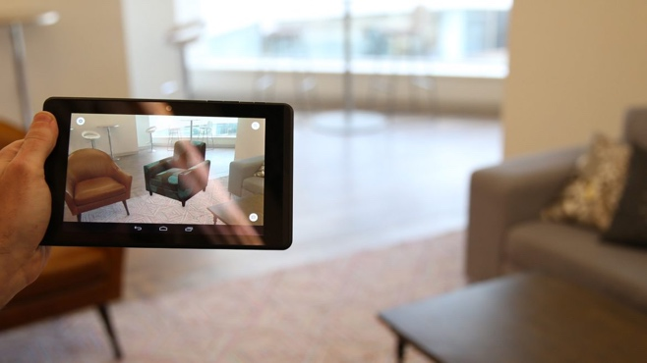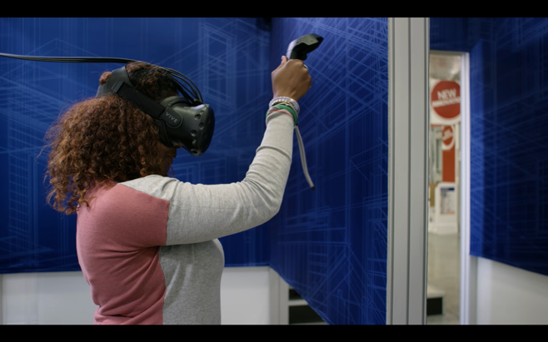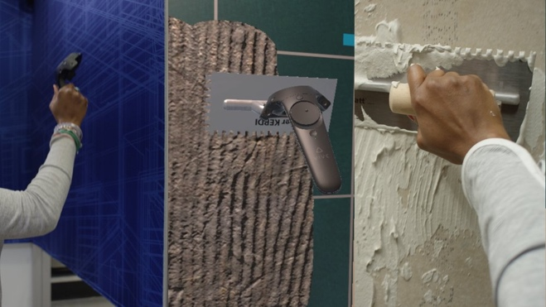

Specsavers, a UK based optitions and glasses company have experimented with AR technology. Their Frame Styler experience allows users to use their web browser and web camera to create a virtual 3D scan of their face. The experience then uses facial mapping to assign a face type to the user, and suggest selections of frames which would suite their face shape. In the browser the usr can then see these glasses from multiple angles and then see them on their face, mapping them onto the prerecorded video. As a browser based experience this works both through a desktop computer, but also on a smart phone.
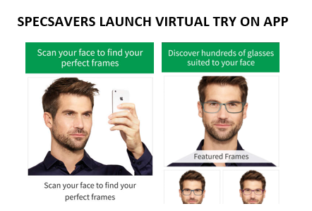
Example: Specsavers offers a cross platform, cross browser experience to help customers try on glasses before purchase from any location.
Adding a new, more immersive and exhilarating dimension to traditional print and video story-telling
Smartphone manufacturer OnePlus developed a VR space station to launch its latest handset. As part of the campaign, 60,000 people were ‘beamed up’ to the space station where they learnt about the phone and its features. Within six hours, the conversion rate was an impressive 30%, giving a very promising return on investment.
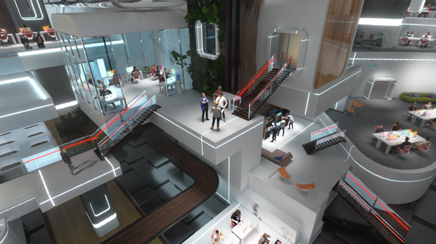
Example: PlusOne created a virtual space station to help customers asscoiate their brand with future living.
Design agency Trekk worked with the well established paper company International Paper to rethink their approach to engaging customers with print collateral. The company created a series of news letters and sales brochures which gave information and tutorials on their products. The print materials where enhanced with AR which gave additional content to make the technologies come to life. The agency then extended the campaign for the expo at one of the sectors leading conventions Adobe MAX. to extend the campign the agency developed a series of collectable, cut and fold characters for International Paper, that visitors collected over the 5 day event. Each character would then come to life in different ways using their AR app.
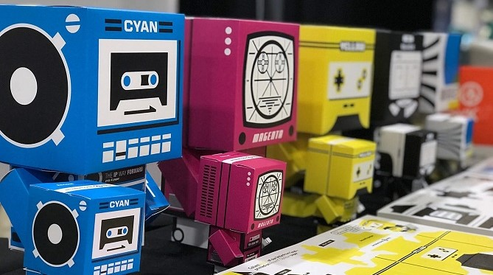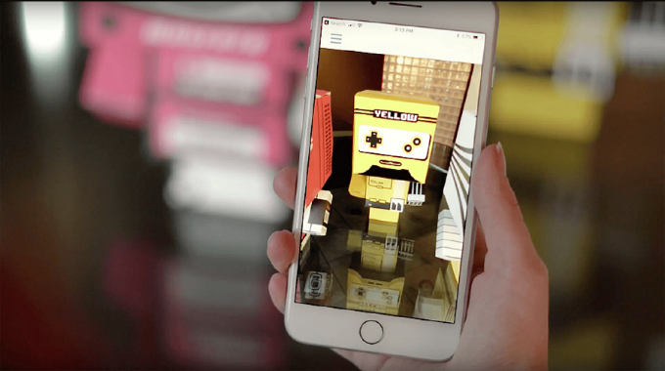
Example: International Paper created unique, collectable AR markers for trade shows what were desirable objects but worked as AR triggers.
Showing how a brand can fit into an aspirational lifestyle
In an effort to attract millennials, Mercedes-Benz engaged Kelly Lund, who loves sharing outdoor adventures with his Wolfdog, Loki (a YouTube and Instagram sensation), to create a special 360-degree VR video of their trip to the snowy mountains of Colorado. (MB & Loki 360-degree film). Loki’s 2D and 3D videos have earned more than 4 million video views across platforms and nearly 80 thousand social media engagements. As a result of the campaign, MBUSA’s Instagram followers grew by 57,000, and today, slightly more than 40% of visitors to MBUSA’s site are between 18 and 34.

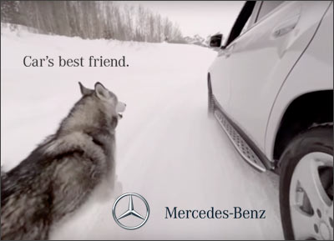
Example: Mercedes-Benz teamed with influencers to enhance the brand identity and target new markets using immersive experiences.

A GUIDE TO DEVELOPING IMMERSIVE TECHNOLOGY MARKETING SOLUTIONS
In providing a model of best-practice for developing immersive technology marketing solutions, this framework addresses the following questions:
- What should marketers consider when designing immersive experiences?
- How and when should marketers co-produce these experiences with consumers?
- How can marketers craft compelling immersive experiences that tell brand narratives, create value, and engage consumers?

Designing AR experiences
These five ingredients–—AR content, users, targets, bystanders, and background–—are the building blocks required to design and optimize AR campaigns.
They need to be considered first when making basic design decisions about how an AR campaign is accessed, populated with content, and experienced by users in their current context.
Marketers can then leverage the dynamics between these five ingredients in order to increase the efficacy of their AR initiatives.
- Define your target audience and communications objectives (establish campaign goals);
Do they want to create awareness for a new product, convey product knowledge, create emotional experiences, or cultivate communities and relationships?
- Determine how the AR layer will be activated for users (trigger);
Each individual user will engage in some deliberate action to activate the AR layer, such as scanning an active print advertisement in a magazine with a mobile device. Here, the user is in control over when and often where an AR layer is activated; this is likely to make users feel more positive about the AR content and explore it in further detail.
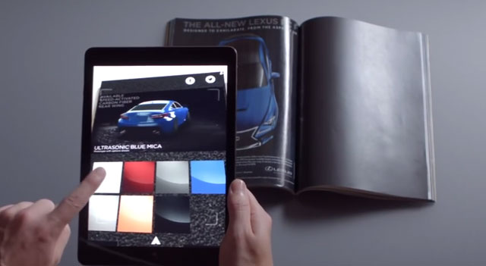
Example: Lexus use print advertisement to trigger their vehicle configurator via AR
Conversely, marketers can trigger an AR layer for consumers, putting the marketer in control of who participates in an AR experience in a particular time and space. For example, the National Geographic Channel installed large screens across malls in Hungary and Belgium to create an AR experience in which shoppers were able to stand with and pretend to touch virtual cheetahs, dolphins, and astronauts. When marketers trigger the AR layer, consumers need not take deliberate action, which decreases the friction of initiating AR experiences. Thus, this type of trigger is particularly useful when the communications objective is to create awareness.
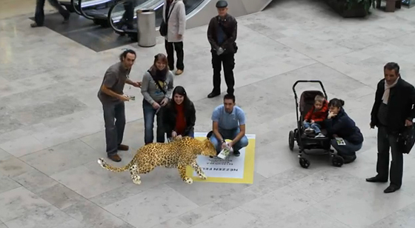
Example: National Geographic large scale AR experience removes barriers to participation

- Regulate how, and by whom, the AR layer will be furnished with targets and AR content (content contribution);
The concept of content contribution describes who is authorized to furnish the AR layer by adding targets to the AR content. In most cases, targets and AR content are controlled by a small group of people who tightly control the AR experience. It is more important to tightly control the AR experience when the objective of the campaign is to accurately convey information, of when a marketer is concerned that unregulated generated content might undermine the authenticity and identity value of a branding story.
Alternatively, content may also be co-created by a wider range of users who are encouraged to make their own contributions or to modify existing digital content. For example, AR graffiti apps (e.g., Street Tag, Tagd) turn the physical world into a digital canvas in which consumers can leave messages or images on walls and public landmarks. Marketers may allow for the co-creation of content in order to empower consumers, cultivate brand communities, and stimulate advocacy. However, they should retain some control by developing community and content management policies to govern which users can contribute content, what types of content can be contributed (e.g., text, pictures, videos), and what type of content will be most valued and prioritized for display (e.g., consumer-rated, new, brand consistent). Marketers should also devise plans for how the community or marketer will deal with inappropriate or brand-critical content in ways that do not damage the reputation of the brand.
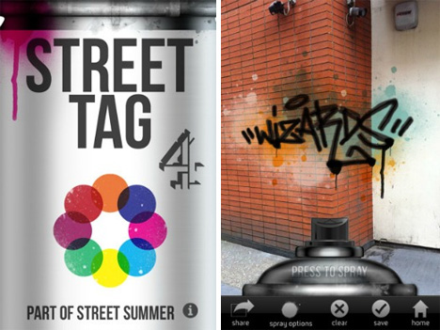
Example: Channel 4 developed an AR Graffiti App as part of their marketing for ‘Street Summer’ – a celebration of street art, hip hop and urban culture.
In terms of step 2 and step 3, these decisions profoundly shape the user experience and the amount of control marketers have over the AR campaign.

- Establish how the AR layer will integrate with specific social and physical contexts (context integration).
When deciding on how much an AR campaign is integrated with its surrounding social and physical contexts, marketers should keep in mind their communications objectives and the user experience they wish to offer. They should also consider constraints, as high levels of context integration typically require more planning, technical capability, and money.
In some instances, marketers may wish to not integrate their experience into the surrounding context. For example, they may be able to save resources and still achieve their objectives of providing information and generating an emotional response by digitally layering a video over a product package. Such a video could be viewed almost anywhere with little change in the meanings it conveys, making it potentially easier to plan and execute.
On the other hand, marketers may wish to take greater advantage of AR’s unique potential and integrate digital information more completely into the physical world. For example, IKEA recognized that consumers who buy new furniture for their homes often face insecurity over how the new item will fit into their existing arrangements and designed spaces. AR has the unique ability to visually demonstrate how a new item would complement such existing consumption constellations.

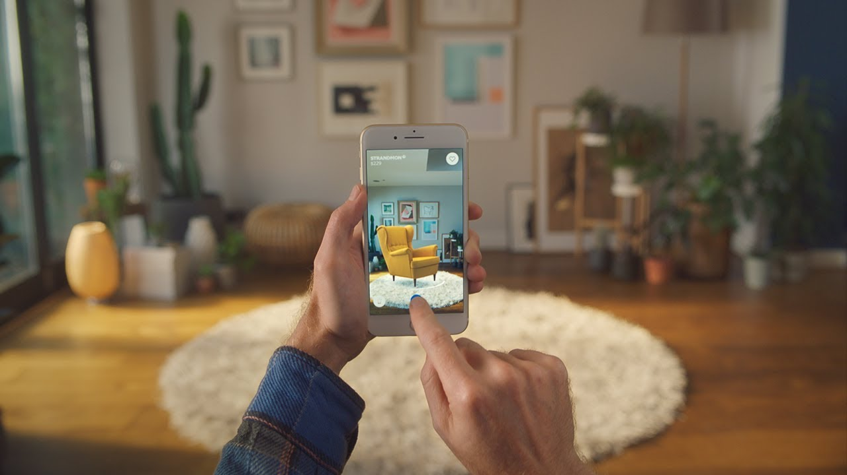
Example: IKEA use AR to easy anxiety around large furniture purchases

To summarize: To design successful AR experiences, marketeers should first formulate campaign goals by defining their target audience and communications objectives. Using this information, they should then guide decisions about how an AR layer is triggered and how it is populated with content. Finally, marketers should decide the extent to and ways in which an AR layer is integrated with the social/physical world.
However, to truly optimize an augmented reality campaign, marketers must think beyond these considerations. They need to understand and address the dynamics between different active and passive AR ingredients in order to maximize consumer engagement and create immersive augmented reality experiences.

How can marketers optimize their AR initiatives to maximize consumer engagement?

- User-brand engagement - occurs when consumers act toward inanimate objects. The highest level of user-brand engagement is achieved when an AR initiative affords users the ability to interact with AR content. For example, shoppers pretend to pet digital cheetahs displayed in a National Geographic campaign. (See example above)
- User-user engagement - occurs when branded content is inserted into and/or facilitates interactions between members of an online community. Greek chocolate brand Lacta provides sociability for specific groups of users by enabling customers to augment the chocolate bar’s wrapper with private messages that are shared with friends and loved ones. Increasing the level of sociability is a powerful way to add value to an AR initiative because it embeds the branded content into consumers’ conversations.
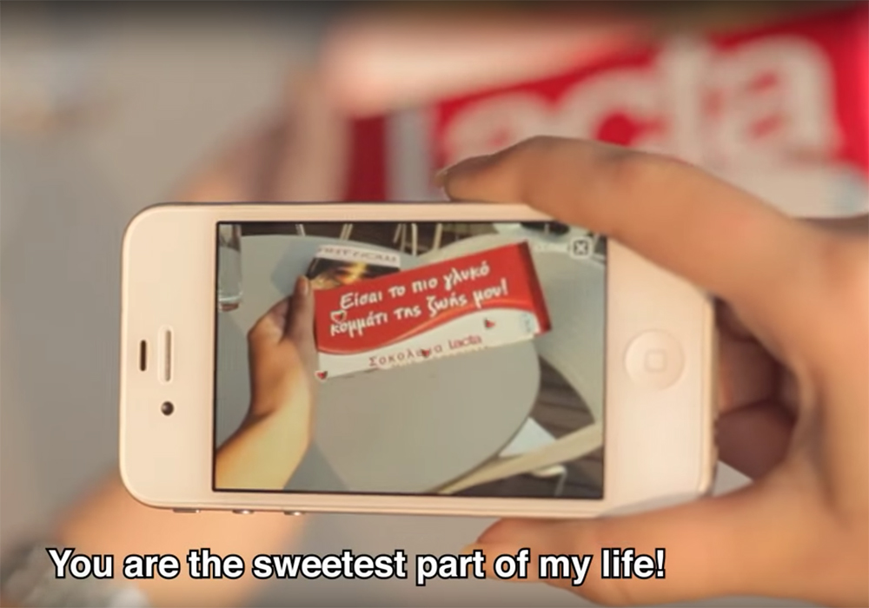
Example: Lacta use AR to engage users in powerful social exchanges

- User-bystander engagement – occurs when users are provided with the opportunity to create artifacts that they can share in their social networks. For example, users can share a snapshot of their digitally decorated pint of Guinness on Facebook, however, these types of artifacts are unlikely to result in sustained user bystander engagement because they do not offer much practical or social value to either the user or the bystander. Research on viral marketing) suggests that messages which provide the sender with social currency or identity value are more likely to be shared; in addition, receivers are more likely to investigate messages that provide practical value, are surprising, or trigger an emotional response.

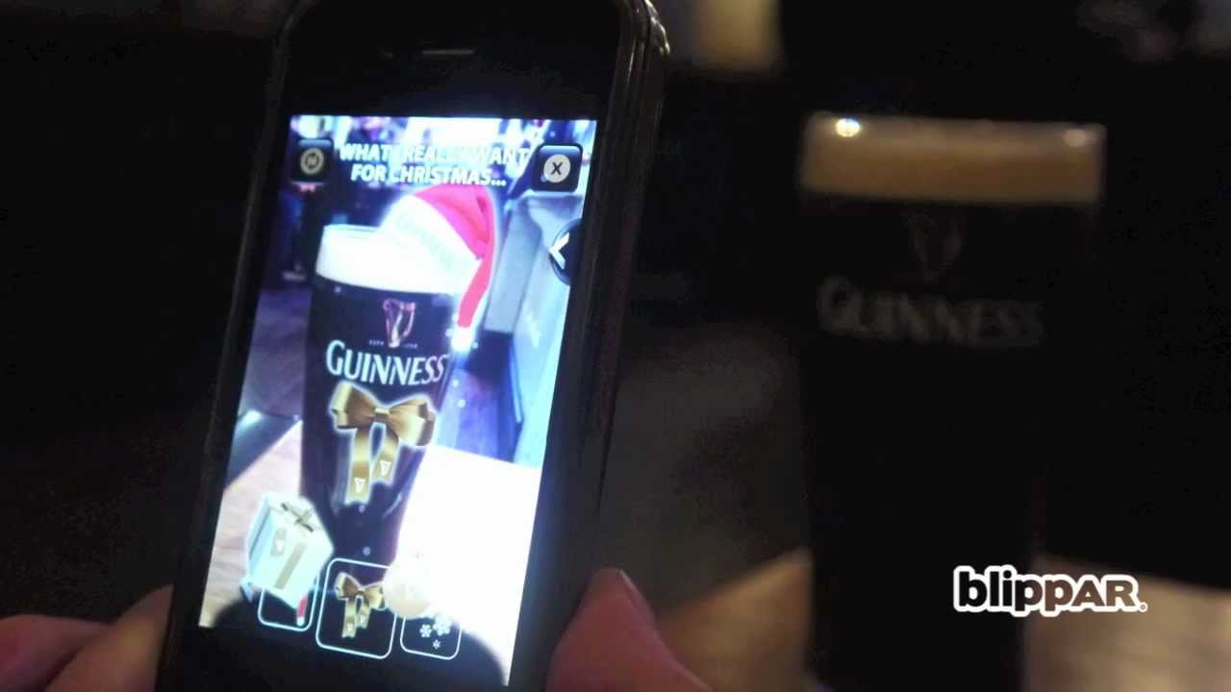
Example: The Guinness AR experience is unlikely to result in sustained engagement with the brand.
Thus, marketers should keep in mind users’ and bystanders’ perspectives and their shared relationships when designing artifacts. For example, Total Film magazine created an AR campaign involving a compelling identity-bolstering artifact: users who viewed the cover of its 2012 interactive issue through an AR application were able to share an image of themselves on the cover of the publication. Creating this personalized artifact playfully supported the fantasy of being a celebrity; consequently, users were more likely to share this artifact because it supported self-presentation and identity goals. Bystanders, in turn, were surprised by seeing a familiar face in an unexpected and unanticipated context, fueling their curiosity about the origins of the image. These types of user-bystander interactions successfully employ word-of-mouth to reach new target audiences.

Entangling augmented reality: Recommendations for marketers
- Design for experiences: Augmented reality initiatives should be consumer-experience driven rather than technology driven.
- Create nourishing engagement: Marketers should focus their attention on nourishing consumer engagement.

Designing VR Experiences
VR applications are unique in that they elicit a sense of presence or the feeling of actually being in another place.
Common to this description of virtual reality is an understanding that the technology allows for dynamic control over the user’s viewpoint, and supports human encounters that mimic the user’s interpretation of the world around them.
Immersive virtual space that incorporates play, performance, creativity and ritual (Boellstorff, Nardi, Pearce & Taylor, 2012).
VR as a Consumer Experience
In employing VR for marketing purposes, this might include product development, product promotion and product trial. More significant to these approaches, is the potential of virtual reality as an effective platform for what is known as experience marketing. In experience marketing, businesses focus on developing and providing memorable events for customers, which in themselves become products (the “experience”), with monetary value in the transformational benefits offered by the experiences. From the experiential marketing perspective, consumers are understood as both rational and emotional, and seeking pleasurable experiences.
There are 4 key elements that are essential to the VR consumer experience:
- The virtual world environment inhabited by the user (including 3D digital objects, space and rules);
- The feeling of immersion in the virtual world or actually “being there”;

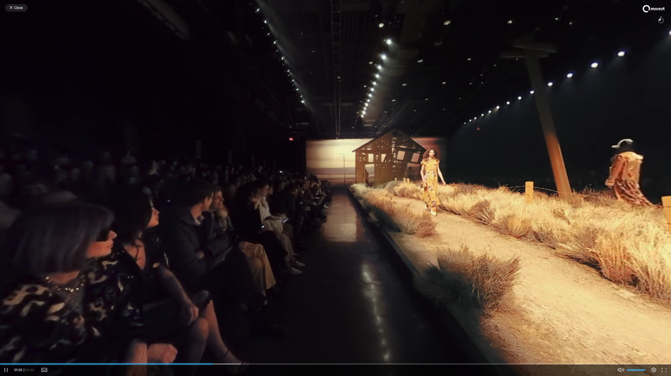
Example: Fashion label Coach used VR to allow users to sit front row at the New York Fashion Show. Full experience at: Coach VR
- Interactivity – the degree to which the user can interact with the virtual world, its objects, characters and places, and how it responds; and
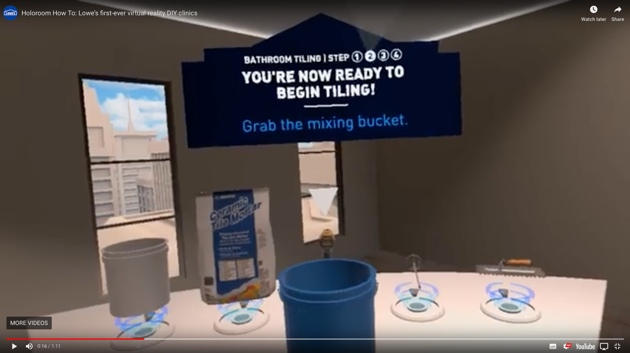

Example: DIY brand Lowes used Interactive VR to allow users to practice DIY tasks before attempting the real thing at home. Video of the experience at: Lowes VR

- The selective provision of sensory feedback to the user based on user input, such as navigation.
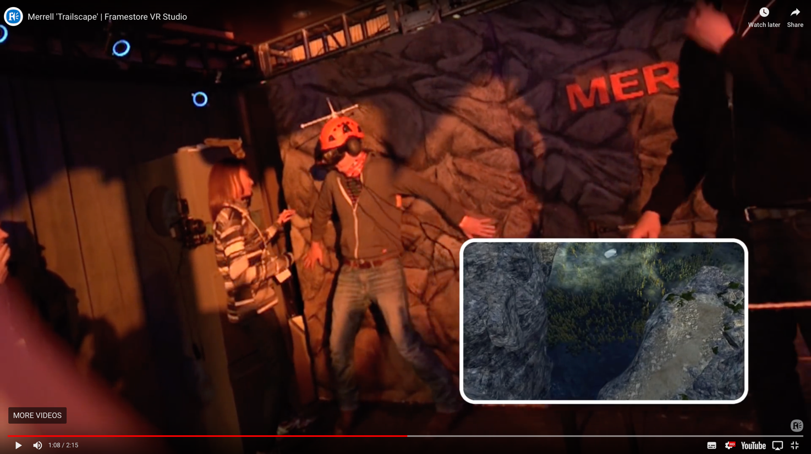

Example: Hiking shoe brand Merrell used VR to allow users to experience a hike through the Dolomite mountains. They added wind machines, shaking floors and a rope bridge to enhance the experience. Recording of the experience at: Merrell VR

Virtual reality as a consumer experience can be delivered in a number of different ways:
- Passive VR (i.e. watching an immersive 360-degree video using a headset)
- Interactive VR (i.e. interacting with immersive 360-degree video content)
Passive VR can be considered as a platform for delivering passive participation, particularly aesthetic and entertainment experiences, while interactive VR is capable of active participation, and hence a suitable medium for educational and escapist experiences.
VR experiences can be delivered either in-store VR (provided via an event, store, or street environment) or remotely, providing VR app content (typically from the comfort of the consumer’s home).

The use of VR for marketing will typically be targeted on one or more of three key types of consumer engagement outcome: cognitive, affective and conative change.
- Cognitive change occurs through increasing awareness and knowledge regarding the product, service, and/or brand through memorable VR content, increasing the likelihood of attention and absorption. (See Coach example above)
- Affective change occurs by attempting to strike a bond with consumers and providing pleasurable experiences, increasing their liking and preference for the product, service and/or brand by highlighting key features or benefits. (See Merrell example above)
- Conative change involves allows VR consumers to experience aspects of the product, service and or brand, attempting to increase the desire to make actual purchases, which may be facilitated through the virtual world, and other positive social outcomes such as sharing VR experiences or endorsement of brands from VR. (See Lowes example above – Lowes claims customers who did the VR experience had 36% better recall than those that watched a YouTube video)

Challenges for VR
There are also a number of problems that arise with the deployment of VR as a consumer experience.
- Motion sickness can be experienced by some consumers both during and after viewing content. If the VR experience is not well shot or designed, this can affect an individual’s sense of balance and inertia, and may result in a sense of nausea. This type of physical reaction will ultimately operate to reduce a sense of telepresence
- The VR marketing industry is much less developed than the media and games sector, and therefore lacks technical expertise. It will take some time for marketing departments to gain the requisite skills.
- There is an under-developed infrastructure and standards for supporting VR. There are many competing platforms, including Facebook, HTC and Sony. There are different standards for operating systems, different smartphones, varying screen standards, and a multitude of manufacturers. To add to this, although there are some standards for video content, there are not clear standards for providing full VR applications or software development guidelines. This is likely to providing a continuing fragmentation in the VR market and a barrier to growth, at least until standards are formed or one standard becomes ‘dominant’.

IMPLEMENTING AN IMMERSIVE TECHNOLOGY STRATEGY
There are five steps involved in implementing an immersive technology strategy:
- Plan: Research immersive technologies and providers to understand their capabilities and determine what solutions may work for your company’s specific business processes. Consider collaborating with immersive developers for pilot projects, but also develop internal expertise to cultivate knowledge and consistency.
- Identify: Pinpoint where AR and VR can help seize opportunities or overcome challenges with the goal to instigate behavioural change (cognitive, affective or conative).
- Design: Develop architect use cases, focus on the use of immersion to design experiences and solutions that match business data to immersive worlds.
- Scale: Map use cases to business outcomes, capabilities and processes to determine how AR and VR can incite improvements.
- Analyse: Continue to improve and create a valuable user experience (UX). Repeat AR and VR programs and use analytics to determine what generates the best UX and meets predetermined business goals.

Budgeting for an immersive technology strategy

VR experience design costs
The design process starts with a detailed project documentation. This is the guarantee that the VR application will exactly meet the needs of the customers. It should include all the important information about the project. Identify the functional specifications, the main aim of the VR development, its key features. Develop the user story, specifying which problems the potential user has and how the VR application is going to solve them. The success of the experience is dependent on knowing the user/ customer.
Describe the journey through the VR app development, where does the user start, which actions does s/he take, how much time does s/he spend with ther virtual reality application and in which way the VR experience is positioned to bring about change.
- Project documentation for VR experience development: £500 - £2500 (3-10 days).

VR experience development costs
Depending on the complexity of the app the development time can vary from 1 month up to several years. A simple VR game, where for example the protagonist is falling (running, flying etc.) towards the finish line and has to avoid some barriers like stones, meteors or other players can be created by one developer in approximately one month.
- Simplest game for VR/AR – £4K – £6K
The development of a more complex experience, such a VR shop in which the customer can look around the products for sale or even try them on, will take around 2-3 months for coding and backend development.
- Online shop in virtual reality – £12K – £20K

AR experience design costs
As with VR development, the AR development process starts with a detailed project documentation. This is the guarantee that the AR application will exactly meet the needs of the customers. It should include all the important information about the project, including details about the product vision, its features, APIs and technical details, dependencies and others. Design development documentation produced by an AR developer, should include Wireframe creation, design of any 3D graphic models, UI/UX design, visual design treatment etc.
- Project documentation cost for AR app development: £500-£1,000 (3-10 days).

AR experience development costs
The complexity of these apps depends on the AR type and client requirements. It may be a simple gyroscope-based app or using SLAM technology. 3D models and simple user interfaces are also necessary. Both 3D modeler and UX/UI designer should be engaged in the development process. Their scope of work depends on how many 3D models an app would include, and whether additional features have been added to make the app more flexible, personalized, secured or customized. For example, the AR browser may cooperate with print media to add augmented reality content to its print media. Company products may also be purchasable directly from the browser. These types of added functionality would require additional payment gateway integration, security measures and 3D models of a product.
To work, augmented reality browsers use location-based and market-based AR features. They also require a stable internet connection, as well as GPS, compass, gyroscope and the device’s APIs.
- Gyroscope-based AR
The simplest way to make AR application is the use of device’s gyroscope. According to the information from the gyroscope, applications can place virtual models around the user.
No SDK is required to do such simple features. Example: Vortex Planetarium – Astronomy app uses the gyroscope to place planets, constellations, stars around a user.
Cost for gyroscope-based AR £6/7.5K – £10/35K
Average time required is 150-250 hours.
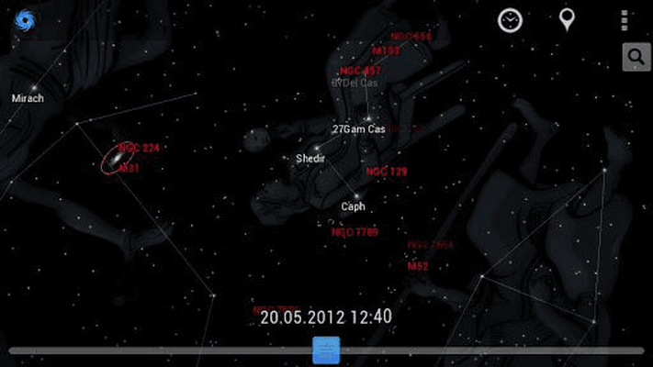
Example: Vortex Planetarium App for Android available at: Vortex Planetarium

- Marker-based AR
Another way to initiate augmented reality in application is to use trigger-markers in the real world. Markers may be anything from simple QR-codes, icons, cards, images, or even movie posters. Device’s camera captures such kind of triggers. Then application then projects a specific AR model or media onto it.
Marker-based technologies are pretty easy to develop and integrate. However, most of the time is spent setting triggers. Each trigger image should be designed, specialized, scanned and integrated into the app individually.
Cost for gyroscope-based AR £8K/30K - £16K/£60K
Average time required to complete such an app is around 200-400 hours.
Content Production/ Cost Matrix
Type | Simple VR/AR Game; 360-degree VR promotional video (single scene) | VR/AR Game; Interactive VR/AR video (multiple scenes, user interaction)
System Type | Mobile | Stand Alone
Platforms | Android or iOS | Android and iOS
Headset | Google Cardboard | Gear VR/ HTC Vive/ HTC Vive Pro VR Kit/ Oculus Rift/ Oculus Go/ Other
Engine | Unity | Unreal/ AppGameKitVR/ libGDX/ CryEngine/ Other
Scene | Simple (using existing brand media and/or rapid media development of new still or moving images) | Roller Coaster/ Interactive Room/ Complex game (using bespoke development of still and moving digital media assets)
3D Model Quantity | <5 | 10 - 50
Model Quality | Low Poly | High Poly
Animation of 3D model | None/ Simple (using existing brand media and/or rapid media development of new still or moving images) | Complex (new media developed and animated)
Server | Cloud | Custom/ Other
Backend | None/ Basic | Advanced
Extra Features | Audio/ Analytics | Audio/ Analytics/ Ads/ Controller Integration/ Integration with other hardware
Additional Content Elements | None (using existing brand media) | Development of new media assets/ Customized brand experience
COSTS | Anticipated cost of each POC based upon the content production identified in column above: £4K - £6K | Anticipated cost of each extended project based upon the content production identified in column above: £15K - £25K

