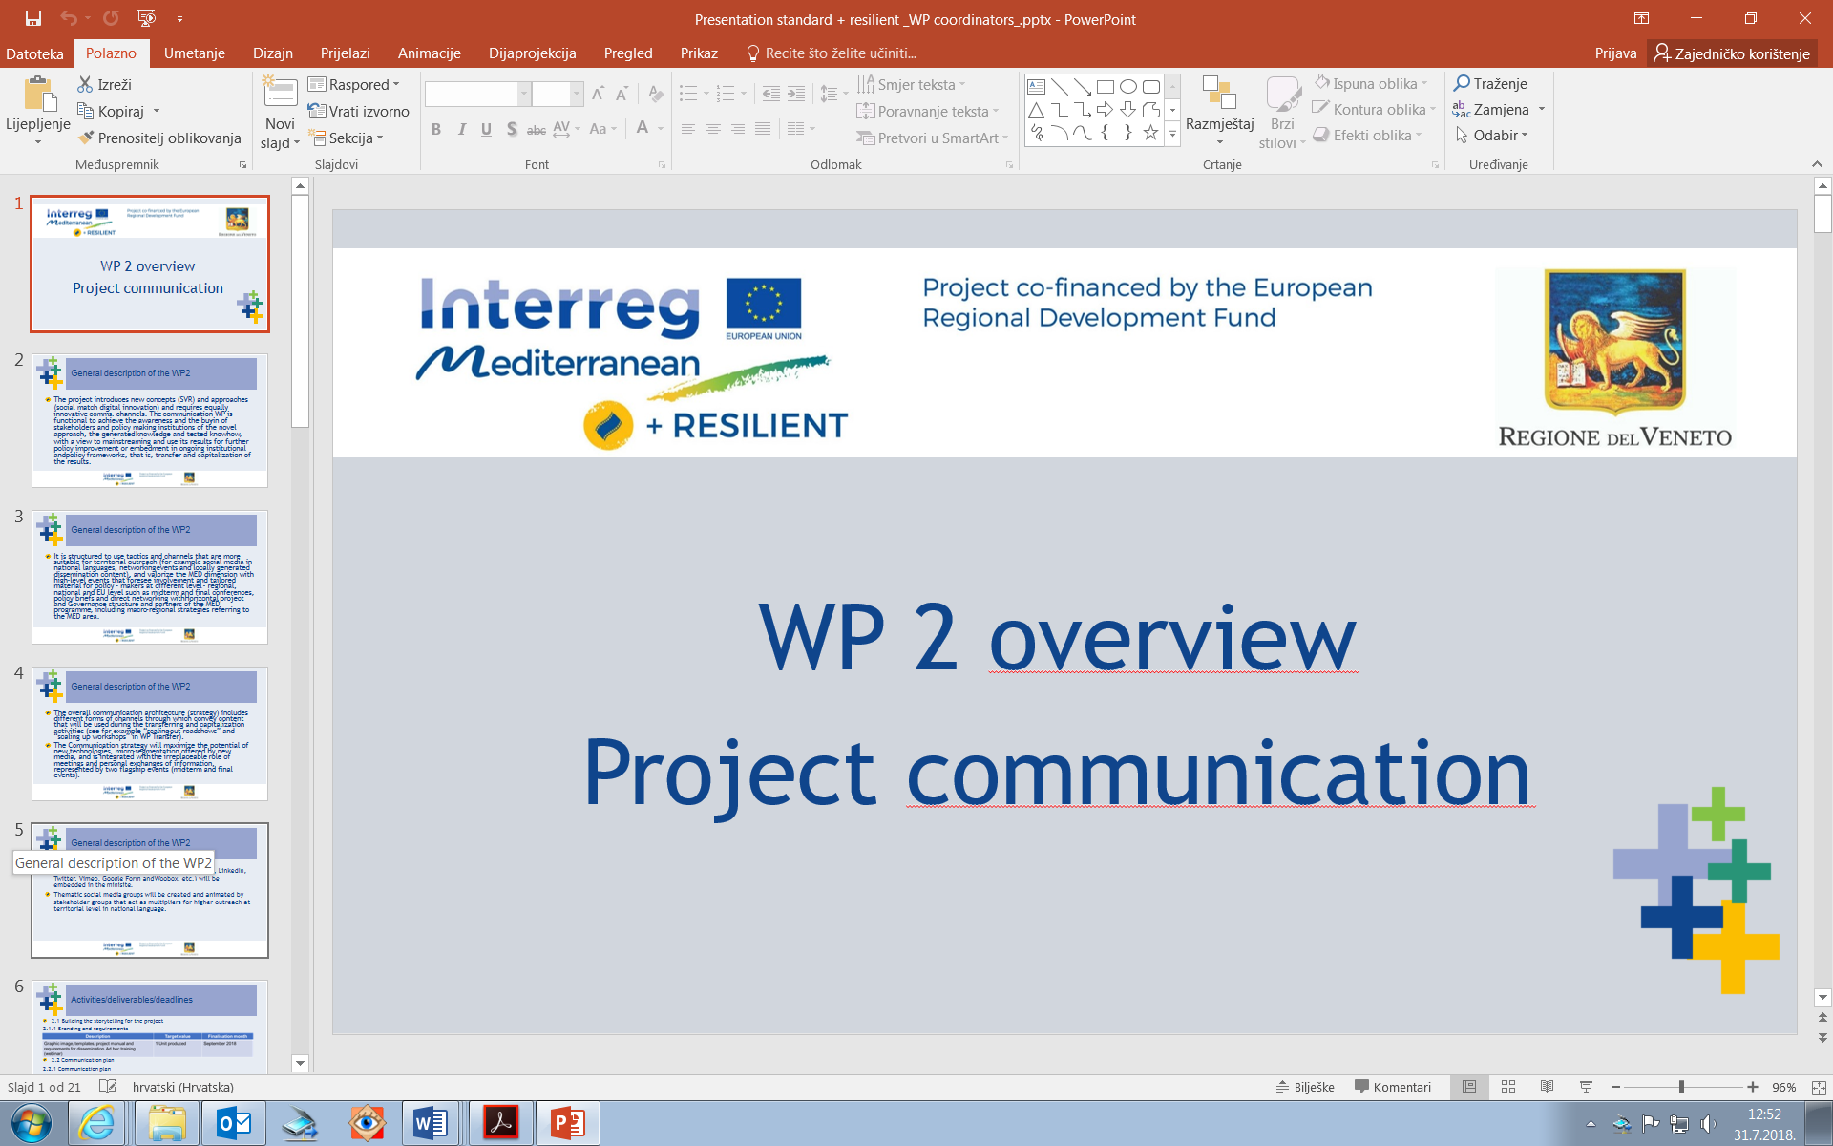****

+RESILIENT- Mediterranean Open REsouRcEs for Social Innovation of SociaLly ResponsIve ENTerprises

+RESILIENT STRATEGY AND ACTION PLAN

Deliverable 3.6.4

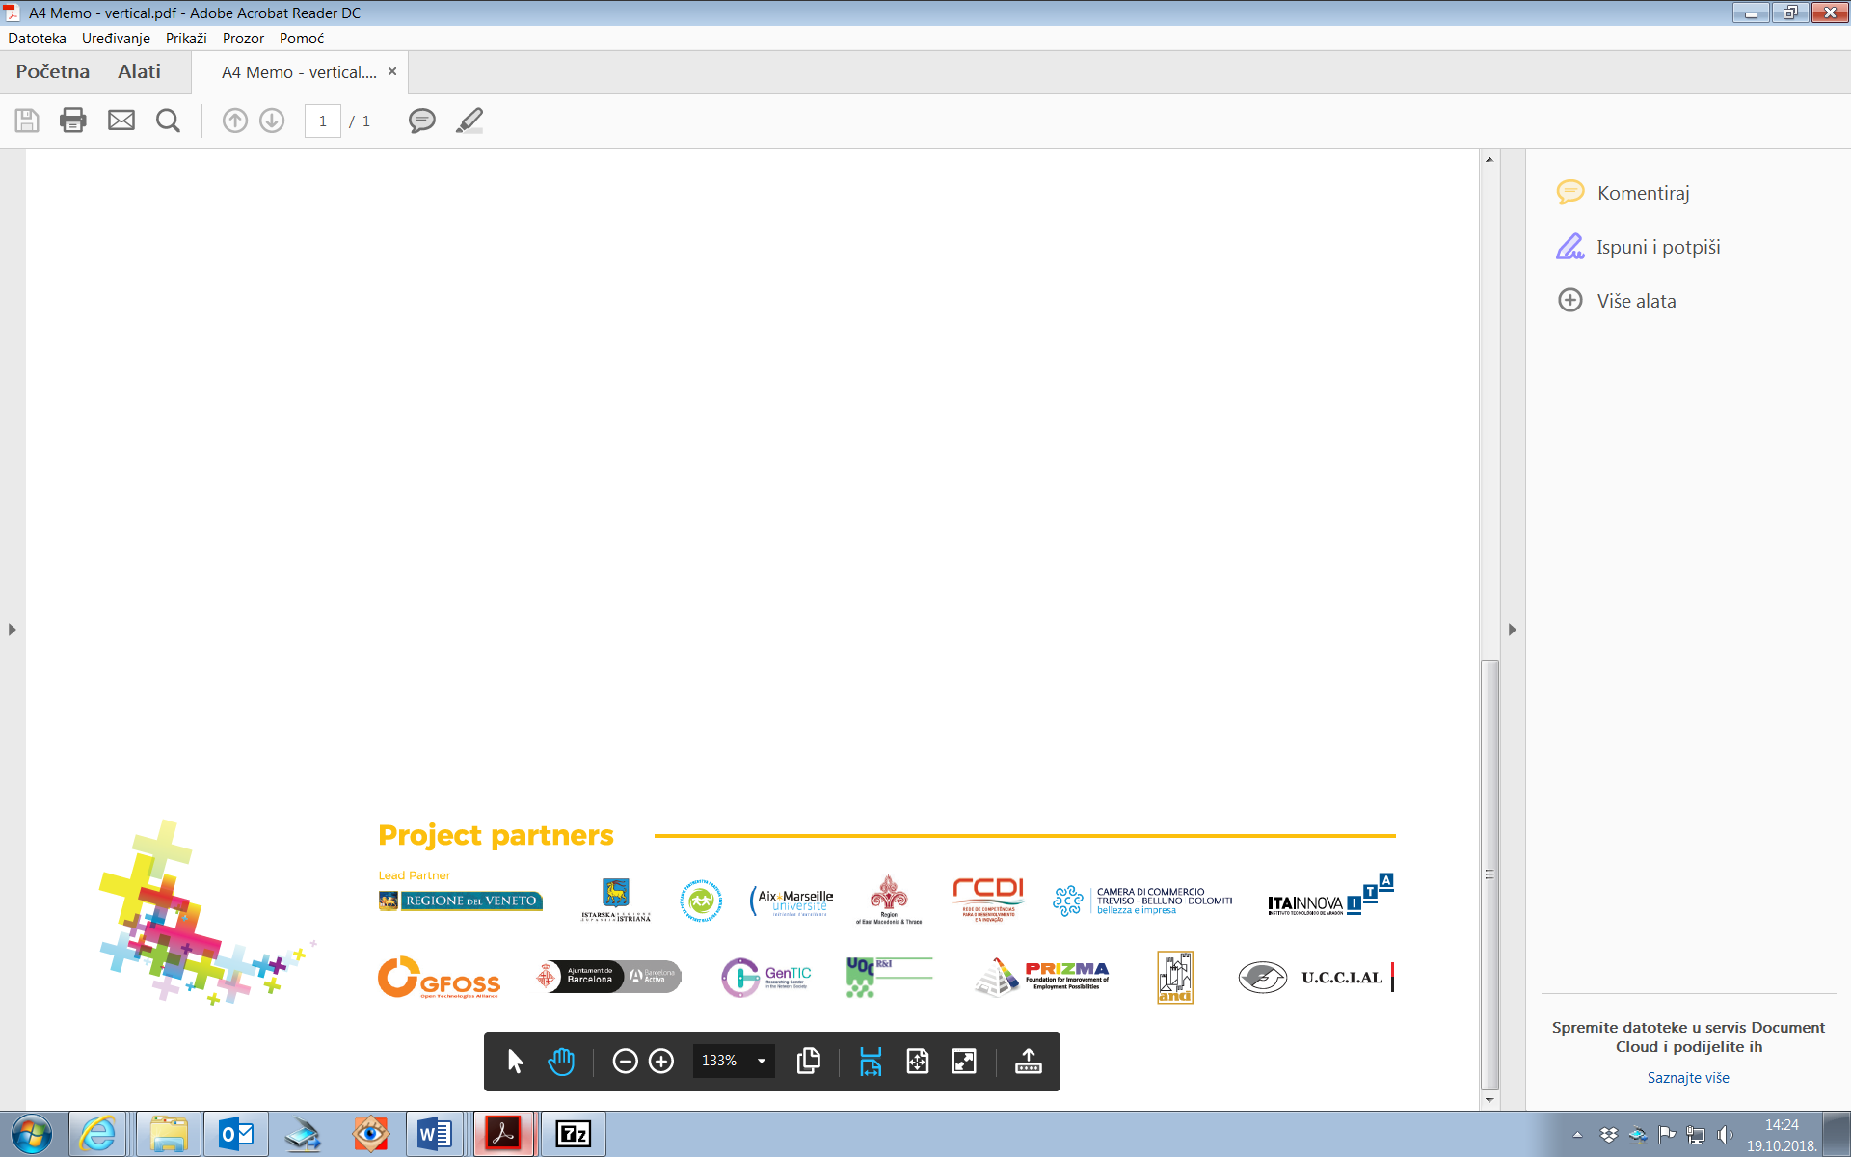

|  |  |
| --- | --- |
| **DELIVERABLE SUMMARY** | |
| **PROJECT INFORMATION** | |
| **Project acronym:** | +Resilient |
| **Project title:** | Mediterranean Open REsouRcEs for Social Innovation of SociaLly ResponsIve ENTerprises |
| **Contract number:** | 4MED17_1.1_M123_062 |
| **Starting date:** | 01.02.2018. |
| **Ending date:** | 31.01.2022. |
| **Project website address:** | <https://plus-resilient.interreg-med.eu/> |
| **Lead partner organisation:** | Veneto Region – Operational Unit for EU and State Relations |
| **Name of representative:** | Marco Paolo Mantile, Head of U.O Rapporti UE e Stato |
| **Project manager:** | Chiara Rossetto |
| **E-mail:** | [Chiara.rossetto@regione.veneto.it](mailto:Chiara.rossetto@regione.veneto.it) |
| **Telephone number:** |  |
| **DELIVERABLE INFORMATION** | |
| **Title of the deliverable:** | +RESILIENT STRATEGY AND ACTION PLAN |
| **WP no. / activity related to the deliverable:** | WP 3 – ACTIVITY 3-6 D 3.6.4 |
| **Type (internal/restricted/public):** | Public |
| **WP leader:** | Veneto Region |
| **Activity leader:** | GFOSS |
| **Participating partner(s):** | Veneto Region |
| **Author:** | Sandra Rainero |
| **E-mail:** | [Sandra.rainero@venetolavoro.it](mailto:Sandra.rainero@venetolavoro.it) |
| **Telephone number:** |  |
| **DELIVERY DEADLINE** | |
| **Date of the delivery:** | 30.06.2019 outline  31.08-2019 – first final version |

**TABLE OF CONTENTS**

INTRODUCTION 3

1. SITUATION ANALYSIS 5

2. + RESILIENT PARTICIPATORY APPROACH 9

3. + RESILIENT STRATEGY 15

4. ACTION PLAN 21

INTRODUCTION

This document makes synthesis of the main results of the Module 1 activities and lays out the strategic vision for the Module 2 and 3 of the project.

Its purpose is to offer a general strategic and operational framework to design the testing, transferring and capitalization phases, taking into account the findings of the first phase of studying. It is meant as a support rather than a prescriptive scheme.

It offers partners as a primary audience - and the MED community at large - a short overview of the methodological approach and the highlights of the implementation of the WP 3 roadmap, to insert it in a wider perspective, by back-casting the whole project’s rationale that has been designed to achieve the final outcomes. This means it addresses the change on the ways regions and territories in the involved countries intend to tackle emerging social needs, by reinforcing the so-called Social Vocation and Responsiveness Clusters.

The document is made up of four chapters. Chapter 1 and 2 summarize the findings and results of the process of collection, assessment and identification of social innovation priorities, and the role of SVRCs.

The overall strategic approach to be applied in the Module 2 and 3 is provided in Chapter 3, while Chapter 4 outlines common standards and tools/templates for partners to move forward with the implementation of the activities, in coherence with the strategic vision on the one side and the requirements of the project on the other side.

|  |  |  |  |  |  |  |  |  |  |  |  |  |  |  |
| --- | --- | --- | --- | --- | --- | --- | --- | --- | --- | --- | --- | --- | --- | --- |
| 04/18 | 05/18 | 06/18 | 07/18 | 08/18 | 09/18 | 10/18 | 11/18 | 12/18 | 01/19 | 02/19 | 03/19 | 04/19 | 05/19 | 06/19 |

The STUDYING roadmap



1. SITUATION ANALYSIS

Definitions

Before highlighting the main features of the several dimensions that have been explored during the first year (WP Studying- see chart on previous page), for clarity’s sake we recall some important terms and concepts that the partners have used to frame the issue of social innovation that + RESILIENT intends to tackle:

Emerging clusters with high social vocation and responsiveness (SVRC)

*For the definition of clusters, we use the MED glossary: “Groupings of independent undertakings — innovative start-ups, small, medium and large undertakings as well as research organisations, public administration or social and solidarity economy organizations — operating in a particular sector and region and designed to stimulate innovative activity by promoting intensive interactions, sharing of facilities and exchange of knowledge and expertise and by contributing effectively to a large type of innovations, technology, organisational or social transfer, networking and information dissemination among the undertakings in the cluster. These groups may be recognized in a formal way (e.g.: the French “pôles de compétitivité”) or operate as informal networks as long as they constitute a stable ecosystem.”*

Our SVR clusters therefore are defined as:

*Loosely connected and diverse companies, private/public, profit/no-profit working for a positive social impact- e.g. social enterprises dealing with social cohesion, ageing, migrations and sustainability, they include the social-related aspects & impacts of regions’ RIS3 addressing synergies to be valorized in the effort to consolidate SVRC to achieve a critical mass & become a fully-fledged “clusters” with a social vocation, streamlined into cohesion policy and funds.*

In the initial phase of the project, we have identified three macro-scenarios, general enough to be adapted to territorial diversity, but codified enough to make sure that the lines of action and testing can be compared and refer to a shared and composite scope of “Clusters with Social Vocation and Responsiveness”. These are:

*1) the delivery of innovative public services (social entrepreneurship development, e-health, vulnerable groups, long-term unemployed, migrants and refugees etc),*

*2) support to SMEs with social vocation and responsiveness: (businesses linked to smart specialization, ex: social farming, sustainable tourism, education etc)*

*3) capacity building of social enterprises, sharing economy, third sector, citizens' organizations, crowdfunding initiatives etc.*

The three macro-scenarios have been the reference point for the collection of information and definition of more specific “action scenarios” of scoping and use-cases and consequently of local pilot actions.

The main results from the collection of data (Activity 3.3- Deliverables 3.3.1, 3.3.2, 3.3.3)

The analysis of the baseline situation is described in Deliverable 3.5.1, to which we refer for more details, in the following pages we summarize the main highlights from it:

Analysis of information on Social Vocation and Responsiveness Clusters (SVRC)

* Collected data on SVRC is not homogeneous and the differences between regions and countries is clearly visible.
* Most of the clusters have a legal status. The type of governance is therefore stated in their founding agreement (Laws or statues).
* Some SVRC are articulated as projects, we can consider that they have a special force that can catalyze the creation of new clusters.
* Many but not all clusters incorporate the 4-helix model.
* The year of creation is very different. We can observe a great movement in recent years in countries like Croatia or Slovenia, where aid policies at the European level are being more visible. Countries such as France and Spain, with the case of Catalonia, have SRVCs of great tradition, which come from the 90's.
* It is noted that aid and policies at different levels have been a catalyst for the creation of clusters. However, in some cases this aid has ceased to exist (for example, in some of the clusters in France), so the solution adopted is the creation of payments by members.
* The sectors of operations are also very varied. There is no predominant sector and it depends a lot on the region in which the cluster is established. On the other hand, most of the identified clusters operate in a sector included in its regional strategy RIS3.
* All the clusters emphasize the follow-up of the EU principles.

Skills and capabilities assessment of SVRC

The result of over 350 practitioners and experts (17 focus groups and 32 interviews) have highlighted that, at individual and organization levels, the skills for social innovations have the following features:

* Relevant value recognized to soft skills (... but with the clear definition of a precise scope of action).
* Transversal skills: both soft (entrepreneurial, communication, networking) and work-related: analysis, digital skills, problem solving, management and logical thinking etc
* **”Knowledge in action” skills and competences, learning by doing:** the acquisition of skills and competences in the field of social innovation occurs mainly through **implicit learning processes** that derive from action and concrete experience.
* Professionalism (soft and transversal skills), or an evolution of existing ones, is rather necessary. There may also be profiles that can acquire a different identity in a new context. But there are no one-fits-all profiles.

Study visits

The five study visits on urban regeneration in Reggio Emilia, sharing economies and tech-led social innovation in Marseille and Barcelona, Open Data in Zaragoza-Aragón and rural development in Maribor and Podravje Region, showed the wide diversity of realities and cases of SVRC’s (both metropolitan and rural) that are present in the different regions of the +Resilient project.

* The five study cases confirmed that the rise of economic activities with social vocation is tightly linked with the peculiarities and traditions of local economies.
* The visits displayed as well different ways and strategies of the 4 helix partnerships to strengthen the ecosystem of social economy in every region and how public actors maintain in many of the cases a role of leadership in the processes (especially through funding).
* They also showed that transferability is possible, but adaptation and some institutional conditions are usually needed.

The study cases demonstrate the possibility to build bridges between:

* Open Data and social innovation
* Rural development and social economy
* Sharing economies and public policies
* Social needs & digital and technological solutions

Open data – availability of open data at regional and local level and stakeholders’ needs

The state of play on open data comprised of two sets of information that have been collected by partners. Following a short summary of the main highlights resulting from the collection of information:

3.3.1.a: Open Data resources fact sheet

* Overall there are several initiatives in both local and national levels around Open Data
* Open Data are available in several categories (employment, science and technology, education, environment, society, health, social services, citizenship, property and citizen's participation and collaboration, transportation, agriculture, demography, housing, business, etc)
* The quality of such data is not always clearly proven

3.3.1.b: Stakeholders’ needs of open data

* Lack of awareness about OD and how they can benefit from them
* Specific requests about categories that are of interest for Social Innovation
* Training Required
* Data Providers are willing to open up data

Mapping of stakeholders – 3.3.3

Partners have also created a first database of their SVRC stakeholders. The database, now an Excel matrix, containing over 600 stakeholders will be used for the + RESILIENT platform.

The mapping exercise has allowed to identify 4-helix stakeholders of very different nature, depending on the same diversity that has been recorded in the SVRC.

2. + RESILIENT PARTICIPATORY APPROACH

The collected information that represents the baseline situation (see D 3.5.1 for details) has undergone a participatory process of assessment and progressive choice (scoping and definition of use-case scenarios), which have been conducive to the initial identification of priorities – within the three macro-scenarios – upon which the development of the pilot actions will be built.

The benchlearning process has consisted in the sharing of the main findings and characteristics of SVRCs, skills and open data study phase.

Results of benchlearning

Nine benchlearning workshops have been conducted by the partners of the + Resilient project. The comparative analysis has been conducted by the AMU team and is based on the “benchlearning reports” elaborated by the implementing partners. See D 3.4.1 for details.

Some countries clearly prioritized sectors, and some priorities.

In Albania, agro-food and tourism are a priority, while in Barcelona the priority is the development of the care economy for dependent people and for the elderly.

Greek partners showed particular interest about the creation of a supporting mechanism / capacity building for social enterprises.

In Portugal, the interests are mainly on the provision of social care and healthcare for disadvantaged people and on delivering of social assistance and care services of general interest.

Portuguese participants emphasized the need of the development of a digital tool providing information on the regional supply of social care services.

Slovenian stakeholders underlined the importance of social entrepreneurship, and the necessity to give support to the creation of new (social) enterprises through the development of financial support, financial instruments, but also development of cultural and social norms.

Italy is interested in organizing Community hubs for enhancement of unused places, identification of areas accessible to the community for social, professional, recreational and cultural purposes.

The major results or lessons from the process:

*1) The need of public support to social innovation*

Many partners stressed the importance of public support to steer social innovation that is generated from the bottom. Public bodies should therefore be seen as “enabling platforms”.

*2) The lack of access to funding is considered as a major barrier to develop social innovation initiatives*

In addition to public support, private funds should be mobilized as well. The co-funding with citizen’s financial contribution is an interesting process to be analysed more in depth.

*3) The importance of citizens’ involvement*

In some regions, the lack of citizens’ awareness and involvement can be a barrier to the development of social innovation. Even if public support and political willingness have been stressed as important levers for developing social innovation initiatives, many partners insist on the involvement of citizens and stakeholders in processes of co-creation.

*4) The need to develop training in most regions to support social innovation*

Training is one lever to create the conditions of citizens’ involvement. The lack of skills has often been mentioned by the participants.

*5) The need to identify and to experiment with other practice*

In order to transfer or adapt a practice, time and in-depth understanding of the mechanisms at work in one context are necessary to be adopted in a different context.

*6)The growing concern of evaluating or measuring the social impact of these initiatives*

Measuring impact is becoming an important issue, at least in Italy.

*7) The use of open data for social innovation*

Although some open data have been produced for few years in some regions, the question of their use is **still challenging**. Most partners agree that there is a need for more *useful* and *usable* data. Start from the needs from the stakeholders in terms of data could be a guiding principle in the production of open data.

The process of selection of local and territorial cases for the creation of the platform and the pilot actions

The scoping workshops (D. 3.6.1) and the elaboration of the Use-case scenarios (D. 3.6.2) closely follow the analysis and the priorities already highlighted in the benchlearning process. As for the benchlearning workshops, nine reports produced by the partners inform the selection process.

It can be noted that the scoping workshops were used to identify and elaborate on the Use-case scenarios, therefore these two steps are part of a single process of choice of priority and concrete field of action for the Testing phase.

The main results of this process, which reflect a lot what has already been underscored in the benchlearning process, are summarized here:

1. The scoping workshops and use-case scenarios cover all three macro-scenarios. (In table 1, a summary of the results);
2. The cases relating to the innovation of public services (or public-private delivery of public services) are connected to the main demographic trends (notably ageing in the case of the care service), but also to other global changes (mismatch of skills due to the gap between education and productive systems, new forms of poverty and exclusion etc);
3. Capacity-building, including training and upskilling of individuals and organizational competences to meet emerging social needs, is considered pivotal for the strengthening of social innovation. This also includes training and capacitation on the added value of open data which remain an unexplored resource for social innovation;
4. The multi-stakeholder approach (in some cases 3- helix, but in most cases 4- helix) is deemed central to all the scenarios and use-cases. However, the relationships are always complex to manage;
5. Open knowledge resources (creation of platforms, physical and virtual) to foster social innovation at territorial level represent one of the main strategies of the identified scenarios;
6. There are (in some cases, established) relations between social innovation and sectors. This is true for some sectors of the smart specialization of the involved regions, especially those linked to sustainable development such as smart agro-food, cultural and creative sectors also related to sustainable and accessible tourism, health;
7. Co-creation tools and involvement of beneficiaries in the design but also in the evaluation of innovative services is deemed paramount in the majority of cases.

|  |  |  |  |  |
| --- | --- | --- | --- | --- |
| **Partner** | **Scenario 1:**  Delivery of public innovative services | **Scenario 2:**  Support to SVR SME’s | **Scenario 3**: Capacity building of social enterprises | Country – region |
| Veneto Region | Community pf practice for innovative services against mismatch |  |  | Veneto Region(NUT 2)  ITALY |
| ANCI | Civic monitoring of public services; Generativity pacts for social innovation (4helix) |  |  | Italy  ITALY |
| ITANNOVA | Creation of open resources and data for 4 helix SVRC |  |  | Aragon (NUT 2)  SPAIN |
| RDCI | Regional portal for social care |  |  | Alentejo (NUT 2)  PORTUGAL |
| Barcelona Activa |  |  | Care sector upskilling and training | Barcelona (NUT 3)  SPAIN |
| REMTH |  |  | Social enterprises training | Region East Macedonia and Thrace (NUT 2) GREECE |
| PRIZMA |  |  | Social innovation info points | Podravje Region (NUT 2)  SLOVENIA |
| FOUNDATION- ISTRA REGION |  |  | Reginal centre for social innovation  Portal for social innovation | ISTRA REGION (NUT 2) CROATIA |
| Chamber of Commerce TV-BL |  | Support for social innovation of SMEs (tourism and agrofood) |  | Belluno province (NUT 3)ITALY |
| UCCIAL |  | Support for social innovation of SMEs (tourism and agrofood) |  | TIRANA (NUT 3????) ALBANIA |

Table 1: Overview of use-case scenarios that will be further adapted for the pilot actions of the testing.

The open data platform functionalities

The analysis of the D. 3.3.1 (see previous chapter) sheds light on the main potential and criticalities concerning the value of open data.

The analysis of the use-case scenarios reinforces the main results of the qualitative phase of investigation and it gives indications for the creation of a + RESILIENT platform, which is being designed in 3.6.3 but that should contain tools/functions as follows:

* Understanding and contributing to the quality of data
* Links to existing open data resources (as per fact sheets provided)
* Awareness raising on open data, including training formats
* Examples of use of open data in the design, implementation and evaluation of social innovation

**Functionalities**

* non expert information for SVRC who have little time to go in-depth
* tutorials for use of open data
* training platform
* possibility to crowd-source and contribute to open data
* mapping
* links to the regional platform foreseen in pilot actions (PT, HR, Aragon, Slo)

SWOT analysis

|  |  |
| --- | --- |
| STRENGHTS | WEAKNESSES |
| Many SVRC already rely on different stakeholders, in some cases 4-helix  Partners have already identified focus of action based on participatory process  The project is consistent and supported at policy level in the involved regions  There is convergence of the skills and abilities required to foster social innovation  There are virtuous examples of SVRC who implement cross-sectoral collaboration between the social sector and other sectors (notably agriculture, services, tourism, green and circular economy, also related to industry) albeit often spontaneous and not codified.  Study visits and benchlearning have been useful for most partners and elements of innovation to include in pilot action is inspired by new knowledge. | Low awareness and knowledge of open data and resources for social innovation  Diversity of the clusters and focus of action make it hard to compare and transfer best practice  There are not specific or common education/training paths or profiles for key positions that lead social innovation  Still a great divide between social economy and other sectors in terms of social responsiveness and investments in spite of existing tools  In general, financial support for social investment or funding social undertakings of innovative nature remains insufficient  Low attention to monitoring and evaluation of social innovation in some countries  In some regions, the lack of citizens’ awareness and involvement can be a barrier to the development of social innovation |
| OPPORTUNITIES | THREATS |
| There are complementary actions in some of the regions that can support or improve the + RESILIENT approach  European and national policy frameworks that support social innovation and digital innovation continue to be relevant in the MED area  The urban context (European Urban Agenda) also supports participatory policy and social innovation  Technology that can support new forms of social economy/innovation | Complexity of converting data/open data in useful information and knowledge  Change of policy that supports social innovation due to global situation  New economic/social crises  Technology that can lead to digital divide of more vulnerable groups |

3. + RESILIENT STRATEGY

General goals

The +RESILIENT project integrates different phases of development of social innovation related to, on the on hand, to emerging and unmet social needs, new forms of poverty, marginalization, exclusion and the sustainable economic and environmental territorial development with an eye on the role of SMEs in the different sectors of the economy on the other hand.

Given the complexity and variety of the baseline situation of the so-called SVRCs in the involved regions, as the studying phase has shown, but also some common challenges that have been highlighted especially in the field of needs of the stakeholders, the project remains focused on the three macro-scenarios of social change which looks at social innovation from three (interrelated) perspectives: the public sector as responsible for ensuring social rights for citizens, the social economy and third sector whose mission is also providing assistance related to social rights, and the “market” – that is SMEs in the main economic sectors that are not “social” per se, but nonetheless pursue social rights and impact.

The project has defined three main medium-long term goals, following the 4 – step modular approach of studying, testing, transferring and capitalizing actions, practices and policies that exist or that can be co-created.

Such goals are pursued through actions that aim at increasing coherence with socially-driven market requirements as well as employability, entrepreneurship, required competences, support measures and mechanisms (policy, financial etc) to improve capacities to stimulate growth, jobs and sustainable development of the territories.

These actions intend to positively influence, adapt/change structural elements of policy governing SVRCs using technology, open data and successful models with the ultimate aim of mainstreaming the innovations in existing institutional frameworks at local, national and Structural funds policy level also in view to the next EU programming period.

In other words, + RESILIENT contributes to a change in the involved territories, which the partnership envisions as follows:

* *We create new jobs, professions, companies and services, we attract new investment (public/private) that are resilient in terms of global social challenges*
* *We learn from models/initiatives that support economic initiatives that respond to societal needs and adapt them in our contexts*
* *We improve, by involving different actors, the «infrastructural» levels enabling innovative social economy and companies interested in having a positive social impact (policy and practice)*
* *We use in new ways data, technology, open resources to plan, improve, assess the wellbeing / welfare of our communities, especially the most in need*
* *We make available such improvements for other areas*

In this framework, this chapter describes the overall strategic goals for the definition of pilot actions following the participatory scoping exercise in Module 1, which will be tested, shared and made available for transferring through adaptations and re-use (hence capitalized), and finally embedded into local practice and policy. Practical guidance and standards for their implementation are outlined in chapter 4.

The two main objectives of the strategy

The strategy, which is based on the main outcomes of the study phase, intends to guide and provide common principles, an operational framework and indications for the next phases of the project, namely the pilot actions (WP4), the actions to scale-up and scale-out the pilot actions (WP5) and the capitalization and streamlining of the innovations (WP6).

The strategy finds middle ground with two objectives that are consistent with European Territorial Cooperation: the regional priorities and the added value of transnational cooperation.

1. *To provide territorial 4-helix stakeholders of SVRCs with tools and platforms to increase their capacity of policymaking, socially-responsive economic activities and support services to respond to emerging social needs, and contribute to sustainable development, jobs and social rights*

1. *To foster a transnational SVRC network that shares capacity building, knowledge transfer and co-creation of innovative solutions for the benefit of common solutions capable to promote scalability, transfer, mobility and policy improvement in the different territories of the MED area*

The table below (Table 2) summarizes the coherence between projects goals, results, strategic objectives, the choice of pilot actions and activities for their implementation, transferring and ultimate policy change.

After that, we propose a visual chart (Chart 3) that shows the interconnectedness among the different Modules/Phases and the functions of each step/activity in the overall architecture of the project.

|  |  |  |  |  |  |  |
| --- | --- | --- | --- | --- | --- | --- |
|  | Programme’s objective | Project’s objectives | Project’s results | | | |
| To increase transnational activity of innovative clusters and networks of key sectors of the MED area | To influence, adapt and change structural elements of policy governing SVRCs by leveraging on innovation dynamics led by technology, open data & successful models | SVR Clusters implement sets of innovative transnational /common policies/operations | SVRCs become integrated elements and measures of mainstream policy and funding | SVRC generate jobs, skills and social cohesion | SVRCs respond better to socially-driven market requirements in different sub-sectors and in other MED areas |
| + RESILIENT Strategy | *TRANSNATIONAL SVRC NETWORK* | *TOOLS AND PLATFORMS TO INCREASE 4 HELIX TERRITORIAL STAKEHOLDERS CAPACITY* | X | X | X | X |
| Pilot actions |  | X | X |  | X | X |
| Transfer actions | X | X | X | X | X | X |
| Capitalization | X | X |  | X | X |  |

Table 2: coherence with objectives and actions

Consistency of the strategy with the project’s rationale and activities (WP and Modules)

The strategy is also embedded in the project’s rationale, and the action plan (see next chapter) will take into consideration the whole process designed in the integrated approach.

MODULE 2 (WP 4-5)

Testing

Testing aims at selecting, implementing at a small scale and assessing the use-case scenarios defined in module 1 in order to verify the effectiveness of + RESILIENT approach on current frameworks and regional contexts, organizational, process and service innovation and impact on direct and indirect target groups.

Piloting is therefore necessary to gain insight on actual implementation of identified innovative measures and to increase, through evidence collected from their evaluation, the transfer and capitalization actions.

In order to embed transferability and capitalization, each pilot action will:

1. include activities to leverage the use of open data and PSI;

2. Make clear reference to the policy framework that it aims at improving/changing (ex: RIS3, ESF Funds, local or national policy framework);

3. Refer to the common scenarios and strategic objectives defined to facilitate transfer afterwards;

4. Involve different stakeholders and participatory approaches for co-creation or co-implementation;

5. Include a transnational element that highlight the added value of the transnational cooperation (I.E. at least two pilot actions in two countries will focus on the same scenario).

The transnational pilot, the + RESILIENT “living lab” represents an inspirational format to create the MED SVRC network useful for defining actions at MED level and transferring action.

The evaluation system will provide evidence of the expected positive impact and will contribute to create a more robust storytelling capable to create buy-in in the transfer and capitalization activities.

Transfer

The transfer phase aims at creating scale-up (increase the users of specific pilot actions methods and tools/services) and scale- out (by cross-fertilization in other key sectors) effects of the tested model and to pave the way for their capitalization.

The transfer consists of 4 main activities:

1. During the development of the studying and testing phases, methods and tools are consolidated as a set of usable resources during the transferring phase, a session to collect or develop the resources for the transferring action plan and kit will be carried out and represent a topic of 6 webinars.

2. 8 scaling-up workshops the carried out by partners also in coordination with specific activities of the horizontal project. Scaling up workshops are based on the transnational pilot action "+ RESILIENT LAB".

3. 8 Scaling out “roadshows” are Business roadshows showcasing transferable elements of Open Data platform and pilot actions for the benefit of other SMEs and stakeholders

4. Towards the end of the testing phase, the + RESILIENT network will be formalized, an executive plan describing timing and content of transferring activities will be made available and monitored. A series of capacity building/training and exchange of information sessions that target 4-helix audiences will take place, also in coordination with specific activities of the horizontal project.

MODULE 3: CAPITALIZATION

Capitalization

The capitalization strategy, supported by communication and dissemination activities, will be defined later on during the project, but the main tenets have been already identified:

1) knowledge systemization for MED

2) policy change actions

3) sustainability, and lobbying/advocacy actions

Chart 3: a visual process of + RESILIENT’s integrated approach

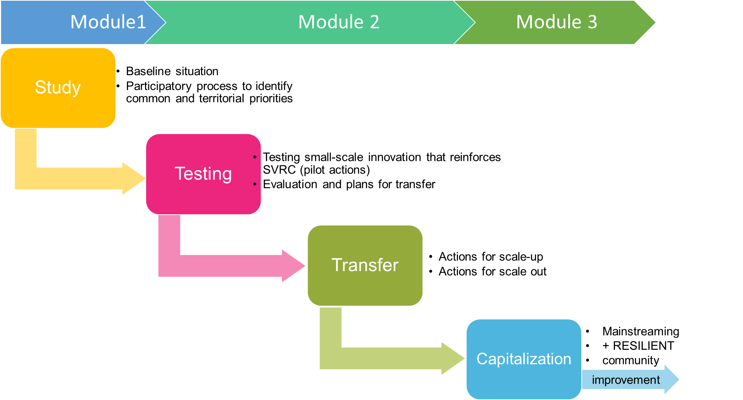

4. ACTION PLAN

This chapter defines the steps, tools for the design, implementation, evaluation, transfer and capitalization of the pilot actions/ local activities, as generally described in the previous chapter. It intends to provide a common working method for the partnership for the next activities.

In the following pages we provide some tables and working tools that intend to guide partners in the definition of local action plans, referred not only to the pilot testing, but also the links to the transferring, the transnational dimension and the capitalization.

This table (Table 5) is an overview of the use-case scenario upon which the testing phase will develop.

|  |  |  |  |  |  |
| --- | --- | --- | --- | --- | --- |
| **Partner** | **Scenario 1:**  Delivery of public innovative services | **Scenario 2:**  Support to SVR SME’s | **Scenario 3**: Capacity building of social enterprises | Country – region | Twinning |
| Veneto Region | Community pf practice for innovative services against mismatch |  |  | Veneto Region(NUT 2)  ITALY | A |
| ANCI | Civic monitoring of public services  Generativity pacts for social innovation (4helix) |  |  | Italy  ITALY |
| ITANNOVA | Creation of open resources and data for 4 helix SVRC |  |  | Aragon (NUT 2)  SPAIN | B |
| RDCI | Regional portal for social care |  |  | Alentejo (NUT 2)  PORTUGAL |
| Barcelona Activa |  |  | Care sector upskilling and training | Barcelona (NUT 3)  SPAIN | C |
| REMTH |  |  | Social enterprises training | Region East Macedonia and Thrace (NUT 2) GREECE |
| PRIZMA |  |  | Social innovation info points | Podravje Region (NUT 2)  SLOVENIA | D |
| FOUNDATION- ISTRA REGION |  |  | Regional centre for social innovation  Portal for social innovation | ISTRA REGION (NUT 2) CROATIA |
| Chamber of Commerce TV-BL |  | Support for social innovation of SMEs (tourism and agrofood) |  | Belluno province (NUT 3)ITALY | E |
| UCCIAL |  | Support for social innovation of SMEs (tourism and agrofood) |  | TIRANA (NUT 3????) ALBANIA |
| AMU | Share and capture LIVING LABS | Share and capture LIVING LABS | Share and capture LIVING LABS | Transnational |  |

Table 5 -Overview of pilot actions per scenario

The (common) road to planning

In this part we provide a general vision and framework to define the local action plans. Remember that the plans should contain the pilot action but should have a broader perspective, including what happens in the transfer and capitalization and how you use the pilot experience to contribute to the change you envision:

|  |  |  |  |
| --- | --- | --- | --- |
| **STRATEGIC OBJECTIVE** | **SCENARIOS** | **SPECIFIC RESULTS** | **TYPES OF ACTIVITIES** |
| provide territorial 4-helix stakeholders of SVRCs with tools and platforms to increase their capacity | delivery of innovative public services | stakeholders are involved in co-creation and implementation of new/renewed services with positive and sustainable social impact | Tools for improving or creating innovative services  Methods for improving or creating innovative services  Awareness-raising, network building or communication |
| support to SMEs with social vocation and responsiveness | The number of SMEs operating with social responsiveness increase in the territory, increasing jobs and positive social cohesion and impact | Tools for increasing social responsiveness in SMEs  Methods for increasing social responsiveness in SMEs  Awareness-raising, network building or communication |
| capacity building of social enterprises | The number of social enterprises catering vulnerable clients increase on a sustainable manner also thanks to improved skills | Tools for improving or creating new social enterprises  Methods/tools for improving skills or capabilities  Awareness-raising, network building or communication |
| foster a transnational SVRC network that shares capacity building, knowledge transfer and co-creation of innovative solutions | delivery of innovative public services | Stakeholders are able to share and transfer new approaches/services to other areas | Contribution to transnational pilot action (living lab in Marseilles) and transfer activities (workshops and webinars) |
| support to SMEs with social vocation and responsiveness | Transnational activities of SMEs that become part of SVRC increase | Contribution to transnational pilot action (living lab in Marseilles) and transfer activities (workshops and webinars) |
| capacity building of social enterprises | Transnational activities and cooperation among social enterprises increase | Contribution to transnational pilot action (living lab in Marseilles) and transfer activities (workshops and webinars) |

*Table 6: linking strategic objectives, macro scenarios, expected outcomes and general type of activities.*

***N.B. The Module 2 working group will be responsible for managing the whole process.***

|  |  |  |
| --- | --- | --- |
| TASK | RESPONSIBILITY | TIMING |
| ACTION PLAN DELIVERY | Veneto Region | August 2019 |
| COMMENTS AND REVIEW | All partners | September 2019 |
| TRANSNATIONAL MEETING | ANCI | October 2019 |
| DRAFTING LOCAL ACTION PLANS AND PILOT ACTIONS | REMTH/ Chamber of Commerce of TVBL | Mid-November 2019 |
| START OF PILOT ACTION | Each partner | January 2020 |
| END OF PILOT ACTION | Each partner | September 2020 |

*Table 7: overview of the first phase of the action PLAN – tasks, timing and responsibility/roles.*

Following is the template for the design of the pilot action and its consistency with the transferring and capitalization phases. The template should be filled in by each partner implementing a pilot action(s).

|  |  |
| --- | --- |
| ***Pilot action name*** |  |
| ***Area/territory involved*** |  |
| ***Scenario*** | Choose one or more macro scenarios |
| ***Type of action*** | Choose one or more from foreseen activities |
| ***Aim of the pilot action*** | Max 300 characters |
| ***Outcome (change) envisioned as a result of the pilot action*** | Max 300 characters |
| ***General description of tasks and activities*** | Max 2000 characters |
| ***Stakeholder and players to involve*** | Max 300 characters |
| ***Target group*** | Max 300 characters |
| ***Responsibilities and roles*** | Max 1000 characters |
| ***Results*** | Max 1000 characters |
| ***Impact*** | Max 1000 characters |
| ***How you will measure it?*** | Max 1000 characters |
| ***What indicators will you use?*** | Process indicators  Result indicators |
| ***Activities/results to be capitalized and transferred for the transnational LIVING LAB*** | Max 1000 characters |
| ***Activities/results to be transferred in WP5*** | Max 1000 characters |
| ***Activities/results to be capitalized in WP 6*** | Max 1000 characters |
| ***Links with WP 2 (communication)*** | Max 1000 characters |
| ***Resources needed*** | Human, material etc quantify as much as possible  Max 500 characters |
| ***Timing*** | From – to |

The definition of the local action plan should be done with your RSG/PCG. In the next page you can find a user-friendly matrix that can be used for facilitating the development of the local action plan with your local stakeholders.

|  |  |  |  |
| --- | --- | --- | --- |
| **WE ARE HERE! OUR BASELINE SITUATION** | **ENVISIONING OUR RESULTS AT THE END OF THE PROJECT** | **OUR ROADMAP- HOW TO GET THERE** | |
| The challenge:  *[Describe the issue you want to tackle with reference to your chosen scenario]* | VISUALIZING HOW IT WILL BE (SCENARIO)  *After the testing*  *After the transfering*  *After capitalization* | The methodology we apply: | |
| Relevance for our territory  *[Why it is important to act on the specific issue tackled by the pilot action]* | ELEMENTS /ACTIVITIES  *[The components/phases of your action for testing, transferring and capitalizing]* | Milestones – important moments | |
| What we have done until now in the field | Local stakeholders | Partners and network |
| Our assets  *[What are the available resources or environment that you can mobilize]* | What is the purpose of the pilot actions? |
| Our barriers  *[What are the limiting factors that you need to consider as risks or weaknesses]* | How do we measure if we achieve the objectives *[Which indicators do we identify?]* | How we monitor the progress  *[what, when, which tools do we use?]* | |

*This tool (Matrix for the development of local action plan) can be useful for partners to draft the local action plan.*